Grade 1 math
Practice workbook
Achievement First Elementary Math

Practice Workbooks - Achievement First Elementary Math – Grade 1
Contents
Practice Workbook A 4
1.NBT.A.1 – Count to 120, starting at any number less than 120. In this range, read and write numerals and represent a number of objects with a written numeral. 4
Practice Workbook B 7
1.OA.C.6 – Add and subtract within 20, demonstrating fluency for addition and subtraction within 10. Use mental strategies such as counting on; making ten; decomposing a number leading to a ten; using the relationship between addition and subtraction; and creating equivalent but easier or known sums. 7
Practice Workbook C 14
1.OA.C.7 – Understand the meaning of the equal sign, and determine if equations involving addition and subtraction are true or false. 14
1.OA.C.8 – Determine the unknown whole number in an addition or subtraction equation relating three whole numbers. 16
Practice Workbook D 21
1.NBT.B.2 – Understand that the two digits of a two-digit number represent amounts of tens and ones. Understand the following as special cases: a) 10 can be thought of as a bundle of ten ones – called a “ten.” b) the numbers from 11 to 19 are composed of a ten and one, two, three, four, five, six, seven, eight, or nine ones. c) The numbers 10, 20, 30, 40, 50, 60, 70, 80, 90 refer to one, two, three, four, five, six, seven, either, or nine tens (and 0 ones) 21
1.NBT.B.3 – Compare two two-digit numbers based on meanings of the tens and ones digits, recording the results of comparisons with the symbols >, =, and <. 24
1.NBT.C.5 – Given a two-digit number, mentally find 10 more or 10 less than the number, without having to count; explain the reasoning being used. 27
1.NBT.C.6 – Subtract multiples of ten in the range 10-90 from multiples of 10 in the range 10-90 (positive or zero differences), using concrete models or drawings and strategies based on place value, properties of operations, and/or the relationship between addition and subtraction; relate the strategy to a written method and explain the reasoning used. 29
Practice Workbook E 31
1.MD.C.4 – Organize, represent, and interpret data with up to three categories; ask and answer questions about the total number of data points, how many in each category, and how many more or less in one category than in another. 31
1.MD.A.1 – Order three objects by length; compare the lengths of two objects indirectly by using a third object. 36
1.MD.A.2 – Express the length of an object as whole number of length units, by laying multiple copies of a shorter object end to end; understand that then length measurement of an object is the umber of same-size length units that span it with no gaps or overlaps. 38
1.MD.B.3 – Tell and write time in hours and half-hours using analog and digital clocks. 42
1.G.A.3 – Partition circles and rectangles into two and four equal shares, describe the shares using the words halves, fourths, and quarters, and use the phrases half of, fourth of, and quarter of. Describe the whole as two of, or four of the shares. Understand for these examples that decomposing into more equal shares creates smaller shares. 47
Practice Workbook F 49
1.NBT.C.4 – Add within 100, including adding a two-digit number and a one-digit number, and adding a two-digit number and a multiple of 10, using concrete models, or drawings and strategies based on place value, properties of operations, and/or the relationship between addition and subtraction; relate the strategy to a written method and explain the reasoning used. Understand that in adding two-digit numbers, one adds tens and tens, ones and ones; and sometimes it is necessary to compose a ten. 49

Practice Workbook A

1.NBT.A.1 – Count to 120, starting at any number less than 120. In this range, read and write numerals and represent a number of objects with a written numeral.

Crossing the Decade Concentration from Illustrative Mathematics
Choral Counting II from Illustrative Mathematics
Hundred Chart Digit Game from Illustrative Mathematics
Start/Stop Counting II from Illustrative Mathematics
Number of the Day from Illustrative Mathematics

- Fill in the number that comes next.
85, 86, 87, 88, 89, _________
- Fill in the number that comes next.
39, 40, 41, 42, 43, _________
- Fill in the number that comes next.
95, 96, 97, 98, 99, _________
- Fill in the number that comes next.
101, 102, 103, 104, 105, _________
- Fill in the number that comes next.
105, 106, 107, 108, 109, _________
6. Fill in the rest of the chart.
51 | 52 | 53 | 54 | 55 | 56 | 57 | 58 | 59

7. Fill in the rest of the chart.
31 | 32 | 33 | 34 | 35 | 36

8. Fill in the rest of the chart.
91 | 92 | 93 | 94 | 95 | 96 | 97 | 98

9. Fill in the rest of the chart.
71 | 72 | 73 | 74 | 75 | 76 | 77

10. Fill in the rest of the chart.
21 | 22 | 23 | 24 | 25 | 26 | 27 | 28 | 29

Practice Workbook B

1.OA.C.6 – Add and subtract within 20, demonstrating fluency for addition and subtraction within 10. Use mental strategies such as counting on; making ten; decomposing a number leading to a ten; using the relationship between addition and subtraction; and creating equivalent but easier or known sums.

Activity: SHAKE THOSE DISKS: 6 (7 minutes)  Materials: (S) Per set of partners: six disks (e.g., counters two-color beans, or pennies) one Shake Those Disks 6 board (Fluency Template 1)  Standards: 1.OA.C.6  EngageNY Module 1, Lesson 5 | Directions:  Break students into partners. Give each set of partners six disks. Instruct them to take turns as the Shaker and the Recorder. The Shaker shakes the disks and tosses them on the table. The Recorder then records the roll on the Shake Those Disks board. (For example, if the Shaker rolls four red and two white, the Recorder puts an X on the graph above the 4 and 2 number bond.)  This activity can be repeated for numbers 6-10. All templates can be found on EngageNY website in Module 1.

Activity: NUMBER BOND DASH: 6 (5 minutes)  Materials: (S) Seven counters and one die per partner  Standards: 1.OA.C.6  EngageNY Module 1, Lesson 5 | Directions:  Distribute the Dash to students, face down. Instruct students to flip their papers when you say, “Go!” and complete as many number bonds as they can in 90 seconds. Assure them it is okay if they run out of time before they finish. Tell them if they finish, they can practice counting on to 20 on the back of their papers, starting with the number 5.  T: (Set the timer for 90 seconds) ON your mark, get set, GO! (press start)  T: (When the timer goes off, tell students to put down their pencils and grab a marker to correct their work.)  T: When you get an answer correct, put a check mark on the problem number. If you need to change your answer, just change it with your marker.  T; (Read the number bonds aloud, starting with Problem 1.) When you are finished checking all the problems, write the number you got correct in the star-like shape on top.  Change the counting sequence to meet the needs of students in later lessons. As you choose a counting sequence, consider counting forward or backward by different numbers. When counting forward, it is beneficial to change the starting number.

Activity: TARGET PRACTICE: 6 and 7 (8 minutes)  Materials: (T) Stopwatch or timer, (S) number bond dash 6, (Fluency Template 2), marker to correct work  Notes: This activity can be used for numbers 6-10, All templates can be found on EngageNY website in Module 1.  Standards: 1.OA.C.6  EngageNY Module 1, Lesson 6 | Directions:  Break students into partners. Give each set of partners 6 counters. Instruct them to take turns as the Roller and the Target Finder. The Roller rolls the dice. The Target Finder determines the partner to six. Students may use counters as needed. First, play with six as the target number, and then distribute another counter to each set of partners, and practice determining the partners to seven. You can extend up to ten.

Activity: 5-GROUP FLASH PARTNERS TO 10 (5 minutes)  Materials: (T/S) 5-group cards (Lesson 5 Template 1)  Standards: 1.OA.C.6  EngageNY Module 1, Lesson 9 | Directions:  Flash 5-group cards for 2-3 seconds, and then instruct students to say the number at the snap. On the second snap, ask students to identify the partner to 10. Remind students they can use their fingers to help. Flash higher numbers first to facilitate finding the partner to 10 so that all students can feel successful. Next, assign students partners, and instruct them to take turns flashing their 5-group cards with each other.

Activity: X-RAY VISION: PARTNERS TO 10 (5 minutes)  Materials: (T) Ten counters, container  Standards: 1.OA.C.6  EngageNY Module 1, Lesson 9 | Directions:  Tell students there is a rumor that some of the children in the class are superheroes, and some of them may have x-ray vision. Place 10 counters on the floor next to a container. Tell students to close their eyes. Put one of the items into the container. Tell students to open their eyes and identify how many counters were put inside it. When a student figures it out, deem her a superhero with x-ray vision!  Continue the game, eliciting all partners to 10.
Activity: SLAM PARTNERS TO 6 (10 minutes)  Materials: (T/S) 5-group cards (Lesson 5 Template 1)  Standards: 1.OA.C.6  EngageNY Module 1, Lesson 12 | Directions:  Tell students to order cards 0-6 on their desks beginning with 0. Flash a 5-group card, and instruct students to “slam” the card with the partner to 6 (students carefully slap the card of the table). Tell students to say the partners they found when they hear a snap, beginning with the card they just slammed (5 and 1 make 6). Then, tell them to say it again, beginning with the card that was flashed (1 and 5 make 6).  Continue playing until students have found all possible partners to 6. Then, give them time to play the game with partners.

Activity: TEN AND TUCK (5 minutes)  Materials: None  Standards: 1.OA.C.6  EngageNY Module 1, Lesson 13 | Directions:  Tell students to show 10 fingers. Instruct them to tuck three (students put down the pinky, ring finger, and middle finger on their right hands). Ask them how many fingers are up (7) and how many are tucked (3). Then, ask them to say the number sentence aloud, beginning with the larger part (7 + 3 = 10), beginning with the smaller part (3 + 7 = 10), and beginning with the whole (10 = 3 + 7 or 10 = 3 + 7).

Activity: MEMORY: PARTNERS TO 10 (10 minutes)  Materials: (S) Per group, one set of single-sided 5-group cards, one set of single-sided numeral cards (Lesson 5 Template 1, single-sided)  Standards: 1.OA.C.6  EngageNY Module 1, Lesson 13 | Directions:  Give Partner A a set of single-sided 5-group cards and Partner B a set of single-sided numeral cards. Tell students to sit facing each other and line up their cards in front of them, face down. Tell students to take turns flipping over one of their cards and one of their partner’s cards to try to make a ten. When they make a ten, they place the cards in a separate pile and keep them until the end of the game. The player with the most cards at the end of the game wins.

Activity: MEMORY: PARTNERS TO 10 (10 minutes)  Materials: (S) Per group, one set of single-sided 5-group cards, one set of single-sided numeral cards (Lesson 5 Template 1, single-sided)  Standards: 1.OA.C.6  EngageNY Module 1, Lesson 13 | Directions:  Give Partner A a set of single-sided 5-group cards and Partner B a set of single-sided numeral cards. Tell students to sit facing each other and line up their cards in front of them, face down. Tell students to take turns flipping over one of their cards and one of their partner’s cards to try to make a ten. When they make a ten, they place the cards in a separate pile and keep them until the end of the game. The player with the most cards at the end of the game wins.

Activity: COUNT ON CHEERS: 2 MORE (3 minutes)  Materials: None  Standards: 1.OA.C.6  EngageNY Module 1, Lesson 14 | Directions:  The teacher says a number aloud. Students repeat the number, touching their heads and counting on as they put their fists in the air, one at a time. Alternately, students can count on with boxing punches. Extend the game by counting back 2.  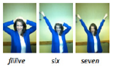

Activity: MISSING PART: MAKE 10 (6 minutes)  Materials: (S) 5-group cards (Lesson 5 Template 1)  Standards: 1.OA.C.6  EngageNY Module 1, Lesson 14 | Directions:  Students work with a partner, using 5-group cards. Each student puts a card on his or her forehead. The partner tells how many more to make 10. Students must guess the cards on their foreheads. Partners can play simultaneously, each putting a card on his or her forehead. If appropriate, remind students that they may use their fingers to help.

Activity: MATH HANDS FLASH: PARTNERS OF 10 (5 minutes)  Materials: None  Notes: This activity provides an opportunity for students to maintain their fluency with partners of 10 and strengthen their visualization of 5-groups by using their hands to see the math. The activity also continues to support students in seeing the connection between addition and subtraction. Guide students to relate addition and subtraction problems while building fluency with partners of 10.  Standards: 1.OA.C.6  EngageNY Module 1, Lesson 30 | Directions:  T: (Hold up nine fingers.) Show me how many fingers I need to make 10.  S: (Hold up one finger)  T: 9 plus what number equals 10?  S: 1.  T: Good! 9 + 1 = 10, so 10 – 9 = ? Look at your hands.  S: 1.  Continue playing, eliciting all partners of 10. If students are highly successful, switch to other totals within 10, such as 9, 8, or 7.

Activity: 5-GROUP MATCH: PARTNERS TO 10 (10 minutes)  Materials: (S) 5-group cards (0-10) with one extra 5 card per pair  Standards: 1.OA.C.6  EngageNY Module 1, Lesson 32 | Directions:  Assign students partners. Partner 1 closes his eyes. Partner 2 quickly lays out the 5-group cards, numeral side up. Partner 1 opens his eyes and tries to match all the partners to ten as quickly as possible. Each player tries twice in a row to see if they can increase their speed.
Activity: LINKING CUBE PARTNERS: 10 (10 minutes)  Materials: (S) 10 linking cubes (five cubes one color, five cubes another color) per pair, personal white board  Notes: This activity provides practice with the commutative property.  Standards: 1.OA.C.6  EngageNY Module 1, Lesson 20 | Directions:  Show students 10 linking cubes in a stick with a color change at the 5, and then remove it from sight. Break off a part and show the part to students. Students make a number bond and two number sentences to match the part shown and the part hidden (commutative property).

Activity: NUMBER PATH HOP (3 minutes)  Materials: (S) 5-group cards (Lesson 5 Template 1), one counter  Notes: This activity connects fluency work of addition and subtraction within 10 with the number path as a tool for modeling addition and subtraction  Standards: 1.OA.C.6  EngageNY Module 1, Lesson 26 | Directions:  Students make a number path by ordering their 5-group cards from 0 to 10. Instruct the students to place their counters on 0, and give a series of directions:  “Hop forward two. Where are you?”  “Hop back one space. What number are you on?”  “Hop from 1 to 5. How many hops did you make?”  “What number do you add to 5 to make 9?”

Activity: NUMBER BOND ROLL (5 minutes)  Materials: (S) Die (with 6 replaced by 0), personal white board  Notes: Reviewing number bonds allows students to build and maintain fluency with addition and subtraction facts within 10.  Standards: 1.OA.C.6  EngageNY Module 1, Lesson 27 | Directions:  Match partners of equal ability. Each student rolls one die. Students use the numbers on their own die and their partner’s die as the parts of a number bond. They each write a number bond, addition sentence, and subtraction sentence on their personal white boards. Once both partners have made their number bonds and number sentences, they check each other’s work. For example, if Partner A rolls a 2 and Partner B rolls a 3, they each write the number bond showing 2 and 3 making 5 and write number sentences such as 2 + 3 = 5 and 5 – 3 = 2.

Activity: SUBTRACTION WITH CARDS (7 minutes)  Materials: (S) One set of numeral-side-only 5-group cards (Lesson 5, Template 1) per pair, counters (if needed)  Notes: This activity addresses the core fluency objective for Grade 1 of adding and subtracting within 10.  Standards: 1.OA.C.6  EngageNY Module 1, Lesson 29 | Directions:  Students place cards face down between them. Each partner flips over two cards and subtracts the smaller number from the larger number. The partner with the smallest difference keeps the cards played by both players that round. The player with the most cards at the end of the game wins.

Activity: PENNY DROP: 7 (5 minutes)  Materials: (T) 7 pennies, 1 can  Standards: 1.OA.C.6  EngageNY Module 1, Lesson 24 | Directions:  Show students 7 pennies. Have students close their eyes and listen. Drop some of the pennies in a can, one at a time. Ask students to open their eyes and guess how many pennies are still in the teacher’s hand. Then, have students say how many pennies they heard drop and count on to 7, using the remaining pennies. Can extend to 10.

Activity: COLD CALL: 2 MORE AND 2 LESS (3 minutes)  Materials: None  Standards: 1.OA.C.6  EngageNY Module 1, Lesson 24 | Directions:  Say a number aloud and instruct students to think about the number that is 2 more. Let them know that the teacher will cold call students to say the number as quickly as possible. Alternate between calling on individual students, the whole class, and groups of students (e.g., only girls, only boys, etc.) Play again, cold calling students to say the number that is 2 less.

Activity: NUMBER BONDS OF 10 (8 minutes)  Materials: (S) Numeral cards 1-10 (single-sided numerals from 5-group cards (Lesson 5, Template 1), 10 two-sided beans or counters, a personal board with ten-frame (Fluency Template)  Standards: 1.OA.C.6  EngageNY Module 1, Lesson 36 | Directions:  Assign students partners of equal ability. Students put numeral cards face down in front of them. One partner flips a card and adds counters to the ten-frame (e.g., a partner flips 9 and adds nine red counters to the ten-frame). The other partner fills up the empty cells, using the other side of the counters (e.g., one white counter). The partners then work together to fill in a number bond and write two number sentences to match.

Activity: 5-GROUP FLASH (2 minutes)  Materials: (T) 5-group cards (Lesson 5, Template 1)  Standards: 1.OA.C.6  EngageNY Module 1, Lesson 37 | Directions:  Flash a 5-group card for 2-3 seconds and instruct students to identify the number at a signal (or snap). Ask for a number sentence to solve 10 minus the number flashed.
Activity: DECOMPOSING ADDITION SENTENCES (5 minutes)  Materials: None  Notes: This activity reviews how to decompose numbers to make ten, creating equivalent but easier number sentences  Standards: 1.OA.C.6  EngageNY Module 2, Lesson 10 | Directions:  T: (Write 9 + 5 = _ on the board.) What does 9 need to make ten?  S: 1.  T: (Write 9 = 1 below 9 + 5 = _.)  T: (Point to the 5.) If we take 1 from 5 to make ten, what part is left?  S: 4.  T: (Add + 4 after 9 + 1.) Say the number sentence with the answer.  S: 9 + 1 + 4 = 14.  T: (Write 14 to complete 9 + 1 + 4 = _). 9 + 1 + 4 = 14. 9 + 5 is…?  S: 14  T: (Write 14 to complete 9 + 5 = _.)  Continue with other 9 + n and 8 + n addition sentences. If students are ready, have them use their boards to independently decompose addition sentences into three parts.

Activity: 5-GROUP FLASH: TAKE FROM TEN (5 minutes)  Materials: (T) 5-group row cards (Lesson 12 Fluency Template 1) (S) Personal white board with 5-group row insert (Lesson 12 Fluency Template 2)  Notes: This maintenance fluency activity with partners to ten facilitates the take form ten subtraction strategy that students are learning  Standards: 1.OA.C.6  EngageNY Module 2, Lesson 13 | Directions:  Flash a card (e.g., 9) for one to three seconds. Students cross off the number flashed from the 5-group row insert and write the corresponding subtraction sentence.  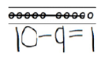

Activity: SUBTRACTION WITHIN 10 (10 minutes)  Materials: (S) Subtraction Within 10 Sprint  Standards: 1.OA.C.6  EngageNY Module 2, Lesson 14 | Directions:  For directions on how to use sprints, see appendix.

*Each of the above can be adjusted to use difference wholes in the 1-20 range.

Practice Workbook C

1.OA.C.7 – Understand the meaning of the equal sign, and determine if equations involving addition and subtraction are true or false.

Valid Equalities? from Illustrative Mathematics
Equality Number Sentences from Illustrative Mathematics
1. Tell if each equation is TRUE or FALSE
7 + 6 = 14
2 + 2 + 2 = 6
10 – 5 = 5
10 – 7 = 4
4 + 4 = 7
- + 4 = 9
8 - 3 = 6
14 – 6 =9
6 + 5 = 11
8 + 10 = 19
20 – 7 =15
19 – 4 = 13

2. Tell if each equation is TRUE or FALSE
4 + 1 = 2 + 3
2 + 5 = 4 + 3
6 + 4 = 4 + 6
2 + 7 = 8 + 3
9 + 1 = 6 + 3
5 + 1 = 6 + 0
8 + 1 = 3 + 6
6 + 2 = 4 + 3
12 + 3 = 5 + 9
5 + 6 = 7 + 4
3. Tell if each equation is TRUE or FALSE
14 – 6 = 12 – 4
10 – 5 = 5 – 0
7 – 3 = 8 – 2
12 – 6 = 14 – 6
16 – 6 = 17 – 7
8 – 3 = 12 – 6
17 – 9 = 19 – 11
6 – 2 = 8 – 4
13 – 6 = 14 – 7
19 – 5 = 17 – 3

4. Make Each Equation True
4 + 6 = _____+ 8
5 + _____ = 4 + 4
_____ + 3 = 4 + 1
0 + 7 = 6 + _____
9 + 1 = 4 + _____
8 + _____ = 0 + 9
2 + 3 = _____ + 2
_____ + 7 = 8 + 2
6 + 3 = _____ + 4
5 + _____ = 4 + 3

1.OA.C.8 – Determine the unknown whole number in an addition or subtraction equation relating three whole numbers.

Find the Missing Number from Illustrative Mathematics
Kiri’s Mathematic Match Game from Illustrative Mathematics
1. Write the related number sentences for the number bonds.

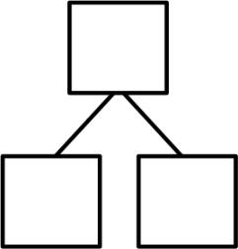
9
6
3
10
7
3

____ – _____ = ____  ____ + _____ = ____  ____ _____ = ____  ____ _____ = ____ | ____ – _____ = ____  ____ + _____ = ____  ____ _____ = ____  ____ _____ = ____
2. Write the related number sentences for the number bonds.

5
2

6
3

____ – _____ = ____  ____ + _____ = ____  ____ _____ = ____  ____ _____ = ____ | ____ – _____ = ____  ____ + _____ = ____  ____ _____ = ____  ____ _____ = ____
8
6

10
4

____ – _____ = ____  ____ + _____ = ____  ____ _____ = ____  ____ _____ = ____ | ____ – _____ = ____  ____ + _____ = ____  ____ _____ = ____  ____ _____ = ____
3. Write the related number sentences for the number bonds.

7

3
5

3

____ – _____ = ____  ____ + _____ = ____  ____ _____ = ____  ____ _____ = ____ | ____ – _____ = ____  ____ + _____ = ____  ____ _____ = ____  ____ _____ = ____
6
3
3
4
1
3

____ – _____ = ____  ____ + _____ = ____  ____ _____ = ____  ____ _____ = ____ | ____ – _____ = ____  ____ + _____ = ____  ____ _____ = ____  ____ _____ = ____
4. Write the related number sentences for the number bonds.

9
2

2
3

____ – _____ = ____  ____ + _____ = ____  ____ _____ = ____  ____ _____ = ____ | ____ – _____ = ____  ____ + _____ = ____  ____ _____ = ____  ____ _____ = ____
9
7

12
4

____ – _____ = ____  ____ + _____ = ____  ____ _____ = ____  ____ _____ = ____ | ____ – _____ = ____  ____ + _____ = ____  ____ _____ = ____  ____ _____ = ____
5. Write the related number sentences for the number bonds.

13

3
8

3

____ – _____ = ____  ____ + _____ = ____  ____ _____ = ____  ____ _____ = ____ | ____ – _____ = ____  ____ + _____ = ____  ____ _____ = ____  ____ _____ = ____

Practice Workbook D

1.NBT.B.2 – Understand that the two digits of a two-digit number represent amounts of tens and ones. Understand the following as special cases: a) 10 can be thought of as a bundle of ten ones – called a “ten.” b) the numbers from 11 to 19 are composed of a ten and one, two, three, four, five, six, seven, eight, or nine ones. c) The numbers 10, 20, 30, 40, 50, 60, 70, 80, 90 refer to one, two, three, four, five, six, seven, either, or nine tens (and 0 ones)

Roll & Build from illustrative Mathematics
1. What does the 2 mean in the number 28?  28  A. 12  B. 200  C. 20  D. 2 | 2. Which number has 6 tens?  A. 46  B. 96  C. 62  D. 59
3. How many tens are in 58?  A. 50  B. 8  C. 5  D. 80 | 4. Which number has 7 ones and 4 tens?  A. 74  B. 704  C. 47  D. 407
- Which number is represented? | - Show the number 57 in tens and ones?

7. What does the 7 mean in the number 67?  67  A. 67  B. 7  C. 70  D. 700 | 8. Which number has 4 tens?  A. 46  B. 94  C. 52  D. 56
9. How many tens are in 37?  A. 3  B. 7  C. 30  D. 70 | 10. Which number has 6 ones and 8 tens?  A. 68  B. 806  C. 86  D. 608
- Which number is represented?  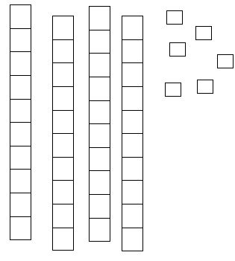  ____________ | - Show the number 39 in tens and ones.

13. What does the 8 mean in the number 89?  89  _________________ | 14. Which number has 7 ones?  A. 76  B. 56  C. 57  D. 75
15. How many tens are in 97?  A. 9  B. 7  C. 90  D. 70 | 16. Which number has 5 tens and 4 ones?  A. 45  B. 54  C. 504  D. 405
- Which number is represented?  ________________ | - Show the number 83 in tens and ones.

1.NBT.B.3 – Compare two two-digit numbers based on meanings of the tens and ones digits, recording the results of comparisons with the symbols >, =, and <.

Ordering Numbers from Illustrative Mathematics
Where Do I Go? from Illustrative Mathematics
Comparing Numbers from Illustrative Mathematics

- Which number is more than 52 but less than 63?  - 65  - 59  - 49  - 70 | - Which number belongs in the blank?  ______ > 75  A. 72  B. 78  C. 67  D. 75
- Fill in the blanks with the correct symbol.  - ____ 34  92 ____ 57  92 _____ 95  - ____ 61 | - Which number would make this statement true?  ______ < 56  A. 65  B. 72  C. 49  D. 58
- Circle all of the numbers that would make this statement true:  _____ < 71  A. 58  B. 71  C. 86  D. 49 | - Which number belongs in the blank?  ______ = 78  A. 72  B. 78  C. 67  D. 75
- Which number is more than 37, but less than 47?  - 65  - 59  - 49  - 40 | - Which number belongs in the blank?  ______ > 89  A. 72  B. 88  C. 67  D. 90
- Fill in the blanks with the correct symbol.  58____ 85  37____ 47  - _____ 17  66____ 66 | - Which number would make this statement true?  ______ < 33  A. 65  B. 27  C. 49  D. 58
- Circle all of the numbers that would make this statement true:  _____ < 56  A. 55  B. 71  C. 86  D. 49 | - Which number belongs in the blank?  ______ = 33  A. 72  B. 78  C. 33  D. 75

- Which number is more than 85 but less than 98?  - 93  - 99  - 49  - 84 | - Which number belongs in the blank?  ______ > 29  A. 32  B. 28  C. 17  D. 9
- Fill in the blanks with the correct symbol.  36____ 25  90____ 80  - _____37  67____ 66 | - Which number would make this statement true?  ______ < 33  A. 65  B. 27  C. 49  D. 58
- Circle all of the numbers that would make this statement true:  _____ < 56  A. 55  B. 71  C. 86  D. 49 | - Which number belongs in the blank?  ______ = 33  A. 72  B. 78  C. 33  D. 75

1.NBT.C.5 – Given a two-digit number, mentally find 10 more or 10 less than the number, without having to count; explain the reasoning being used.

Number Square from Illustrative Mathematics
1. Write the amount that is 10 more than the given number.
57 ⁺¹⁰ |  | 80 ⁺¹⁰
34 ⁺¹⁰ |  | 56 ⁺¹⁰
21 |  | 41
89 |  | 77
63 |  | 29
48 |  | 62
72 |  | 35
90 |  | 79

2. Write the amount that is 10 less than the given number.
57 ⁻¹⁰ |  | 80 ⁻¹⁰
34 ⁻¹⁰ |  | 56 ⁻¹⁰
21 |  | 41
89 |  | 77
63 |  | 29
48 |  | 62
72 |  | 35
90 |  | 93

3. Write the amount that is 10 more than the given number.
15 ⁺¹⁰ |  | 11 ⁺¹⁰
23 ⁺¹⁰ |  | 73 ⁺¹⁰
76 |  | 48
31 |  | 52
49 |  | 35
66 |  | 84
81 |  | 77
90 |  | 19

4. Write the amount that is 10 less than the given number
15 ⁻¹⁰ |  | 11 ⁻¹⁰
23 ⁻¹⁰ |  | 73 ⁻¹⁰
76 |  | 48
31 |  | 52
49 |  | 35
66 |  | 84
81 |  | 77
90 |  | 19

1.NBT.C.6 – Subtract multiples of ten in the range 10-90 from multiples of 10 in the range 10-90 (positive or zero differences), using concrete models or drawings and strategies based on place value, properties of operations, and/or the relationship between addition and subtraction; relate the strategy to a written method and explain the reasoning used.
1. Subtract.
80 – 60 =
70 – 30 =
90 – 50 =
40 – 20 =
60 – 50 =
50 – 30 =
30 – 10 =
20 – 20 =
80 – 50 =
70 – 20 =
90 – 40 =
40 – 10 =
60 – 40 =
50 – 20 =
30 – 20 =
20 – 10 =
80 – 80 =
70 – 50 =
90 – 70 =
40 – 40 =
60 – 10 =
50 – 40 =
30 – 30 =
2. Subtract.
80 – 30 =
70 – 10 =
90 – 20 =
40 – 10 =
60 – 20 =
50 – 40 =
30 – 20 =
20 – 0 =
80 – 20 =
70 – 10 =
90 – 20 =
40 – 30 =
60 – 20 =
50 – 40 =
30 – 30 =
20 – 20 =
80 – 30 =
70 – 20 =
90 – 40 =
40 – 10 =
60 – 20 =
50 – 10 =
30 – 20 =

Practice Workbook E

1.MD.C.4 – Organize, represent, and interpret data with up to three categories; ask and answer questions about the total number of data points, how many in each category, and how many more or less in one category than in another.
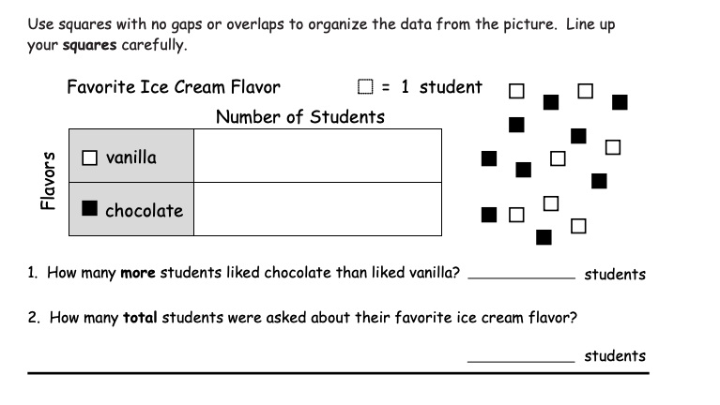

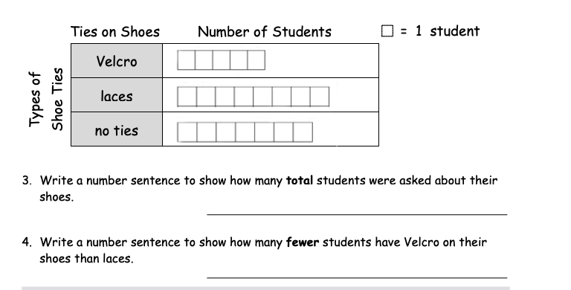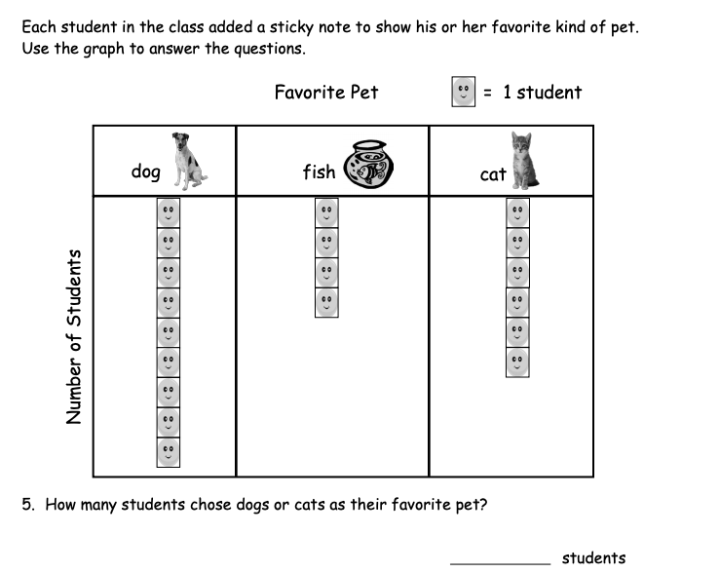
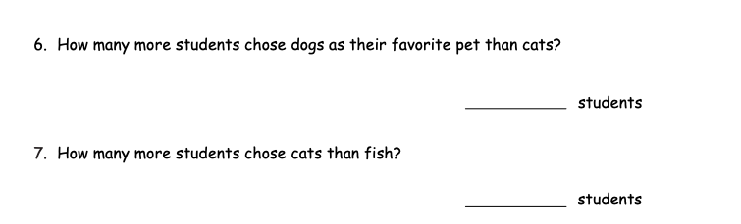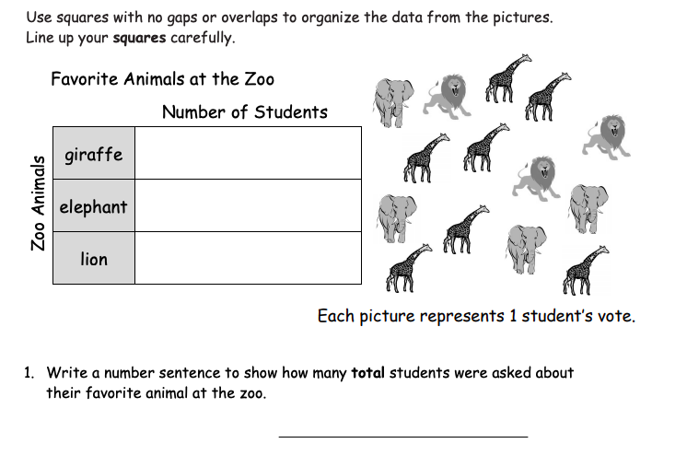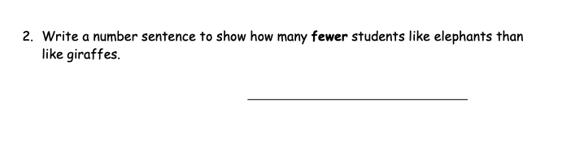
9.
8.
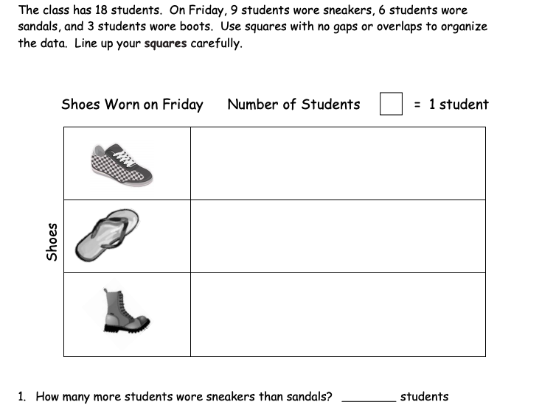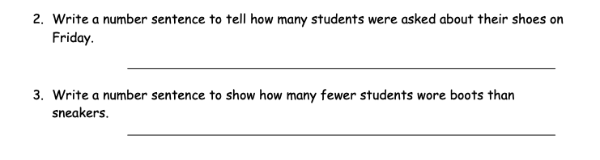
12.
11.
10.
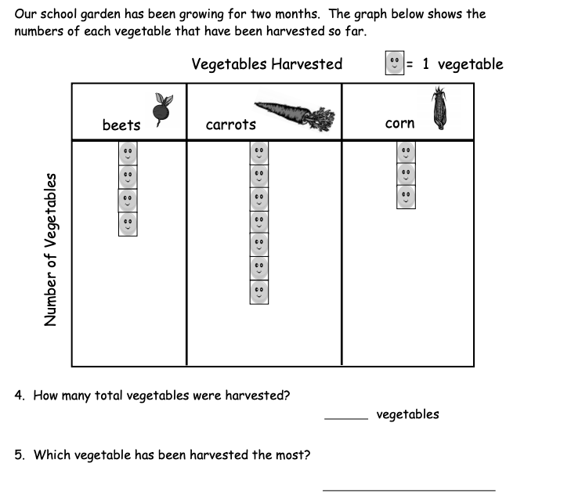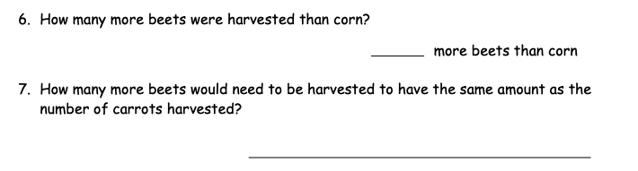
16.
15.
14.
13.

1.MD.A.1 – Order three objects by length; compare the lengths of two objects indirectly by using a third object.

1. 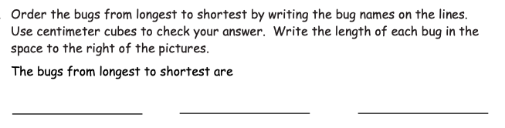
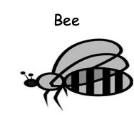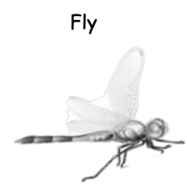

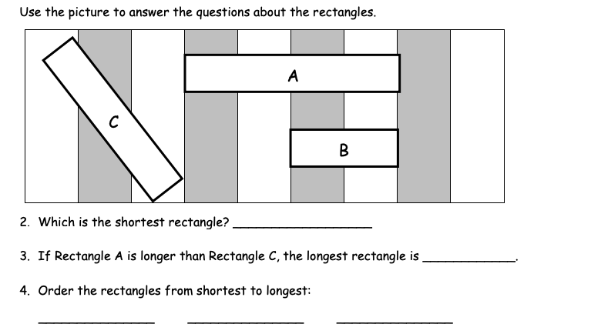

1.MD.A.2 – Express the length of an object as whole number of length units, by laying multiple copies of a shorter object end to end; understand that then length measurement of an object is the umber of same-size length units that span it with no gaps or overlaps.
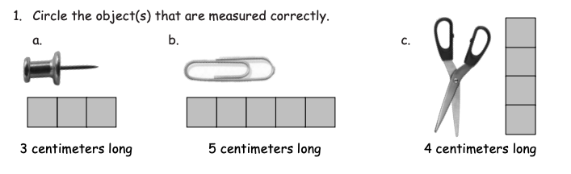

- Use centimeter cubes to measure the length of this marker. How many centimeters cubes long is the marker?

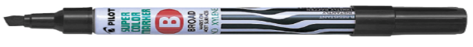 _______________

- Marta is trying to measure this piece of string. Help her find the length of the string, in centimeter cubes.

________________cm cubes

4. Use inch tiles to measure. Record your measurements.
Object | Length (inch tiles)

5. Circle Yes or No to tell if each measure tells the length of the line.

a.

6 centimeter cubes Yes No
b.
3 centimeter cubes Yes No

c.

4 centimeter cubes Yes No
d.
5 centimeter cubes Yes No

- Use an inch tiles to measure each snake to the nearest inch.
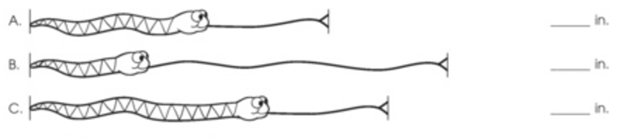

For numbers 7-10, measure with inch tiles.
- How long is the board? ______________

- How long is the crayon?__________________

- How long is the eraser?____________________

10. How long is the snake? ______________

1.MD.B.3 – Tell and write time in hours and half-hours using analog and digital clocks.

1. What time is shown on the clock?
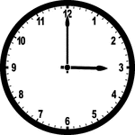 |  | 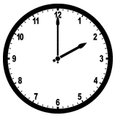
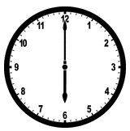 |  | 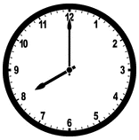
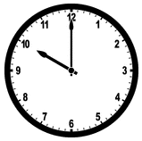 |  | 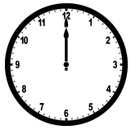
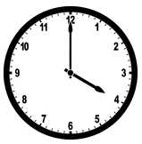 |  | 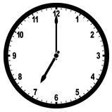

2. What time is shown on the clock?
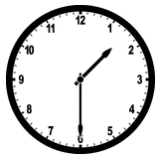 |  | 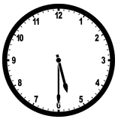
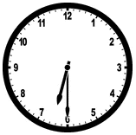 |  | 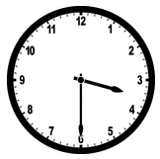
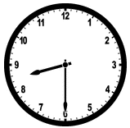 |  | 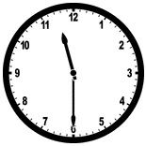
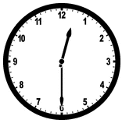 |  | 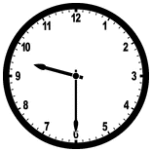

3. Circle the clock that matches the time shown. 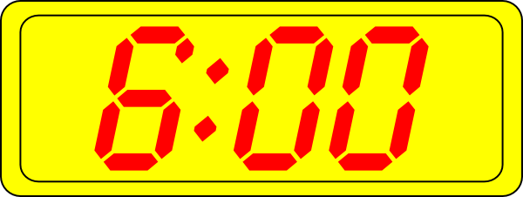
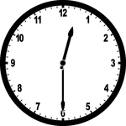 | 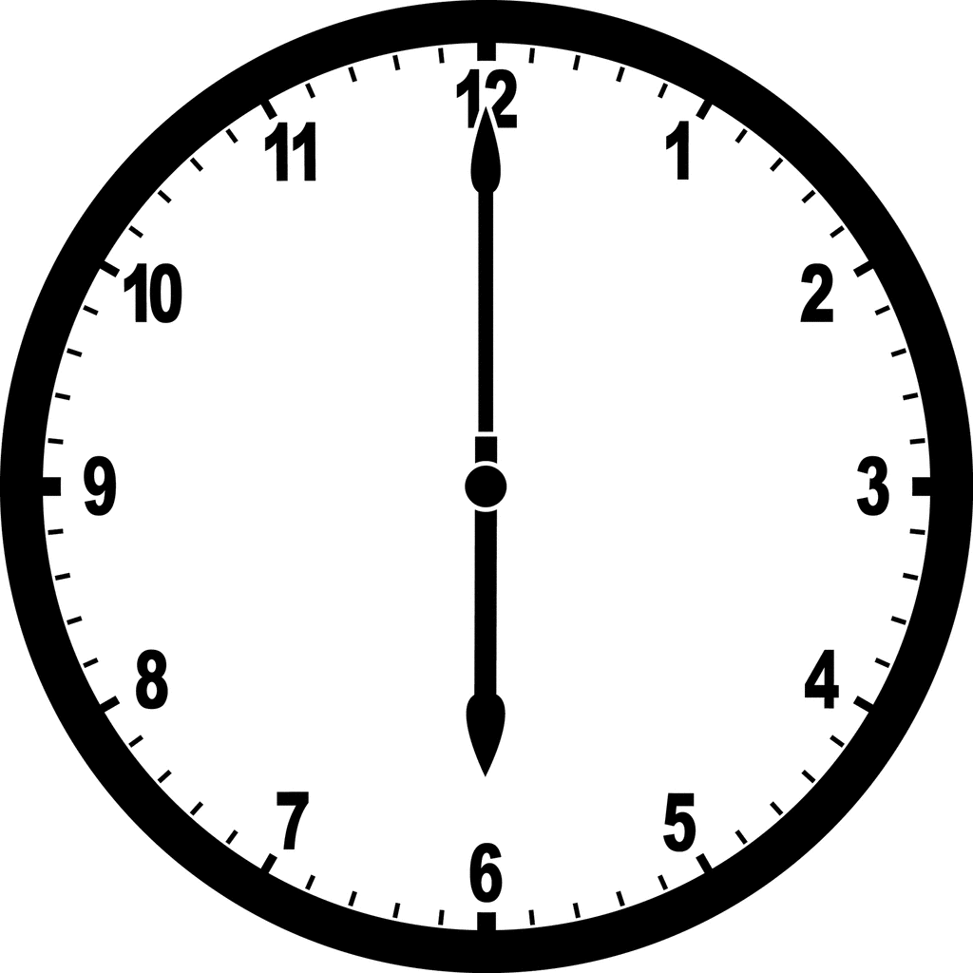
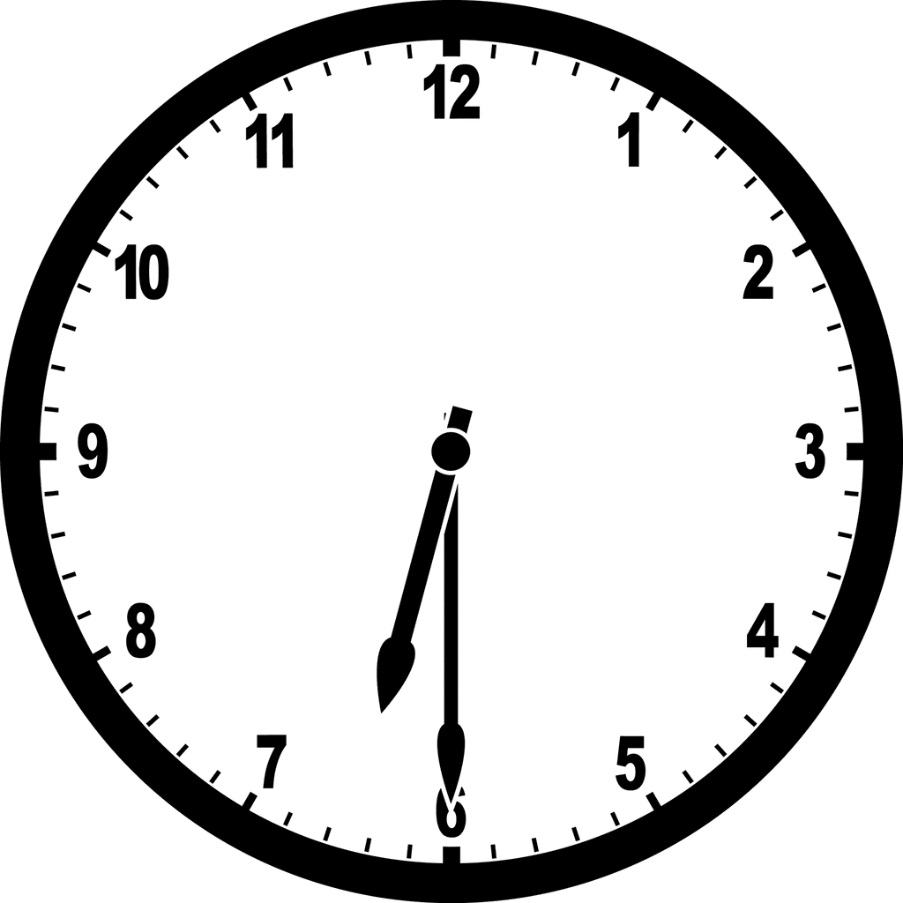

4. Circle the clock that matches the time shown. 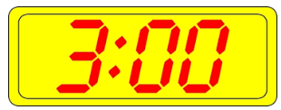

5. Circle the clock that matches the time shown. 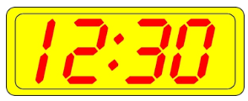

6. Circle the clock that matches the time shown. 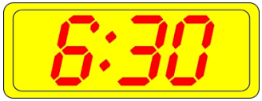

7. Draw hands on the clock to show the time.
9:30 | 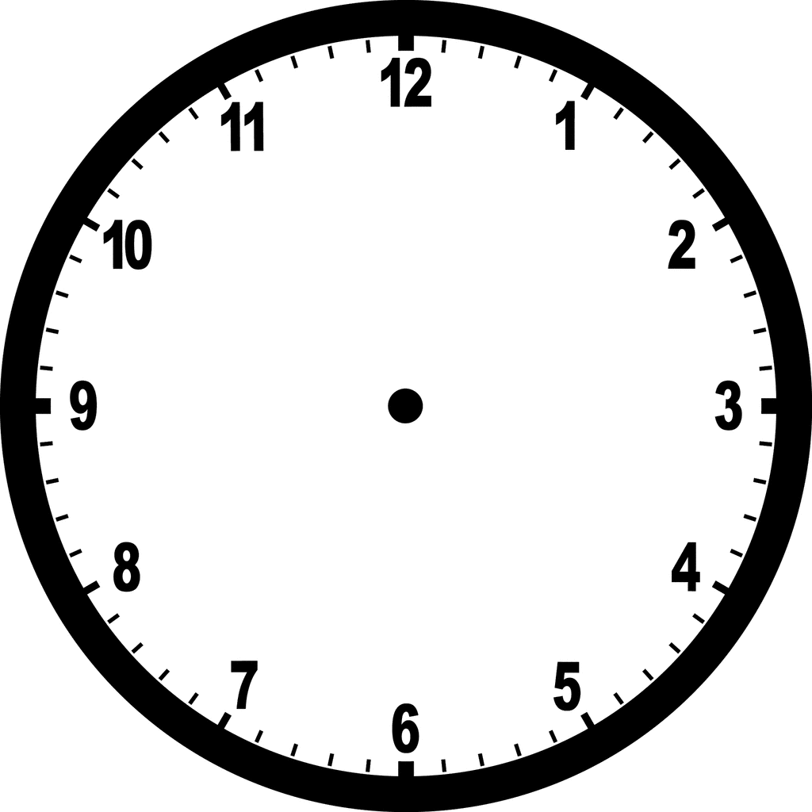 | 6 o’clock
4 o’clock |  | Half past 3
Half past 2 |  | 12:30
10:00 |  | 12:00

1.G.A.3 – Partition circles and rectangles into two and four equal shares, describe the shares using the words halves, fourths, and quarters, and use the phrases half of, fourth of, and quarter of. Describe the whole as two of, or four of the shares. Understand for these examples that decomposing into more equal shares creates smaller shares.

1. X all of the shapes that show ½ colored in.
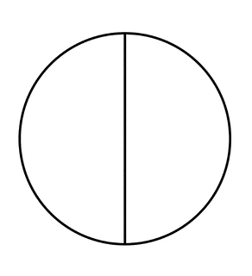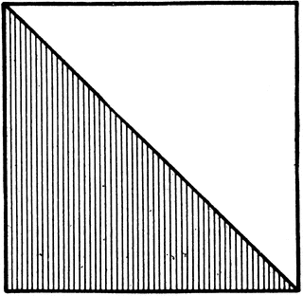
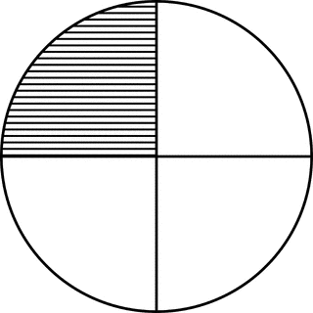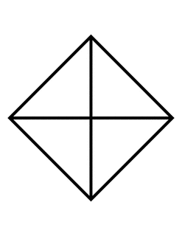

2. Show different ways to divide the rectangle into halves.

4. Show different ways to divide the square into fourths.

3. X all of the shapes that show ¼ colored in.

4. Show different ways to divide the rectangle into quarters.

4. Color one half of the square and one quarter of the circle.

Practice Workbook F

1.NBT.C.4 – Add within 100, including adding a two-digit number and a one-digit number, and adding a two-digit number and a multiple of 10, using concrete models, or drawings and strategies based on place value, properties of operations, and/or the relationship between addition and subtraction; relate the strategy to a written method and explain the reasoning used. Understand that in adding two-digit numbers, one adds tens and tens, ones and ones; and sometimes it is necessary to compose a ten.

1. Add.
72+7= | 48+7=
43+3= | 88+6=
58+2= | 73+9=
62+4= | 55+8=
83+5= | 66+5=
93+6= | 37+9=

2. Add.
72+10= | 40+11=
40+23= | 88+10=
58+20= | 73+20=
60+34= | 55+30=
83+10= | 60+23=
70+16= | 30+51=

3. Add.
72+9= | 48+10=
43+20= | 88+7=
50+24= | 6+28=
52+9= | 50+37=
73+18= | 66+25=
3+29= | 3+55=

Copyright: Achievement First. Unless otherwise noted, all of the content in this resource is licensed under a Creative Commons Attribution International 4.0 (CC BY) license.
“Illustrative Math” by University of Arizona. Achievement First does not own the copyright in “Fluency Workbook” and claims no copyright in this material. The material is being used exclusively for non-profit educational purposes under fair use principles in U.S. Copyright laws. The user should make the judgment about whether this material may be used under fair use / fair dealing permissions in the user’s country.
EngageNY First Grade by EngageNY licensed under Creative Commons Attribution International 4.0 (CC BY-NC-SA.) Achievement First does not own the copyright in “Fluency Workbook” and claims no copyright in this material. The material is being used exclusively for non-profit educational purposes under fair use principles in U.S. Copyright laws. The user should make the judgment about whether this material may be used under fair use / fair dealing permissions in the user’s country.
EngageNY First Grade by EngageNY licensed under Creative Commons Attribution International 4.0 (CC BY-NC-SA.) Achievement First does not own the copyright in “Fluency Workbook” and claims no copyright in this material. The material is being used exclusively for non-profit educational purposes under fair use principles in U.S. Copyright laws. The user should make the judgment about whether this material may be used under fair use / fair dealing permissions in the user’s country.
EngageNY First Grade by EngageNY licensed under Creative Commons Attribution International 4.0 (CC BY-NC-SA.) Achievement First does not own the copyright in “Fluency Workbook” and claims no copyright in this material. The material is being used exclusively for non-profit educational purposes under fair use principles in U.S. Copyright laws. The user should make the judgment about whether this material may be used under fair use / fair dealing permissions in the user’s country.
EngageNY First Grade by EngageNY licensed under Creative Commons Attribution International 4.0 (CC BY-NC-SA.) Achievement First does not own the copyright in “Fluency Workbook” and claims no copyright in this material. The material is being used exclusively for non-profit educational purposes under fair use principles in U.S. Copyright laws. The user should make the judgment about whether this material may be used under fair use / fair dealing permissions in the user’s country.
“Illustrative Math” by University of Arizona. Achievement First does not own the copyright in “Fluency Workbook” and claims no copyright in this material. The material is being used exclusively for non-profit educational purposes under fair use principles in U.S. Copyright laws. The user should make the judgment about whether this material may be used under fair use / fair dealing permissions in the user’s country.
“Illustrative Math” by University of Arizona. Achievement First does not own the copyright in “Fluency Workbook” and claims no copyright in this material. The material is being used exclusively for non-profit educational purposes under fair use principles in U.S. Copyright laws. The user should make the judgment about whether this material may be used under fair use / fair dealing permissions in the user’s country.
EngageNY First Grade by EngageNY licensed under Creative Commons Attribution International 4.0 (CC BY-NC-SA.) Achievement First does not own the copyright in “Fluency Workbook” and claims no copyright in this material. The material is being used exclusively for non-profit educational purposes under fair use principles in U.S. Copyright laws. The user should make the judgment about whether this material may be used under fair use / fair dealing permissions in the user’s country.
EngageNY First Grade by EngageNY licensed under Creative Commons Attribution International 4.0 (CC BY-NC-SA.) Achievement First does not own the copyright in “Fluency Workbook” and claims no copyright in this material. The material is being used exclusively for non-profit educational purposes under fair use principles in U.S. Copyright laws. The user should make the judgment about whether this material may be used under fair use / fair dealing permissions in the user’s country.
EngageNY First Grade by EngageNY licensed under Creative Commons Attribution International 4.0 (CC BY-NC-SA.) Achievement First does not own the copyright in “Fluency Workbook” and claims no copyright in this material. The material is being used exclusively for non-profit educational purposes under fair use principles in U.S. Copyright laws. The user should make the judgment about whether this material may be used under fair use / fair dealing permissions in the user’s country.
EngageNY First Grade by EngageNY licensed under Creative Commons Attribution International 4.0 (CC BY-NC-SA.) Achievement First does not own the copyright in “Fluency Workbook” and claims no copyright in this material. The material is being used exclusively for non-profit educational purposes under fair use principles in U.S. Copyright laws. The user should make the judgment about whether this material may be used under fair use / fair dealing permissions in the user’s country.
EngageNY First Grade by EngageNY licensed under Creative Commons Attribution International 4.0 (CC BY-NC-SA.) Achievement First does not own the copyright in “Fluency Workbook” and claims no copyright in this material. The material is being used exclusively for non-profit educational purposes under fair use principles in U.S. Copyright laws. The user should make the judgment about whether this material may be used under fair use / fair dealing permissions in the user’s country.
“Illustrative Math” by University of Arizona. Achievement First does not own the copyright in “Fluency Workbook” and claims no copyright in this material. The material is being used exclusively for non-profit educational purposes under fair use principles in U.S. Copyright laws. The user should make the judgment about whether this material may be used under fair use / fair dealing permissions in the user’s country.
“Illustrative Math” by University of Arizona. Achievement First does not own the copyright in “Fluency Workbook” and claims no copyright in this material. The material is being used exclusively for non-profit educational purposes under fair use principles in U.S. Copyright laws. The user should make the judgment about whether this material may be used under fair use / fair dealing permissions in the user’s country.
“Illustrative Math” by University of Arizona. Achievement First does not own the copyright in “Fluency Workbook” and claims no copyright in this material. The material is being used exclusively for non-profit educational purposes under fair use principles in U.S. Copyright laws. The user should make the judgment about whether this material may be used under fair use / fair dealing permissions in the user’s country.
EngageNY First Grade by EngageNY licensed under Creative Commons Attribution International 4.0 (CC BY-NC-SA.) Achievement First does not own the copyright in “Fluency Workbook” and claims no copyright in this material. The material is being used exclusively for non-profit educational purposes under fair use principles in U.S. Copyright laws. The user should make the judgment about whether this material may be used under fair use / fair dealing permissions in the user’s country.
EngageNY First Grade by EngageNY licensed under Creative Commons Attribution International 4.0 (CC BY-NC-SA.) Achievement First does not own the copyright in “Fluency Workbook” and claims no copyright in this material. The material is being used exclusively for non-profit educational purposes under fair use principles in U.S. Copyright laws. The user should make the judgment about whether this material may be used under fair use / fair dealing permissions in the user’s country.
EngageNY First Grade by EngageNY licensed under Creative Commons Attribution International 4.0 (CC BY-NC-SA.) Achievement First does not own the copyright in “Fluency Workbook” and claims no copyright in this material. The material is being used exclusively for non-profit educational purposes under fair use principles in U.S. Copyright laws. The user should make the judgment about whether this material may be used under fair use / fair dealing permissions in the user’s country.
EngageNY First Grade by EngageNY licensed under Creative Commons Attribution International 4.0 (CC BY-NC-SA.) Achievement First does not own the copyright in “Fluency Workbook” and claims no copyright in this material. The material is being used exclusively for non-profit educational purposes under fair use principles in U.S. Copyright laws. The user should make the judgment about whether this material may be used under fair use / fair dealing permissions in the user’s country.
EngageNY First Grade by EngageNY licensed under Creative Commons Attribution International 4.0 (CC BY-NC-SA.) Achievement First does not own the copyright in “Fluency Workbook” and claims no copyright in this material. The material is being used exclusively for non-profit educational purposes under fair use principles in U.S. Copyright laws. The user should make the judgment about whether this material may be used under fair use / fair dealing permissions in the user’s country.
EngageNY First Grade by EngageNY licensed under Creative Commons Attribution International 4.0 (CC BY-NC-SA.) Achievement First does not own the copyright in “Fluency Workbook” and claims no copyright in this material. The material is being used exclusively for non-profit educational purposes under fair use principles in U.S. Copyright laws. The user should make the judgment about whether this material may be used under fair use / fair dealing permissions in the user’s country.
EngageNY First Grade by EngageNY licensed under Creative Commons Attribution International 4.0 (CC BY-NC-SA.) Achievement First does not own the copyright in “Fluency Workbook” and claims no copyright in this material. The material is being used exclusively for non-profit educational purposes under fair use principles in U.S. Copyright laws. The user should make the judgment about whether this material may be used under fair use / fair dealing permissions in the user’s country.
EngageNY First Grade by EngageNY licensed under Creative Commons Attribution International 4.0 (CC BY-NC-SA.) Achievement First does not own the copyright in “Fluency Workbook” and claims no copyright in this material. The material is being used exclusively for non-profit educational purposes under fair use principles in U.S. Copyright laws. The user should make the judgment about whether this material may be used under fair use / fair dealing permissions in the user’s country.
“ETC” by Florida Center for Instructional Technology. Achievement First does not own the copyright in “Fluency Workbook” and claims no copyright in this material. The material is being used exclusively for non-profit educational purposes under fair use principles in U.S. Copyright laws. The user should make the judgment about whether this material may be used under fair use / fair dealing permissions in the user’s country.
“ETC” by Florida Center for Instructional Technology. Achievement First does not own the copyright in “Fluency Workbook” and claims no copyright in this material. The material is being used exclusively for non-profit educational purposes under fair use principles in U.S. Copyright laws. The user should make the judgment about whether this material may be used under fair use / fair dealing permissions in the user’s country.
“ETC” by Florida Center for Instructional Technology. Achievement First does not own the copyright in “Fluency Workbook” and claims no copyright in this material. The material is being used exclusively for non-profit educational purposes under fair use principles in U.S. Copyright laws. The user should make the judgment about whether this material may be used under fair use / fair dealing permissions in the user’s country.
“ETC” by Florida Center for Instructional Technology. Achievement First does not own the copyright in “Fluency Workbook” and claims no copyright in this material. The material is being used exclusively for non-profit educational purposes under fair use principles in U.S. Copyright laws. The user should make the judgment about whether this material may be used under fair use / fair dealing permissions in the user’s country.
“ETC” by Florida Center for Instructional Technology. Achievement First does not own the copyright in “Fluency Workbook” and claims no copyright in this material. The material is being used exclusively for non-profit educational purposes under fair use principles in U.S. Copyright laws. The user should make the judgment about whether this material may be used under fair use / fair dealing permissions in the user’s country.
“ETC” by Florida Center for Instructional Technology. Achievement First does not own the copyright in “Fluency Workbook” and claims no copyright in this material. The material is being used exclusively for non-profit educational purposes under fair use principles in U.S. Copyright laws. The user should make the judgment about whether this material may be used under fair use / fair dealing permissions in the user’s country.
“ETC” by Florida Center for Instructional Technology. Achievement First does not own the copyright in “Fluency Workbook” and claims no copyright in this material. The material is being used exclusively for non-profit educational purposes under fair use principles in U.S. Copyright laws. The user should make the judgment about whether this material may be used under fair use / fair dealing permissions in the user’s country.

