Grade K math
Practice workbook
Achievement First Elementary Math

Practice Workbooks - Achievement First Elementary Math – Grade K
Contents
Practice Workbook A 3
K.CC.A.3 (to 10) – Write numbers from 0 to 20. Represent a number of objects with a written numeral 0-20 (with 0 representing a count of no objects). 3
K.CC.B.5 (to 10) – Count to answer “How many?” questions about as many as 20 things arranged in a line, a rectangular array, or a circle, or as many as 10 things in a scattered configuration; given a number 1-20, count out that many objects. 5
K.CC.B.4c – Understand that each successive number name refers to a quantity that is one larger. 10
K.MD.B.3 – Classify objects into given categories based on their attributes; count the numbers of objects in each category and sort the categories by the count. 12
Practice Workbook B 13
K.G.A.1 – Describe objects in the environment using names of shapes, and describe the relative positions of these objects using terms such as above, below, besides, in front of, behind, and next to. 13
K.G.A.2 – Correctly name shapes regardless of their orientations or overall size. 13
Practice Workbook C 17
K.CC.A.3 (to 20) - Write numbers from 0 to 20. Represent a number of objects with a written numeral 0-20 (with 0 representing a count of no objects). 17
K.CC.B.5– Count to answer “How many?” questions about as many as 20 things arranged in a line, a rectangular array, or a circle, or as many as 10 things in a scattered configuration; given a number 1-20, count out that many objects. 22
Practice Workbook D 28
K.CC.C.7– Compare two numbers between 1 and 10 presented with written numerals. 28
Practice Workbook E 29
K.CC.A.1 - Count to 100 by ones and by tens. 29
K.CC.A.2 - Count forward beginning from a given number within the known sequence (instead of having to begin at 1). 31
K.OA.A.5 – Fluently add and subtract within 5. 31
Practice Workbook F 35
K.OA.A.2 – Solve addition and subtraction word problems, and add and subtract within 10, e.g., by using objects or drawings to represent the problem. 35
K.OA.A.3 – Decompose numbers less than or equal to 10 into pairs in more than one way, e.g., by using objects or drawings and recording each decomposition with a drawing or equation. 38
2. Write equations to show all of the ways to make each number. 39
K.OA.A.4– For any number 1 to 9, find the number that makes 10 when added to the given number, e.g., by using objects or drawings, and record the answer with a drawing or equation. 40
K.CC.A.3 (to 20) - Write numbers from 0 to 20. Represent a number of objects with a written numeral 0-20 (with 0 representing a count of no objects). 43
K.CC.B.5– Count to answer “How many?” questions about as many as 20 things arranged in a line, a rectangular array, or a circle, or as many as 10 things in a scattered configuration; given a number 1-20, count out that many objects. 45
Practice Workbook G 49
K.NBT.A.1 –Compose and decompose number s from 11 to 19 into ten ones and some further ones, e.g., by using objects or drawings, and record each composition or decomposition by a drawing or equation (such as 18=1-+8); understand that these numbers are composed of ten ones and one, two, three, four, five, six, seven, eight , or nine ones. 49

Practice Workbook A

K.CC.A.3 (to 10) – Write numbers from 0 to 20. Represent a number of objects with a written numeral 0-20 (with 0 representing a count of no objects).

- Fill in the missing number.
1 | 2 | 3 | 4 |  | 6

- Fill in the missing number.
1 | 2 |  | 4 | 5 | 6

- Fill in the missing number.
5 | 6 | 7 |  | 9 | 10

- Fill in the missing numbers.
1 | 2

- Fill in the missing numbers.
1 | 2 | 3 |  | 5

- Write the numbers from 1 to 10.

- Write the numbers from 1 to 10.

K.CC.B.5 (to 10) – Count to answer “How many?” questions about as many as 20 things arranged in a line, a rectangular array, or a circle, or as many as 10 things in a scattered configuration; given a number 1-20, count out that many objects.

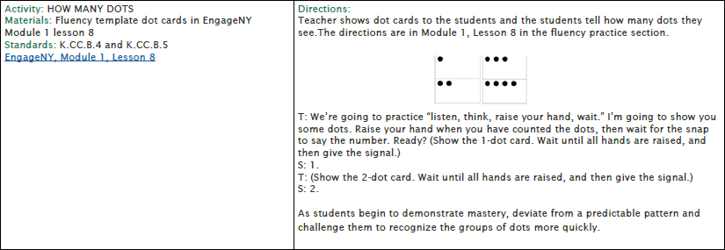
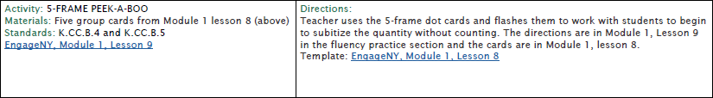
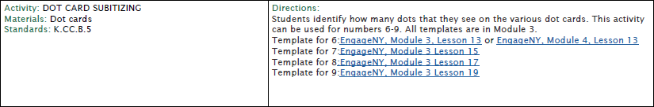
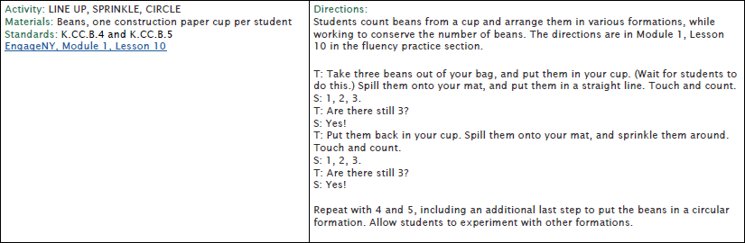
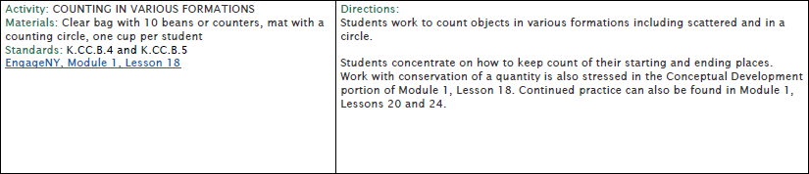

1. How many?
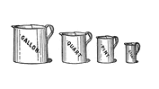
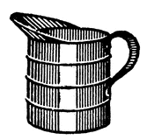
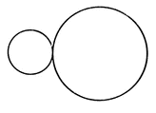

2. How many?

- How many?
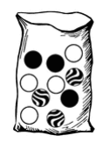

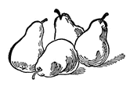

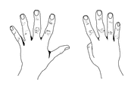

- How many?
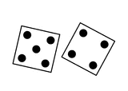

K.CC.B.4c – Understand that each successive number name refers to a quantity that is one larger.

1. Write the number that is one more.
One more?
8
4
6
7
5

2. Write the number that is one more.

One more?
9
3
1
2

K.MD.B.3 – Classify objects into given categories based on their attributes; count the numbers of objects in each category and sort the categories by the count.

- Color each group of 3.

- How many ? _________________

- How many ? _________________

Practice Workbook B

K.G.A.1 (position words) – Describe objects in the environment using names of shapes, and describe the relative positions of these objects using terms such as above, below, beside, in front of, behind, and next to.

- Look at the Ninja Turtle. Draw a circle above the Ninja Turtle. Draw a triangle below the Ninja Turtle. Draw a rectangle beside the Ninja Turtle.

- Look at the star. Draw a circle below the star. Draw a triangle above the star. Draw a rectangle next to the star.

- Look at the star. Circle the shape above the star.

- Look at the star. Circle the shape below the star.

- Look at the star. Circle the shape next to the star.

K.G.A.2 – Correctly name shapes regardless of their orientations or overall size.

1. X all of the squares.

- X all of the triangles.

- X all of the circles.

- X all of the rectangles.

Practice Workbook C

K.CC.A.3 (to 20) - Write numbers from 0 to 20. Represent a number of objects with a written numeral 0-20 (with 0 representing a count of no objects).

- Fill in the missing number.
15 | 16 | 17 | 18 |  | 20

- Fill in the missing number.
11 | 12 |  | 14 | 15 | 16

- Fill in the missing number.
5 | 6 | 7 |  | 9 | 10

- Fill in the missing numbers.
1 | 2

- Fill in the missing numbers.
10 | 11

- Fill in the missing number.
15 |  | 17 | 18 | 19 | 20

- Fill in the missing number.
11 |  | 13 | 14 | 15 | 16

- Fill in the missing number.
5 |  | 7 | 8 | 9 | 10

- Fill in the missing numbers.
11 | 12 | 13

- Fill in the missing numbers.
10 |  |  |  | 14 | 15

- Write the numbers from 1 to 20.

- Write the numbers from 1 to 20.

- Write the numbers from 1 to 20.

K.CC.B.5 (to 20)– Count to answer “How many?” questions about as many as 20 things arranged in a line, a rectangular array, or a circle, or as many as 10 things in a scattered configuration; given a number 1-20, count out that many objects.

1. Write how many.

2. Write how many.
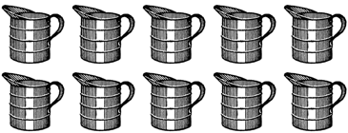

3. Write how many.

4. Write how many.

Practice Workbook D

K.CC.C.7– Compare two numbers between 1 and 10 presented with written numerals.

Guess the Marbles in the Bag from Illustrative Mathematics.
1. Sandra was playing cards. She flipped a 3 and a 6. Which number is greater?
Circle the number that is greater.
3 | 6

2. Circle the number that is less than 7.
9
7
6
8
3. Circle ALL of the numbers that are greater than 6.
5
7
4
9
4. Michael was playing cards. He flipped an 8 and a 6. Which number is less?
Circle the number that is less.
8 | 6

5. Circle the number that is more than 7.
9
7
6
5
6. Circle ALL of the numbers that are less than 6.
5
7
4
9

- Circle the number that is greater.
5 or 7
9 or 3
8 or 9
5 or 4
2 or 1

- Circle the number that is less.
5 or 3
9 or 7
8 or 9
5 or 2
2 or 4

9. Circle the number that is greater.
9 or 6
9 or 10
6 or 9
3 or 2
4 or 2

10. Circle the number that is less.
4 or 6
8 or 6
7 or 9
5 or 3
5 or 4

Practice Workbook E

K.CC.A.1 - Count to 100 by ones and by tens.
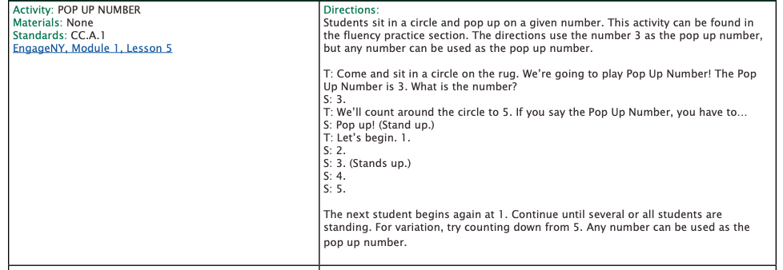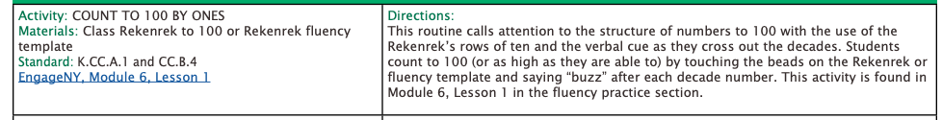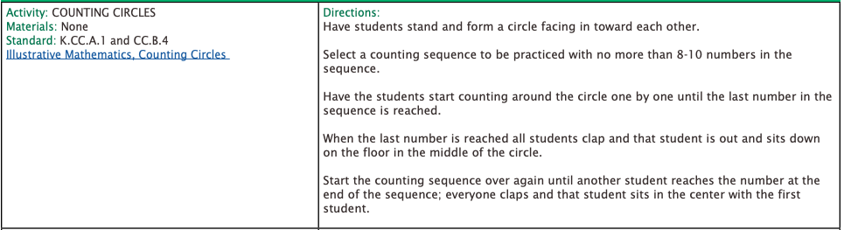
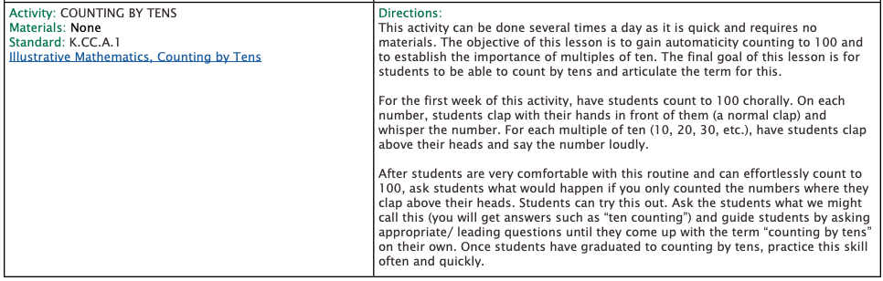
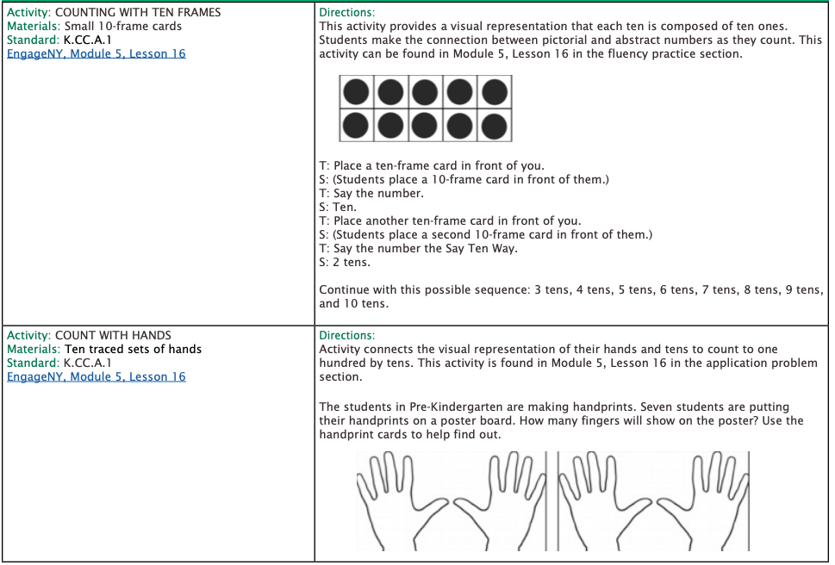

K.CC.A.2 - Count forward beginning from a given number within the known sequence (instead of having to begin at 1).
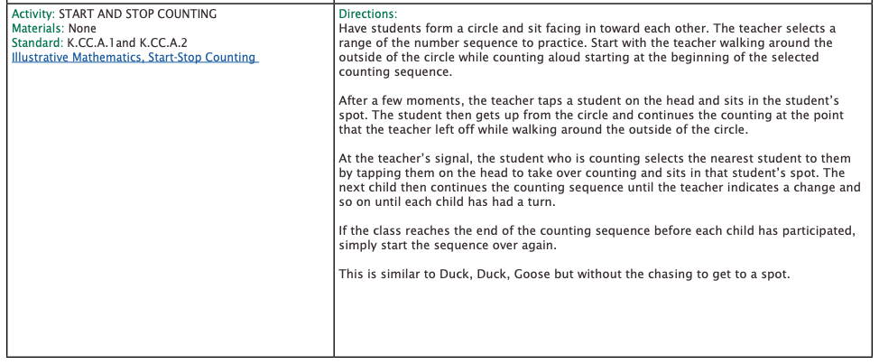

K.OA.A.5 – Fluently add and subtract within 5.
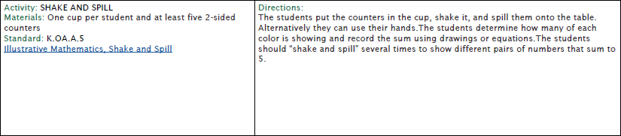
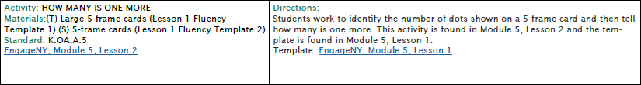
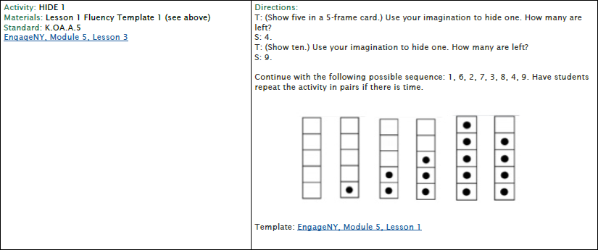
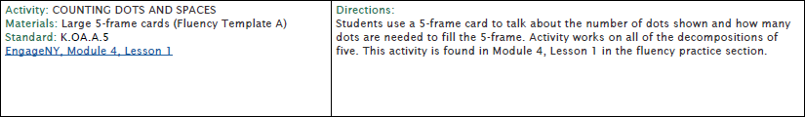
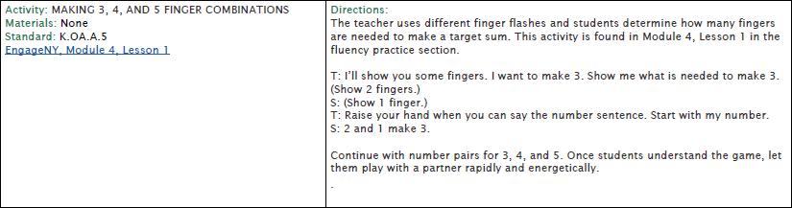

1 | 3 + 2 = ____
2 | 4 + 1 =____
3 | 2 + 0 = ____
4 | 3 + 1 = ____
5 | 0 + 5 = ____
6 | 1 + 2 = ____
7 | 1 + 3 = ____
8 | 2 + 2 = ____
9 | 1 + 1 = ____
10 | 0 + 2 = ____
11 | 1 + 4 = ____
12 | 3 + 2 = ____
13 | 2 + 3 = ____
14 | 2 + 3 = ____
15 | 5 + 0 = ____
16 | 4 + 1 = ____

Practice Workbook F

K.OA.A.2 – Solve addition and subtraction word problems, and add and subtract within 10, e.g., by using objects or drawings to represent the problem.

Draw a picture to help you solve.
1 | 5 + 2 = ____
2 | 4 + 3 =____
3 | 2 + 4 = ____
4 | 6 + 3 = _____
5 | 7 + 3 = _____
6 | 7 + 2 = _____
7 | 8 + 1 = _____
8 | 5 + 3 = ____
9 | 3 + 3 =____
10 | 4 + 4 = ____
11 | 6 + 4 = _____
12 | 4 + 3 = _____
13 | 4 + 2 = _____
14 | 8 + 2 = _____
15 | 2 + 3 = _____

Draw a picture to help you solve.
16 | 5 + 3 = ____
17 | 4 + 2 =____
18 | 3 + 4 = ____
19 | 6 + 3 = _____
20 | 7 + 2 = _____
21 | 5 + 2 = _____
22 | 8 + 1 = _____
23 | 5 + 1 = ____
24 | 3 + 3 =____
25 | 4 + 5 = ____
26 | 4 + 4 = _____
27 | 5 + 3 = _____
28 | 4 + 5 = _____
29 | 7 + 2 = _____
30 | 2 + 3 = _____

K.OA.A.3 – Decompose numbers less than or equal to 10 into pairs in more than one way, e.g., by using objects or drawings, and record each decomposition by a drawing or equation (e.g., 5 = 2 + 3 and 5 = 4 + 1).
Pick Two from Illustrative Mathematics
Make 9 from Illustrative Mathematics
1. Circle all of the ways to make 10.
10 = 7 – 3
10 = 2 + 8
10 = 4 + 6
1 + 0 = 10
2. Circle all of the ways to make a total of 6.
6 = 5 + 1
6 + 1 = 6
3 + 3 = 6
6 = 2 + 4
3. Circle all of the ways to make 8.
- = 6 – 2
8 = 0 + 8
8 = 5 – 3
8 = 1 + 7

4. Draw a picture to show 2 ways the make each number.
6
4
7
6
3
1
8
9
5

5. How many ways can you make each number?
5
6
7
8
9

6,. Write equations to show all of the ways to make each number.
5
4
3
7
6

K.OA.A.4– For any number 1 to 9, find the number that makes 10 when added to the given number, e.g., by using objects or drawings, and record the answer with a drawing or equation.

1. Draw circles or write numbers to make the equation true.
10 = |  | +
10 = |  | +
10 = |  | +
10 = |  | +
10 = |  | +
10 = |  | +
10 = |  | +
10 = |  | +
10 = |  | +
10 = |  | +

2. Draw circles or write numbers to make the equation true.

10 = |  | +
10 = |  | +
10 = |  | +
10 = |  | +
10 = |  | +
10 = |  | +
10 = |  | +
10 = |  | +
10 = |  | +
10 = |  | +

3. Draw circles and write a number to show how many more are needed to make 10.
How many to make 10?
2
4
7
6
3
1
8
9
5

4. Write numbers to make the equations true.
10 = | 2 | +
10 = | 8 | +
10 = | 4 | +
10 = | 5 | +
10 = | 10 | +
10 = | 3 | +
10 = | 9 | +
10 = | 7 | +
10 = | 1 | +
10 = | 6 | +
10 = | 0 | +

5. Write numbers to make the equations true.

10 = | 4 | +
10 = | 9 | +
10 = | 5 | +
10 = | 3 | +
10 = | 10 | +
10 = | 2 | +
10 = | 8 | +
10 = | 1 | +
10 = | 7 | +
10 = | 0 | +
10 = | 6 | +

6. Fill in the blanks to make the equations true. Use pictures or objects to help you.
1 + ____ = 10 | 5 + ____ = 10 | 9 + ____ = 10
7 + ____ = 10 | 3 + ____ = 10 | 4 + ____ = 10
2 + ____ = 10 | 1 + ____ = 10 | 5 + ____ = 10
8 + ____ = 10 | 6 + ____ = 10 | 7+ ____ = 10

K.CC.A.3 (to 20) - Write numbers from 0 to 20. Represent a number of objects with a written numeral 0-20 (with 0 representing a count of no objects).

- Fill in the missing number.
15 |  | 17 | 18

- Fill in the missing number.
11 |  |  | 14

- Fill in the missing number.
5 |  | 7 |  |  | 10

- Fill in the missing numbers.
1 | 2

- Fill in the missing numbers.
10

- Fill in the missing number.
15 |  |  | 18 |  | 20

- Fill in the missing number.
11 |  |  |  |  | 16

- Fill in the missing number.
5

- Fill in the missing numbers.
11

- Fill in the missing numbers.
13

- Write the numbers from 1 to 20.

K.CC.B.5– Count to answer “How many?” questions about as many as 20 things arranged in a line, a rectangular array, or a circle, or as many as 10 things in a scattered configuration; given a number 1-20, count out that many objects.

1. Write how many.

2. Write how many.

3. Write how many.

4. Write how many.

Practice Workbook G
K.NBT.A.1 –Compose and decompose number s from 11 to 19 into ten ones and some further ones, e.g., by using objects or drawings, and record each composition or decomposition by a drawing or equation (such as 18=1-+8); understand that these numbers are composed of ten ones and one, two, three, four, five, six, seven, eight , or nine ones.

What Makes a Teen Number? from Illustrative Mathematics
1. What number is represented in each line below?
12
2. Write an equation to show each amount below.

3. Complete the tens frames to match the equation.

10 + 7 = 17
10 + 3 = 13
10 + 2 = 12
10 + 6 = 16
10 + 8 = 18
10 + 1 = 11

4. Write an equation to show each amount below.
10 + 2 = 12

5. Draw a picture to show each number as ten ones and some more ones.
14
12
15
11
18
13
16
17
19

6. Draw a picture to show 18 as a ten ones and some more ones. Write a number sentence to match.
7. Draw a picture to show 13 as ten ones and some more ones. Write a number sentence to match.

8. Draw a picture to show 19 as ten ones and some more ones. Write a number sentence to match.
9. Draw a picture to show 17 as ten ones and some more ones. Write a number sentence to match.

10. Draw a picture to show 11 as ten ones and some more ones. Write a number sentence to match.
11. Draw a picture to show 12 as ten ones and some more ones. Write a number sentence to match.

12. Draw a picture to show 18 as ten ones and some more ones. Write a number sentence to match.

13. Draw a picture to show 13 as ten ones and some more ones. Write a number sentence to match.

14. Draw a picture to show 19 as ten ones and some more ones. Write a number sentence to match.

15. Draw a picture to show 17 as ten ones and some more ones. Write a number sentence to match.
16. Draw a picture to show 11 as ten ones and some more ones. Write a number sentence to match.

16. Draw a picture to show 12 as ten ones and some more ones. Write a number sentence to match.

Copyright: Achievement First. Unless otherwise noted, all of the content in this resource is licensed under a Creative Commons Attribution International 4.0 (CC BY) license.
EngageNY Kindergarten by EngageNY licensed under Creative Commons Attribution International 4.0 (CC BY-NC-SA.) Achievement First does not own the copyright in “Fluency Workbook” and claims no copyright in this material. The material is being used exclusively for non-profit educational purposes under fair use principles in U.S. Copyright laws. The user should make the judgment about whether this material may be used under fair use / fair dealing permissions in the user’s country.
“Illustrative Math” by University of Arizona. Achievement First does not own the copyright in “Fluency Workbook” and claims no copyright in this material. The material is being used exclusively for non-profit educational purposes under fair use principles in U.S. Copyright laws. The user should make the judgment about whether this material may be used under fair use / fair dealing permissions in the user’s country.
EngageNY Kindergarten by EngageNY licensed under Creative Commons Attribution International 4.0 (CC BY-NC-SA.) Achievement First does not own the copyright in “Fluency Workbook” and claims no copyright in this material. The material is being used exclusively for non-profit educational purposes under fair use principles in U.S. Copyright laws. The user should make the judgment about whether this material may be used under fair use / fair dealing permissions in the user’s country.
“ETC” by Florida Center for Instructional Technology. Achievement First does not own the copyright in “Fluency Workbook” and claims no copyright in this material. The material is being used exclusively for non-profit educational purposes under fair use principles in U.S. Copyright laws. The user should make the judgment about whether this material may be used under fair use / fair dealing permissions in the user’s country.
“ETC” by Florida Center for Instructional Technology. Achievement First does not own the copyright in “Fluency Workbook” and claims no copyright in this material. The material is being used exclusively for non-profit educational purposes under fair use principles in U.S. Copyright laws. The user should make the judgment about whether this material may be used under fair use / fair dealing permissions in the user’s country.
“ETC” by Florida Center for Instructional Technology. Achievement First does not own the copyright in “Fluency Workbook” and claims no copyright in this material. The material is being used exclusively for non-profit educational purposes under fair use principles in U.S. Copyright laws. The user should make the judgment about whether this material may be used under fair use / fair dealing permissions in the user’s country.
“ETC” by Florida Center for Instructional Technology. Achievement First does not own the copyright in “Fluency Workbook” and claims no copyright in this material. The material is being used exclusively for non-profit educational purposes under fair use principles in U.S. Copyright laws. The user should make the judgment about whether this material may be used under fair use / fair dealing permissions in the user’s country.
EngageNY Kindergarten by EngageNY licensed under Creative Commons Attribution International 4.0 (CC BY-NC-SA.) Achievement First does not own the copyright in “Fluency Workbook” and claims no copyright in this material. The material is being used exclusively for non-profit educational purposes under fair use principles in U.S. Copyright laws. The user should make the judgment about whether this material may be used under fair use / fair dealing permissions in the user’s country.
“ETC” by Florida Center for Instructional Technology. Achievement First does not own the copyright in “Fluency Workbook” and claims no copyright in this material. The material is being used exclusively for non-profit educational purposes under fair use principles in U.S. Copyright laws. The user should make the judgment about whether this material may be used under fair use / fair dealing permissions in the user’s country.
“ETC” by Florida Center for Instructional Technology. Achievement First does not own the copyright in “Fluency Workbook” and claims no copyright in this material. The material is being used exclusively for non-profit educational purposes under fair use principles in U.S. Copyright laws. The user should make the judgment about whether this material may be used under fair use / fair dealing permissions in the user’s country.
“Illustrative Math” by University of Arizona. Achievement First does not own the copyright in “Fluency Workbook” and claims no copyright in this material. The material is being used exclusively for non-profit educational purposes under fair use principles in U.S. Copyright laws. The user should make the judgment about whether this material may be used under fair use / fair dealing permissions in the user’s country.
EngageNY Kindergarten by EngageNY licensed under Creative Commons Attribution International 4.0 (CC BY-NC-SA.) Achievement First does not own the copyright in “Fluency Workbook” and claims no copyright in this material. The material is being used exclusively for non-profit educational purposes under fair use principles in U.S. Copyright laws. The user should make the judgment about whether this material may be used under fair use / fair dealing permissions in the user’s country.
EngageNY Kindergarten by EngageNY licensed under Creative Commons Attribution International 4.0 (CC BY-NC-SA.) Achievement First does not own the copyright in “Fluency Workbook” and claims no copyright in this material. The material is being used exclusively for non-profit educational purposes under fair use principles in U.S. Copyright laws. The user should make the judgment about whether this material may be used under fair use / fair dealing permissions in the user’s country.
EngageNY Kindergarten by EngageNY licensed under Creative Commons Attribution International 4.0 (CC BY-NC-SA.) Achievement First does not own the copyright in “Fluency Workbook” and claims no copyright in this material. The material is being used exclusively for non-profit educational purposes under fair use principles in U.S. Copyright laws. The user should make the judgment about whether this material may be used under fair use / fair dealing permissions in the user’s country.
“Illustrative Math” by University of Arizona. Achievement First does not own the copyright in “Fluency Workbook” and claims no copyright in this material. The material is being used exclusively for non-profit educational purposes under fair use principles in U.S. Copyright laws. The user should make the judgment about whether this material may be used under fair use / fair dealing permissions in the user’s country.
EngageNY Kindergarten by EngageNY licensed under Creative Commons Attribution International 4.0 (CC BY-NC-SA.) Achievement First does not own the copyright in “Fluency Workbook” and claims no copyright in this material. The material is being used exclusively for non-profit educational purposes under fair use principles in U.S. Copyright laws. The user should make the judgment about whether this material may be used under fair use / fair dealing permissions in the user’s country.
“Illustrative Math” by University of Arizona. Achievement First does not own the copyright in “Fluency Workbook” and claims no copyright in this material. The material is being used exclusively for non-profit educational purposes under fair use principles in U.S. Copyright laws. The user should make the judgment about whether this material may be used under fair use / fair dealing permissions in the user’s country.
“ETC” by Florida Center for Instructional Technology. Achievement First does not own the copyright in “Fluency Workbook” and claims no copyright in this material. The material is being used exclusively for non-profit educational purposes under fair use principles in U.S. Copyright laws. The user should make the judgment about whether this material may be used under fair use / fair dealing permissions in the user’s country.
“ETC” by Florida Center for Instructional Technology. Achievement First does not own the copyright in “Fluency Workbook” and claims no copyright in this material. The material is being used exclusively for non-profit educational purposes under fair use principles in U.S. Copyright laws. The user should make the judgment about whether this material may be used under fair use / fair dealing permissions in the user’s country.
“Illustrative Math” by University of Arizona. Achievement First does not own the copyright in “Fluency Workbook” and claims no copyright in this material. The material is being used exclusively for non-profit educational purposes under fair use principles in U.S. Copyright laws. The user should make the judgment about whether this material may be used under fair use / fair dealing permissions in the user’s country.

