Grade 2 math Practice workbook

Achievement First Elementary Math

[[1]](#footnote-1)

**Practice Workbooks - Achievement First Elementary Math – Grade 2**

Contents

Workbook A 3

2.MD.A.1 - Measure the length of an object by selecting and using appropriate tools such as rulers, yardsticks, meter sticks, and measuring tapes. 3

2.MD.A.2 – Measure the length of an object twice, using length units of different lengths for the two measurements; describe how the two measurements relate to the size of the unit chosen. 8

2.MD.A.4 - Measure to determine how much longer one object is than another, expressing the length difference in terms of a standard length unit. 10

Workbook B 21

2.OA.B.2 - Fluently add and subtract within 20 using mental strategies. By end of Grade 2, know from memory all sums of two one-digit numbers. 21

2.NBT.A.2 - Count within 1000; skip-count by 5s, 10s, and 100s. 33

2.NBT.B.5 - Fluently add and subtract within 100 using strategies based on place value, properties of operations, and/or the relationship between addition and subtraction. 38

2.NBT.B.6 - Add up to four two-digit numbers using strategies based on place value and properties of operations. 50

Workbook C 57

2.MD.D.9 – Generate measurement data by measuring the lengths of several objects to the nearest whole unit, or by making repeated measurements of the same object. Show the measurements by making a line plot, where the horizontal scale is marked off in whole units. 57

2.MD.D.10 – Draw a picture graph and a bar graph (with single-unit scale) to represent a data set with up to four categories. Solve simple put-together, take-apart, and compare problems using information presented in a bar graph. 70

2.MD.C.7 - Tell and write time from analog and digital clocks to the nearest five minutes, using a.m. and p.m. 95

Workbook D 102

2.NBT.A.1 - Understand that the three digits of a three-digit number represent amounts of hundreds, tens, and ones; e.g., 706 equals 7 hundreds, 0 tens, and 6 ones. 102

2.NBT.A.3 - Read and write numbers to 1000 using base-ten numerals, number names, and expanded form. 109

2.NBT.A.4 - Compare two three-digit numbers based on meanings of the hundreds, tens, and ones digits, using >, =, and < symbols to record the results of comparisons. 120

2.NBT.B.8 - Mentally add 10 or 100 to a given number 100-900, and mentally subtract 10 or 100 from a given number 100-900. 128

Workbook E 133

2.NBT.B.7 - Add and subtract within 1000, using concrete models or drawings and strategies based on place value, properties of operations, and/or the relationship between addition and subtraction; justify the reasoning used with a written explanation. Understand that in adding or subtracting three-digit numbers, one adds or subtracts hundreds and hundreds, tens and tens, ones and ones; and sometimes it is necessary to compose or decompose tens or hundreds. 133

Workbook F 139

2.OA.C.3 - Determine whether a group of objects (up to 20) has an odd or even number of members, e.g., by pairing objects or counting them by 2s; write an equation to express an even number as a sum of two equal addends. 139

2.OA.C.4 - Use addition to find the total number of objects arranged in rectangular arrays with up to 5 rows and up to 5 columns; write an equation to express the total as a sum of equal addends. 146

Workbook G 152

2.G.A.1 – Recognize and draw shapes having specified attributes, such as a given number of angels or a given number of equal faces. Identify triangles, quadrilaterals, pentagons, hexagons, and cubes. 152

2.G.A.2 – Partition a rectangle in to rows and columns of same-size squares and count to find the total number of them. 165

2.G.A.3 – Partition circles and rectangles into two, three, or four equal shares, describe the shares using the words halves, thirds, half of, a third of, etc., and describe the whole as two halves, three thirds, four fourths. Recognize that equal shares of identical wholes need not have the same shape. 169

# Workbook A

## 2.MD.A.1 - Measure the length of an object by selecting and using appropriate tools such as rulers, yardsticks, meter sticks, and measuring tapes.

1. Use **one** centimeter cube to measure the length of this marker. How many centimeters long is the marker?

Macintosh HD:Users:rachelwong:Desktop:Screen Shot 2016-08-04 at 10.53.17 AM.png \_\_\_\_\_\_\_\_\_\_\_\_\_\_\_

1. Marta is trying to measure this piece of string. Help her find the length of the string, in centimeters.



\_\_\_\_\_\_\_\_\_\_\_\_\_\_\_\_cm

|  |
| --- |
| 1. Circle Yes or No to tell if each measure tells the length of the line.   a.  6 centimeters Yes No  b.  3 centimeters Yes No  c.  4 centimeters Yes No  d.  5 centimeters Yes No |

1. Circle the best unit to measure each object.

The length of a soccer field: **centimeter meter**

The length of a pencil: **centimeter meter**

1. Measure the length of the line to the nearest inch.

Total length: \_\_\_\_\_\_\_\_\_\_\_\_\_\_\_\_\_\_\_\_

1. Measure the length of the line to the nearest inch.

Total length: \_\_\_\_\_\_\_\_\_\_\_\_\_\_\_\_\_\_\_\_

1. Measure the length of the line to the nearest inch and then the nearest cm.

Total inches: \_\_\_\_\_\_\_\_\_\_\_\_\_\_\_\_\_\_\_\_\_\_\_\_\_ Total centimeters: \_\_\_\_\_\_\_\_\_\_\_\_\_\_\_\_\_\_\_\_

1. Circle the best unit to measure each object.

The height of a locker: **inch foot**

The length of a marker: **yard inch**

1. Measure the length of the line to the nearest inch.

**Total length: \_\_\_\_\_\_\_\_\_\_\_\_\_\_\_\_\_\_\_\_\_\_\_\_\_**

1. Measure the lines in inches and in centimeters

Inches: \_\_\_\_\_\_\_\_\_\_\_\_\_\_\_\_\_\_\_\_ Centimeters: \_\_\_\_\_\_\_\_\_\_\_\_\_\_\_

1. Measure the line to the nearest inch.

Total length: \_\_\_\_\_\_\_\_\_\_\_\_\_\_\_\_\_\_\_\_\_\_\_\_\_\_\_\_\_\_\_\_\_\_\_\_\_\_\_\_\_\_

1. Use an inch ruler to measure the total length:

Total length: \_\_\_\_\_\_\_\_\_\_\_\_\_\_\_\_\_\_\_\_\_\_\_\_\_\_

1. Use a ruler to measure the length of this line to the nearest centimeter and the nearest inch.

Total inches: \_\_\_\_\_\_\_\_\_\_\_\_\_\_\_\_\_ Total centimeters: \_\_\_\_\_\_\_\_\_\_

1. Circle the best unit to measure each object.
2. The length of a book: **yard inch**
3. The perimeter of the classroom: **yard foot**
4. Use a ruler to measure the length of this line to the nearest centimeter and the nearest inch.

Total inches: \_\_\_\_\_\_\_\_\_\_\_\_\_\_\_\_\_\_\_\_\_\_\_\_\_ Total centimeters: \_\_\_\_\_\_\_\_\_\_\_\_\_\_\_\_\_\_\_\_

1. Use a ruler to measure the length of this line to the nearest centimeter and the nearest inch.

Total inches: \_\_\_\_\_\_\_\_\_\_\_\_\_\_\_\_\_\_\_\_\_\_\_\_\_ Total centimeters: \_\_\_\_\_\_\_\_\_\_\_\_\_\_\_\_\_\_\_\_

1. Use an inch ruler to measure the total length of the shape below:

Total Length: \_\_\_\_\_\_\_\_\_\_\_\_\_\_\_\_\_\_\_\_\_\_\_

## 2.MD.A.2 – Measure the length of an object twice, using length units of different lengths for the two measurements; describe how the two measurements relate to the size of the unit chosen.

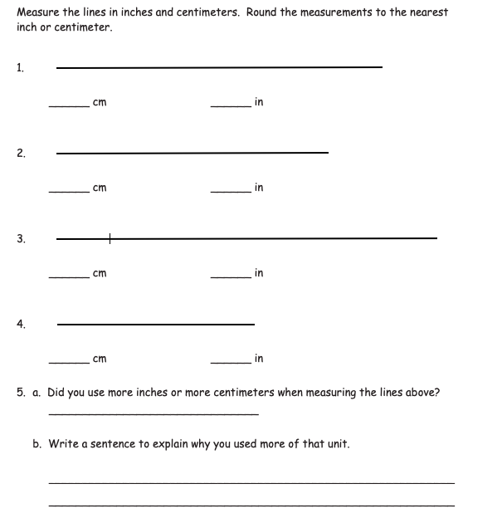 [[2]](#endnote-1)

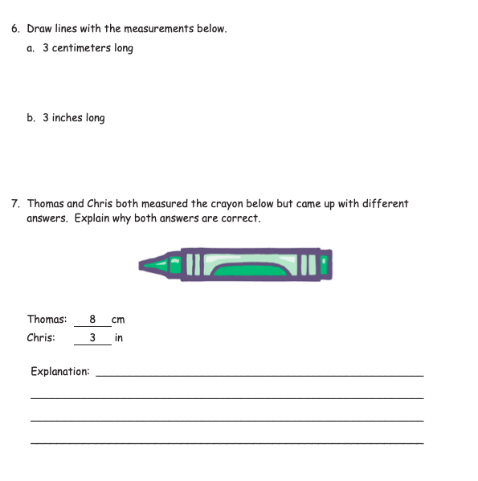[[3]](#endnote-2)

## 2.MD.A.4 - Measure to determine how much longer one object is than another, expressing the length difference in terms of a standard length unit.

In the figure below, the points labeled A through G are spaced evenly along the line. Use the figure to answer questions 1 and 2

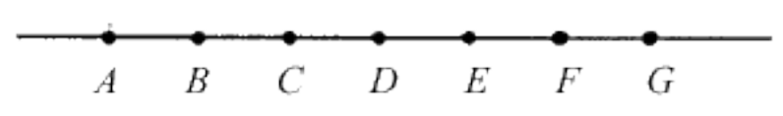

1. Use your centimeter ruler to help you answer this question:

Which distance below is the longest?

* 1. From A to D
  2. From B to F
  3. From C to G
  4. From B to G

1. Using the same figure, which distance is the shortest?
   1. From C to D
   2. From B to D
   3. From B to G
   4. From A to C
2. Measure each scarf to the nearest inch.

**Scarf A: \_\_\_\_\_\_**

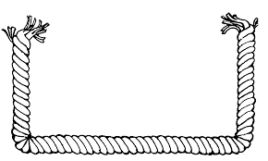

**Scarf B: \_\_\_\_\_\_\_\_\_**

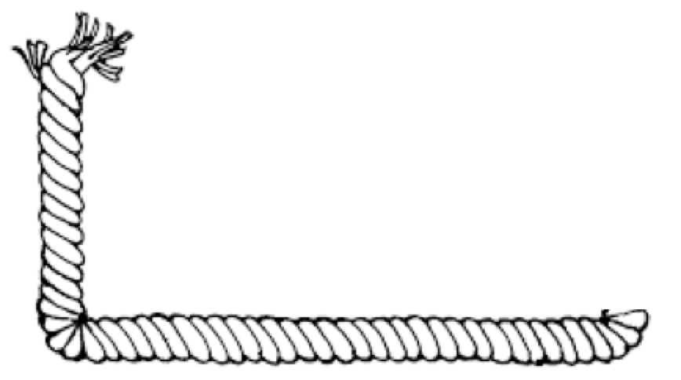

**How much longer is scarf A than scarf B? \_\_\_\_\_\_\_\_\_\_\_**

1. How long is the board? Measure to the nearest centimeter.

\_\_\_\_\_\_\_\_\_\_\_\_\_\_\_\_\_\_\_\_

How much longer would the board need to be in order to be 20 centimeters long?

\_\_\_\_\_\_\_\_\_\_\_\_\_\_\_\_\_\_\_\_\_

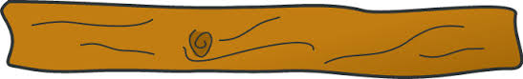

1. How much shorter in inches in the eraser than the crayon?

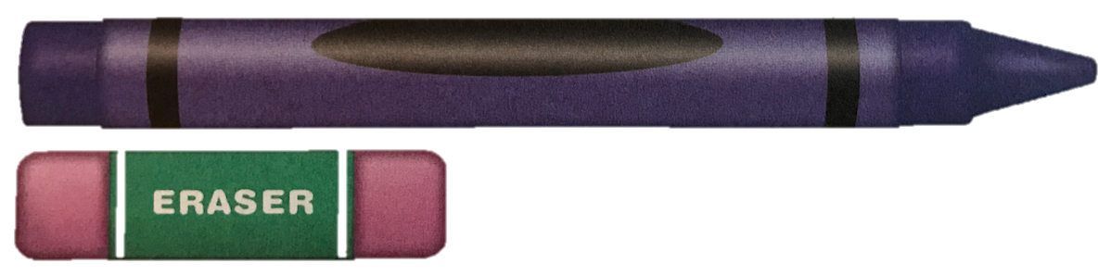

\_\_\_\_\_\_\_\_\_\_\_\_\_\_\_\_\_\_\_\_ inches

1. Tim has a piece of yarn that is 3 inches long. Which piece of yarn is 1 inch shorter than Tim’s yarn?

A.

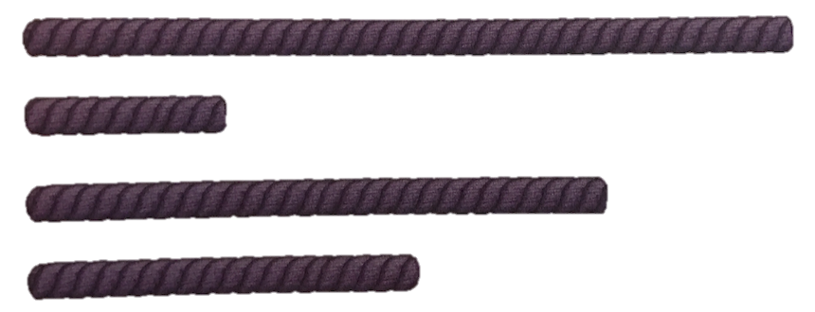

D.

C.

B.

1. What is the difference in the lengths of the two lines below?

Measuring using inches.

­­­\_\_\_\_\_\_\_\_\_\_\_\_\_\_\_\_\_\_\_ inches

Line B

Line A

1. How much longer, in centimeters, is the pencil than the key?



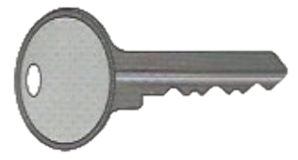

1. Use an inch ruler to measure each snake to the nearest inch.

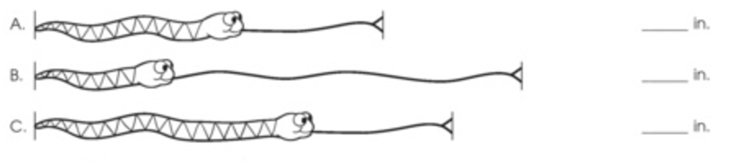

How much longer is Snake A than Snake B? \_\_\_\_\_\_\_\_\_\_\_\_\_\_\_\_\_\_\_\_\_\_\_

How much shorter is Snake A than Snake C? \_\_\_\_\_\_\_\_\_\_\_\_\_\_\_\_\_\_\_\_\_\_\_

How much longer is the longest snake than the shortest snake?

\_\_\_\_\_\_\_\_\_\_\_\_\_\_\_\_\_\_\_\_\_\_\_\_\_\_\_\_\_\_\_\_\_\_\_\_\_\_\_\_\_\_\_\_\_\_\_\_\_\_\_\_\_\_\_\_\_\_\_\_\_\_\_\_\_\_

1. Measure each line to the nearest centimeter.

Line A = \_\_\_\_\_\_\_ cm

Line B = \_\_\_\_\_\_\_ cm

Which line is longer? \_\_\_\_\_\_\_\_\_\_\_\_\_\_\_\_\_\_\_\_\_\_\_\_\_\_\_\_\_\_\_\_\_\_\_\_\_\_

How much longer?\_\_\_\_\_\_\_\_\_\_\_\_\_\_\_\_\_\_\_\_\_\_\_\_\_\_\_\_\_\_\_\_\_\_\_\_\_\_\_\_

1. Use a centimeter ruler to measure the height of each flower to the nearest centimeter.

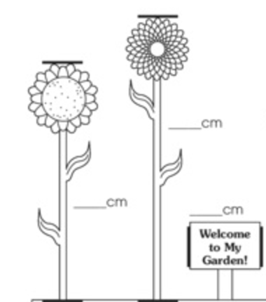

How much shorter is Flower A than Flower B?

\_\_\_\_\_\_\_\_\_\_\_\_\_\_\_\_\_\_\_\_\_\_\_\_\_

Flower A Flower B

1. How much longer is Line B than Line A?

Line B

Line A

1. How much longer is line A than line B? Measure to the nearest centimeter.

Line A:

Line B:

\_\_\_\_\_\_\_\_\_\_\_\_\_\_\_\_\_\_\_\_\_\_\_\_\_\_\_\_\_\_\_\_\_\_\_\_\_\_\_\_\_\_\_\_\_\_\_\_\_\_\_\_\_\_\_\_\_\_\_\_\_\_\_\_\_\_\_\_\_\_\_\_\_\_\_

1. Use a ruler to measure the lines to the nearest inch.

Line G

Total length: \_\_\_\_\_\_\_\_\_\_\_\_\_\_\_\_\_\_\_\_

Line H

Total length: \_\_\_\_\_\_\_\_\_\_\_\_\_\_\_\_\_\_\_\_

Which line is longer? \_\_\_\_\_\_\_\_\_\_\_\_\_\_\_\_\_\_\_\_ How much longer? \_\_\_\_\_\_\_\_\_\_\_\_\_\_\_\_\_\_\_

1. Measure each line and write the length. Then complete the comparison sentence.

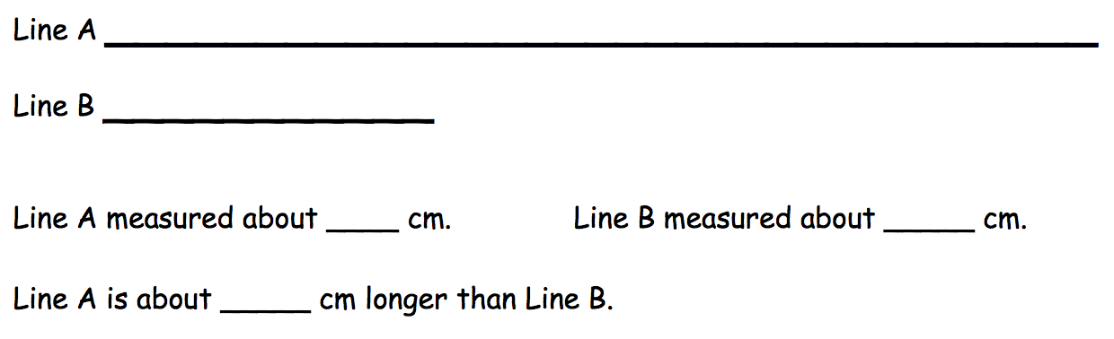

Line A measured about \_\_\_\_\_\_\_\_ cm. Line B measured about \_\_\_\_\_\_\_ cm.

Line A is about \_\_\_\_\_\_\_\_ cm longer than Line B.

1. 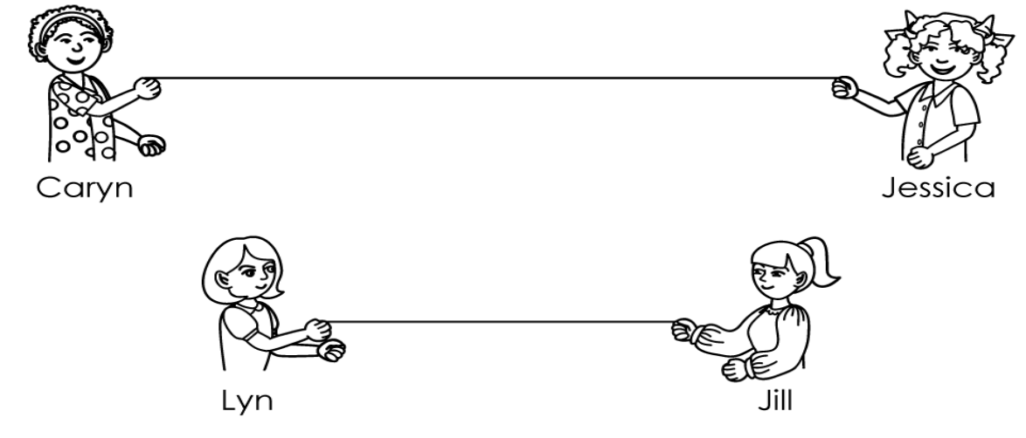How many inches long is each string? How much longer is Caryn and Jessica’s string than Lyn and Jill’s string?

Caryn and Jessica’s string \_\_\_\_\_\_\_\_\_\_\_\_\_ Lyn and Jill’s string \_\_\_\_\_\_\_\_\_\_\_\_\_\_

Caryn and Jessica’s string is \_\_\_\_\_\_\_\_\_\_\_\_\_ inches longer than Lyn and Jill’s string.

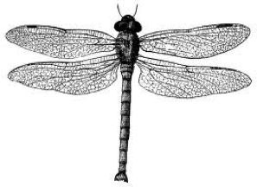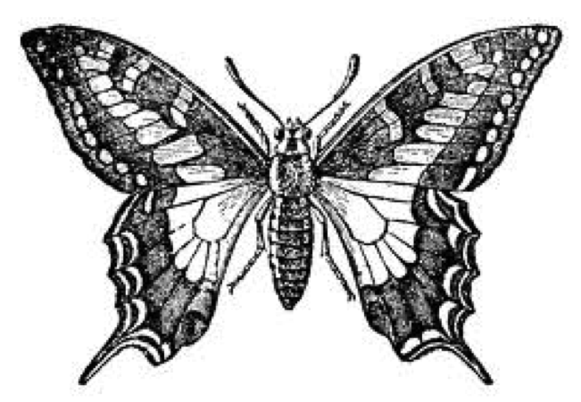

17. The lines show the wingspan of a dragonfly and a butterfly. How many centimeters longer is the butterfly’s wingspan than the dragonfly’s wingspan?

\_\_\_\_\_\_\_ centimeters longer

18. How much longer is A than B in inches?



\_\_\_\_\_\_\_ inches longer

1. How much longer is the longer snake than the shorter snake, in inches?

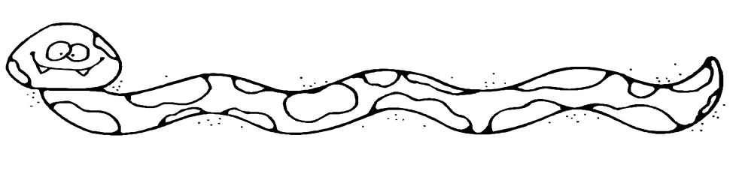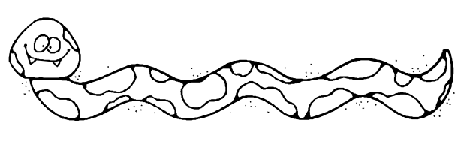

1. How much shorter is the eraser than the key, in centimeters?

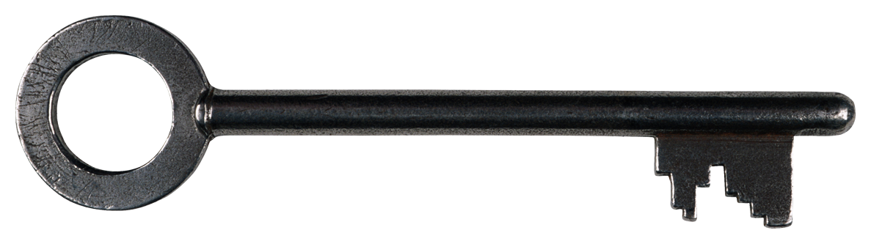

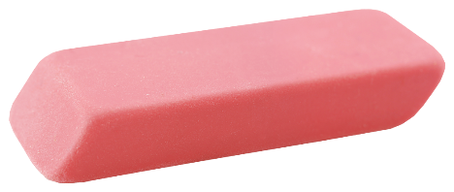

\_\_\_\_\_\_\_\_\_\_\_\_\_\_\_\_\_\_\_\_\_\_\_\_\_\_\_\_\_\_\_\_\_\_\_\_\_\_\_\_\_\_\_\_\_\_\_\_\_\_\_\_\_\_\_\_\_\_

# Workbook B

## 2.OA.B.2 - Fluently add and subtract within 20 using mental strategies. By end of Grade 2, know from memory all sums of two one-digit numbers.

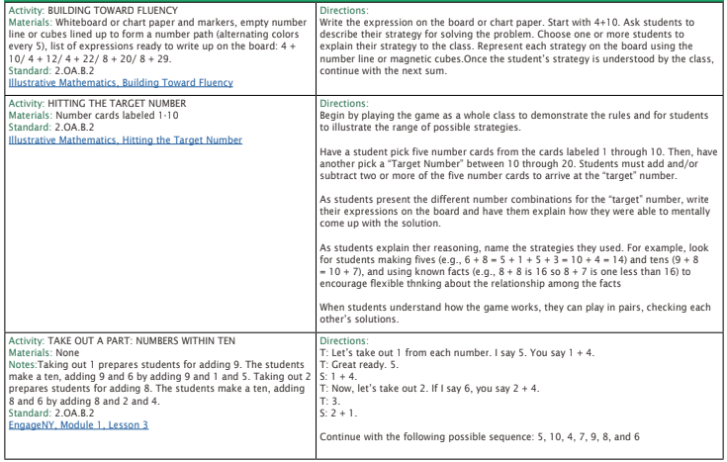

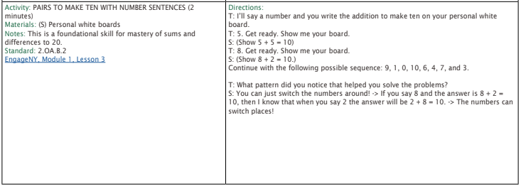

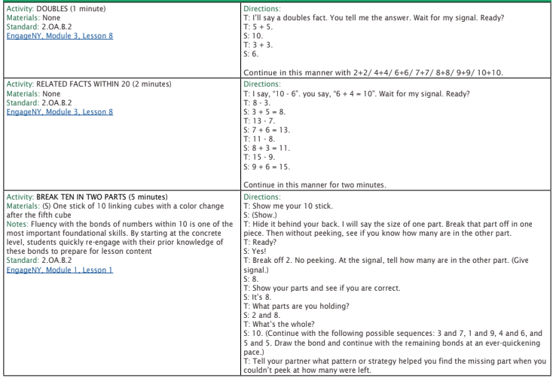  
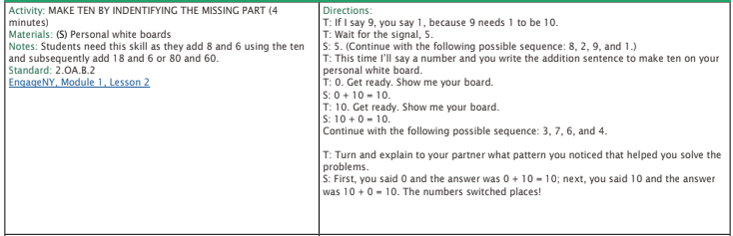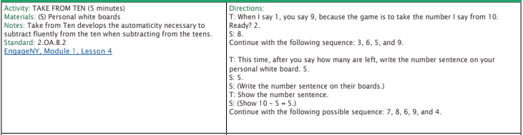

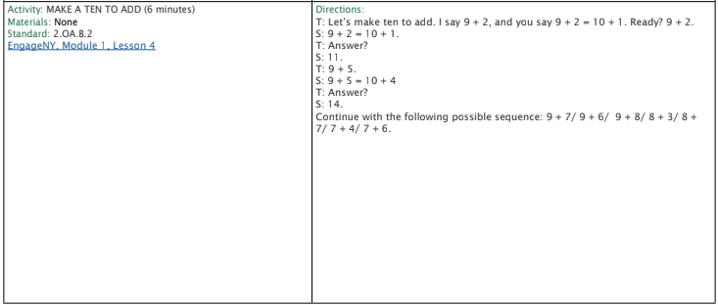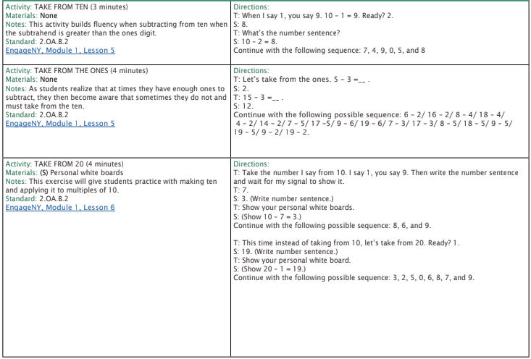

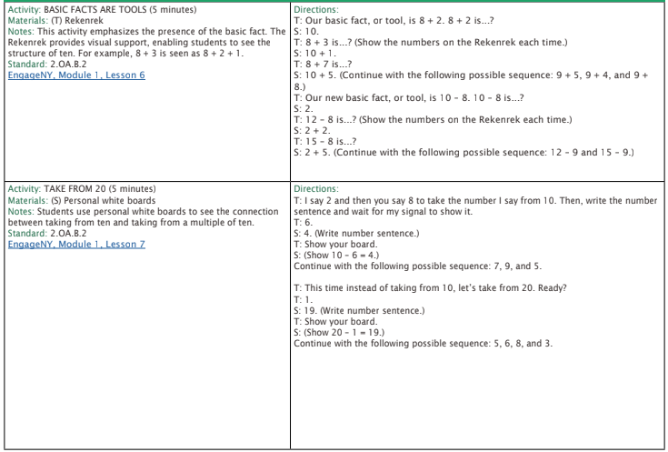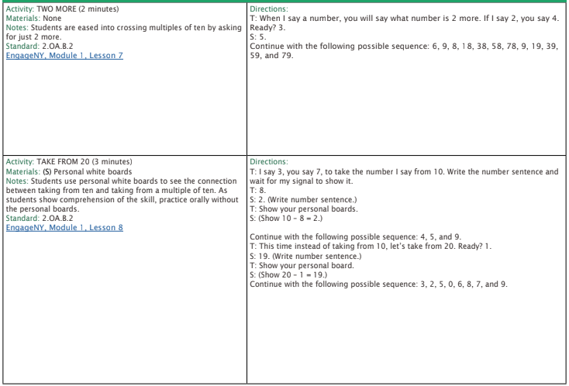

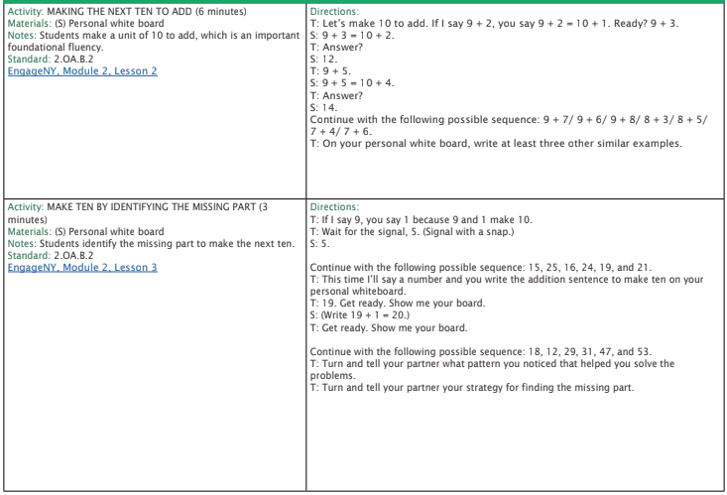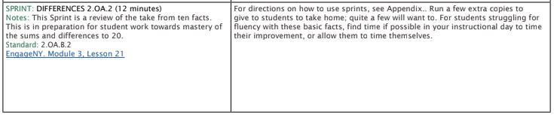

1. Solve each doubles fact.

4 + 4 = \_\_\_\_\_ 2 + 2 = \_\_\_\_\_ 8 + 8 = \_\_\_\_\_

5 + 5 = \_\_\_\_\_ 1 + 1 = \_\_\_\_\_ 9 + 9 = \_\_\_\_\_

7 + 7 = \_\_\_\_\_ 6 + 6 = \_\_\_\_\_ 3 + 3 = \_\_\_\_\_

2. Solve each doubles +1 fact.

4 + 5 = \_\_\_\_\_ 2 + 3 = \_\_\_\_\_ 8 + 9 = \_\_\_\_\_

5 + 6 = \_\_\_\_\_ 1 + 2 = \_\_\_\_\_ 9 + 10 = \_\_\_\_\_

7 + 8 = \_\_\_\_\_ 6 + 7 = \_\_\_\_\_ 3 + 4 = \_\_\_\_\_

3. Solve each doubles +2 fact.

2 + 4 = \_\_\_\_\_ 5 + 7 = \_\_\_\_\_ 3 + 5 = \_\_\_\_\_

8 + 10 = \_\_\_\_\_ 6 + 8 = \_\_\_\_\_ 4 + 6 = \_\_\_\_\_

1 + 3 = \_\_\_\_\_ 9 + 11 = \_\_\_\_\_ 7 + 9 = \_\_\_\_\_

4. Solve each number sentence.

7 + 5 = \_\_\_\_\_ 6 + 3 = \_\_\_\_\_ 9 + 2 = \_\_\_\_\_

3 + 1 = \_\_\_\_\_ 5 + 8 = \_\_\_\_\_ 4 + 2 = \_\_\_\_\_

8 + 4 = \_\_\_\_\_ 1 + 9 = \_\_\_\_\_ 2 + 7 = \_\_\_\_\_

5. Solve each number sentence.

4 + 7 = \_\_\_\_\_ 3 + 8 = \_\_\_\_\_ 2 + 6 = \_\_\_\_\_

1 + 5 = \_\_\_\_\_ 8 + 6 = \_\_\_\_\_ 9 + 3 = \_\_\_\_\_

7 + 4 = \_\_\_\_\_ 5 + 9 = \_\_\_\_\_ 6 + 3 = \_\_\_\_\_

6. Solve each number sentence.

5 + 3 = \_\_\_\_\_ 1 + 8 = \_\_\_\_\_ 4 + 2 = \_\_\_\_\_

2 + 6 = \_\_\_\_\_ 6 + 6 = \_\_\_\_\_ 2 + 7 = \_\_\_\_\_

8 + 4 = \_\_\_\_\_ 3+ 9 = \_\_\_\_\_ 6 + 4 = \_\_\_\_\_

7. Solve.

|  |  |  |
| --- | --- | --- |
| **1 + 9 = \_\_\_\_\_\_** | **2 + 14 = \_\_\_\_\_\_\_** | **9 + 4 = \_\_\_\_\_\_** |
| **19 – 7 = \_\_\_\_\_\_** | **7 + 8 = \_\_\_\_\_\_\_** | **16 – 8 = \_\_\_\_\_\_** |
| **15 + 1 = \_\_\_\_\_\_\_** | **5 + \_\_\_\_\_\_\_ = 15** | **12 + 7 = \_\_\_\_\_\_\_** |
| **9 – 6 = \_\_\_\_\_\_** | **\_\_\_\_\_\_\_ = 1 + 8** | **11 – 6 = \_\_\_\_\_\_** |
| **\_\_\_\_\_\_\_ = 9 - 7** | **\_\_\_\_\_\_\_ = 4 + 2** | **\_\_\_\_\_\_\_ = 13 - 7** |
| **\_\_\_\_\_\_\_ = 3 + 9** | **17 – \_\_\_\_\_\_ = 5** | **\_\_\_\_\_\_\_ = 10 + 9** |
| **7 + 6 = \_\_\_\_\_\_\_** | **\_\_\_\_\_\_\_ = 8 + 3** | **6 + 8 = \_\_\_\_\_\_\_** |

1. Solve.

|  |  |  |
| --- | --- | --- |
| **2 + 9 = \_\_\_\_\_\_** | **2 + 11 = \_\_\_\_\_\_\_** | **7 + 4 = \_\_\_\_\_\_** |
| **15 – 3 = \_\_\_\_\_\_** | **3 + 8 = \_\_\_\_\_\_\_** | **17 – 9 = \_\_\_\_\_\_** |
| **12 + 1 = \_\_\_\_\_\_\_** | **6 + \_\_\_\_\_\_\_ = 16** | **11 + 9 = \_\_\_\_\_\_\_** |
| **9 – 4 = \_\_\_\_\_\_** | **\_\_\_\_\_\_\_ = 1 + 4** | **11 – 5 = \_\_\_\_\_\_** |
| **\_\_\_\_\_\_\_ = 8 - 2** | **\_\_\_\_\_\_\_ = 5 + 2** | **\_\_\_\_\_\_\_ = 14 - 7** |
| **\_\_\_\_\_\_\_ = 4 + 9** | **16 – \_\_\_\_\_\_ = 3** | **\_\_\_\_\_\_\_ = 10 + 3** |
| **7 + 8 = \_\_\_\_\_\_\_** | **\_\_\_\_\_\_\_ = 6 + 3** | **4 + 8 = \_\_\_\_\_\_\_** |

10. Solve the problem.

**10 + 6 + 2 = \_\_\_\_\_\_\_\_**

1. Solve.

|  |  |  |
| --- | --- | --- |
| **3 + 7 = \_\_\_\_\_\_** | **3 + 12 = \_\_\_\_\_\_\_** | **7 + 2 = \_\_\_\_\_\_** |
| **15 – 7 = \_\_\_\_\_\_** | **7 + 6 = \_\_\_\_\_\_\_** | **14 – 6 = \_\_\_\_\_\_** |
| **12 + 1 = \_\_\_\_\_\_\_** | **5 + \_\_\_\_\_\_\_ = 11** | **10 + 7 = \_\_\_\_\_\_\_** |
| **8 – 2 = \_\_\_\_\_\_** | **\_\_\_\_\_\_\_ = 1 + 5** | **11 – 3 = \_\_\_\_\_\_** |
| **\_\_\_\_\_\_\_ = 6 - 2** | **\_\_\_\_\_\_\_ = 5 + 2** | **\_\_\_\_\_\_\_ = 16 - 9** |
| **\_\_\_\_\_\_\_ = 3 + 8** | **14 – \_\_\_\_\_\_ = 5** | **\_\_\_\_\_\_\_ = 10 + 6** |
| **8 + 6 = \_\_\_\_\_\_\_** | **\_\_\_\_\_\_\_ = 7 + 3** | **5 + 8 = \_\_\_\_\_\_\_** |

|  |  |
| --- | --- |
| 12. Fill in the missing numbers. You can use a number bond to help you.  Macintosh HD:Users:rachelwong:Desktop:Screen Shot 2016-07-29 at 10.08.41 AM.png  14 – 6 = \_\_\_\_\_ is the same as 6 + \_\_\_\_\_ = 14 | 13.Use the number bond to write two addition number sentences.  \_\_\_\_\_ + \_\_\_\_\_ = \_\_\_\_\_  \_\_\_\_\_ + \_\_\_\_\_ = \_\_\_\_\_  9  10  19  Macintosh HD:Users:rachelwong:Desktop:Screen Shot 2016-07-29 at 10.08.41 AM.png |
| 1. Create a number bond to help you solve.   **5 + \_\_\_\_\_\_\_\_ = 16**  Macintosh HD:Users:rachelwong:Desktop:Screen Shot 2016-07-29 at 10.08.41 AM.png | 1. Solve.   **3 + 2 + 8 = \_\_\_\_\_\_\_** |
| Write the four number sentences that go with this number bond.  Macintosh HD:Users:rachelwong:Desktop:Screen Shot 2016-07-29 at 10.08.41 AM.png  11  \_\_\_\_\_\_\_\_\_\_\_\_\_\_\_\_\_\_\_\_\_\_\_\_\_\_\_\_\_\_\_\_\_\_  \_\_\_\_\_\_\_\_\_\_\_\_\_\_\_\_\_\_\_\_\_\_\_\_\_\_\_\_\_\_\_\_\_\_  \_\_\_\_\_\_\_\_\_\_\_\_\_\_\_\_\_\_\_\_\_\_\_\_\_\_\_\_\_\_\_\_\_\_  \_\_\_\_\_\_\_\_\_\_\_\_\_\_\_\_\_\_\_\_\_\_\_\_\_\_\_\_\_\_\_\_\_\_\_\_\_\_\_\_  7  4 | |

1. Solve.

|  |  |  |
| --- | --- | --- |
| **11 + 9 = \_\_\_\_\_\_** | **2 + 15 = \_\_\_\_\_\_\_** | **19 + 0 = \_\_\_\_\_\_** |
| **14 – 7 = \_\_\_\_\_\_** | **3 + 8 = \_\_\_\_\_\_\_** | **18 – 5 = \_\_\_\_\_\_** |
| **9 + 8 = \_\_\_\_\_\_\_** | **11 + \_\_ \_\_\_ = 15** | **11 + 7 = \_\_\_\_\_\_\_** |
| **13 – 6 = \_\_\_\_\_\_** | **\_\_\_\_\_\_\_ = 11 + 8** | **17 – 6 = \_\_\_\_\_\_** |
| **\_\_\_\_\_\_ = 12 - 4** | **\_\_\_\_\_\_\_ = 8 + 2** | **\_\_\_\_\_\_\_ = 12 - 7** |
| **\_\_\_\_\_\_\_ = 2 + 9** | **17 – \_\_\_\_\_\_ = 8** | **\_\_\_\_\_\_\_ = 3 + 10** |
| **8 + 6 = \_\_\_\_\_\_\_** | **\_\_\_\_\_\_\_ = 9 + 3** | **5 + 8 = \_\_\_\_\_\_\_** |

## 2.NBT.A.2 - Count within 1000; skip-count by 5s, 10s, and 100s.

Directions for this page: Count up – write the number that comes next.

Example:

\_\_362\_\_ \_\_363\_\_ \_\_364\_\_ \_\_365\_\_ \_\_366\_\_ \_\_367\_\_

1. \_\_231\_\_ \_\_\_\_\_\_\_\_\_ \_\_\_\_\_\_\_\_\_ \_\_\_\_\_\_\_\_\_ \_\_\_\_\_\_\_\_\_ \_\_\_\_\_\_\_\_\_
2. \_\_804\_\_ \_\_\_\_\_\_\_\_\_ \_\_\_\_\_\_\_\_\_ \_\_\_\_\_\_\_\_\_ \_\_\_\_\_\_\_\_\_ \_\_\_\_\_\_\_\_\_
3. \_177\_\_ \_\_\_\_\_\_\_\_\_ \_\_\_\_\_\_\_\_\_ \_\_\_\_\_\_\_\_\_ \_\_\_\_\_\_\_\_\_ \_\_\_\_\_\_\_\_\_
4. \_\_639\_\_ \_\_\_\_\_\_\_\_\_ \_\_\_\_\_\_\_\_\_ \_\_\_\_\_\_\_\_\_ \_\_\_\_\_\_\_\_\_ \_\_\_\_\_\_\_\_\_
5. \_\_201\_\_ \_\_\_\_\_\_\_\_\_ \_\_\_\_\_\_\_\_\_ \_\_\_\_\_\_\_\_\_ \_\_\_\_\_\_\_\_\_ \_\_\_\_\_\_\_\_\_
6. \_\_86\_\_\_ \_\_\_\_\_\_\_\_\_ \_\_\_\_\_\_\_\_\_ \_\_\_\_\_\_\_\_\_ \_\_\_\_\_\_\_\_\_ \_\_\_\_\_\_\_\_\_
7. \_\_900\_\_ \_\_\_\_\_\_\_\_\_ \_\_\_\_\_\_\_\_\_ \_\_\_\_\_\_\_\_\_ \_\_\_\_\_\_\_\_\_ \_\_\_\_\_\_\_\_\_
8. \_\_497\_\_ \_\_\_\_\_\_\_\_\_ \_\_\_\_\_\_\_\_\_ \_\_\_\_\_\_\_\_\_ \_\_\_\_\_\_\_\_\_ \_\_\_\_\_\_\_\_\_
9. \_\_555\_\_ \_\_\_\_\_\_\_\_\_ \_\_\_\_\_\_\_\_\_ \_\_\_\_\_\_\_\_\_ \_\_\_\_\_\_\_\_\_ \_\_\_\_\_\_\_\_\_
10. \_\_383\_\_ \_\_\_\_\_\_\_\_ \_\_\_\_\_\_\_\_ \_\_\_\_\_\_\_\_ \_\_\_\_\_\_\_\_ \_\_\_\_\_\_\_\_

Directions for this page: Skip count by 5 – write the number that comes next.

Example:

\_\_360\_\_ \_\_365\_\_ \_\_370\_\_ \_\_375\_\_ \_\_380\_\_ \_\_385\_\_

1. \_\_735\_\_ \_\_\_\_\_\_\_\_\_ \_\_\_\_\_\_\_\_\_ \_\_\_\_\_\_\_\_\_ \_\_\_\_\_\_\_\_\_ \_\_\_\_\_\_\_\_\_
2. \_\_200\_\_ \_\_\_\_\_\_\_\_\_ \_\_\_\_\_\_\_\_\_ \_\_\_\_\_\_\_\_\_ \_\_\_\_\_\_\_\_\_ \_\_\_\_\_\_\_\_\_
3. \_185\_\_ \_\_\_\_\_\_\_\_\_ \_\_\_\_\_\_\_\_\_ \_\_\_\_\_\_\_\_\_ \_\_\_\_\_\_\_\_\_ \_\_\_\_\_\_\_\_\_
4. \_\_520\_\_ \_\_\_\_\_\_\_\_\_ \_\_\_\_\_\_\_\_\_ \_\_\_\_\_\_\_\_\_ \_\_\_\_\_\_\_\_\_ \_\_\_\_\_\_\_\_\_
5. \_\_380\_\_ \_\_\_\_\_\_\_\_\_ \_\_\_\_\_\_\_\_\_ \_\_\_\_\_\_\_\_\_ \_\_\_\_\_\_\_\_\_ \_\_\_\_\_\_\_\_\_
6. \_\_85\_\_\_ \_\_\_\_\_\_\_\_\_ \_\_\_\_\_\_\_\_\_ \_\_\_\_\_\_\_\_\_ \_\_\_\_\_\_\_\_\_ \_\_\_\_\_\_\_\_\_
7. \_\_970\_\_ \_\_\_\_\_\_\_\_\_ \_\_\_\_\_\_\_\_\_ \_\_\_\_\_\_\_\_\_ \_\_\_\_\_\_\_\_\_ \_\_\_\_\_\_\_\_\_
8. \_\_495\_\_ \_\_\_\_\_\_\_\_\_ \_\_\_\_\_\_\_\_\_ \_\_\_\_\_\_\_\_\_ \_\_\_\_\_\_\_\_\_ \_\_\_\_\_\_\_\_\_
9. \_\_525\_\_ \_\_\_\_\_\_\_\_\_ \_\_\_\_\_\_\_\_\_ \_\_\_\_\_\_\_\_\_ \_\_\_\_\_\_\_\_\_ \_\_\_\_\_\_\_\_\_
10. \_\_610\_\_ \_\_\_\_\_\_\_\_ \_\_\_\_\_\_\_\_ \_\_\_\_\_\_\_\_ \_\_\_\_\_\_\_\_ \_\_\_\_\_\_\_\_

Directions for this page: Skip count by 10 – write the number that comes next.

Example:

\_\_360\_\_ \_\_370\_\_ \_\_380\_\_ \_\_390\_\_ \_\_400\_\_ \_\_410\_\_

1. \_\_220\_\_ \_\_\_\_\_\_\_\_\_ \_\_\_\_\_\_\_\_\_ \_\_\_\_\_\_\_\_\_ \_\_\_\_\_\_\_\_\_ \_\_\_\_\_\_\_\_\_
2. \_\_600\_\_ \_\_\_\_\_\_\_\_\_ \_\_\_\_\_\_\_\_\_ \_\_\_\_\_\_\_\_\_ \_\_\_\_\_\_\_\_\_ \_\_\_\_\_\_\_\_\_
3. \_470\_\_ \_\_\_\_\_\_\_\_\_ \_\_\_\_\_\_\_\_\_ \_\_\_\_\_\_\_\_\_ \_\_\_\_\_\_\_\_\_ \_\_\_\_\_\_\_\_\_
4. \_\_90\_\_ \_\_\_\_\_\_\_\_\_ \_\_\_\_\_\_\_\_\_ \_\_\_\_\_\_\_\_\_ \_\_\_\_\_\_\_\_\_ \_\_\_\_\_\_\_\_\_
5. \_\_180\_\_ \_\_\_\_\_\_\_\_\_ \_\_\_\_\_\_\_\_\_ \_\_\_\_\_\_\_\_\_ \_\_\_\_\_\_\_\_\_ \_\_\_\_\_\_\_\_\_
6. \_\_530\_\_\_ \_\_\_\_\_\_\_\_\_ \_\_\_\_\_\_\_\_\_ \_\_\_\_\_\_\_\_\_ \_\_\_\_\_\_\_\_\_ \_\_\_\_\_\_\_\_\_
7. \_\_360\_\_ \_\_\_\_\_\_\_\_\_ \_\_\_\_\_\_\_\_\_ \_\_\_\_\_\_\_\_\_ \_\_\_\_\_\_\_\_\_ \_\_\_\_\_\_\_\_\_
8. \_\_710\_\_ \_\_\_\_\_\_\_\_\_ \_\_\_\_\_\_\_\_\_ \_\_\_\_\_\_\_\_\_ \_\_\_\_\_\_\_\_\_ \_\_\_\_\_\_\_\_\_
9. \_\_850\_\_ \_\_\_\_\_\_\_\_\_ \_\_\_\_\_\_\_\_\_ \_\_\_\_\_\_\_\_\_ \_\_\_\_\_\_\_\_\_ \_\_\_\_\_\_\_\_\_
10. \_\_270\_\_ \_\_\_\_\_\_\_\_ \_\_\_\_\_\_\_\_ \_\_\_\_\_\_\_\_ \_\_\_\_\_\_\_\_ \_\_\_\_\_\_\_\_

Directions for this page: Skip count by 10 – write the number that comes next.

Example:

\_\_233\_\_ \_\_243\_\_ \_\_253\_\_ \_\_263\_\_ \_\_273\_\_ \_\_283\_\_

1. \_\_725\_\_ \_\_\_\_\_\_\_\_\_ \_\_\_\_\_\_\_\_\_ \_\_\_\_\_\_\_\_\_ \_\_\_\_\_\_\_\_\_ \_\_\_\_\_\_\_\_\_
2. \_\_504\_\_ \_\_\_\_\_\_\_\_\_ \_\_\_\_\_\_\_\_\_ \_\_\_\_\_\_\_\_\_ \_\_\_\_\_\_\_\_\_ \_\_\_\_\_\_\_\_\_
3. \_321\_\_ \_\_\_\_\_\_\_\_\_ \_\_\_\_\_\_\_\_\_ \_\_\_\_\_\_\_\_\_ \_\_\_\_\_\_\_\_\_ \_\_\_\_\_\_\_\_\_
4. \_\_617\_\_ \_\_\_\_\_\_\_\_\_ \_\_\_\_\_\_\_\_\_ \_\_\_\_\_\_\_\_\_ \_\_\_\_\_\_\_\_\_ \_\_\_\_\_\_\_\_\_
5. \_\_832\_\_ \_\_\_\_\_\_\_\_\_ \_\_\_\_\_\_\_\_\_ \_\_\_\_\_\_\_\_\_ \_\_\_\_\_\_\_\_\_ \_\_\_\_\_\_\_\_\_
6. \_\_85\_\_\_ \_\_\_\_\_\_\_\_\_ \_\_\_\_\_\_\_\_\_ \_\_\_\_\_\_\_\_\_ \_\_\_\_\_\_\_\_\_ \_\_\_\_\_\_\_\_\_
7. \_\_366\_\_ \_\_\_\_\_\_\_\_\_ \_\_\_\_\_\_\_\_\_ \_\_\_\_\_\_\_\_\_ \_\_\_\_\_\_\_\_\_ \_\_\_\_\_\_\_\_\_
8. \_\_210\_\_ \_\_\_\_\_\_\_\_\_ \_\_\_\_\_\_\_\_\_ \_\_\_\_\_\_\_\_\_ \_\_\_\_\_\_\_\_\_ \_\_\_\_\_\_\_\_\_
9. \_\_177\_\_ \_\_\_\_\_\_\_\_\_ \_\_\_\_\_\_\_\_\_ \_\_\_\_\_\_\_\_\_ \_\_\_\_\_\_\_\_\_ \_\_\_\_\_\_\_\_\_
10. \_\_888\_\_ \_\_\_\_\_\_\_\_ \_\_\_\_\_\_\_\_ \_\_\_\_\_\_\_\_ \_\_\_\_\_\_\_\_ \_\_\_\_\_\_\_\_

Directions for this page: Skip count by 100 – write the number that comes next.

Example:

\_\_365\_\_ \_\_465\_\_ \_\_565\_\_ \_\_665\_\_ \_\_765\_\_ \_\_865\_\_

1. \_\_222\_\_ \_\_\_\_\_\_\_\_\_ \_\_\_\_\_\_\_\_\_ \_\_\_\_\_\_\_\_\_ \_\_\_\_\_\_\_\_\_ \_\_\_\_\_\_\_\_\_
2. \_\_408\_\_ \_\_\_\_\_\_\_\_\_ \_\_\_\_\_\_\_\_\_ \_\_\_\_\_\_\_\_\_ \_\_\_\_\_\_\_\_\_ \_\_\_\_\_\_\_\_\_
3. \_190\_\_ \_\_\_\_\_\_\_\_\_ \_\_\_\_\_\_\_\_\_ \_\_\_\_\_\_\_\_\_ \_\_\_\_\_\_\_\_\_ \_\_\_\_\_\_\_\_\_
4. \_\_275\_\_ \_\_\_\_\_\_\_\_\_ \_\_\_\_\_\_\_\_\_ \_\_\_\_\_\_\_\_\_ \_\_\_\_\_\_\_\_\_ \_\_\_\_\_\_\_\_\_
5. \_\_134\_\_ \_\_\_\_\_\_\_\_\_ \_\_\_\_\_\_\_\_\_ \_\_\_\_\_\_\_\_\_ \_\_\_\_\_\_\_\_\_ \_\_\_\_\_\_\_\_\_
6. \_\_500\_\_\_ \_\_\_\_\_\_\_\_\_ \_\_\_\_\_\_\_\_\_ \_\_\_\_\_\_\_\_\_ \_\_\_\_\_\_\_\_\_ \_\_\_\_\_\_\_\_\_
7. \_\_340\_\_ \_\_\_\_\_\_\_\_\_ \_\_\_\_\_\_\_\_\_ \_\_\_\_\_\_\_\_\_ \_\_\_\_\_\_\_\_\_ \_\_\_\_\_\_\_\_\_
8. \_\_210\_\_ \_\_\_\_\_\_\_\_\_ \_\_\_\_\_\_\_\_\_ \_\_\_\_\_\_\_\_\_ \_\_\_\_\_\_\_\_\_ \_\_\_\_\_\_\_\_\_
9. \_\_450\_\_ \_\_\_\_\_\_\_\_\_ \_\_\_\_\_\_\_\_\_ \_\_\_\_\_\_\_\_\_ \_\_\_\_\_\_\_\_\_ \_\_\_\_\_\_\_\_\_
10. \_\_385\_\_ \_\_\_\_\_\_\_\_ \_\_\_\_\_\_\_\_ \_\_\_\_\_\_\_\_ \_\_\_\_\_\_\_\_ \_\_\_\_\_\_\_\_

## 2.NBT.B.5 - Fluently add and subtract within 100 using strategies based on place value, properties of operations, and/or the relationship between addition and subtraction.

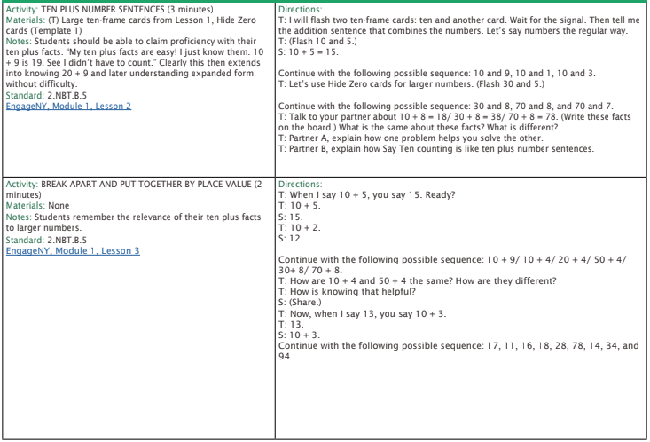

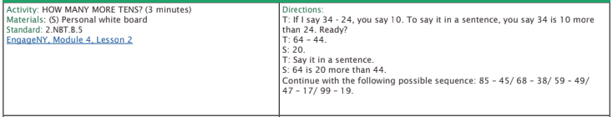

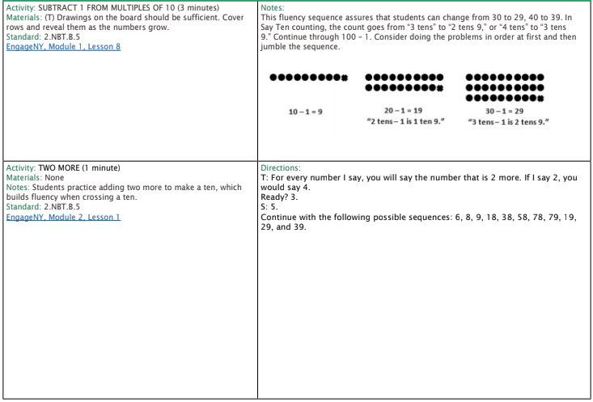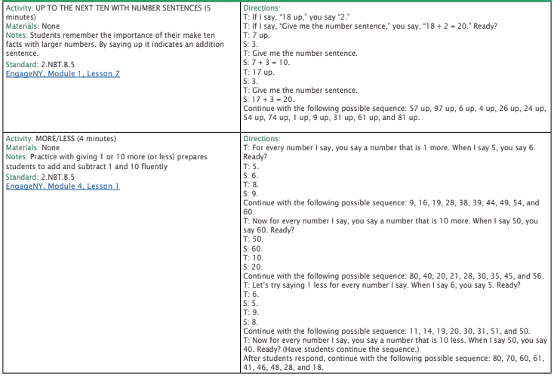

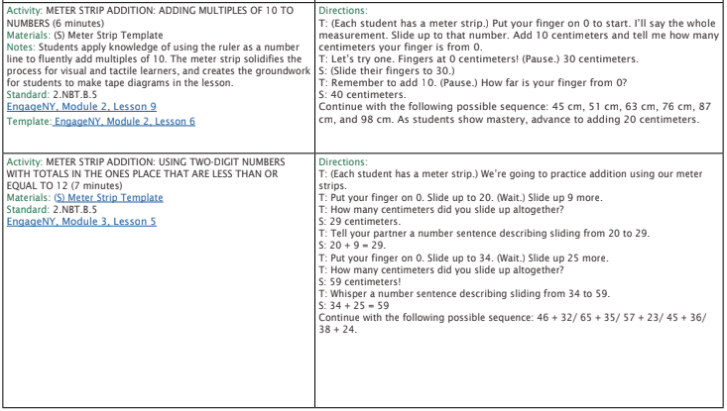

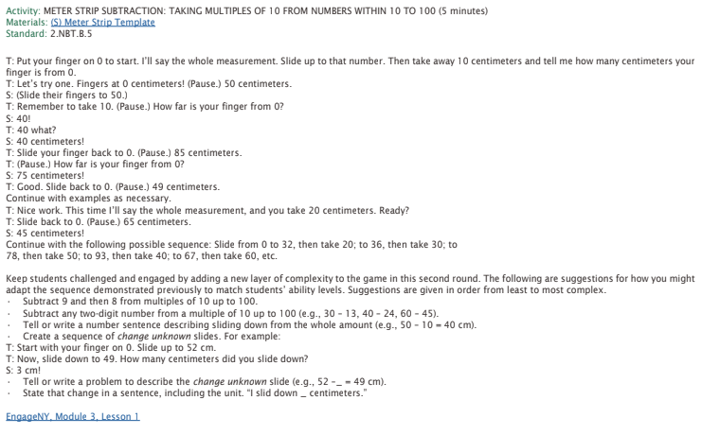

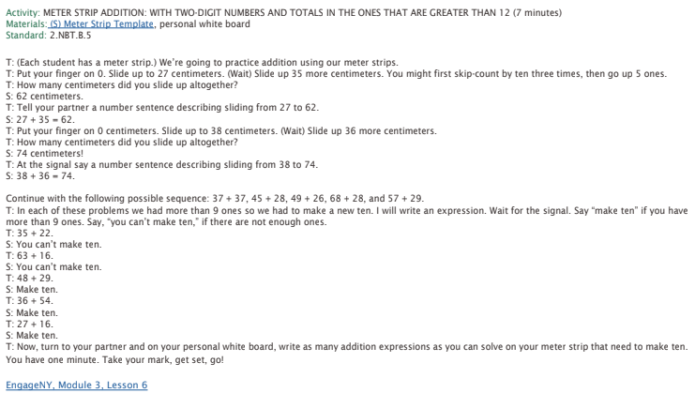

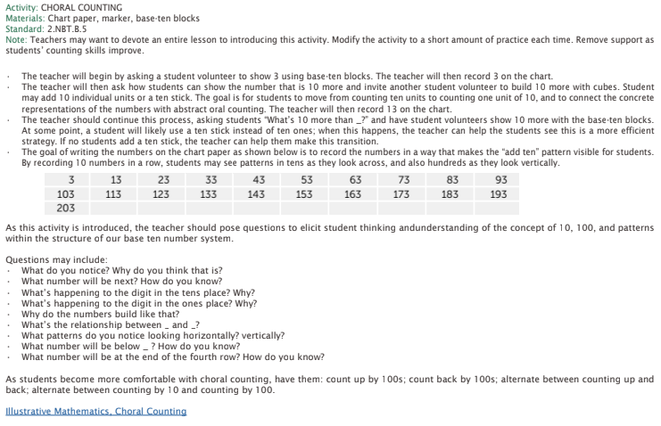

1. **\_\_\_\_\_\_\_ + 45 = 63**

1. **26 + 37 = \_\_\_\_\_\_\_**
2. **73 – 26 = \_\_\_\_\_\_\_**

Solve.

1. 45 + \_\_\_\_\_\_\_ = 100
2. 35 + \_\_\_\_\_\_\_ = 50
3. \_\_\_\_\_ + 25 = 100
4. \_\_\_\_\_ + 15 = 50
5. 100 = \_\_\_\_\_\_ + 80
6. 50 = 20 + \_\_\_\_\_\_

1. Calculate.

|  |  |  |
| --- | --- | --- |
| 65  - 37 | 60  - 43 | 45 – 28 = \_\_\_\_\_ |
| 55 + 29 = \_\_\_\_\_ | 23  + 73 | 17  + 58 |

1. **67 + 25 = \_\_\_\_\_**

1. **75 - \_\_\_\_\_\_ = 23**

1. **55 – 19 = \_\_\_\_\_\_\_**
2. Use a number line to solve.

93 – 27 = \_\_\_

https://docs.google.com/a/achievementfirst.org/drawings/d/sKeeVXlVaNtZLmL7v92ENjA/image?w=667&h=3&rev=1&ac=1

1. Solve.
2. **- 34 = \_\_\_\_\_\_\_\_\_**

1. Solve. **\_\_\_\_\_\_\_ = 22 + 59**

1. Solve. **\_\_\_\_\_\_\_ = 33 + 47**

1. Solve. **74 - 28 = \_\_\_\_\_\_\_\_\_**
2. Calculate.

|  |  |  |
| --- | --- | --- |
| 76  - 37 | 50  - 23 | 75 – 48 = \_\_\_\_\_ |
| 56 + 39 = \_\_\_\_\_ | 13  + 74 | 27  + 52 |

1. **76 + 18 = \_\_\_\_\_**

1. **53 - \_\_\_\_\_\_ = 28**

1. **65 – 36 = \_\_\_\_\_\_\_**
2. Calculate.

|  |  |  |
| --- | --- | --- |
| 95  - 38 | 60  - 47 | 55 – 38 = \_\_\_\_\_ |
| 55 + 29 = \_\_\_\_\_ | 24  + 76 | 27  + 58 |

1. Find the missing number.

**\_\_\_\_\_\_\_\_\_\_ - 29 = 48**

1. Find the missing number.

**\_\_\_\_\_\_\_\_\_ + 43 = 73**

|  |  |
| --- | --- |
| Use sticks and dots to find the total.  **52 + 43 = \_\_\_\_\_\_\_\_\_** | Use expanded notation to solve.   1. **51 = \_\_\_\_\_\_\_\_\_** |

|  |  |  |  |  |  |
| --- | --- | --- | --- | --- | --- |
| Solve.  **15 + 22 = \_\_\_\_\_\_\_\_\_** | 1. Which would give you a total of 61? Circle your answer.  |  |  | | --- | --- | | 20 + 0  + 40 + 1 | 30 + 0  + 10 + 0 | | 60 + 1  + 60 + 0 | 3 + 1  + 3 + 0 | |

|  |  |
| --- | --- |
| 1. Solve.   **22+ 43 = \_\_\_\_\_\_\_\_\_** | 1. Solve.   **17+ 63 = \_\_\_\_\_\_\_\_\_** |

|  |  |
| --- | --- |
| 1. Solve.   **22+ 43 = \_\_\_\_\_\_\_\_\_** | 1. Solve.   **17+ 63 = \_\_\_\_\_\_\_\_\_** |

|  |  |  |  |  |  |
| --- | --- | --- | --- | --- | --- |
| 1. Circle which set of sticks and dots will help to find the total?  **62 + 24 = \_\_\_\_\_\_\_\_\_**  |  |  |  |  | | --- | --- | --- | --- | | IIIIII.. II…. | ……II ..II | ………….. | IIIIII II | | |
| 1. Solve.   **26 + 43 = \_\_\_\_\_\_\_** | 1. Solve.   **34 + 48 = \_\_\_\_\_\_\_** |

|  |  |
| --- | --- |
| 1. Solve. 2. **- 30 = \_\_\_\_\_\_\_** | 1. Solve to find the total.   **57 + 28 = \_\_\_\_\_\_\_\_\_** |

|  |
| --- |
| 1. Solve.   **24 + 49 = \_\_\_\_\_\_** |
| Solve using a number line. **28 + 36 = \_\_\_\_\_\_\_\_\_** |
| 1. Solve.   **45 – 30 = \_\_\_\_\_\_** |
| 1. Solve using a number line. **28 + 36 = \_\_\_\_\_\_\_\_\_** |
| 1. Solve using a number line. **22 + 71 = \_\_\_\_\_\_\_\_\_\_\_\_\_\_** |
| 1. Solve using sticks and dots.   **68 - \_\_\_\_\_\_\_ = 34** |
| 1. Solve.   **\_\_\_\_\_ = 34 + 45** |

## 2.NBT.B.6 - Add up to four two-digit numbers using strategies based on place value and properties of operations.

1. Solve.

13 + 10 + 21 + 30 = \_\_\_\_

1. Which 3 numbers add to a total of 40?

|  |  |  |  |
| --- | --- | --- | --- |
| 22 | 10 | 18 | 8 |

Answer: \_\_\_\_\_\_\_\_\_\_\_\_\_\_\_\_\_\_\_\_\_\_\_\_\_

1. Solve.

33 + 34 + 26 = \_\_\_

1. 17 + 24 + 33 + 19 = \_\_\_\_
2. Which 4 numbers add to a total of 100?

|  |  |  |
| --- | --- | --- |
| 12 | 48 | 30 |
| 10 | 56 | 14 |

Answer: \_\_\_\_\_\_\_\_\_\_\_\_\_\_\_\_\_\_\_\_\_\_\_\_\_

1. 45 + 31 + 12 = \_\_\_\_\_\_
2. What are two ways that you can make 65 using 3 addends?

|  |  |
| --- | --- |
| \_\_\_\_\_\_\_\_\_\_ + \_\_\_\_\_\_\_\_\_\_ +\_\_\_\_\_\_\_\_\_\_ = 65 | \_\_\_\_\_\_\_\_\_\_ + \_\_\_\_\_\_\_\_\_\_ +\_\_\_\_\_\_\_\_\_\_ = 65 |

1. 27 + 55 + 17 = \_\_\_\_\_\_\_\_\_\_\_\_\_\_\_\_
2. Find the total.

2 4

2 1

3 5

+ 1 1

1. What are two ways that you can make 92 using 3 addends?

|  |  |
| --- | --- |
| \_\_\_\_\_\_\_\_\_\_ + \_\_\_\_\_\_\_\_\_\_ +\_\_\_\_\_\_\_\_\_\_ = 92 | \_\_\_\_\_\_\_\_\_\_ + \_\_\_\_\_\_\_\_\_\_ +\_\_\_\_\_\_\_\_\_\_ = 92 |

1. Which 3 numbers can be added together to make a total of 50?

|  |  |
| --- | --- |
| 27 | 13 |
| 60 | 10 |

\_\_\_\_\_\_\_\_\_\_\_ + \_\_\_\_\_\_\_\_\_\_\_ + \_\_\_\_\_\_\_\_\_\_\_ = 50

1. Gunther was playing a card game. Below are the 4 cards he pulled. What is his total?

10

17

24

31

1. Solve.

13 + 10 + 21 + 30 = \_\_\_\_

1. Which 3 numbers add to a total of 50?

|  |  |  |  |
| --- | --- | --- | --- |
| 22 | 10 | 18 | 8 |

Answer: \_\_\_\_\_\_\_\_\_\_\_\_\_\_\_\_\_\_\_\_\_\_\_\_\_

1. Solve.

23 + 54 + 17 = \_\_\_

1. 15 + 22 + 13 + 39 = \_\_\_\_
2. Which 4 numbers add to a total of 100?

|  |  |  |
| --- | --- | --- |
| 11 | 39 | 30 |
| 25 | 34 | 16 |

Answer: \_\_\_\_\_\_\_\_\_\_\_\_\_\_\_\_\_\_\_\_\_\_\_\_\_

1. 25 + 41 + 17 = \_\_\_\_\_\_

19. What are two ways that you can make a total of 50 using 3 addends?

|  |  |
| --- | --- |
| \_\_\_\_\_\_\_\_\_\_ + \_\_\_\_\_\_\_\_\_\_ +\_\_\_\_\_\_\_\_\_\_ = 50 | \_\_\_\_\_\_\_\_\_\_ + \_\_\_\_\_\_\_\_\_\_ +\_\_\_\_\_\_\_\_\_\_ = 50 |

1. 52 + 15 + 27 = \_\_\_\_\_\_\_\_\_\_\_\_\_\_\_\_
2. Find the total.

3 4

1 8

2 5

+ 1 3

1. What are two ways that you can find 77 using at least 3 addends?

|  |  |
| --- | --- |
| \_\_\_\_\_\_\_\_\_\_ + \_\_\_\_\_\_\_\_\_\_ +\_\_\_\_\_\_\_\_\_\_ = 77 | \_\_\_\_\_\_\_\_\_\_ + \_\_\_\_\_\_\_\_\_\_ +\_\_\_\_\_\_\_\_\_\_ = 77 |

1. Which 3 numbers can be added together to make a total of 75?

|  |  |
| --- | --- |
| 37 | 13 |
| 30 | 25 |

1. Devon was playing a card game. Below are the 4 cards he pulled. What is his total?

33

19

14

21

# Workbook C

## 2.MD.D.9 – Generate measurement data by measuring the lengths of several objects to the nearest whole unit, or by making repeated measurements of the same object. Show the measurements by making a line plot, where the horizontal scale is marked off in whole units. [[4]](#endnote-3)

## [[5]](#endnote-4)[[6]](#endnote-5)[[7]](#endnote-6)[[8]](#endnote-7)[[9]](#endnote-8)[[10]](#endnote-9)[[11]](#endnote-10)[[12]](#endnote-11)[[13]](#endnote-12)

3.

2.

4.

5.

6.

7.

8.

9.

10.

11.

12.

13.

# 2.MD.D.10 – Draw a picture graph and a bar graph (with single-unit scale) to represent a data set with up to four categories. Solve simple put-together, take-apart, and compare problems using information presented in a bar graph.[[14]](#endnote-13)

# 

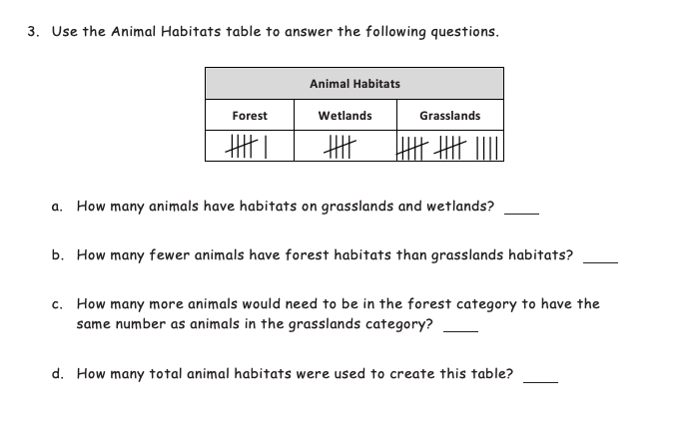

# [[15]](#endnote-14) [[16]](#endnote-15) [[17]](#endnote-16)[[18]](#endnote-17)[[19]](#endnote-18)[[20]](#endnote-19)[[21]](#endnote-20)[[22]](#endnote-21)[[23]](#endnote-22)[[24]](#endnote-23)[[25]](#endnote-24)[[26]](#endnote-25)[[27]](#endnote-26)[[28]](#endnote-27)[[29]](#endnote-28)[[30]](#endnote-29)[[31]](#endnote-30)[[32]](#endnote-31)[[33]](#endnote-32)[[34]](#endnote-33)[[35]](#endnote-34)[[36]](#endnote-35)

5.

6.

7.

8.

9.

10.

11.

12.

13.

14.

15.

16.

17.

18.

19.

20.

21.

22.

23.

24.

25.

26.

27.

28.

## 2.MD.C.7 - Tell and write time from analog and digital clocks to the nearest five minutes, using a.m. and p.m.

* + 1. What time is it?

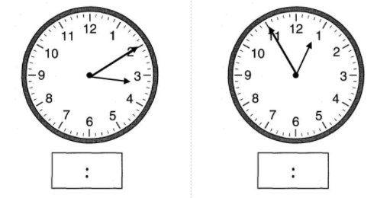

* + 1. The clock shows when Marco went to bed. Write the same time on the digital clock. Circle AM or PM.

**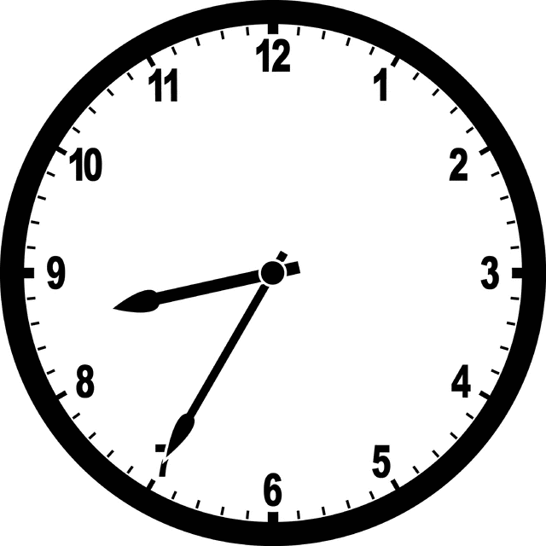 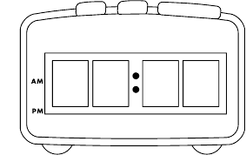**

* + 1. What time is on each clock?

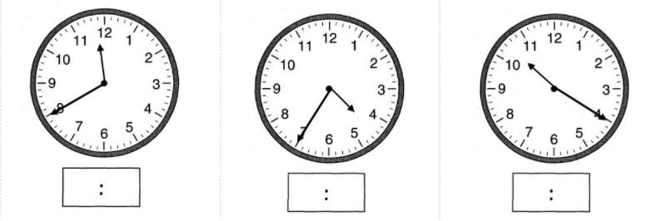

* + 1. The minute hand on the clock points at the 10. What time could it be? Circle **all** of the correct answers.

1. 10:10
2. 4:50
3. 10:20
4. 8:50
5. 9:10
   * 1. Eddie’s piano lesson starts at 6:40 p.m. Draw the time on the clock below.

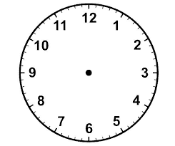[[37]](#endnote-36)

* + 1. The clock shows when Maria gets home from school. Write the same time on the digital clock. Circle AM or PM.



**AM PM**

* + 1. Draw the time on each clock.

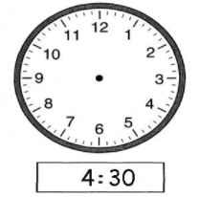  

7**:**55 6**:**15 11**:**35

  

4**:**20 5**:**25 12**:**10

* + 1. What time is shown on the clock below?

[[38]](#endnote-37)

* + 1. Draw the time on each clock.

  

12**:**25 11**:**50 9**:**40

  

4**:**55 8**:**05 7**:**35

* + 1. Draw the hands on the analog clock to match the time shown on the digital clock. Then, circle a.m. or p.m. based on the description given.

a. Time to get out of bed

6:45 a.m. or p.m.



b. Time to go home from school.

3:20 a.m. or p.m.

* + 1. Tyshawn eats lunch at 12:25 p.m. Draw the time on the clock below.



* + 1. Draw the time on each clock.

  

2**:**05 12**:**20 9**:**45

  

4**:**15 8**:**30 7**:**55

* + 1. The minute hand on the clock points at the 5. What time could it be? Circle **all** of the correct answers.

1. 10:05
2. 8:05
3. 6:25
4. 11:35
5. 5:00
6. 4:25
   * 1. The hour hand on the clock points between the 4 and the 5. What time could it be? Circle **all** of the correct answers.
7. 4:00
8. 5:40
9. 5:00
10. 5:25
11. 4:20
12. 5:45
    * 1. Draw the time on each clock.

  [[39]](#endnote-38)

9**:**35 2**:**15 10**:**05

* + 1. What time is it? Write the correct time beneath each clock.

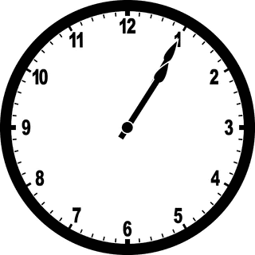 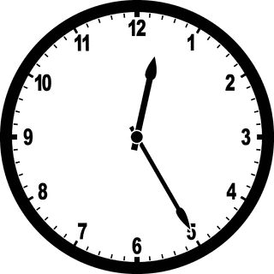 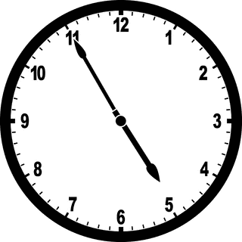

\_\_\_\_ : \_\_\_\_ \_\_\_\_ : \_\_\_\_ \_\_\_\_ : \_\_\_\_

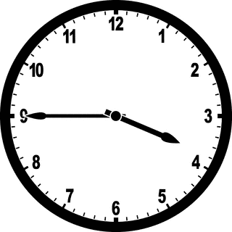 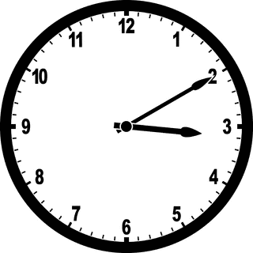 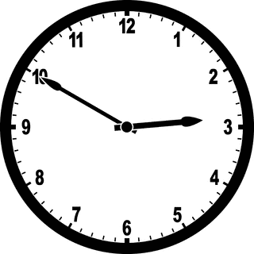

\_\_\_\_ : \_\_\_\_ \_\_\_\_ : \_\_\_\_ \_\_\_\_ : \_\_\_\_

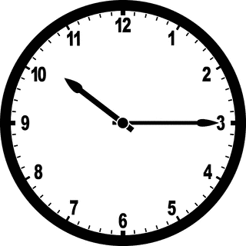 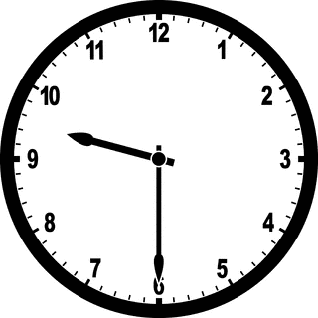 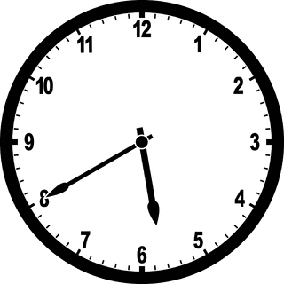

\_\_\_\_ : \_\_\_\_ \_\_\_\_ : \_\_\_\_ \_\_\_\_ : \_\_\_\_

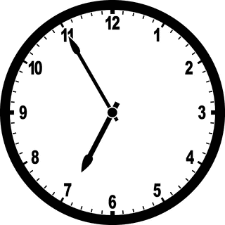 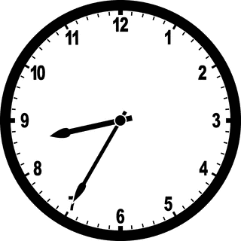 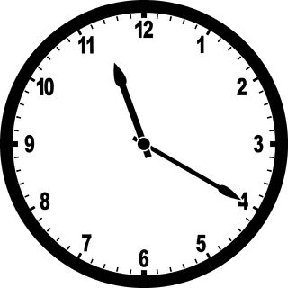[[40]](#endnote-39)

\_\_\_\_ : \_\_\_\_ \_\_\_\_ : \_\_\_\_ \_\_\_\_ : \_\_\_\_

# Workbook D

## 2.NBT.A.1 - Understand that the three digits of a three-digit number represent amounts of hundreds, tens, and ones; e.g., 706 equals 7 hundreds, 0 tens, and 6 ones.

Understand the following as special cases:

[2.NBT.A.1.A](http://www.corestandards.org/Math/Content/2/NBT/A/1/a/) - 100 can be thought of as a bundle of ten tens — called a "hundred."

[2.NBT.A.1.B](http://www.corestandards.org/Math/Content/2/NBT/A/1/b/) - The numbers 100, 200, 300, 400, 500, 600, 700, 800, 900 refer to one, two, three, four, five, six, seven, eight, or nine hundreds (and 0 tens and 0 ones).

1. 4 ones + \_\_\_\_ ones = 10 2. 7 tens + \_\_\_\_ tens = 1 hundred

4 + \_\_\_\_ = 10 70 + \_\_\_\_ = 100

1. Rewrite in order from largest to smallest amount.

7 tens 2 hundreds 9 ones

\_\_\_\_\_\_\_\_\_\_\_\_\_\_\_\_\_\_\_\_\_ \_\_\_\_\_\_\_\_\_\_\_\_\_\_\_\_\_\_\_\_ \_\_\_\_\_\_\_\_\_\_\_\_\_\_\_\_\_\_

Largest Smallest

1. Count each group. What is the total number in each group?



\_\_\_\_\_\_\_\_\_\_\_\_\_ \_\_\_\_\_\_\_\_\_\_\_\_\_ ­­­­­­­­­­­­­­­­\_\_\_\_\_\_\_\_\_\_\_\_\_\_

What is the total number? \_\_\_\_\_\_\_

Draw flats, sticks, and dots to represent each number. Then answer the questions.

5. 6.

**705**

**362**

How many **more ones** will make a ten? \_\_\_\_\_\_

How many **more tens** will make a hundred? \_\_\_\_

How many **more hundreds** will make a   
thousand? \_\_\_\_\_\_

How many **more ones** will make a ten? \_\_\_\_\_\_

How many **more tens** will make a hundred? \_\_\_\_

How many **more hundreds** will make a   
thousand? \_\_\_\_\_\_\_

**7. 8.**

**721**

**363**

How many **more ones** will make a ten? \_\_\_\_\_\_

How many **more tens** will make a hundred? \_\_\_\_

How many **more hundreds** will make a   
thousand? \_\_\_\_\_\_

How many **more ones** will make a ten? \_\_\_\_\_\_

How many **more tens** will make a hundred? \_\_\_\_

How many **more hundreds** will make a   
thousand? \_\_\_\_\_\_

1. Count each group. What is the total number in each group?





\_\_\_\_\_\_\_\_\_\_\_\_\_ \_\_\_\_\_\_\_\_\_\_\_\_\_ ­­­­­­­­­­­­­­­­\_\_\_\_\_\_\_\_\_\_\_\_\_\_

What is the total number? \_\_\_\_\_\_\_

1. 4 ones + \_\_\_\_ ones = 10 11. 8 tens + \_\_\_\_ tens = 1 hundred

4 + \_\_\_\_ = 10 80 + \_\_\_\_ = 100

Draw place value models to represent each number.

**209**

12. 13.

**723**

1. Write each number in base ten numeral form.
2. 623 b) 508

|  |  |  |
| --- | --- | --- |
| Hundreds | Tens | Ones |
|  |  |  |

|  |  |  |
| --- | --- | --- |
| Hundreds | Tens | Ones |
|  |  |  |

1. Count the flats, sticks, and dots. Write each number in standard form and base ten numeral form.

|  |  |  |
| --- | --- | --- |
| Hundreds | Tens | Ones |
|  |  |  |

Standard form: \_\_\_\_\_\_\_\_\_\_\_\_\_\_\_\_\_

1. Count the flats, sticks, and dots. Write each number in standard form and base ten numeral form.

|  |  |  |
| --- | --- | --- |
| Hundreds | Tens | Ones |
|  |  |  |

Standard form: \_\_\_\_\_\_\_\_\_\_\_\_\_\_\_\_\_

1. Write each number in unit form:

602: \_\_\_\_\_\_\_\_\_\_\_\_\_\_\_\_\_\_\_\_\_\_\_\_\_\_\_\_\_\_\_\_\_\_\_\_\_\_\_\_\_\_\_\_\_\_\_\_\_\_\_\_\_\_\_\_\_

796: \_\_\_\_\_\_\_\_\_\_\_\_\_\_\_\_\_\_\_\_\_\_\_\_\_\_\_\_\_\_\_\_\_\_\_\_\_\_\_\_\_\_\_\_\_\_\_\_\_\_\_\_\_\_\_\_\_

365: \_\_\_\_\_\_\_\_\_\_\_\_\_\_\_\_\_\_\_\_\_\_\_\_\_\_\_\_\_\_\_\_\_\_\_\_\_\_\_\_\_\_\_\_\_\_\_\_\_\_\_\_\_\_\_\_\_

1. What is another way to write 7 ones 4 tens 5 hundreds?

a. 457 b. 754 c. 574 d. 547

1. What is another way to write 7 tens 1 hundred 8 ones?

a. 718 b. 178 c. 871 d. 781

1. Write 206 in unit form.

\_\_\_\_\_\_\_\_\_\_\_\_\_\_\_\_\_\_\_\_\_\_\_\_\_\_\_\_\_\_\_\_\_\_\_\_\_\_\_\_\_\_\_\_\_\_\_\_\_\_\_\_\_\_\_\_\_\_\_\_\_\_\_\_\_\_\_\_\_\_\_\_\_\_\_\_

1. Write 219 in unit form.

\_\_\_\_\_\_\_\_\_\_\_\_\_\_\_\_\_\_\_\_\_\_\_\_\_\_\_\_\_\_\_\_\_\_\_\_\_\_\_\_\_\_\_\_\_\_\_\_\_\_\_\_\_\_\_\_\_\_\_\_\_\_\_\_\_\_\_\_\_\_\_\_\_\_\_\_

1. Write 670 in unit form.

\_\_\_\_\_\_\_\_\_\_\_\_\_\_\_\_\_\_\_\_\_\_\_\_\_\_\_\_\_\_\_\_\_\_\_\_\_\_\_\_\_\_\_\_\_\_\_\_\_\_\_\_\_\_\_\_\_\_\_\_\_\_\_\_\_\_\_\_\_\_\_\_\_\_\_\_

**Draw each number in flats, sticks, and dots. Then write the number in unit form.**

1. 340 24. 272

**Unit form: \_\_\_\_\_\_\_\_\_\_\_\_\_\_\_\_\_\_\_\_\_\_\_\_\_\_\_\_\_\_ Unit form: \_\_\_\_\_\_\_\_\_\_\_\_\_\_\_\_\_\_\_\_\_\_\_\_\_\_**

1. Read the unit form and write the number in standard form.
2. 9 hundreds 4 ones = \_\_\_\_\_\_\_\_\_\_\_\_\_\_\_\_\_\_\_\_\_\_\_\_\_\_\_\_\_\_\_\_\_\_\_\_
3. 9 tens 4 ones = \_\_\_\_\_\_\_\_\_\_\_\_\_\_\_\_\_\_\_\_\_\_\_\_\_\_\_\_\_\_\_\_\_\_\_\_
4. 4 tens 9 ones = \_\_\_\_\_\_\_\_\_\_\_\_\_\_\_\_\_\_\_\_\_\_\_\_\_\_\_\_\_\_\_\_\_\_\_\_
5. Lucas has 375 Skittles. Write the amount of Skittles Lucas has in three different ways by filling in the blanks.

|  |  |
| --- | --- |
| Unit Form |  |
| Base Ten Numeral Form |  |
| Place Value Models |  |

1. Write 291 in unit form.

\_\_\_\_\_\_\_\_\_\_\_\_\_\_\_\_\_\_\_\_\_\_\_\_\_\_\_\_\_\_\_\_\_\_\_\_\_\_\_\_\_\_\_\_\_\_\_\_\_\_\_\_\_\_\_\_\_\_\_\_\_\_\_\_\_\_\_\_\_\_\_\_\_\_\_\_

1. Write 187 in unit form.

\_\_\_\_\_\_\_\_\_\_\_\_\_\_\_\_\_\_\_\_\_\_\_\_\_\_\_\_\_\_\_\_\_\_\_\_\_\_\_\_\_\_\_\_\_\_\_\_\_\_\_\_\_\_\_\_\_\_\_\_\_\_\_\_\_\_\_\_\_\_\_\_\_\_\_\_

1. Write each number in base ten numeral form.
2. 472

|  |  |  |
| --- | --- | --- |
| Hundreds | Tens | Ones |
|  |  |  |

1. 371

|  |  |  |
| --- | --- | --- |
| Hundreds | Tens | Ones |
|  |  |  |

## 2.NBT.A.3 - Read and write numbers to 1000 using base-ten numerals, number names, and expanded form.

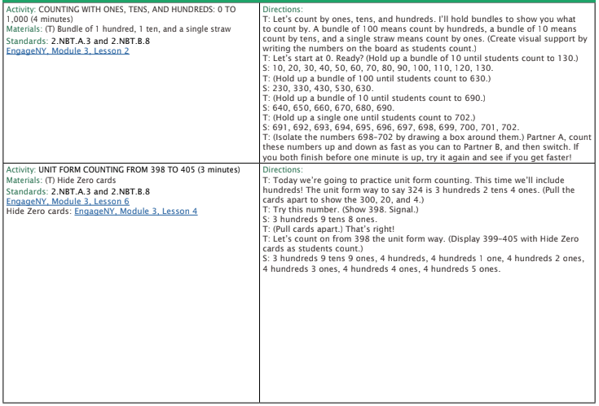

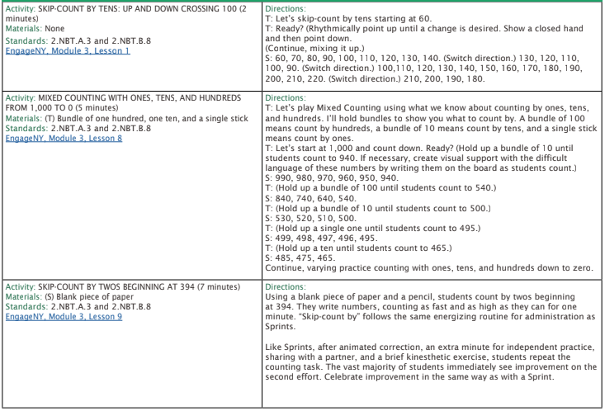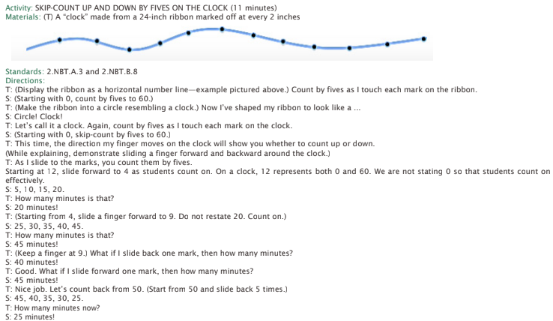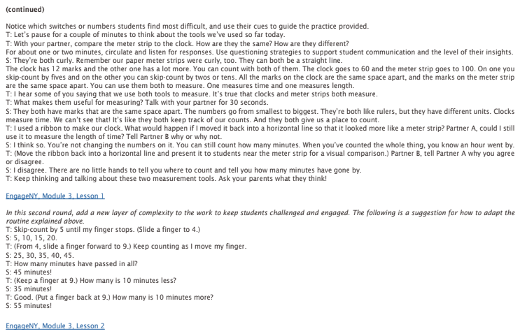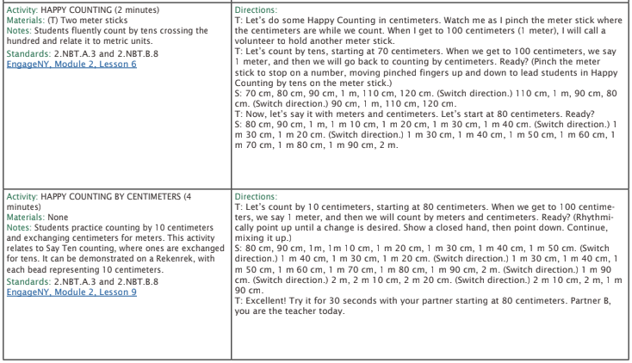

* + - 1. Fill in the table by writing the numbers in word form and standard form.

|  |  |  |  |  |  |  |  |  |  |  |  |  |  |  |  |  |  |  |
| --- | --- | --- | --- | --- | --- | --- | --- | --- | --- | --- | --- | --- | --- | --- | --- | --- | --- | --- |
| |  |  |  | | --- | --- | --- | | **Starting Number** | **Standard Form** | **Word Form** | | 6 hundreds, 2 ten, 7 ones |  |  | |  |  |  | | |  |  |  | | --- | --- | --- | | **H** | **T** | **O** | | 9 | 0 | 5 | |  |  | |

* + - 1. Re-write each number from word form to standard form.

|  |  |
| --- | --- |
| **Starting Number** | **Standard Form** |
| Three hundred twenty |  |
| Seventy-two |  |
| One hundred eighty-four |  |

* + - 1. Write 419 in word form

\_\_\_\_\_\_\_\_\_\_\_\_\_\_\_\_\_\_\_\_\_\_\_\_\_\_\_\_\_\_\_\_\_\_\_\_\_\_\_\_\_\_\_\_\_\_\_\_\_\_\_\_\_\_\_\_\_\_\_\_\_\_\_\_\_\_\_\_\_\_\_

* + - 1. Write 265 in unit form

\_\_\_\_\_\_\_\_\_\_\_\_\_\_\_\_\_\_\_\_\_\_\_\_\_\_\_\_\_\_\_\_\_\_\_\_\_\_\_\_\_\_\_\_\_\_\_\_\_\_\_\_\_\_\_\_\_\_\_\_\_\_\_\_\_\_\_\_\_\_\_

* + - 1. Write 804 in word form

\_\_\_\_\_\_\_\_\_\_\_\_\_\_\_\_\_\_\_\_\_\_\_\_\_\_\_\_\_\_\_\_\_\_\_\_\_\_\_\_\_\_\_\_\_\_\_\_\_\_\_\_\_\_\_\_\_\_\_\_\_\_\_\_\_\_\_\_\_\_\_

* + - 1. Write 140 in unit form

\_\_\_\_\_\_\_\_\_\_\_\_\_\_\_\_\_\_\_\_\_\_\_\_\_\_\_\_\_\_\_\_\_\_\_\_\_\_\_\_\_\_\_\_\_\_\_\_\_\_\_\_\_\_\_\_\_\_\_\_\_\_\_\_\_\_\_\_\_\_\_

* + - 1. Write in standard form

1. Two hundred thirty-six = \_\_\_\_\_\_\_\_\_\_\_\_\_\_\_\_\_\_\_\_\_\_\_\_\_\_\_
2. Five hundred seven = \_\_\_\_\_\_\_\_\_\_\_\_\_\_\_\_\_\_\_\_\_\_\_\_\_\_\_
3. 2 hundreds, 5 tens, 3 ones = \_\_\_\_\_\_\_\_\_\_\_\_\_\_\_\_\_\_\_\_\_\_\_\_\_\_\_
4. Six hundred thirteen = \_\_\_\_\_\_\_\_\_\_\_\_\_\_\_\_\_\_\_\_\_\_\_\_\_\_\_
5. 4 hundreds, 8 tens = \_\_\_\_\_\_\_\_\_\_\_\_\_\_\_\_\_\_\_\_\_\_\_\_\_\_\_

|  |  |  |
| --- | --- | --- |
| * + - 1. **418 =** * Four hundred eighty-one * Four hundred ten-eight * Four hundred eighteen * Forty-one eight | * + - 1. **seven hundred thirty =** * 73 * 730 * 703 * 713 | * + - 1. **4 tens 7 ones =** * 47 * 470 * 74 * 407 |

* + - 1. Fill in the missing parts of the chart.

|  |  |  |  |
| --- | --- | --- | --- |
| **Standard Form** | **Place Value models**  **(flats, sticks, and dots)** | **Unit Form** | **Word Form** |
| 694 |  |  |  |
|  |  |  |  |
|  |  | 5 tens, 3 hundreds |  |
| 204 |  |  |  |
|  |  |  | Five hundred seventy |

* + - 1. Write in standard form

1. Two hundred seventy-four = \_\_\_\_\_\_\_\_\_\_\_\_\_\_\_\_\_\_\_\_\_\_\_\_\_\_\_
2. Seven hundred sixty = \_\_\_\_\_\_\_\_\_\_\_\_\_\_\_\_\_\_\_\_\_\_\_\_\_\_\_
3. 8 ones, 2 hundreds, 7 tens = \_\_\_\_\_\_\_\_\_\_\_\_\_\_\_\_\_\_\_\_\_\_\_\_\_\_\_
4. Four hundred six = \_\_\_\_\_\_\_\_\_\_\_\_\_\_\_\_\_\_\_\_\_\_\_\_\_\_\_
5. 3 hundreds, 6 tens = \_\_\_\_\_\_\_\_\_\_\_\_\_\_\_\_\_\_\_\_\_\_\_\_\_\_\_
   * + 1. Write in word form
6. 726 = \_\_\_\_\_\_\_\_\_\_\_\_\_\_\_\_\_\_\_\_\_\_\_\_\_\_\_\_\_\_\_\_\_\_\_\_\_\_\_\_\_\_\_\_
7. 8 hundreds, 3 tens = \_\_\_\_\_\_\_\_\_\_\_\_\_\_\_\_\_\_\_\_\_\_\_\_\_\_\_\_\_\_\_\_\_\_\_\_\_\_\_\_\_\_\_\_\_\_\_
8. 5 hundreds, six tens, 4 ones = \_\_\_\_\_\_\_\_\_\_\_\_\_\_\_\_\_\_\_\_\_\_\_\_\_\_\_\_\_\_\_\_\_\_\_\_\_\_\_\_\_\_\_\_\_\_\_
9. 902 = \_\_\_\_\_\_\_\_\_\_\_\_\_\_\_\_\_\_\_\_\_\_\_\_\_\_\_\_\_\_\_\_\_\_\_\_\_\_\_\_\_\_\_\_\_\_\_
10. 2 hundreds, 9 tens, 2 ones = \_\_\_\_\_\_\_\_\_\_\_\_\_\_\_\_\_\_\_\_\_\_\_\_\_\_\_\_\_\_\_\_\_\_\_\_\_\_\_\_\_\_\_\_\_\_\_

|  |  |  |
| --- | --- | --- |
| * + - 1. **250 =** * Two hundred five * Two hundred fifty * 2 hundreds, 5 tens * Two hundreds, 5 ones | * + - 1. **671 =** * 6 hundreds, 7 tens, 1 one * Six hundred seventeen * 6 hundreds, 1 ten, 7 ones * Six hundred seventy-one | * + - 1. **715 =** * Seven hundred fifteen * Seven hundred fifty * 7 hundreds, 5 tens * 5 ones, 1 ten, 7 hundreds |

Fill in all answers that apply. You may choose more than one answer.

* + - 1. Fill in the missing parts of the chart.

|  |  |  |  |
| --- | --- | --- | --- |
| **Standard Form** | **Place Value models**  **(flats, sticks, and dots)** | **Unit Form** | **Word Form** |
|  |  | 2 hundreds, 3 ones |  |
|  |  |  |  |
|  |  |  | Eight hundred twenty |
| 711 |  |  |  |
|  |  |  | Five hundred thirty-six |

18. Fill in the table by writing the numbers in word form and standard form.

|  |  |  |
| --- | --- | --- |
| **Starting Number** | **Standard Form** | **Word Form** |
| 8 hundreds, 9 tens, 7 ones |  |  |
|  |  |  |
| |  |  |  | | --- | --- | --- | | **H** | **T** | **O** | | 3 | 0 | 8 | |  |  |

1. Write each number in standard form and expanded form.

|  |  |  |
| --- | --- | --- |
|  | **Standard Form** | **Expanded Form** |
| Three hundred fifty-two | 352 | 300 + 50 + 2 |
| Eight hundred seventy-one |  |  |
| 5 tens, 4 hundreds, 8 ones |  |  |
| One hundred twelve |  |  |
| 4 ones, 3 hundreds, 5 tens |  |  |

1. Write the answer in standard form.

|  |  |
| --- | --- |
| **Expanded Form** | **Standard Form** |
| 500 + 30 + 2 |  |
| 70 + 600 + 8 |  |
| 5 + 200 |  |
| 1. 800 + 7 |  |

Write the answer in standard form.

|  |  |
| --- | --- |
| 1. 2 + 50 + 300 = | 1. 700 + 3 + 10 = |
| 1. 50 + 800 + 9 = | 1. 20 + 600 + 1 = |

Write the answer in standard form. Then write each number in expanded form.

|  |  |
| --- | --- |
| 1. 1 hundred, 5 tens, 7 ones   Standard form: \_\_\_\_\_\_\_\_\_\_\_\_\_\_\_\_\_  Expanded form: | 1. 3 hundreds, 6 ones   Standard form: \_\_\_\_\_\_\_\_\_\_\_\_\_\_\_\_\_  Expanded form: |
| 1. 8 hundreds, 2 tens   Standard form: \_\_\_\_\_\_\_\_\_\_\_\_\_\_\_\_\_  Expanded form: | 1. 4 hundreds, 1 ten, 7 ones   Standard form: \_\_\_\_\_\_\_\_\_\_\_\_\_\_\_\_\_  Expanded form: |

**Write each number in expanded form.**

|  |  |
| --- | --- |
| 1. 831 | 1. 430 |
| 1. 792 | 1. 203 |

## 2.NBT.A.4 - Compare two three-digit numbers based on meanings of the hundreds, tens, and ones digits, using >, =, and < symbols to record the results of comparisons.

1. Use the numbers 467 and 463 to complete each number sentence.

\_\_\_\_\_\_\_\_\_ > \_\_\_\_\_\_\_\_\_ \_\_\_\_\_\_\_\_\_ < \_\_\_\_\_\_\_\_\_

Why can you write two different number sentences to compare 467 and 463?

\_\_\_\_\_\_\_\_\_\_\_\_\_\_\_\_\_\_\_\_\_\_\_\_\_\_\_\_\_\_\_\_\_\_\_\_\_\_\_\_\_\_\_\_\_\_\_\_\_\_\_\_\_\_\_\_\_\_\_\_\_\_\_\_\_\_\_\_\_\_\_\_\_\_\_\_\_\_\_\_\_\_\_\_

\_\_\_\_\_\_\_\_\_\_\_\_\_\_\_\_\_\_\_\_\_\_\_\_\_\_\_\_\_\_\_\_\_\_\_\_\_\_\_\_\_\_\_\_\_\_\_\_\_\_\_\_\_\_\_\_\_\_\_\_\_\_\_\_\_\_\_\_\_\_\_\_\_\_\_\_\_\_\_\_\_\_\_\_

\_\_\_\_\_\_\_\_\_\_\_\_\_\_\_\_\_\_\_\_\_\_\_\_\_\_\_\_\_\_\_\_\_\_\_\_\_\_\_\_\_\_\_\_\_\_\_\_\_\_\_\_\_\_\_\_\_\_\_\_\_\_\_\_\_\_\_\_\_\_\_\_\_\_\_\_\_\_\_\_\_\_\_\_

1. Write < or > in each blank.

624 \_\_\_\_\_\_ 594 104 \_\_\_\_\_\_\_ 140 790\_\_\_\_\_\_\_ 709 592 \_\_\_\_\_\_\_\_ 700

291 \_\_\_\_\_\_ 219 98 \_\_\_\_\_\_\_ 110 608\_\_\_\_\_\_\_ 779 435 \_\_\_\_\_\_\_\_ 453

1. Compare the two numbers using <, >, or =.
   1. 411 \_\_\_\_\_ 40 tens, 11 ones
   2. 400 + 20 + 1 \_\_\_\_\_ 4 hundreds, 2 tens, 21 ones
   3. 300 + 50 + 12 \_\_\_\_\_ 3 hundreds, 5 tens, 2 ones
2. Choose **True** or **False** for each number sentence.

|  |  |  |
| --- | --- | --- |
|  | **True** | **False** |
| Five hundred fifty-one > 500 + 30 + 9 |  |  |
| 824 < 88 tens, 9 ones |  |  |
| 7 Hundreds, 7 tens = 700 + 10 + 7 |  |  |
| 400 + 22 < 425 |  |  |

1. Jill and Iman each write a three-digit number.

**Jill’s number: 305**

**Iman’s number: 3 hundreds, 5 tens**

Which number sentence compares their numbers correctly?

* 1. 305 < 305
  2. 305 = 305
  3. 350 > 305
  4. 350 < 305

\_\_\_\_\_\_\_\_\_\_\_\_\_\_\_\_\_\_\_\_\_\_\_\_\_\_\_\_\_\_\_\_\_\_\_\_\_\_\_\_\_\_\_\_\_\_\_\_\_\_\_\_\_\_\_\_\_\_\_\_\_\_\_\_\_\_\_\_\_\_\_\_\_\_\_\_\_\_\_\_\_\_

1. Kim and Jon tossed beanbags at a target. The grey numbers are the numbers that their beanbags landed on.

|  |  |  |  |  |  |  |
| --- | --- | --- | --- | --- | --- | --- |
| **Kim** | | |  | **Jon** | | |
| **1** | **2** | **3** |  | **1** | **2** | **3** |
| **4** | **5** | **6** |  | **4** | **5** | **6** |
| **7** | **8** | **9** |  | **7** | **8** | **9** |

What is the greatest number that Kim can make? \_\_\_\_\_\_\_\_\_\_\_\_\_\_

What is the greatest number Jon can make? \_\_\_\_\_\_\_\_\_\_\_\_\_\_

Whose number is greater? Write a comparison below using < or >.

\_\_\_\_\_\_\_\_\_\_\_\_\_\_ \_\_\_\_\_\_\_\_\_\_\_\_\_\_

1. Write < or > in each blank.

204 \_\_\_\_\_\_ 24 454 \_\_\_\_\_\_\_ 405 970\_\_\_\_\_\_\_ 709 342 \_\_\_\_\_\_\_\_ 600

391 \_\_\_\_\_\_ 319 918 \_\_\_\_\_\_\_ 111 681\_\_\_\_\_\_\_ 792 353 \_\_\_\_\_\_\_\_ 535

192 \_\_\_\_\_\_ 199 718 \_\_\_\_\_\_\_ 511 612\_\_\_\_\_\_\_ 92 303 \_\_\_\_\_\_\_\_ 350

1. Choose True or False for each comparison. Put an X in the box for each statement.

|  |  |  |
| --- | --- | --- |
|  | **True** | **False** |
| 5 hundreds 51 ones > 539 |  |  |
| 900 + 20 + 4 < 88 tens 9 ones |  |  |
| 700 + 70 = 70 tens 7 ones |  |  |
| 422 < 425 |  |  |

1. Write one of these numbers on each line to make each statement true.

308 380 390

\_\_\_\_\_\_\_\_\_\_\_ > 386

38 tens = \_\_\_\_\_\_\_\_\_\_\_

\_\_\_\_\_\_\_\_\_\_\_ < 384

1. Which number sentence is true?
   1. 43 tens 1 one < 400 + 20 + 7
   2. 540 > 5 hundreds 41 ones
   3. 727 < 772
   4. 9 hundreds 6 tens > 906
2. Write < or > in each blank.

411 \_\_\_\_\_\_ 243 402 \_\_\_\_\_\_\_ 521 740\_\_\_\_\_\_\_ 409 428 \_\_\_\_\_\_\_\_ 650

791 \_\_\_\_\_\_ 794 328 \_\_\_\_\_\_\_ 231 781\_\_\_\_\_\_\_ 772 313 \_\_\_\_\_\_\_\_ 351

234 \_\_\_\_\_\_ 423 778 \_\_\_\_\_\_\_ 711 127\_\_\_\_\_\_\_ 292 343 \_\_\_\_\_\_\_\_ 450

1. Compare the two numbers using <, >, or =.
   1. 300 + 130 + 1 \_\_\_\_\_ 42 tens, 11 ones
   2. 400 + 20 + 1 \_\_\_\_\_ 40 tens, 21 ones
   3. 100 + 150 + 12 \_\_\_\_\_ 2 hundreds, 5 tens, 2 ones
   4. 4 hundreds, three tens \_\_\_\_\_ 42 tens, 11 ones
   5. 200 + 40 + 10 \_\_\_\_\_ 20 tens, 50 ones
   6. 100 + 30 + 1 \_\_\_\_\_ 10 tens, 13 ones
2. Circle whether the statement is **True** or **False.** Prove your answer by drawing flats, sticks, and dots.

**50 + 300 + 3 > 3 hundreds, 5 tens, 26 ones**

1. Circle whether the statement is **True** or **False.** Prove your answer by drawing flats, sticks, and dots.

**Seven hundred seventeen < 600 + 110 + 3**

**True False**

1. Write < or > in each blank to make the comparison sentence true.

264 \_\_\_\_\_\_ 454 154 \_\_\_\_\_\_\_ 250 709\_\_\_\_\_\_\_ 780 172 \_\_\_\_\_\_\_\_ 200

299 \_\_\_\_\_\_ 320 101 \_\_\_\_\_\_\_ 99 618\_\_\_\_\_\_\_ 581 325 \_\_\_\_\_\_\_\_ 352

1. Jayden and Brenda each write a three-digit number.

Jayden’s number: 100 + 30 + 7

Brenda’s Number: 1 hundred, 30 tens, 7 ones

Which number sentence compares their numbers correctly?

* 1. 173 > 137
  2. 137 = 137
  3. 137 < 1307
  4. 137 < 407

1. Write < or > in each blank.

324 \_\_\_\_\_\_ 234 689 \_\_\_\_\_\_\_ 655 145\_\_\_\_\_\_\_ 234 569 \_\_\_\_\_\_\_\_ 695

102 \_\_\_\_\_\_ 210 376 \_\_\_\_\_\_\_ 215 533\_\_\_\_\_\_\_ 612 901 \_\_\_\_\_\_\_\_ 199

254 \_\_\_\_\_\_ 343 255 \_\_\_\_\_\_\_ 632 43\_\_\_\_\_\_\_ 430 291 \_\_\_\_\_\_\_\_ 301

1. Phil has 248 trading cards. Sean has more trading cards than Phil. How many cards could Sean have? Circle **all** of the correct answers.
   1. 239
   2. 245
   3. 252
   4. 260
2. Write one of these numbers in each box to make a true number sentence.

**308 380 390**

> three hundreds, 86 ones

= 38 tens

< 300 + 70 + 14

## 2.NBT.B.8 - Mentally add 10 or 100 to a given number 100-900, and mentally subtract 10 or 100 from a given number 100-900.

* + - * 1. Solve each problem using **mental math.**

|  |  |  |
| --- | --- | --- |
| 678 + 100 = \_\_\_\_\_\_\_ | 678 + 10 = \_\_\_\_\_\_\_\_ | 876 + 100 = \_\_\_\_\_\_\_ |
| 78 + 10 = \_\_\_\_\_\_\_ | 35 + 100 = \_\_\_\_\_\_\_\_ | 723 + 10 = \_\_\_\_\_\_\_ |
| 158 + 100 = \_\_\_\_\_\_\_ | 435 + 100 = \_\_\_\_\_\_\_\_ | 876 + 10 = \_\_\_\_\_\_\_ |
| 203 + 100 = \_\_\_\_\_\_\_ | 203 + 10 = \_\_\_\_\_\_\_\_ | 550 + 100 = \_\_\_\_\_\_\_ |
| 800 + 10 = \_\_\_\_\_\_\_ | 800 + 100 = \_\_\_\_\_\_\_\_ | 676 + 10 = \_\_\_\_\_\_\_ |
| 387 + 100 = \_\_\_\_\_\_\_ | 409 + 10 = \_\_\_\_\_\_\_\_ | 409 + 100 = \_\_\_\_\_\_\_ |

2. Use mental math to solve 324 + 100 = \_\_\_\_\_\_.

1. Solve each problem using **mental math.**

|  |  |  |
| --- | --- | --- |
| 328 - 100 = \_\_\_\_\_\_\_ | 435 - 10 = \_\_\_\_\_\_\_\_ | 678 - 100 = \_\_\_\_\_\_\_ |
| 328 - 10 = \_\_\_\_\_\_\_ | 235 - 100 = \_\_\_\_\_\_\_\_ | 723 - 10 = \_\_\_\_\_\_\_ |
| 158 - 100 = \_\_\_\_\_\_\_ | 200 - 100 = \_\_\_\_\_\_\_\_ | 200 - 10 = \_\_\_\_\_\_\_ |
| 305 - 100 = \_\_\_\_\_\_\_ | 305 - 10 = \_\_\_\_\_\_\_\_ | 850 - 100 = \_\_\_\_\_\_\_ |
| 850 - 10 = \_\_\_\_\_\_\_ | 902 - 100 = \_\_\_\_\_\_\_\_ | 473 - 10 = \_\_\_\_\_\_\_ |
| 387 - 100 = \_\_\_\_\_\_\_ | 904 - 10 = \_\_\_\_\_\_\_\_ | 904 - 100 = \_\_\_\_\_\_\_ |

4. Use mental math to solve 875 - 10 = \_\_\_\_\_\_.

1. Solve each problem using **mental math.**

|  |  |  |
| --- | --- | --- |
| 832 + 100 = \_\_\_\_\_\_\_ | 524 - 10 = \_\_\_\_\_\_\_\_ | 178 + 100 = \_\_\_\_\_\_\_ |
| 208 - 10 = \_\_\_\_\_\_\_ | 530 + 100 = \_\_\_\_\_\_\_\_ | 523 - 10 = \_\_\_\_\_\_\_ |
| 218 - 100 = \_\_\_\_\_\_\_ | 700 - 10 = \_\_\_\_\_\_\_\_ | 325 +10 = \_\_\_\_\_\_\_ |
| 870 + 100 = \_\_\_\_\_\_\_ | 807 + 10 = \_\_\_\_\_\_\_\_ | 421 - 100 = \_\_\_\_\_\_\_ |

6. Use **mental math** to fill in the missing number that makes each equation true.

|  |  |  |
| --- | --- | --- |
| 534 - \_\_\_\_\_ = 524 | 902 - \_\_\_\_\_\_ = 892 | 247 + \_\_\_\_\_ = 347 |
| 758 + \_\_\_\_\_\_ = 858 | 635 + \_\_\_\_\_ = 645 | 703 + \_\_\_\_\_\_ = 713 |
| 198 + \_\_\_\_\_\_\_ = 208 | 354 - \_\_\_\_\_\_ = 254 | 876 - \_\_\_\_\_\_\_ = 776 |
| 201 - \_\_\_\_\_\_ = 101 | 201 -10 = \_\_\_\_\_\_\_\_ | 795 + 100 = \_\_\_\_\_\_\_ |

7. Use **mental math** to fill in the missing number that makes each equation true.

|  |  |  |
| --- | --- | --- |
| \_\_\_\_\_\_\_\_\_ - 10 = 478 | \_\_\_\_\_\_ + 100 = 350 | \_\_\_\_\_\_ - 10 = 723 |
| \_\_\_\_\_\_\_ - 100 = 712 | \_\_\_\_\_\_ - 10 = 796 | \_\_\_\_\_\_ +10 = 796 |
| \_\_\_\_\_\_ + 100 = 796 | \_\_\_\_\_\_ -100 = 397 | \_\_\_\_\_ + 100 = 404 |
| 575 - \_\_\_\_\_\_ = 565 | 211 -\_\_\_\_\_\_\_ = 111 | 1. + 10 = \_\_\_\_\_\_\_ |

1. Fill in the missing numbers.

125 + \_\_\_\_\_\_\_ = 225

506 – \_\_\_\_\_\_\_ = 496

\_\_\_\_\_\_\_ + 100 = 764

1. Fill in the missing numbers on the chart using mental math.

|  |  |  |  |  |
| --- | --- | --- | --- | --- |
| **Number** | **10 More** | **10 Less** | **100 More** | **100 Less** |
| **476** |  |  |  |  |
| **261** |  |  |  |  |
| **852** |  |  |  |  |

1. Choose True or False for each equation.

|  |  |  |
| --- | --- | --- |
|  | **True** | **False** |
| 234 + 10 = 334 |  |  |
| 541 –100 = 441 |  |  |
| 764 – 10 = 774 |  |  |
| 100 + 56 = 156 |  |  |

# Workbook E

## 2.NBT.B.7 - Add and subtract within 1000, using concrete models or drawings and strategies based on place value, properties of operations, and/or the relationship between addition and subtraction; justify the reasoning used with a written explanation. Understand that in adding or subtracting three-digit numbers, one adds or subtracts hundreds and hundreds, tens and tens, ones and ones; and sometimes it is necessary to compose or decompose tens or hundreds.

1. Calculate.

|  |  |  |
| --- | --- | --- |
| 265  - 137 | 651  - 243 | 945 – 328 = \_\_\_\_\_ |
| 545 + 129 = \_\_\_\_\_ | 523  + 273 | 417  + 258 |

1. Solve. Show all of your work:

425 + 357 = \_\_\_\_\_\_\_\_\_

1. Solve. Show all of your work.

703 – 466 = \_\_\_\_\_\_\_\_\_

1. Use the number line to solve. Show your work.

578 + 237 = \_\_\_\_\_\_\_\_\_\_

1. Solve. Show all of your work:

721 - 573 = \_\_\_\_\_\_\_\_\_

1. Solve. Show all of your work.

293 + 409 = \_\_\_\_\_\_\_\_\_

1. Use expanded notation to solve the problem. Show your work.

578 + 237 = \_\_\_\_\_\_\_\_\_\_

1. Calculate.

|  |  |  |
| --- | --- | --- |
| 605  - 327 | 708  - 439 | 875 – 218 = \_\_\_\_\_ |
| 575 + 219 = \_\_\_\_\_ | 238  + 573 | 117  + 582 |

1. Calculate.

|  |  |  |
| --- | --- | --- |
| 673  - 137 | 433  - 182 | 745 –\_\_\_\_\_ = 196 |
| 515 + \_\_\_\_\_ = 729 | 763  + 256 | 442  + 328 |

1. Find the missing number to make the statement true. Show your work.

\_\_\_\_\_\_\_\_ = 504 – 286

1. Solve. Show all of your work.

800 – \_\_\_\_\_\_\_\_ = 500 – 354

1. Use the space below to solve the problem correctly. Show your work.
2. – 246 = \_\_\_\_\_\_\_\_\_\_
3. Calculate.

|  |  |  |
| --- | --- | --- |
| 903  - 465 | 922  - 573 | 721 – 238 = \_\_\_\_\_ |
| 495 + 129 = \_\_\_\_\_ | 243  + 713 | 317  + 458 |

14. Solve. Show your work.

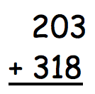 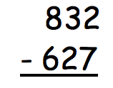

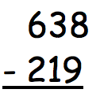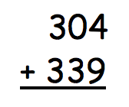

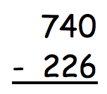 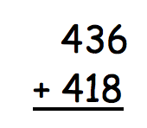

1. Solve to find the missing numbers.

142 + \_\_\_\_\_\_\_ = 225

506 – \_\_\_\_\_\_\_ = 329

\_\_\_\_\_\_\_ + 344 = 764

# Workbook F

## 2.OA.C.3 - Determine whether a group of objects (up to 20) has an odd or even number of members, e.g., by pairing objects or counting them by 2s; write an equation to express an even number as a sum of two equal addends.

1. Does the picture below show an even or an odd number of stars?

|  |  |
| --- | --- |
|  | draw a picture to show how you know |

**Even or Odd**

1. Does the picture below show an even or an odd number of circles?

|  |  |
| --- | --- |
|  | draw a picture to show how you know |

**Even or Odd**

1. Draw a picture to show whether the number is odd or even.

|  |  |  |
| --- | --- | --- |
| Number | Drawing | Odd or Even? |
| **9** |  |  |
| **14** |  |  |
| **17** |  |  |
| **6** |  |  |
| **13** |  |  |
| **8** |  |  |
| **14** |  |  |
| **10** |  |  |

4. Use pairs or teams to determine if a number is odd or even

|  |  |  |
| --- | --- | --- |
| a. | Picture:  **Odd** or  **Even** | Redraw your picture with 1 *less* circle.  **Odd** or  **Even** |

|  |  |  |
| --- | --- | --- |
| b. | Picture:  **Odd** or  **Even** | Redraw your picture with 1 *more* circle.  **Odd** or  **Even** |

1. There is an odd number of students in Miss Jackson’s class. Which of the following could be the number of students in the class? Circle all answers that could be true.

* 16
* 18
* 19
* 20
* 21
* 23

1. Does the picture below show an even or an odd number of stars?

|  |  |
| --- | --- |
|  | Draw a picture to show how you know. |

**Even or Odd**

|  |  |  |
| --- | --- | --- |
| a.  **6** + 1 = **7**  even + 1 = odd | b.  **14** + 1 = **15**  \_\_\_\_\_\_\_\_ + 1 = \_\_\_\_\_\_\_\_\_ | c.  **61** + 1= **62**    \_\_\_\_\_\_\_\_ + 1 = \_\_\_\_\_\_\_\_\_ |
| d.  **17** + 1 = **18**  \_\_\_\_\_\_\_\_ + 1 = \_\_\_\_\_\_\_\_\_ | e.  **93** + 1= **94**    \_\_\_\_\_\_\_\_ + 1 = \_\_\_\_\_\_\_\_\_ | f.  **52** + 1= **53**    \_\_\_\_\_\_\_\_ + 1 = \_\_\_\_\_\_\_\_\_ |

1. Write to identify the **bold** numbers as even or odd. The first one has been done for you.
2. Predict if the answer to each number sentence will be even or odd. Solve the number sentence to prove if your prediction was correct.

|  |  |  |
| --- | --- | --- |
| Number Sentence | Even or Odd? | Solution |
| 10 + 17= \_\_\_\_\_ |  |  |
| 21 + 12 = \_\_\_\_\_ |  |  |
| 30 +15 = \_\_\_\_\_\_ |  |  |

1. Are the **bold** numbers even or odd? Explain how you know using words or pictures.

|  |  |
| --- | --- |
| a. **29**  even/odd |  |
| b. **36**  even/odd |  |
| c. **54**  even/odd |  |
| d. **70**  even/odd |  |
| a.  **81**  even/odd |  |
| b.  **32**  even/odd |  |

1. Write the numbers from 75 to 85 in the boxes below. Circle the **even** numbers.

|  |  |  |  |  |  |  |  |  |  |  |
| --- | --- | --- | --- | --- | --- | --- | --- | --- | --- | --- |
|  |  |  |  |  |  |  |  |  |  |  |

1. Write the numbers from 68 to 78 in the boxes below. Circle the **odd** numbers.

|  |  |  |  |  |  |  |  |  |  |  |
| --- | --- | --- | --- | --- | --- | --- | --- | --- | --- | --- |
|  |  |  |  |  |  |  |  |  |  |  |

1. Write the numbers from 125 to 135 in the boxes below. Circle the **even** numbers.

|  |  |  |  |  |  |  |  |  |  |  |
| --- | --- | --- | --- | --- | --- | --- | --- | --- | --- | --- |
|  |  |  |  |  |  |  |  |  |  |  |

1. Write the numbers from 23 to 33 in the boxes below. Circle the **odd** numbers.

|  |  |  |  |  |  |  |  |  |  |  |
| --- | --- | --- | --- | --- | --- | --- | --- | --- | --- | --- |
|  |  |  |  |  |  |  |  |  |  |  |

1. Write the numbers from 208 to 218 in the boxes below. Circle the **even numbers.**

|  |  |  |  |  |  |  |  |  |  |  |
| --- | --- | --- | --- | --- | --- | --- | --- | --- | --- | --- |
|  |  |  |  |  |  |  |  |  |  |  |

## 2.OA.C.4 - Use addition to find the total number of objects arranged in rectangular arrays with up to 5 rows and up to 5 columns; write an equation to express the total as a sum of equal addends.

1. Circle groups of five. Then, draw the triangles into equal rows of five.

There are \_\_\_\_\_\_\_\_\_ rows of \_\_\_\_\_\_\_\_\_\_\_.

1. Circle groups of three. Redraw the groups of three as rows.

There are \_\_\_\_\_\_\_\_\_ rows of \_\_\_\_\_\_\_\_\_\_\_.

1. Anna Beth is organizing her hats. She put them into a rectangular array to try to find out how many total hats she has.

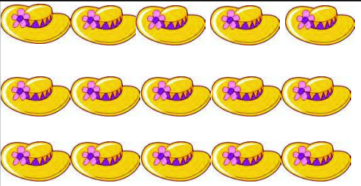

Write an addition equation and then solve to find out how many hats she has.

\_\_\_\_\_\_\_\_\_\_\_\_\_\_\_\_\_\_\_\_\_\_\_\_\_\_\_\_\_\_\_\_\_\_\_\_\_\_\_\_\_\_\_  **=** \_\_\_\_\_\_\_\_\_\_\_\_

1. Create a rectangular array using circles to solve the equation below.

**4 + 4 + 4 + 4 + 4 = \_\_\_\_\_\_\_\_\_\_**

1. Draw 2 columns of 3 squares. Then write a repeated addition equation that explains your array.

\_\_\_\_\_\_\_\_\_\_\_\_\_\_\_\_\_\_\_\_\_\_\_\_\_\_\_\_\_\_\_\_\_\_\_\_\_\_\_\_\_\_\_  **=** \_\_\_\_\_\_\_\_\_\_\_\_

1. A library has 4 fiction books on each of 3 shelves. Draw an array using circles to represent the books on the library shelves.

Write a repeated addition equation to represent the books on the library shelves and then solve to tell how many total books are on the shelves.

\_\_\_\_\_\_\_\_\_\_\_\_\_\_\_\_\_\_\_\_\_\_\_\_\_\_\_\_\_\_\_\_\_\_\_\_\_\_\_\_\_\_\_  **=** \_\_\_\_\_\_\_\_\_\_\_\_

1. Alicia is trying to decide how she will eat her candy that she got as a treat from her grandma. Her mom said that she would have two choices for the candy:

Choice 1: Get 3 pieces a day for the next 3 days.

Choice 2: Get 2 pieces a day for the next 4 days.

1. Draw an array for each choice.

|  |  |
| --- | --- |
|  |  |

1. Which way would Alicia get more candy?

\_\_\_\_\_\_\_\_\_\_\_\_\_\_\_\_\_\_\_\_\_\_\_\_\_\_\_\_\_\_\_\_\_\_\_\_\_\_\_\_\_\_\_\_\_\_\_\_\_\_\_\_\_\_\_\_\_\_\_\_\_\_

1. 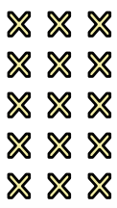Write an equation to match the array and then solve.

\_\_\_\_\_\_\_\_\_\_\_\_\_\_\_\_\_\_\_\_\_\_\_\_\_\_\_\_\_\_\_\_\_\_\_\_\_\_\_\_\_\_\_  **=** \_\_\_\_\_\_\_\_\_\_\_\_

1. Create and array to match the number sentence. Then solve.

**5 + 5 + 5 = \_\_\_\_\_\_\_\_**

1. Allie has 18 jellybeans. She made a rectangular array so she could count them easily. Draw an array that Allie could have made and write a repeated addition number sentence to match.

\_\_\_\_\_\_\_\_\_\_\_\_\_\_\_\_\_\_\_\_\_\_\_\_\_\_\_\_\_\_\_\_\_\_\_\_\_\_\_\_\_\_\_  **=** \_\_\_\_\_\_\_\_\_\_\_\_

1. Draw circles to match and then solve.

**2 + 2 + 2 + 2 + 2 + = \_\_\_\_\_\_\_\_\_**

1. 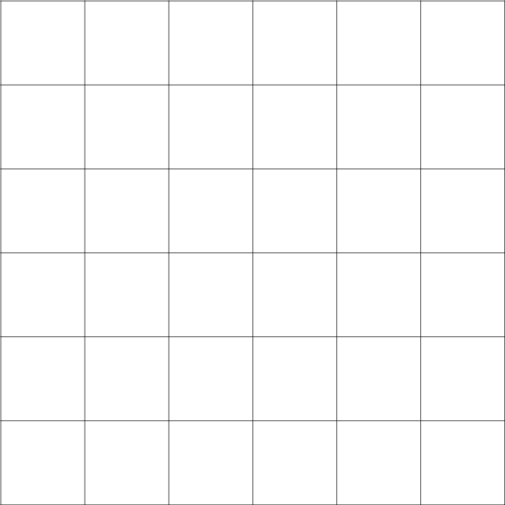Construct an array with 16 squares on the grid below.



Write a repeated addition equation to match the array.

\_\_\_\_\_ rows with \_\_\_\_ in each row **=** \_\_\_\_\_ in all

\_\_\_\_\_\_\_\_\_\_\_\_\_\_\_\_\_\_\_\_\_\_\_\_\_\_\_\_\_\_\_\_\_\_\_\_\_\_\_\_\_\_  **=** \_\_\_\_\_\_\_\_\_\_\_

1. Circle groups of three. Then, draw the clouds into equal columns.

There are \_\_\_\_\_\_ columns of \_\_\_\_\_\_\_\_\_\_.

There are \_\_\_\_\_\_\_\_ clouds in all.

# Workbook G

## 2.G.A.1 – Recognize and draw shapes having specified attributes, such as a given number of angels or a given number of equal faces. Identify triangles, quadrilaterals, pentagons, hexagons, and cubes.

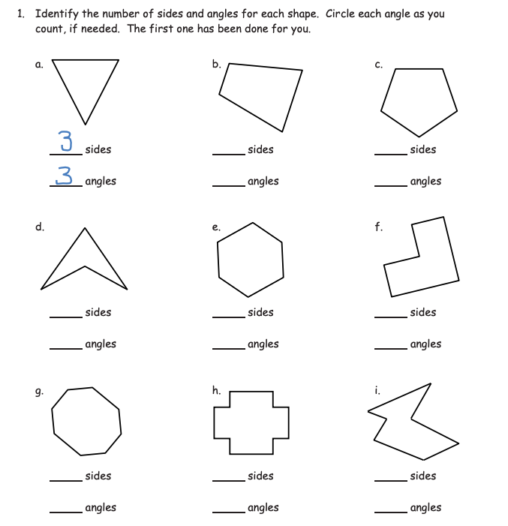[[41]](#endnote-40)

2. 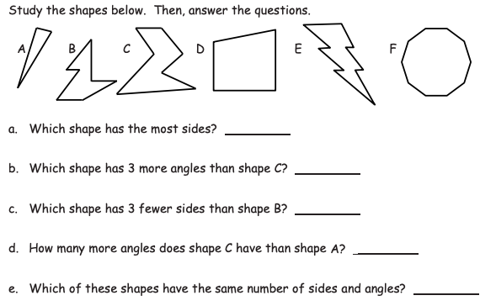

3. 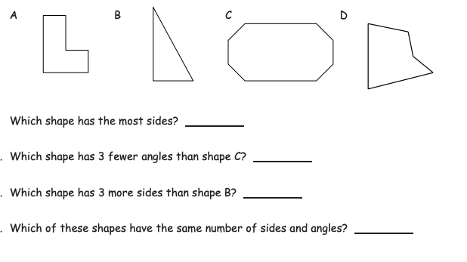[[42]](#endnote-41)

4. 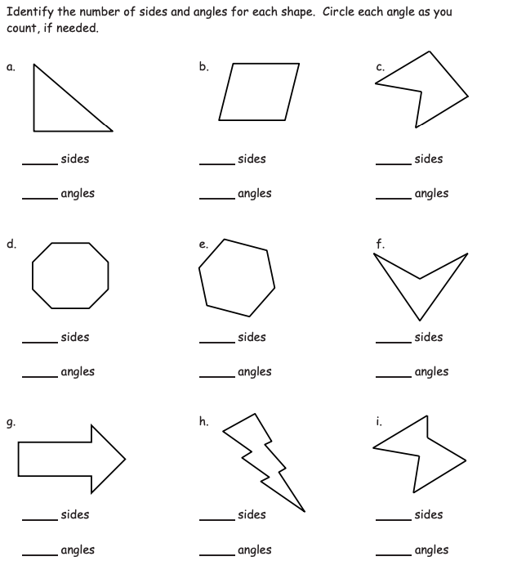[[43]](#endnote-42)

5. 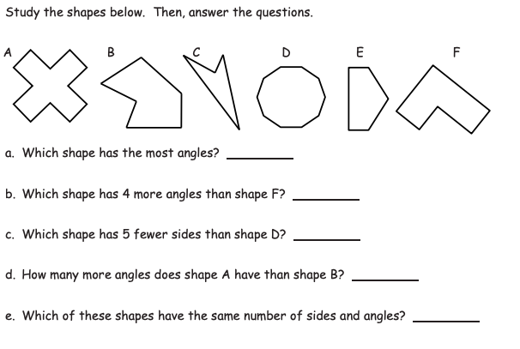[[44]](#endnote-43)

6. 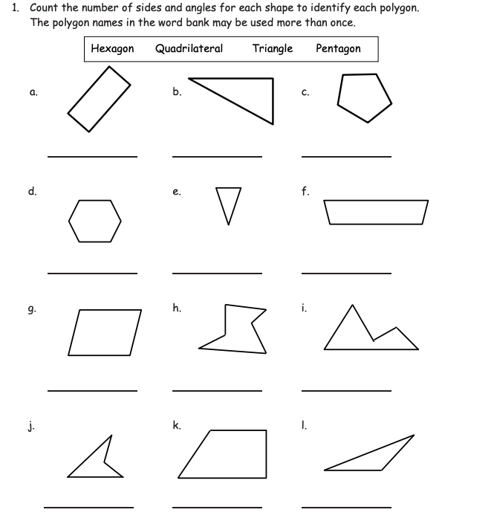[[45]](#endnote-44)

7. 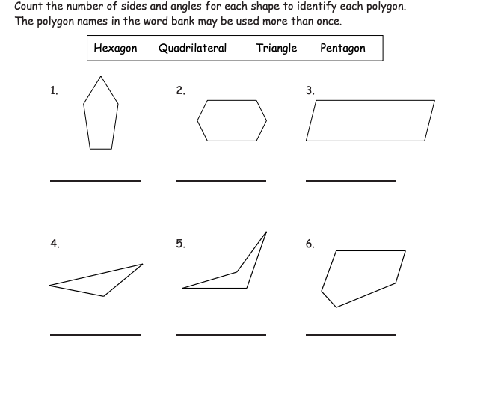[[46]](#endnote-45)

8. 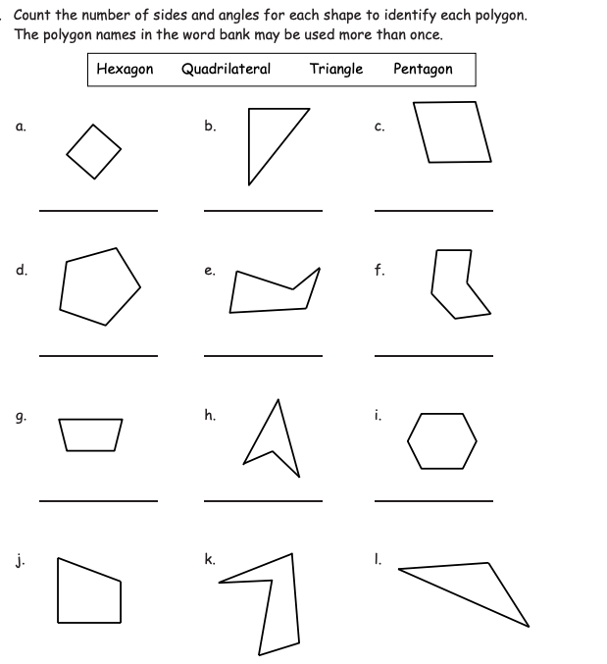[[47]](#endnote-46)

9. 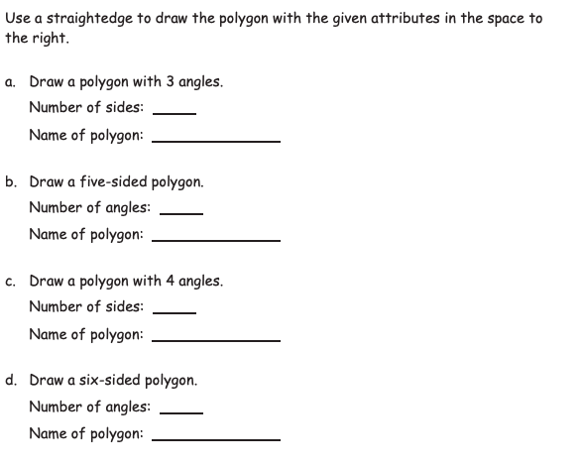[[48]](#endnote-47)

10. Use your straightedge to draw 2 new examples of each polygon that are different from those you drew in number 9.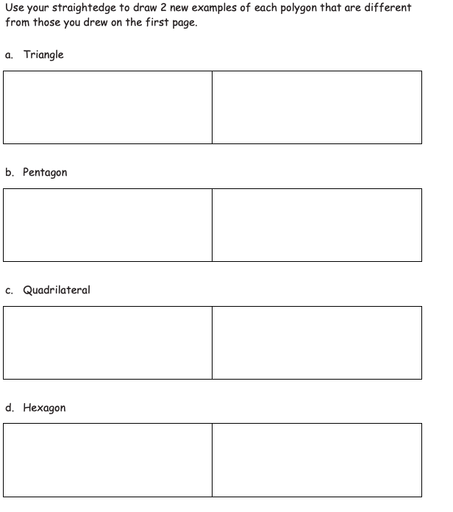

11. 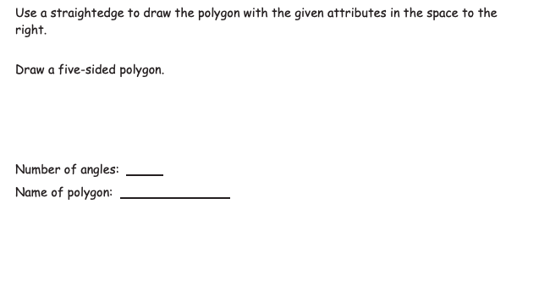12. 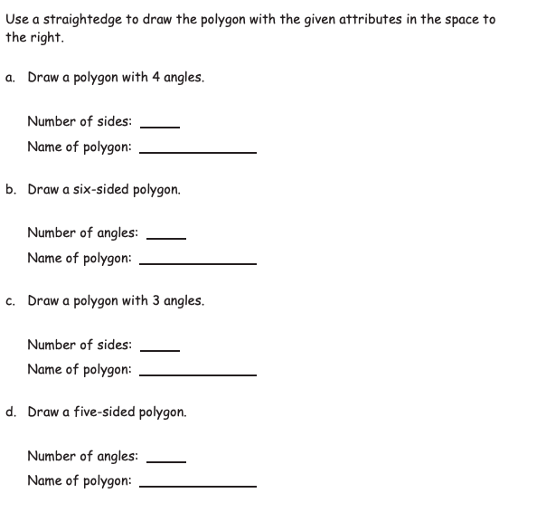

13. Use your straightedge to draw 2 new examples of each polygon that are different from those you drew in number 12.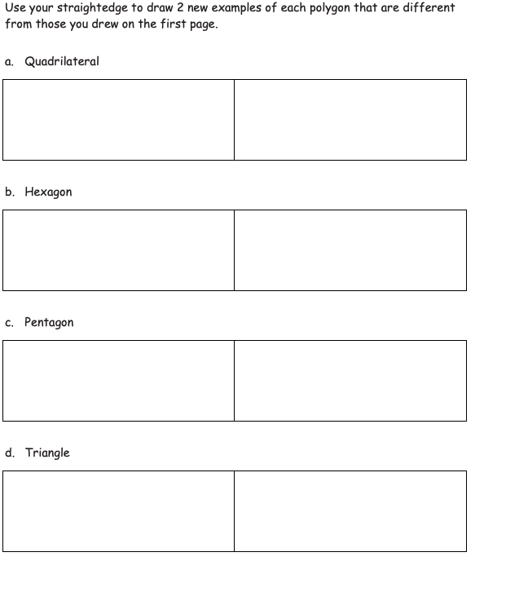

14.

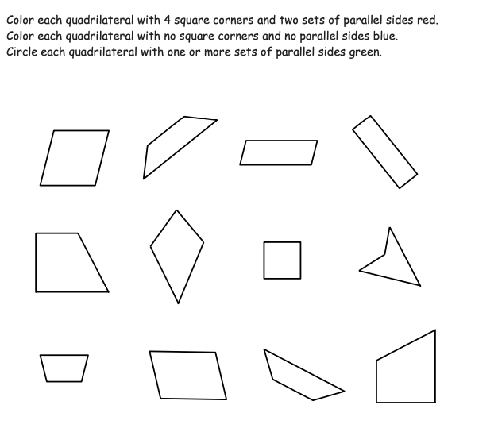

## 2.G.A.2 – Partition a rectangle in to rows and columns of same-size squares and count to find the total number of them. [[49]](#endnote-48)

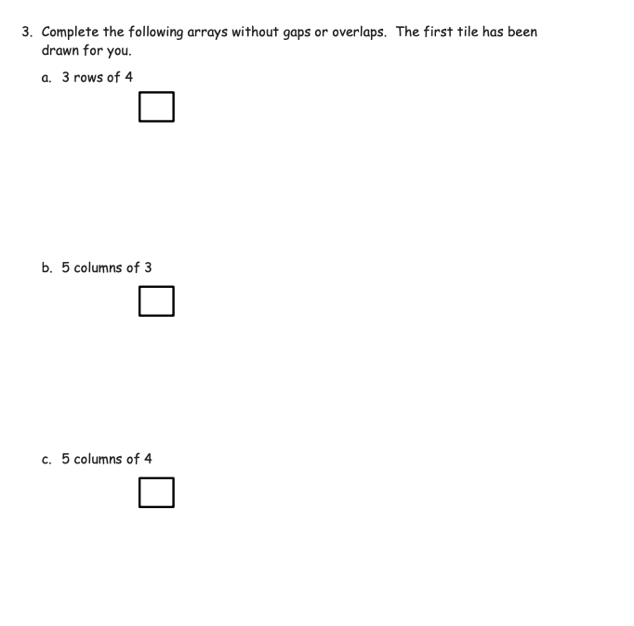5. 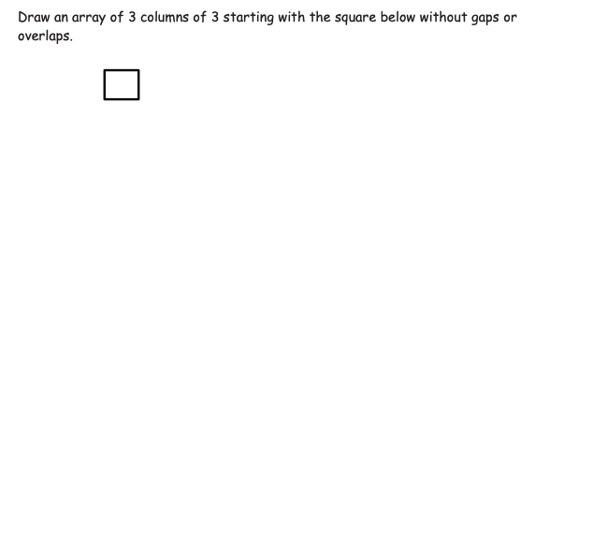[[50]](#endnote-49)

6. Draw an array with 3 rows of 5.

Write an equation to show the total number of squares: \_\_\_\_\_\_\_\_\_\_\_\_\_\_\_\_\_\_\_\_\_\_\_\_\_\_\_\_\_\_\_

7. Draw an array with 2 rows of 6.

Write an equation to show the total number of squares: \_\_\_\_\_\_\_\_\_\_\_\_\_\_\_\_\_\_\_\_\_\_\_\_\_\_\_\_\_\_\_

8. Draw an array with 8 rows of 2.

Write an equation to show the total number of squares: \_\_\_\_\_\_\_\_\_\_\_\_\_\_\_\_\_\_\_\_\_\_\_\_\_\_\_\_\_\_\_

1. Draw an array with 3 rows of 2.

Write an equation to show the total number of squares: \_\_\_\_\_\_\_\_\_\_\_\_\_\_\_\_\_\_\_\_\_\_\_\_\_\_\_\_\_\_\_

1. Draw an array with 4 rows of 2.

Write an equation to show the total number of squares: \_\_\_\_\_\_\_\_\_\_\_\_\_\_\_\_\_\_\_\_\_\_\_\_\_\_\_\_\_\_\_

1. Draw an array with 6 rows of 3.

Write an equation to show the total number of squares: \_\_\_\_\_\_\_\_\_\_\_\_\_\_\_\_\_\_\_\_\_\_\_\_\_\_\_\_\_\_\_

## 2.G.A.3 – Partition circles and rectangles into two, three, or four equal shares, describe the shares using the words halves, thirds, half of, a third of, etc., and describe the whole as two halves, three thirds, four fourths. Recognize that equal shares of identical wholes need not have the same shape.

## [[51]](#endnote-50)

## [[52]](#endnote-51)

3.

## [[53]](#endnote-52) [[54]](#endnote-53) [[55]](#endnote-54) [[56]](#endnote-55) [[57]](#endnote-56) [[58]](#endnote-57) [[59]](#endnote-58)[[60]](#endnote-59) [[61]](#endnote-60) [[62]](#endnote-61) [[63]](#endnote-62)

5.

4.

6.

7. Circle the images that show ½ shaded.

8.

9.

10.

11.

13.

12.

14.

15.

16.

17.

18.

## [[64]](#endnote-63)

20.

19.

1. Copyright: Achievement First.  Unless otherwise noted, all of the content in this resource is licensed under a [Creative Commons Attribution International 4.0](https://creativecommons.org/licenses/by/4.0/) (CC BY) license. [↑](#footnote-ref-1)
2. [EngageNY Second Grade](https://www.engageny.org/resource/grade-1-mathematics) by EngageNY licensed under  [Creative Commons Attribution International 4.0](https://creativecommons.org/licenses/by-nc-sa/4.0/" \t "_blank)  (CC BY-NC-SA.)  Achievement First does not own the copyright in “Fluency Workbook” and claims no copyright in this material.  The material is being used exclusively for non-profit educational purposes under fair use principles in U.S. Copyright laws.  The user should make the judgment about whether this material may be used under fair use / fair dealing permissions in the user’s country. [↑](#endnote-ref-1)
3. [EngageNY Second Grade](https://www.engageny.org/resource/grade-1-mathematics) by EngageNY licensed under  [Creative Commons Attribution International 4.0](https://creativecommons.org/licenses/by-nc-sa/4.0/" \t "_blank)  (CC BY-NC-SA.)  Achievement First does not own the copyright in “Fluency Workbook” and claims no copyright in this material.  The material is being used exclusively for non-profit educational purposes under fair use principles in U.S. Copyright laws.  The user should make the judgment about whether this material may be used under fair use / fair dealing permissions in the user’s country. [↑](#endnote-ref-2)
4. [EngageNY Second Grade](https://www.engageny.org/resource/grade-1-mathematics) by EngageNY licensed under  [Creative Commons Attribution International 4.0](https://creativecommons.org/licenses/by-nc-sa/4.0/" \t "_blank)  (CC BY-NC-SA.)  Achievement First does not own the copyright in “Fluency Workbook” and claims no copyright in this material.  The material is being used exclusively for non-profit educational purposes under fair use principles in U.S. Copyright laws.  The user should make the judgment about whether this material may be used under fair use / fair dealing permissions in the user’s country. [↑](#endnote-ref-3)
5. [EngageNY Second Grade](https://www.engageny.org/resource/grade-1-mathematics) by EngageNY licensed under  [Creative Commons Attribution International 4.0](https://creativecommons.org/licenses/by-nc-sa/4.0/" \t "_blank)  (CC BY-NC-SA.)  Achievement First does not own the copyright in “Fluency Workbook” and claims no copyright in this material.  The material is being used exclusively for non-profit educational purposes under fair use principles in U.S. Copyright laws.  The user should make the judgment about whether this material may be used under fair use / fair dealing permissions in the user’s country. [↑](#endnote-ref-4)
6. [EngageNY Second Grade](https://www.engageny.org/resource/grade-1-mathematics) by EngageNY licensed under  [Creative Commons Attribution International 4.0](https://creativecommons.org/licenses/by-nc-sa/4.0/" \t "_blank)  (CC BY-NC-SA.)  Achievement First does not own the copyright in “Fluency Workbook” and claims no copyright in this material.  The material is being used exclusively for non-profit educational purposes under fair use principles in U.S. Copyright laws.  The user should make the judgment about whether this material may be used under fair use / fair dealing permissions in the user’s country. [↑](#endnote-ref-5)
7. [EngageNY Second Grade](https://www.engageny.org/resource/grade-1-mathematics) by EngageNY licensed under  [Creative Commons Attribution International 4.0](https://creativecommons.org/licenses/by-nc-sa/4.0/" \t "_blank)  (CC BY-NC-SA.)  Achievement First does not own the copyright in “Fluency Workbook” and claims no copyright in this material.  The material is being used exclusively for non-profit educational purposes under fair use principles in U.S. Copyright laws.  The user should make the judgment about whether this material may be used under fair use / fair dealing permissions in the user’s country. [↑](#endnote-ref-6)
8. [EngageNY Second Grade](https://www.engageny.org/resource/grade-1-mathematics) by EngageNY licensed under  [Creative Commons Attribution International 4.0](https://creativecommons.org/licenses/by-nc-sa/4.0/" \t "_blank)  (CC BY-NC-SA.)  Achievement First does not own the copyright in “Fluency Workbook” and claims no copyright in this material.  The material is being used exclusively for non-profit educational purposes under fair use principles in U.S. Copyright laws.  The user should make the judgment about whether this material may be used under fair use / fair dealing permissions in the user’s country. [↑](#endnote-ref-7)
9. [EngageNY Second Grade](https://www.engageny.org/resource/grade-1-mathematics) by EngageNY licensed under  [Creative Commons Attribution International 4.0](https://creativecommons.org/licenses/by-nc-sa/4.0/" \t "_blank)  (CC BY-NC-SA.)  Achievement First does not own the copyright in “Fluency Workbook” and claims no copyright in this material.  The material is being used exclusively for non-profit educational purposes under fair use principles in U.S. Copyright laws.  The user should make the judgment about whether this material may be used under fair use / fair dealing permissions in the user’s country. [↑](#endnote-ref-8)
10. [EngageNY Second Grade](https://www.engageny.org/resource/grade-1-mathematics) by EngageNY licensed under  [Creative Commons Attribution International 4.0](https://creativecommons.org/licenses/by-nc-sa/4.0/" \t "_blank)  (CC BY-NC-SA.)  Achievement First does not own the copyright in “Fluency Workbook” and claims no copyright in this material.  The material is being used exclusively for non-profit educational purposes under fair use principles in U.S. Copyright laws.  The user should make the judgment about whether this material may be used under fair use / fair dealing permissions in the user’s country. [↑](#endnote-ref-9)
11. [EngageNY Second Grade](https://www.engageny.org/resource/grade-1-mathematics) by EngageNY licensed under  [Creative Commons Attribution International 4.0](https://creativecommons.org/licenses/by-nc-sa/4.0/" \t "_blank)  (CC BY-NC-SA.)  Achievement First does not own the copyright in “Fluency Workbook” and claims no copyright in this material.  The material is being used exclusively for non-profit educational purposes under fair use principles in U.S. Copyright laws.  The user should make the judgment about whether this material may be used under fair use / fair dealing permissions in the user’s country. [↑](#endnote-ref-10)
12. [EngageNY Second Grade](https://www.engageny.org/resource/grade-1-mathematics) by EngageNY licensed under  [Creative Commons Attribution International 4.0](https://creativecommons.org/licenses/by-nc-sa/4.0/" \t "_blank)  (CC BY-NC-SA.)  Achievement First does not own the copyright in “Fluency Workbook” and claims no copyright in this material.  The material is being used exclusively for non-profit educational purposes under fair use principles in U.S. Copyright laws.  The user should make the judgment about whether this material may be used under fair use / fair dealing permissions in the user’s country. [↑](#endnote-ref-11)
13. [EngageNY Second Grade](https://www.engageny.org/resource/grade-1-mathematics) by EngageNY licensed under  [Creative Commons Attribution International 4.0](https://creativecommons.org/licenses/by-nc-sa/4.0/" \t "_blank)  (CC BY-NC-SA.)  Achievement First does not own the copyright in “Fluency Workbook” and claims no copyright in this material.  The material is being used exclusively for non-profit educational purposes under fair use principles in U.S. Copyright laws.  The user should make the judgment about whether this material may be used under fair use / fair dealing permissions in the user’s country. [↑](#endnote-ref-12)
14. [EngageNY Second Grade](https://www.engageny.org/resource/grade-1-mathematics) by EngageNY licensed under  [Creative Commons Attribution International 4.0](https://creativecommons.org/licenses/by-nc-sa/4.0/" \t "_blank)  (CC BY-NC-SA.)  Achievement First does not own the copyright in “Fluency Workbook” and claims no copyright in this material.  The material is being used exclusively for non-profit educational purposes under fair use principles in U.S. Copyright laws.  The user should make the judgment about whether this material may be used under fair use / fair dealing permissions in the user’s country. [↑](#endnote-ref-13)
15. [EngageNY Second Grade](https://www.engageny.org/resource/grade-1-mathematics) by EngageNY licensed under  [Creative Commons Attribution International 4.0](https://creativecommons.org/licenses/by-nc-sa/4.0/" \t "_blank)  (CC BY-NC-SA.)  Achievement First does not own the copyright in “Fluency Workbook” and claims no copyright in this material.  The material is being used exclusively for non-profit educational purposes under fair use principles in U.S. Copyright laws.  The user should make the judgment about whether this material may be used under fair use / fair dealing permissions in the user’s country. [↑](#endnote-ref-14)
16. [EngageNY Second Grade](https://www.engageny.org/resource/grade-1-mathematics) by EngageNY licensed under  [Creative Commons Attribution International 4.0](https://creativecommons.org/licenses/by-nc-sa/4.0/" \t "_blank)  (CC BY-NC-SA.)  Achievement First does not own the copyright in “Fluency Workbook” and claims no copyright in this material.  The material is being used exclusively for non-profit educational purposes under fair use principles in U.S. Copyright laws.  The user should make the judgment about whether this material may be used under fair use / fair dealing permissions in the user’s country. [↑](#endnote-ref-15)
17. [EngageNY Second Grade](https://www.engageny.org/resource/grade-1-mathematics) by EngageNY licensed under  [Creative Commons Attribution International 4.0](https://creativecommons.org/licenses/by-nc-sa/4.0/" \t "_blank)  (CC BY-NC-SA.)  Achievement First does not own the copyright in “Fluency Workbook” and claims no copyright in this material.  The material is being used exclusively for non-profit educational purposes under fair use principles in U.S. Copyright laws.  The user should make the judgment about whether this material may be used under fair use / fair dealing permissions in the user’s country. [↑](#endnote-ref-16)
18. [EngageNY Second Grade](https://www.engageny.org/resource/grade-1-mathematics) by EngageNY licensed under  [Creative Commons Attribution International 4.0](https://creativecommons.org/licenses/by-nc-sa/4.0/" \t "_blank)  (CC BY-NC-SA.)  Achievement First does not own the copyright in “Fluency Workbook” and claims no copyright in this material.  The material is being used exclusively for non-profit educational purposes under fair use principles in U.S. Copyright laws.  The user should make the judgment about whether this material may be used under fair use / fair dealing permissions in the user’s country. [↑](#endnote-ref-17)
19. [EngageNY Second Grade](https://www.engageny.org/resource/grade-1-mathematics) by EngageNY licensed under  [Creative Commons Attribution International 4.0](https://creativecommons.org/licenses/by-nc-sa/4.0/" \t "_blank)  (CC BY-NC-SA.)  Achievement First does not own the copyright in “Fluency Workbook” and claims no copyright in this material.  The material is being used exclusively for non-profit educational purposes under fair use principles in U.S. Copyright laws.  The user should make the judgment about whether this material may be used under fair use / fair dealing permissions in the user’s country. [↑](#endnote-ref-18)
20. [EngageNY Second Grade](https://www.engageny.org/resource/grade-1-mathematics) by EngageNY licensed under  [Creative Commons Attribution International 4.0](https://creativecommons.org/licenses/by-nc-sa/4.0/" \t "_blank)  (CC BY-NC-SA.)  Achievement First does not own the copyright in “Fluency Workbook” and claims no copyright in this material.  The material is being used exclusively for non-profit educational purposes under fair use principles in U.S. Copyright laws.  The user should make the judgment about whether this material may be used under fair use / fair dealing permissions in the user’s country. [↑](#endnote-ref-19)
21. [EngageNY Second Grade](https://www.engageny.org/resource/grade-1-mathematics) by EngageNY licensed under  [Creative Commons Attribution International 4.0](https://creativecommons.org/licenses/by-nc-sa/4.0/" \t "_blank)  (CC BY-NC-SA.)  Achievement First does not own the copyright in “Fluency Workbook” and claims no copyright in this material.  The material is being used exclusively for non-profit educational purposes under fair use principles in U.S. Copyright laws.  The user should make the judgment about whether this material may be used under fair use / fair dealing permissions in the user’s country. [↑](#endnote-ref-20)
22. [EngageNY Second Grade](https://www.engageny.org/resource/grade-1-mathematics) by EngageNY licensed under  [Creative Commons Attribution International 4.0](https://creativecommons.org/licenses/by-nc-sa/4.0/" \t "_blank)  (CC BY-NC-SA.)  Achievement First does not own the copyright in “Fluency Workbook” and claims no copyright in this material.  The material is being used exclusively for non-profit educational purposes under fair use principles in U.S. Copyright laws.  The user should make the judgment about whether this material may be used under fair use / fair dealing permissions in the user’s country. [↑](#endnote-ref-21)
23. [EngageNY Second Grade](https://www.engageny.org/resource/grade-1-mathematics) by EngageNY licensed under  [Creative Commons Attribution International 4.0](https://creativecommons.org/licenses/by-nc-sa/4.0/" \t "_blank)  (CC BY-NC-SA.)  Achievement First does not own the copyright in “Fluency Workbook” and claims no copyright in this material.  The material is being used exclusively for non-profit educational purposes under fair use principles in U.S. Copyright laws.  The user should make the judgment about whether this material may be used under fair use / fair dealing permissions in the user’s country. [↑](#endnote-ref-22)
24. [EngageNY Second Grade](https://www.engageny.org/resource/grade-1-mathematics) by EngageNY licensed under  [Creative Commons Attribution International 4.0](https://creativecommons.org/licenses/by-nc-sa/4.0/" \t "_blank)  (CC BY-NC-SA.)  Achievement First does not own the copyright in “Fluency Workbook” and claims no copyright in this material.  The material is being used exclusively for non-profit educational purposes under fair use principles in U.S. Copyright laws.  The user should make the judgment about whether this material may be used under fair use / fair dealing permissions in the user’s country. [↑](#endnote-ref-23)
25. [EngageNY Second Grade](https://www.engageny.org/resource/grade-1-mathematics) by EngageNY licensed under  [Creative Commons Attribution International 4.0](https://creativecommons.org/licenses/by-nc-sa/4.0/" \t "_blank)  (CC BY-NC-SA.)  Achievement First does not own the copyright in “Fluency Workbook” and claims no copyright in this material.  The material is being used exclusively for non-profit educational purposes under fair use principles in U.S. Copyright laws.  The user should make the judgment about whether this material may be used under fair use / fair dealing permissions in the user’s country. [↑](#endnote-ref-24)
26. [EngageNY Second Grade](https://www.engageny.org/resource/grade-1-mathematics) by EngageNY licensed under  [Creative Commons Attribution International 4.0](https://creativecommons.org/licenses/by-nc-sa/4.0/" \t "_blank)  (CC BY-NC-SA.)  Achievement First does not own the copyright in “Fluency Workbook” and claims no copyright in this material.  The material is being used exclusively for non-profit educational purposes under fair use principles in U.S. Copyright laws.  The user should make the judgment about whether this material may be used under fair use / fair dealing permissions in the user’s country. [↑](#endnote-ref-25)
27. [EngageNY Second Grade](https://www.engageny.org/resource/grade-1-mathematics) by EngageNY licensed under  [Creative Commons Attribution International 4.0](https://creativecommons.org/licenses/by-nc-sa/4.0/" \t "_blank)  (CC BY-NC-SA.)  Achievement First does not own the copyright in “Fluency Workbook” and claims no copyright in this material.  The material is being used exclusively for non-profit educational purposes under fair use principles in U.S. Copyright laws.  The user should make the judgment about whether this material may be used under fair use / fair dealing permissions in the user’s country. [↑](#endnote-ref-26)
28. [EngageNY Second Grade](https://www.engageny.org/resource/grade-1-mathematics) by EngageNY licensed under  [Creative Commons Attribution International 4.0](https://creativecommons.org/licenses/by-nc-sa/4.0/" \t "_blank)  (CC BY-NC-SA.)  Achievement First does not own the copyright in “Fluency Workbook” and claims no copyright in this material.  The material is being used exclusively for non-profit educational purposes under fair use principles in U.S. Copyright laws.  The user should make the judgment about whether this material may be used under fair use / fair dealing permissions in the user’s country. [↑](#endnote-ref-27)
29. [EngageNY Second Grade](https://www.engageny.org/resource/grade-1-mathematics) by EngageNY licensed under  [Creative Commons Attribution International 4.0](https://creativecommons.org/licenses/by-nc-sa/4.0/" \t "_blank)  (CC BY-NC-SA.)  Achievement First does not own the copyright in “Fluency Workbook” and claims no copyright in this material.  The material is being used exclusively for non-profit educational purposes under fair use principles in U.S. Copyright laws.  The user should make the judgment about whether this material may be used under fair use / fair dealing permissions in the user’s country. [↑](#endnote-ref-28)
30. [EngageNY Second Grade](https://www.engageny.org/resource/grade-1-mathematics) by EngageNY licensed under  [Creative Commons Attribution International 4.0](https://creativecommons.org/licenses/by-nc-sa/4.0/" \t "_blank)  (CC BY-NC-SA.)  Achievement First does not own the copyright in “Fluency Workbook” and claims no copyright in this material.  The material is being used exclusively for non-profit educational purposes under fair use principles in U.S. Copyright laws.  The user should make the judgment about whether this material may be used under fair use / fair dealing permissions in the user’s country. [↑](#endnote-ref-29)
31. [EngageNY Second Grade](https://www.engageny.org/resource/grade-1-mathematics) by EngageNY licensed under  [Creative Commons Attribution International 4.0](https://creativecommons.org/licenses/by-nc-sa/4.0/" \t "_blank)  (CC BY-NC-SA.)  Achievement First does not own the copyright in “Fluency Workbook” and claims no copyright in this material.  The material is being used exclusively for non-profit educational purposes under fair use principles in U.S. Copyright laws.  The user should make the judgment about whether this material may be used under fair use / fair dealing permissions in the user’s country. [↑](#endnote-ref-30)
32. [EngageNY Second Grade](https://www.engageny.org/resource/grade-1-mathematics) by EngageNY licensed under  [Creative Commons Attribution International 4.0](https://creativecommons.org/licenses/by-nc-sa/4.0/" \t "_blank)  (CC BY-NC-SA.)  Achievement First does not own the copyright in “Fluency Workbook” and claims no copyright in this material.  The material is being used exclusively for non-profit educational purposes under fair use principles in U.S. Copyright laws.  The user should make the judgment about whether this material may be used under fair use / fair dealing permissions in the user’s country. [↑](#endnote-ref-31)
33. [EngageNY Second Grade](https://www.engageny.org/resource/grade-1-mathematics) by EngageNY licensed under  [Creative Commons Attribution International 4.0](https://creativecommons.org/licenses/by-nc-sa/4.0/" \t "_blank)  (CC BY-NC-SA.)  Achievement First does not own the copyright in “Fluency Workbook” and claims no copyright in this material.  The material is being used exclusively for non-profit educational purposes under fair use principles in U.S. Copyright laws.  The user should make the judgment about whether this material may be used under fair use / fair dealing permissions in the user’s country. [↑](#endnote-ref-32)
34. [EngageNY Second Grade](https://www.engageny.org/resource/grade-1-mathematics) by EngageNY licensed under  [Creative Commons Attribution International 4.0](https://creativecommons.org/licenses/by-nc-sa/4.0/" \t "_blank)  (CC BY-NC-SA.)  Achievement First does not own the copyright in “Fluency Workbook” and claims no copyright in this material.  The material is being used exclusively for non-profit educational purposes under fair use principles in U.S. Copyright laws.  The user should make the judgment about whether this material may be used under fair use / fair dealing permissions in the user’s country. [↑](#endnote-ref-33)
35. [EngageNY Second Grade](https://www.engageny.org/resource/grade-1-mathematics) by EngageNY licensed under  [Creative Commons Attribution International 4.0](https://creativecommons.org/licenses/by-nc-sa/4.0/" \t "_blank)  (CC BY-NC-SA.)  Achievement First does not own the copyright in “Fluency Workbook” and claims no copyright in this material.  The material is being used exclusively for non-profit educational purposes under fair use principles in U.S. Copyright laws.  The user should make the judgment about whether this material may be used under fair use / fair dealing permissions in the user’s country. [↑](#endnote-ref-34)
36. [EngageNY Second Grade](https://www.engageny.org/resource/grade-1-mathematics) by EngageNY licensed under  [Creative Commons Attribution International 4.0](https://creativecommons.org/licenses/by-nc-sa/4.0/" \t "_blank)  (CC BY-NC-SA.)  Achievement First does not own the copyright in “Fluency Workbook” and claims no copyright in this material.  The material is being used exclusively for non-profit educational purposes under fair use principles in U.S. Copyright laws.  The user should make the judgment about whether this material may be used under fair use / fair dealing permissions in the user’s country. [↑](#endnote-ref-35)
37. [“ETC”](http://etc.usf.edu/clipart/galleries/722-mathematics) by Florida Center for Instructional Technology. Achievement First does not own the copyright in “Fluency Workbook” and claims no copyright in this material.  The material is being used exclusively for non-profit educational purposes under fair use principles in U.S. Copyright laws. The user should make the judgment about whether this material may be used under fair use / fair dealing permissions in the user’s country. [↑](#endnote-ref-36)
38. [“ETC”](http://etc.usf.edu/clipart/galleries/722-mathematics) by Florida Center for Instructional Technology. Achievement First does not own the copyright in “Fluency Workbook” and claims no copyright in this material.  The material is being used exclusively for non-profit educational purposes under fair use principles in U.S. Copyright laws. The user should make the judgment about whether this material may be used under fair use / fair dealing permissions in the user’s country. [↑](#endnote-ref-37)
39. [“ETC”](http://etc.usf.edu/clipart/galleries/722-mathematics) by Florida Center for Instructional Technology. Achievement First does not own the copyright in “Fluency Workbook” and claims no copyright in this material.  The material is being used exclusively for non-profit educational purposes under fair use principles in U.S. Copyright laws. The user should make the judgment about whether this material may be used under fair use / fair dealing permissions in the user’s country. [↑](#endnote-ref-38)
40. [“ETC”](http://etc.usf.edu/clipart/galleries/722-mathematics) by Florida Center for Instructional Technology. Achievement First does not own the copyright in “Fluency Workbook” and claims no copyright in this material.  The material is being used exclusively for non-profit educational purposes under fair use principles in U.S. Copyright laws. The user should make the judgment about whether this material may be used under fair use / fair dealing permissions in the user’s country. [↑](#endnote-ref-39)
41. [EngageNY Second Grade](https://www.engageny.org/resource/grade-1-mathematics) by EngageNY licensed under  [Creative Commons Attribution International 4.0](https://creativecommons.org/licenses/by-nc-sa/4.0/" \t "_blank)  (CC BY-NC-SA.)  Achievement First does not own the copyright in “Fluency Workbook” and claims no copyright in this material.  The material is being used exclusively for non-profit educational purposes under fair use principles in U.S. Copyright laws.  The user should make the judgment about whether this material may be used under fair use / fair dealing permissions in the user’s country. [↑](#endnote-ref-40)
42. [EngageNY Second Grade](https://www.engageny.org/resource/grade-1-mathematics) by EngageNY licensed under  [Creative Commons Attribution International 4.0](https://creativecommons.org/licenses/by-nc-sa/4.0/" \t "_blank)  (CC BY-NC-SA.)  Achievement First does not own the copyright in “Fluency Workbook” and claims no copyright in this material.  The material is being used exclusively for non-profit educational purposes under fair use principles in U.S. Copyright laws.  The user should make the judgment about whether this material may be used under fair use / fair dealing permissions in the user’s country. [↑](#endnote-ref-41)
43. [EngageNY Second Grade](https://www.engageny.org/resource/grade-1-mathematics) by EngageNY licensed under  [Creative Commons Attribution International 4.0](https://creativecommons.org/licenses/by-nc-sa/4.0/" \t "_blank)  (CC BY-NC-SA.)  Achievement First does not own the copyright in “Fluency Workbook” and claims no copyright in this material.  The material is being used exclusively for non-profit educational purposes under fair use principles in U.S. Copyright laws.  The user should make the judgment about whether this material may be used under fair use / fair dealing permissions in the user’s country. [↑](#endnote-ref-42)
44. [EngageNY Second Grade](https://www.engageny.org/resource/grade-1-mathematics) by EngageNY licensed under  [Creative Commons Attribution International 4.0](https://creativecommons.org/licenses/by-nc-sa/4.0/" \t "_blank)  (CC BY-NC-SA.)  Achievement First does not own the copyright in “Fluency Workbook” and claims no copyright in this material.  The material is being used exclusively for non-profit educational purposes under fair use principles in U.S. Copyright laws.  The user should make the judgment about whether this material may be used under fair use / fair dealing permissions in the user’s country. [↑](#endnote-ref-43)
45. [EngageNY Second Grade](https://www.engageny.org/resource/grade-1-mathematics) by EngageNY licensed under  [Creative Commons Attribution International 4.0](https://creativecommons.org/licenses/by-nc-sa/4.0/" \t "_blank)  (CC BY-NC-SA.)  Achievement First does not own the copyright in “Fluency Workbook” and claims no copyright in this material.  The material is being used exclusively for non-profit educational purposes under fair use principles in U.S. Copyright laws.  The user should make the judgment about whether this material may be used under fair use / fair dealing permissions in the user’s country. [↑](#endnote-ref-44)
46. [EngageNY Second Grade](https://www.engageny.org/resource/grade-1-mathematics) by EngageNY licensed under  [Creative Commons Attribution International 4.0](https://creativecommons.org/licenses/by-nc-sa/4.0/" \t "_blank)  (CC BY-NC-SA.)  Achievement First does not own the copyright in “Fluency Workbook” and claims no copyright in this material.  The material is being used exclusively for non-profit educational purposes under fair use principles in U.S. Copyright laws.  The user should make the judgment about whether this material may be used under fair use / fair dealing permissions in the user’s country. [↑](#endnote-ref-45)
47. [EngageNY Second Grade](https://www.engageny.org/resource/grade-1-mathematics) by EngageNY licensed under  [Creative Commons Attribution International 4.0](https://creativecommons.org/licenses/by-nc-sa/4.0/" \t "_blank)  (CC BY-NC-SA.)  Achievement First does not own the copyright in “Fluency Workbook” and claims no copyright in this material.  The material is being used exclusively for non-profit educational purposes under fair use principles in U.S. Copyright laws.  The user should make the judgment about whether this material may be used under fair use / fair dealing permissions in the user’s country. [↑](#endnote-ref-46)
48. [EngageNY Second Grade](https://www.engageny.org/resource/grade-1-mathematics) by EngageNY licensed under  [Creative Commons Attribution International 4.0](https://creativecommons.org/licenses/by-nc-sa/4.0/" \t "_blank)  (CC BY-NC-SA.)  Achievement First does not own the copyright in “Fluency Workbook” and claims no copyright in this material.  The material is being used exclusively for non-profit educational purposes under fair use principles in U.S. Copyright laws.  The user should make the judgment about whether this material may be used under fair use / fair dealing permissions in the user’s country. [↑](#endnote-ref-47)
49. [EngageNY Second Grade](https://www.engageny.org/resource/grade-1-mathematics) by EngageNY licensed under  [Creative Commons Attribution International 4.0](https://creativecommons.org/licenses/by-nc-sa/4.0/" \t "_blank)  (CC BY-NC-SA.)  Achievement First does not own the copyright in “Fluency Workbook” and claims no copyright in this material.  The material is being used exclusively for non-profit educational purposes under fair use principles in U.S. Copyright laws.  The user should make the judgment about whether this material may be used under fair use / fair dealing permissions in the user’s country. [↑](#endnote-ref-48)
50. [EngageNY Second Grade](https://www.engageny.org/resource/grade-1-mathematics) by EngageNY licensed under  [Creative Commons Attribution International 4.0](https://creativecommons.org/licenses/by-nc-sa/4.0/" \t "_blank)  (CC BY-NC-SA.)  Achievement First does not own the copyright in “Fluency Workbook” and claims no copyright in this material.  The material is being used exclusively for non-profit educational purposes under fair use principles in U.S. Copyright laws.  The user should make the judgment about whether this material may be used under fair use / fair dealing permissions in the user’s country. [↑](#endnote-ref-49)
51. [EngageNY Second Grade](https://www.engageny.org/resource/grade-1-mathematics) by EngageNY licensed under  [Creative Commons Attribution International 4.0](https://creativecommons.org/licenses/by-nc-sa/4.0/" \t "_blank)  (CC BY-NC-SA.)  Achievement First does not own the copyright in “Fluency Workbook” and claims no copyright in this material.  The material is being used exclusively for non-profit educational purposes under fair use principles in U.S. Copyright laws.  The user should make the judgment about whether this material may be used under fair use / fair dealing permissions in the user’s country. [↑](#endnote-ref-50)
52. [EngageNY Second Grade](https://www.engageny.org/resource/grade-1-mathematics) by EngageNY licensed under  [Creative Commons Attribution International 4.0](https://creativecommons.org/licenses/by-nc-sa/4.0/" \t "_blank)  (CC BY-NC-SA.)  Achievement First does not own the copyright in “Fluency Workbook” and claims no copyright in this material.  The material is being used exclusively for non-profit educational purposes under fair use principles in U.S. Copyright laws.  The user should make the judgment about whether this material may be used under fair use / fair dealing permissions in the user’s country. [↑](#endnote-ref-51)
53. [EngageNY Second Grade](https://www.engageny.org/resource/grade-1-mathematics) by EngageNY licensed under  [Creative Commons Attribution International 4.0](https://creativecommons.org/licenses/by-nc-sa/4.0/" \t "_blank)  (CC BY-NC-SA.)  Achievement First does not own the copyright in “Fluency Workbook” and claims no copyright in this material.  The material is being used exclusively for non-profit educational purposes under fair use principles in U.S. Copyright laws.  The user should make the judgment about whether this material may be used under fair use / fair dealing permissions in the user’s country. [↑](#endnote-ref-52)
54. [EngageNY Second Grade](https://www.engageny.org/resource/grade-1-mathematics) by EngageNY licensed under  [Creative Commons Attribution International 4.0](https://creativecommons.org/licenses/by-nc-sa/4.0/" \t "_blank)  (CC BY-NC-SA.)  Achievement First does not own the copyright in “Fluency Workbook” and claims no copyright in this material.  The material is being used exclusively for non-profit educational purposes under fair use principles in U.S. Copyright laws.  The user should make the judgment about whether this material may be used under fair use / fair dealing permissions in the user’s country. [↑](#endnote-ref-53)
55. [EngageNY Second Grade](https://www.engageny.org/resource/grade-1-mathematics) by EngageNY licensed under  [Creative Commons Attribution International 4.0](https://creativecommons.org/licenses/by-nc-sa/4.0/" \t "_blank)  (CC BY-NC-SA.)  Achievement First does not own the copyright in “Fluency Workbook” and claims no copyright in this material.  The material is being used exclusively for non-profit educational purposes under fair use principles in U.S. Copyright laws.  The user should make the judgment about whether this material may be used under fair use / fair dealing permissions in the user’s country. [↑](#endnote-ref-54)
56. [EngageNY Second Grade](https://www.engageny.org/resource/grade-1-mathematics) by EngageNY licensed under  [Creative Commons Attribution International 4.0](https://creativecommons.org/licenses/by-nc-sa/4.0/" \t "_blank)  (CC BY-NC-SA.)  Achievement First does not own the copyright in “Fluency Workbook” and claims no copyright in this material.  The material is being used exclusively for non-profit educational purposes under fair use principles in U.S. Copyright laws.  The user should make the judgment about whether this material may be used under fair use / fair dealing permissions in the user’s country. [↑](#endnote-ref-55)
57. [EngageNY Second Grade](https://www.engageny.org/resource/grade-1-mathematics) by EngageNY licensed under  [Creative Commons Attribution International 4.0](https://creativecommons.org/licenses/by-nc-sa/4.0/" \t "_blank)  (CC BY-NC-SA.)  Achievement First does not own the copyright in “Fluency Workbook” and claims no copyright in this material.  The material is being used exclusively for non-profit educational purposes under fair use principles in U.S. Copyright laws.  The user should make the judgment about whether this material may be used under fair use / fair dealing permissions in the user’s country. [↑](#endnote-ref-56)
58. [EngageNY Second Grade](https://www.engageny.org/resource/grade-1-mathematics) by EngageNY licensed under  [Creative Commons Attribution International 4.0](https://creativecommons.org/licenses/by-nc-sa/4.0/" \t "_blank)  (CC BY-NC-SA.)  Achievement First does not own the copyright in “Fluency Workbook” and claims no copyright in this material.  The material is being used exclusively for non-profit educational purposes under fair use principles in U.S. Copyright laws.  The user should make the judgment about whether this material may be used under fair use / fair dealing permissions in the user’s country. [↑](#endnote-ref-57)
59. [EngageNY Second Grade](https://www.engageny.org/resource/grade-1-mathematics) by EngageNY licensed under  [Creative Commons Attribution International 4.0](https://creativecommons.org/licenses/by-nc-sa/4.0/" \t "_blank)  (CC BY-NC-SA.)  Achievement First does not own the copyright in “Fluency Workbook” and claims no copyright in this material.  The material is being used exclusively for non-profit educational purposes under fair use principles in U.S. Copyright laws.  The user should make the judgment about whether this material may be used under fair use / fair dealing permissions in the user’s country. [↑](#endnote-ref-58)
60. [EngageNY Second Grade](https://www.engageny.org/resource/grade-1-mathematics) by EngageNY licensed under  [Creative Commons Attribution International 4.0](https://creativecommons.org/licenses/by-nc-sa/4.0/" \t "_blank)  (CC BY-NC-SA.)  Achievement First does not own the copyright in “Fluency Workbook” and claims no copyright in this material.  The material is being used exclusively for non-profit educational purposes under fair use principles in U.S. Copyright laws.  The user should make the judgment about whether this material may be used under fair use / fair dealing permissions in the user’s country. [↑](#endnote-ref-59)
61. [EngageNY Second Grade](https://www.engageny.org/resource/grade-1-mathematics) by EngageNY licensed under  [Creative Commons Attribution International 4.0](https://creativecommons.org/licenses/by-nc-sa/4.0/" \t "_blank)  (CC BY-NC-SA.)  Achievement First does not own the copyright in “Fluency Workbook” and claims no copyright in this material.  The material is being used exclusively for non-profit educational purposes under fair use principles in U.S. Copyright laws.  The user should make the judgment about whether this material may be used under fair use / fair dealing permissions in the user’s country. [↑](#endnote-ref-60)
62. [EngageNY Second Grade](https://www.engageny.org/resource/grade-1-mathematics) by EngageNY licensed under  [Creative Commons Attribution International 4.0](https://creativecommons.org/licenses/by-nc-sa/4.0/" \t "_blank)  (CC BY-NC-SA.)  Achievement First does not own the copyright in “Fluency Workbook” and claims no copyright in this material.  The material is being used exclusively for non-profit educational purposes under fair use principles in U.S. Copyright laws.  The user should make the judgment about whether this material may be used under fair use / fair dealing permissions in the user’s country. [↑](#endnote-ref-61)
63. [EngageNY Second Grade](https://www.engageny.org/resource/grade-1-mathematics) by EngageNY licensed under  [Creative Commons Attribution International 4.0](https://creativecommons.org/licenses/by-nc-sa/4.0/" \t "_blank)  (CC BY-NC-SA.)  Achievement First does not own the copyright in “Fluency Workbook” and claims no copyright in this material.  The material is being used exclusively for non-profit educational purposes under fair use principles in U.S. Copyright laws.  The user should make the judgment about whether this material may be used under fair use / fair dealing permissions in the user’s country. [↑](#endnote-ref-62)
64. [EngageNY Second Grade](https://www.engageny.org/resource/grade-1-mathematics) by EngageNY licensed under  [Creative Commons Attribution International 4.0](https://creativecommons.org/licenses/by-nc-sa/4.0/" \t "_blank)  (CC BY-NC-SA.)  Achievement First does not own the copyright in “Fluency Workbook” and claims no copyright in this material.  The material is being used exclusively for non-profit educational purposes under fair use principles in U.S. Copyright laws.  The user should make the judgment about whether this material may be used under fair use / fair dealing permissions in the user’s country. [↑](#endnote-ref-63)