Grade 3 math
Practice workbook
Achievement First Elementary Math

Practice Practice Workbooks - Achievement First Elementary Math – Grade 3
Contents
Practice Workbook A 4
3.MD.C.7a – Find the area of a rectangle with whole-number side lengths by tiling it, and showing that the area is the same as would be found by multiplying side lengths. 9
3.OA.A.4 – Determine the unknown whole number in a multiplication or division equation relating three whole numbers. 15
NBT.A.3 – Multiply one-digit whole numbers by multiples of 10 in the range 10-90 (e.g., 9 x 80, 5 x 60) using strategies based on place value and properties of operations. 22
3.OA.A.1 – Interpret products of whole numbers, e.g., interpret 5 x 7 as the total number of objects in 5 groups of 7 objects each. 28
3.OA.A.2 – Interpret whole-number quotients of whole numbers, e.g., interpret 56 $÷$ 8 as the number of objects in each share when 56 objects are partitioned into equal shares of 8 objects each. 35
Practice Workbook B 42
3.NBT.A.1 – Use place value understanding to round whole numbers to the nearest 10 or 100. 42
3.NBT.A.2 – Fluently add and subtract within 1,000 using strategies and algorithms based on place value, properties of operations, and/or the relationship between addition and subtraction. 47
3.MD.A.1 – Understand time to the nearest minute. 54
Practice Workbook C 60
3.MD.A.2 – Measure and estimate liquid volumes and masses of objects using standard units of grams (g), kilograms (kg), and liters (l). Add, subtract, multiply, or divide to solve one-step word problems involving masses or volumes that are given in the same units, e.g. by using drawings (such as a beaker with a measurement scale) to represent the problem. 60
Practice Workbook D 65
3.G.A.2 – Partition shapes into parts with equal areas. Express the area of each part as a unit fraction of the whole. 65
3.NF.A.1 – Understand a fraction 1/b, with denominators 2, 3, 4, 6, and 8, as the quantity formed by one part when a whole is partitioned into b equal parts; understand a fraction a/b as the quantity formed by a parts of size 1/b. 70
3.NF.A.2 – Understand a fraction with denominators 2, 3, 4, 6, and 8 as a number on a number line diagram. 72
3.NF.A.3b – Recognize and generate simple equivalent fractions, e.g., ½ = 2/4, 4/6 = 2/3. Explain why the fractions are equivalent, e.g., by using a visual fraction model. 78
3.NF.A.3c – Express whole numbers as fractions, and recognize fractions that are equivalent to whole numbers. 83
3.NF.A.3d – Compare two fractions with the same numerator or the same denominator by reasoning about their size. Recognize that comparisons are valid only when the two fractions refer to the same whole. Record the results of comparisons with the symbols >, =, or < and justify the conclusions e.g., by using a visual fraction model. 87
Practice Workbook E 92
3.MD.B.3 – Draw a scaled picture graph and a scaled bar graph to represent a data set with several categories. Solve one- and two-step “how many more” and “how many less” problems using information presented in scaled bar graphs. 92
3.MD.B.4 – Generate measurement data by measuring lengths using rulers marked with halves or fourths of an inch. Show the data by making a line plot, where the horizontal line is marked off in appropriate units, whole numbers, halves, or quarters. 105
Practice Workbook F 111
3.OA.C.7 – Fluently multiply and divide within 100, using strategies such as the relationship between multiplication and division, (e.g., knowing that 8 x 5 =40, one knows 40 ÷ 5 = 8) or properties of operations. By the end of grade 3, know from memory all products of two one-digit numbers. 111
3.MD.C.7b – Multiply side lengths to find the areas of rectangles with whole number side lengths in the context of solving real-world and mathematical problems, and represent whole-number products as rectangular area in mathematical reasoning. 119
3.MD.C.7c – Use tiling to show in a concrete case that the area of a rectangle with whole-number side lengths a and b + c is the sum of a × b and a × c. Use area models to represent the distributive property in mathematical reasoning. 126
3.MD.D.8 – Solve real world mathematical problems involving perimeters of polygons, including finding the perimeter given the side lengths, finding an unknown side length, and exhibiting rectangles with the same perimeter and different areas or with the same area and different perimeters. 133
3.G.A.1 – Understand that shapes in different categories may share attributes. Recognize rhombuses, rectangles, and squares as examples of quadrilaterals, and draw examples of quadrilaterals that do not belong to any of these subcategories. 137

Practice Workbook A

- Find the area of the shape below. __________________
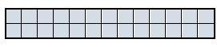
- Find the area of the shape below. __________________
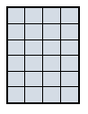
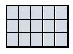
- Find the area of the shape below. __________________

- Find the area of the shape below. __________________
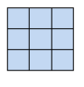

- Circle the shape that has an area of 9 square units.

- Find the area of the shape below. __________________

- Find the area of the shape below. __________________
- Circle the shape that has an area of 8 square units.

- Find the area of the shape below. __________________
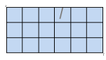
- Find the area of the shape below. __________________
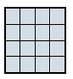
- Find the area of the shape below. __________________
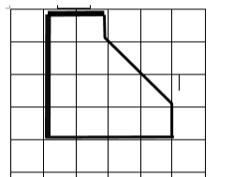

- Find the area of the shape below. __________________
- Circle the shape that has an area of five square units.

- Find the area of the shape below. __________________
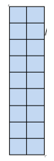

- Find the area of the shape below. __________________
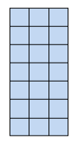

- Find the area of the shape below. __________________
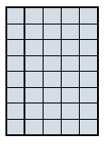

- Find the area of the shape below. __________________

- Find the area of the shape below. __________________

- Find the area of the shape below. __________________

- Find the area of the shape below. __________________
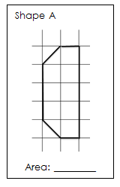

3.MD.C.7a – Find the area of a rectangle with whole-number side lengths by tiling it, and showing that the area is the same as would be found by multiplying side lengths.

- Find the area of the square by filing in the missing tiles.
Area = ___________

- Find the area by filling in the missing tiles.
Area = ___________

- Use tiling to help you find the area.
Area = ___________

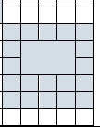
- Find the area of the shaded shape by filling in the missing tiles.

Area = ___________

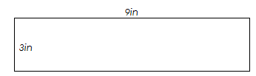
- Use tiling to find the area.

Area = ___________

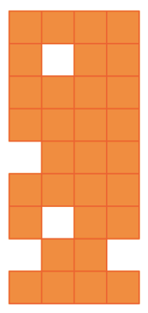

Find the area of the shaded shape.

Area = ___________

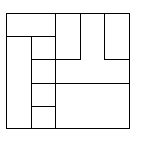
Find the area by filling in the missing tiles.
Area = ___________

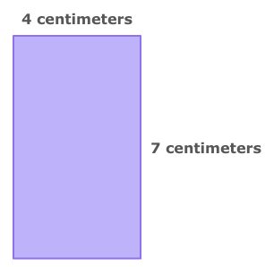
- Use tiling to find the area.
Area = ___________

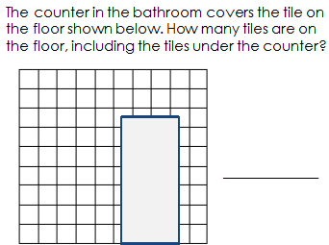

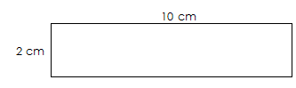
- Use tiling to find the area.
Area = ___________

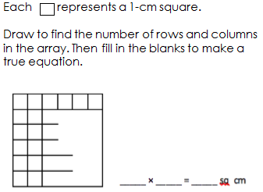

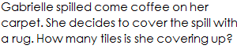
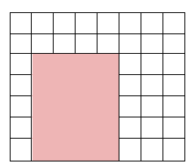

Answer = ___________

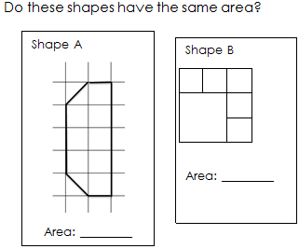

Answer = ___________

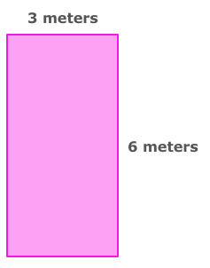

- Use tiling to find the area.
Area = ___________

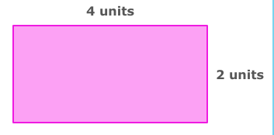

- Use tiling to find the area.
Area = ___________
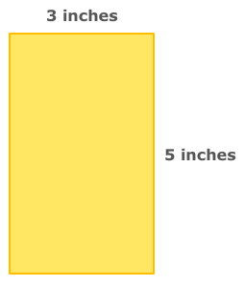

- Use tiling to find the area.
Area = ___________
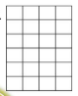
- Find the area by filling in the missing tiles.

Area = ___________

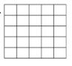
- Find the area by filling in the missing tiles.
Area = ___________

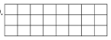
- Find the area by filling in the missing tiles.
Area = ___________

- Use tiling to help you find the area of the shaded figure.
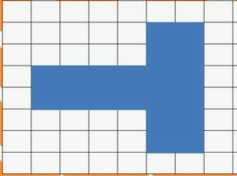

Area = ___________

- Use tiling to help you find the area of this 4 cm x 4 cm square.
Area = ___________

3.OA.A.4 – Determine the unknown whole number in a multiplication or division equation relating three whole numbers.

- Fill in the missing number.

4 groups of _____ equal 12.

- Fill in the missing number.

______ ÷ 2 = 9

- Fill in the missing number

20 ÷ _____ = 4

- Fill in the missing number.

42 ÷ _____ = 7

- Fill in the missing number.

6 x _____ = 42
- Fill in the missing number.

- ÷ _____ = 6

- Fill in the missing number.

- groups of _____ equals 16

- Fill in the missing number.

_____ groups of 5 equals 25

- Fill in the missing number.

12 x _____ = 60

- Fill in the missing number.

_____ x 12 = 24

- Fill in the missing number.

7 groups of 6 = _____

- Fill in the missing number.

6 groups of _____ equals 18

- Fill in the missing number.

9 x _____ = 63

- Fill in the missing number.

10 x _____ = 90

- Fill in the missing number.

3 x _____ = 24

- Fill in the missing number.

5 groups of _____ equals 15

- Fill in the missing number.

10 groups of _____ equals 40

- Fill in the missing number.

4 x ____ = 24

- Fill in the missing number.

____ groups of 8 equals 56

- Fill in the missing number.

- groups of _____ equal 8

- Fill in the missing number.

7 groups of _____ equals 21

- Fill in the missing number.

_____ x 5 = 10

- Fill in the missing number.

10 groups of _____ equals 90

- Fill in the missing number.

_____ groups of 7 equals

- Fill in the missing number.

8 x _____ = 16

26. Fill in the missing number
1 x 9 = ______ | 2 x 4 = _______ | 9 x 4 = ______
9 ÷ 3 = ______ | 7 x 8 = _______ | 16 ÷ 8 = ______
15 x 1 = _______ | 5 x _______ = 15 | 2 x 7 = _______
9 x 6 = ______ | _______ = 1 x 8 | 12 ÷ 6 = ______
_______ = 9 x 7 | _______ = 4 ÷ 2 | _______ = 21 ÷ 7
_______ = 3 x 9 | 7 x ______ = 35 | _______ = 10 x 9
7 x 6 = _______ | _______ = 18 ÷ 3 | 6 x 8 = _______

- Fill in the missing number
1 x 7 = ______ | 3 x 4 = _______ | 6 x 4 = ______
24 ÷ 3 = ______ | 6 x 3 = _______ | 32 ÷ 8 = ______
5 x 4 = _______ | 3 x _______ = 15 | 4 x 7 = _______
8 x 5 = ______ | _______ = 0 x 8 | 36 ÷ 6 = ______
_______ = 8 x 9 | _______ = 40 ÷ 5 | _______ = 28 ÷ 7
_______ = 4 x 8 | 7 x ______ = 42 | _______ = 10 x 6
3 x 9 = _______ | _______ = 54 ÷ 9 | 7 x 8 = _______

- Fill in the missing number
5 x 9 = ______ | 8 x 4 = _______ | 12 x 2 = ______
12 ÷ 3 = ______ | 6 x 9 = _______ | 48 ÷ 8 = ______
5 x 6 = _______ | 6 x _______ = 42 | 8 x 9 = _______
9 x 4 = ______ | _______ = 6 x 7 | 24 ÷ 6 = ______
_______ = 7 x 7 | _______ = 56 ÷ 8 | _______ = 35 ÷ 7
_______ = 9 x 2 | 11 x ______ = 33 | _______ = 11 x 9
8 x 8 = _______ | _______ = 81 ÷ 9 | 7 x 4 = _______

NBT.A.3 – Multiply one-digit whole numbers by multiples of 10 in the range 10-90 (e.g., 9 x 80, 5 x 60) using strategies based on place value and properties of operations.

- 2 x 90 =

- 3 x 30 =

- 4 x 10 =

- 5 x 20 =

- 6 x 30 =

- 8 x 20 =

- 4 x 80 =

- 9 x 90 =

- 10 x 5 =

- 60 x 2 =

- 70 x 3 =

- 50 x 6 =

- 4 x 70 =

- 80 x 5 =

- 70 x 2 =

- 10 x 4 =

- 60 x 4 =

- 3 x 20 =

- 5 x 90 =

- 70 x 8 =

- 3 x 10 =

- 50 x 3 =

- 90 x 8 =

- 8 x 80 =

- 7 x 70 =

26. Fill in the missing number.
10 x 9 = ______ | 10 x 4 = _______ | 8 x 10 = ______
90 x 9 = ______ | 10 x 7 = _______ | 60 x 4 = ______
10 x 1 = _______ | 10 x ______ = 50 | 20 x 7 = _______
90 x 6 = ______ | _______ = 10 x 8 | 20 x 2 = ______
______ = 90 x 7 | _______ = 40 x 4 | _______ = 70 x 7
______ = 30 x 9 | 7 x ______ = 70 | _______ = 10 x 9
70 x 6 = _______ | _______ = 80 x 3 | 60 x 2 = _______

3.OA.A.1 – Interpret products of whole numbers, e.g., interpret 5 x 7 as the total number of objects in 5 groups of 7 objects each.

Write a multiplication sentence to describe the array.

- Complete the multiplication sentence so that it describes the array.

____ x 3 = 9

- Write a multiplication sentence to describe the array.

- Write a multiplication sentence to describe the model.

- Complete the multiplication sentence that describes the model.

____ x 4 = 16

- Complete the multiplication sentence so that it describes the array.

____ x 3 = 18

- Write a multiplication sentence to describe the array.

- Write a multiplication sentence to describe the array.

- Write a multiplication sentence to describe the array.

- Write a multiplication sentence to describe the array.

- Write a multiplication sentence to describe the array.

- Write a multiplication sentence to describe the array.

- Write a multiplication sentence to describe the array.

- Write a multiplication sentence to describe the array.

- Write a multiplication sentence to describe the array.

- Write a multiplication sentence to describe the array.

- Write a multiplication sentence to describe the array.

- Write a multiplication equation to describe the model.

- Write a multiplication equation to describe the array.

- Write a multiplication sentence to describe the model.

- Write a multiplication sentence to describe the model.

- Write a multiplication equation to describe the model.

- Write a multiplication equation to describe the model.

- Write a multiplication equation to describe the model.

- Write a multiplication sentence to describe the model.

- Write a multiplication equation to describe the model.

- Write a multiplication equation to describe the array.

3.OA.A.2 – Interpret whole-number quotients of whole numbers, e.g., interpret 56 $÷$ 8 as the number of objects in each share when 56 objects are partitioned into equal shares of 8 objects each.

1. Write a division sentence to describe the model.

- Fill in the blanks to describe the model.

There are 16 dots divided into 2 equal groups.
There are ______ dots in each group.
So, 16 ÷ 2 = _____

- Fill in the blanks to describe the model.

There are 9 dots divided into 3 equal groups.
There are ______ dots in each group.
So, 9 ÷ 3 = _____

- Write a division equation to describe the model.

- Write a division equation to describe the model.

- Fill in the blanks to describe the array.

There are 36 triangles with 9 triangles in each row.
There are _____ rows of triangles.
So, 36 ÷ 9 = _____.

- Write a division equation to describe the model.

- Write a division equation to describe the array.

- Write a division sentence to describe the model.

- Write a division equation to describe the model.

- Write a division equation to describe the model.

- Write a division equation to describe the model.

- Write a division equation to describe the model.

- Write a division equation to describe the model.

- Write a division equation to describe the model.

- Write a division equation to describe the array.

- Write a division sentence to describe the array.

- Write a division sentence to describe the array.

- Write a division sentence to describe the array.

- Write a division sentence to describe the array.

- Write a division sentence to describe the array.

- Write a division sentence to describe the array.

- Write a division sentence to describe the array.

- Write a division sentence to describe the array.

- Write a division sentence to describe the array.

- Write a division sentence to describe the array.

- Write a division sentence to describe the array.

Practice Workbook B

3.NBT.A.1 – Use place value understanding to round whole numbers to the nearest 10 or 100.

- What is 748 rounded to the nearest hundred? _____

- What is 39 rounded to the nearest ten? _____

- The digits in a certain number are 8 and 6. The number rounds to 70 when rounded to the nearest ten. What is the number? _____

- Susie is thinking of a number. Her number is double the largest number that rounds to 40 when rounding to the nearest ten. What is Susie’s number? _____

- The digits in a certain number are 4 and 6. To the nearest ten, the number rounds to 60. What is the number? _____

- List all of the numbers that round 70 when rounding to the nearest ten

_________________________________________

- Round 602 to the nearest ten. _____

- What is 345 rounded to the nearest hundred? _____

- What is 99 rounded to the nearest ten? _____

- List all the numbers that round to 120 when rounding to the nearest ten.

_________________________________________

- Write two numbers that round to 200 when rounding to the nearest hundred.

_________________________________________

- What is 679 rounded to the nearest hundred? _______

- List 5 numbers that round to 700 when rounding to the nearest hundred.

_________________________________________

- What is 63 rounded to the nearest ten? ______

- What is 823 rounded to the nearest ten? Nearest hundred? ________________

- What is the largest number that will round to 400 when rounding to the nearest hundred?

_________________________________________

- Write 5 numbers that round to 700 when rounding to the nearest hundred.

_________________________________________

- Round 210 to the nearest ten. _______

- What is 67 rounded to the nearest ten? Nearest hundred? ______________

- List all the numbers that round to 40 when rounding to the nearest ten.

_________________________________________

- What is 809 rounded to the nearest ten? ____________

Nearest hundred? _______________

- List 5 numbers that round to 600 when rounding to the nearest hundred.

_________________________________________

- List all the numbers that round to 10 when rounding to the nearest ten.

_________________________________________

- What is 254 rounded to the nearest ten? __________________

Nearest hundred? _________________

- What is the largest number that will round to 500 when rounding to the nearest hundred?

_________________________________________

3.NBT.A.2 – Fluently add and subtract within 1,000 using strategies and algorithms based on place value, properties of operations, and/or the relationship between addition and subtraction.

- 979 + 210 = _______________

- 303 – 165 = __________________

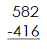

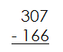

- 870 = 89 + ____________

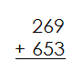

- 823 + __________ =908

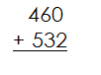

- 56 + ___________ = 459

- __________ - 432 = 189

- Calculate.
605  - 327 | 708  - 439 | 875 – 218 = _____
575 + 219 = _____ | 238  + 573 | 117  + 582

- Calculate.
673  - 137 | 433  - 182 | 745 –_____ = 196
515 + _____ = 729 | 763  + 256 | 442  + 328

- 670 – 487 = ________

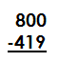

- 450 - _______ = 373

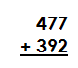

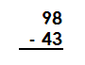

- 806 - __________ = 247

- 89 + 320 = __________

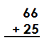

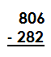

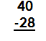

- 346 + ________ = 500

- 56 + 78 = ___________

- 91 – 67 = ____________

- 510 - __________ = 276

- 678 + 190 = _____________

- Calculate.
903  - 465 | 922  - 573 | 721 – 238 = _____
495 + 129 = _____ | 243  + 713 | 317  + 458

- Solve to find the missing numbers.

142 + _______ = 225

506 – _______ = 329

_______ + 344 = 764

- Solve to find the missing numbers.

463 + _______ = 925

801 – _______ = 378

_______ + 492 = 964

3.MD.A.1 – Understand time to the nearest minute.

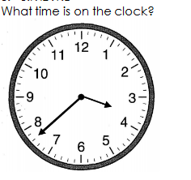
What time is on the clock?

___ ___ : ___ ___

- Bessie is writing her paper. She starts writing it at 9:10. She writes for 34 minutes. What time does she finish writing?

End time: ___ ___ : ___ ___

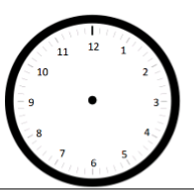
- Show 10:35 on the clock.

- Show ten minutes past 6:15 on the clock.

- Show 7:03 on the clock.

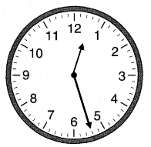
- What time is on the clock?

___ ___ : ___ ___

- Show 4: 23 on the clock.

- Kim is practicing for her talent show. She spends 47 minutes practicing. When she finishes practicing, the clock reads 8:50. What time did she start?

Start Time: ___ ___ : ___ ___

- Show 12: 42 on the clock.

- Jamie left for practice at 10:43. Draw the time he left on the clock.

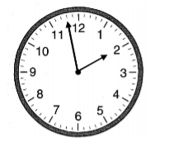
- What time is on the clock?

___ ___ : ___ ___

- Show a quarter past 5 on the clock.

- What time is shown on the clock? ________
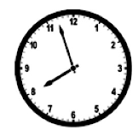

- Independent Reading starts at 1:34 p.m. It ends at 1:56 p.m.

Draw the start time on the clock below. Draw the end time on the clock below.
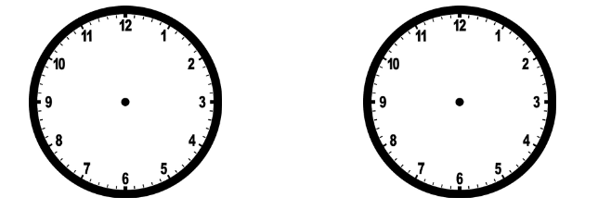

- Show 6: 17 on the clock.

- End Time – 3:40
Elapsed Time – Count backward 36 minutes.
Start Time - ______________

- What time is shown on the clock? ___________

- Label the times given below on the number line. Then, draw hands on the clock faces to show the same times.
Time A = 6:33 Time B = 6:19
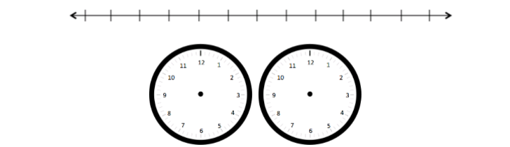

- What time is shown on the clock? _______________

- Show 5: 07 on the clock.

- Show half an hour past 8: 06 on the clock.

- What time is shown on the clock? ______

- Show 7:19 on the clock.

- Show 50 minutes past 2: 30 on the clock.

- What time is shown on the clock?

Practice Workbook C

3.MD.A.2 – Measure and estimate liquid volumes and masses of objects using standard units of grams (g), kilograms (kg), and liters (l). Add, subtract, multiply, or divide to solve one-step word problems involving masses or volumes that are given in the same units, e.g. by using drawings (such as a beaker with a measurement scale) to represent the problem.
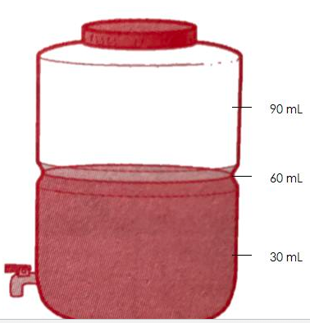
- How much juice is in the jug? __________

- Which is a better estimate for the weight of a bouncy ball?

3 kilograms 3 grams

- Which is a better estimate for the weight of a business card?
7 kilograms 7 grams

- The weight of the cat is 6 kilograms. What is the weight of one dog? ___________

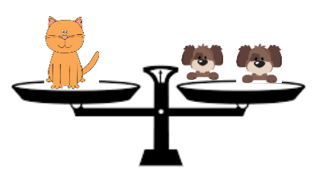

- Which is a better estimate for the volume of a kitchen pot?

7 liters 7 millileters

- What is the volume of liquid in the beaker? ___________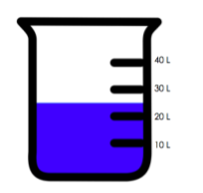
- Which is a better estimate for the weight of a twig?
11 grams 11 kilograms

- Which is a better estimate for the volume of a medicine syringe?

2 liters 2 millileters

- What is the mass of the object? ___________
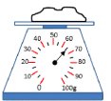

- Which is a better estimate for the weight of a pigeon?

2 grams 2 kilograms

- Which is a better estimate for the weight of a birthday cake?

1 gram 1 kilogram

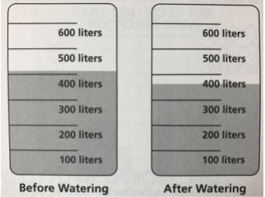
- How much water was used for the plants? __________________

- Which is a better estimate for the height of a city building?

40 meters 40 centimeters

- What is the mass of the object? __________
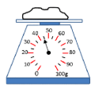
- Which is a better estimate for the volume of a water bottle?

275 liters 275 millileters

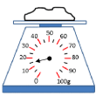
- What is the mass of the object? _________

- Which is a better estimate for the volume of medicine cup?
11 millileters 11 liters

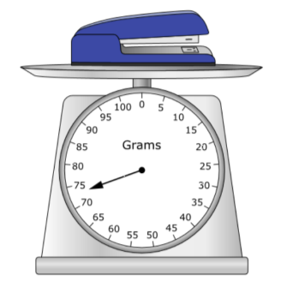
- Which is closest to the mass of a stapler?

  - 15 grams
  - 25 grams
  - 65 grams
  - 75 grams

- Which is a better estimate for the volume of a pasta box?
3 milliliters 3 liters

- How much does one rectangle weigh? ___________________________
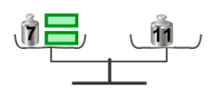

- Which is a better estimate for the volume of a pepper shaker?
48 liters 48 millileters

- Which is a better estimate for the volume of a shoebox?
4 millileters 4 liters

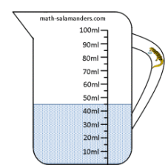

- What is the volume of liquid? __________

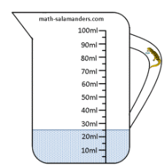
- What is the volume of liquid? __________

Practice Workbook D

3.G.A.2 – Partition shapes into parts with equal areas. Express the area of each part as a unit fraction of the whole.

1. 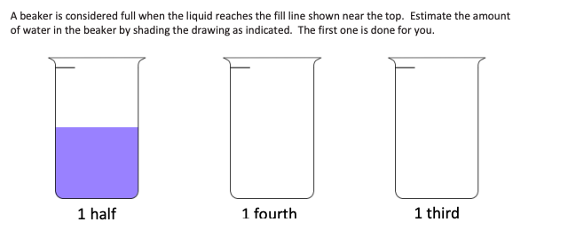

2. 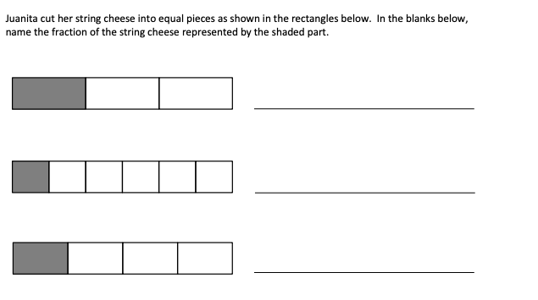
3. 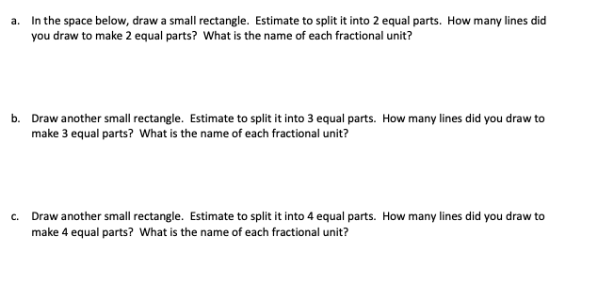
4.
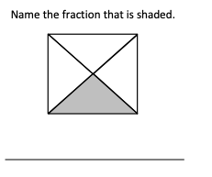

5.
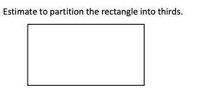

6.
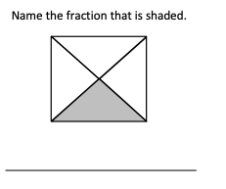
7. 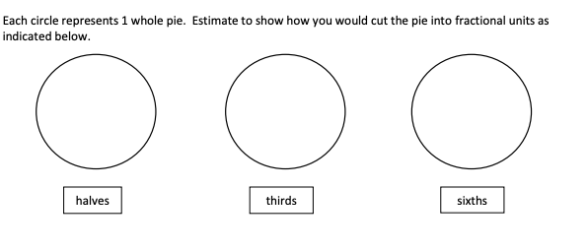
8. 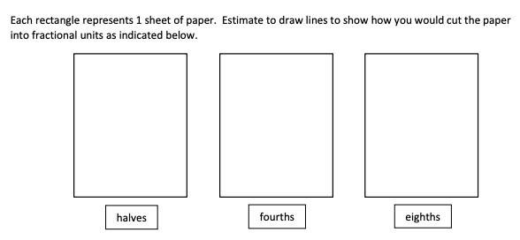
9. 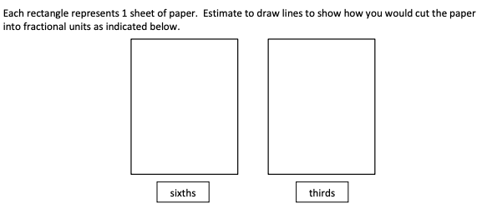

- Draw a circle. Partition it into thirds and label each third.

- Draw a square. Partition it into fourths and label each fourth.

- Show 3 ways you could partition a rectangle into fourths. Label each fourth.

- Show 3 ways you could partition a rectangle into sixths. Label each sixth.

3.NF.A.1 – Understand a fraction 1/b, with denominators 2, 3, 4, 6, and 8, as the quantity formed by one part when a whole is partitioned into b equal parts; understand a fraction a/b as the quantity formed by a parts of size 1/b.

- __________ of the whole is shaded.

- __________ of the whole is shaded.

- __________ of the whole is shaded.

- Shade 5/8 of the fraction bar.

- The fraction bar below has _______ equal parts. Each part is _______ of the whole.

- __________ of the whole is shaded.

- __________ of the whole is shaded.

- __________ of the whole is shaded.

- Shade 2/5 of the fraction bar.

- The fraction bar below has _______ equal parts. Each part is _______ of the whole.

3.NF.A.2 – Understand a fraction with denominators 2, 3, 4, 6, and 8 as a number on a number line diagram.

- Create a number line below between 0 and 1. Partition the number line to show fourths. Label each fourth.

- Write the missing fractions on the number line.
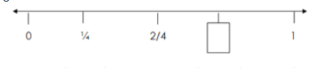
- Write the fraction that goes with the letters below.

- ____________ K. _____________
- ____________ L. _____________
- ____________

- Estimate to label 6/8 on the number line. Be sure to label the fractions at 0 and 1.
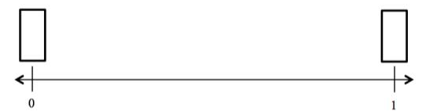

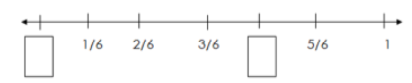
- Write the missing fractions on the number line.

- Which fraction does each point on the number line represent?

F = __________ M = __________ P = ___________
- Write the missing fraction in the box below.
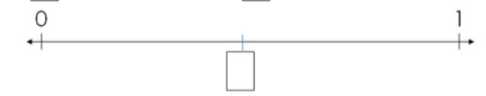

- Write the missing numbers in the number lines below.

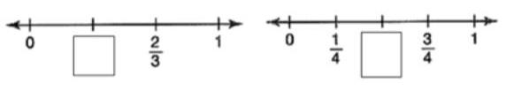

- Partition the number line into thirds. Label each third.

- Estimate to label ¾ on the number line. Be sure to label each fraction.

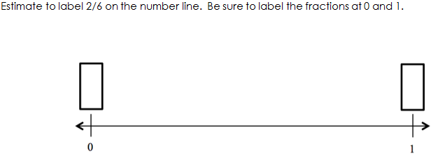

- Partition the number line into eighths. Be sure to label each fraction.

- Estimate to label 2/3 on the number line. Be sure to label the fractions at 0 and 1.

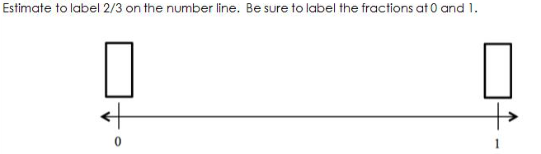

- Estimate to place 5/6 on the number line. Be sure to label the fractions at 0 and 1.

- Partition the number line into sixths. Be sure to label each fraction.

- Estimate to place 2/4 on the number line. Be sure to label each fraction.

- The number line shows two numbers, 0 and 1. Where would 8/6 be on this number line?

- Estimate to label 2/3 on the number line. Be sure to label the fractions at 0 and 1

- Write the fractions represented by the letters on the number line.

A = ___________
B = ___________
C = ___________

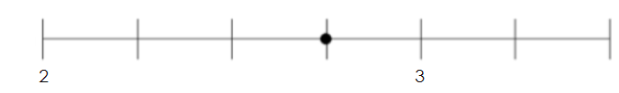
- What fraction is represented by the point on the number line below?

- Partition the number line into fourths, then label ¾ on the line.

- Locate and label the following fractions on the number line.

0 6 12 3 9
6 6 6 6 6
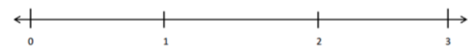

- Draw points on the number line for the fractions below. Label the points. Be as exact as possible.

1 2 3 4 5 6
2 2 2 2 2 2
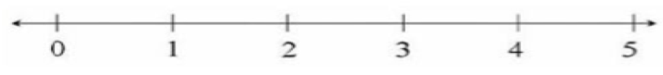

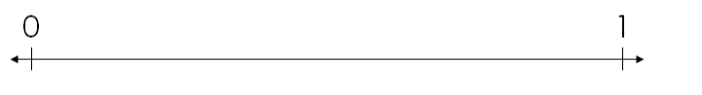
- Estimate to equally partition the line into thirds and label the fractions on the number line. Label the whole numbers as fractions and box them.

- Estimate to equally partition the line into fourths. Label each fraction on the number line.

- Estimate to equally partition the line into eighths. Label each fraction on the number line.

3.NF.A.3b – Recognize and generate simple equivalent fractions, e.g., ½ = 2/4, 4/6 = 2/3. Explain why the fractions are equivalent, e.g., by using a visual fraction model.

1. Create a model to show how many sixths can be equivalent to ½.

- Write a fraction that is equivalent to 4/8.

- Shade the model to show an equivalent fraction.

- Write a fraction that is equivalent to 4/6.

- Fill in the missing denominator to show equivalent fractions.

$\frac{4}{6}$ = $\frac{2}{}$

- Create a model to show many eighths are equivalent to ¾ .

- Fill in the missing denominator to show equivalent fractions.

$\frac{4}{}$ = $\frac{1}{3}$

- Write a fraction that is equivalent to 4/12.

- Write an equivalent fraction for 1/3.

- Write an equivalent fraction for the one shown in the model below: _____________

- Write a fraction that is equivalent to ¼.

- Write an equivalent fraction for the one in the model shown below: ________

- Fill in the missing numerator to show equivalent fractions.

$\frac{4}{10}$ = $\frac{}{100}$

- Fill in the missing denominator to show equivalent fractions.

$\frac{2}{4}$ = $\frac{1}{}$

- Write an equivalent fraction for 5/6.

- Fill in the missing numerator to show equivalent fractions.

$\frac{4}{6}$ = $\frac{}{3}$

- Fill in the missing numerator to show equivalent fractions.

$\frac{6}{10}$= $\frac{}{100}$

- Create a model to show many sixths are equivalent to 1/3.

- Write an equivalent fraction for ¼.

- Create a model to find an equivalent fraction for 3/8.

- Write an equivalent fraction for the one shown in the model below. ________

3.NF.A.3c – Express whole numbers as fractions, and recognize fractions that are equivalent to whole numbers.

- There are ____________ fourths in one whole.

- Draw models to represent each fraction in the pair below. Circle the fraction that is MORE.
3 thirds 3 sixths

- Partition the number line into thirds. Label 3/3 on the number line.
- There are _______________ sixths in one whole.

- Create a model to show 8/4.

- Partition the number line into fourths. Label 4/4.

- Label the following points on the number line.

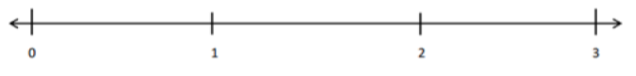
0 6 12 3 9
6 6 6 6 6

- Create a model to show 6/3.

- Where would 8/6 be on this number line?
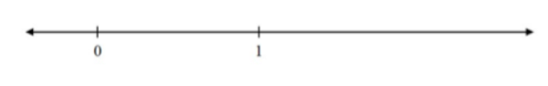

- There are _____________ fourths are in 3 wholes.

- Draw points on the number line for each fraction listed below. Label the points. Be as exact as possible.

1 2 3 4 5 6
3 3 3 3 3 3
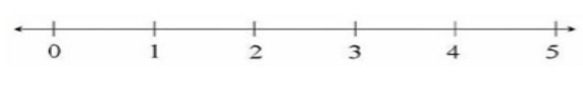

- Create a model to show how many twelfths are in 2 wholes.

- Partition the number line into sixths. Show 6/6 on the number line.

- What mixed number is shown by the model below? _________

- What mixed number is shown by the model below? _________

3.NF.A.3d – Compare two fractions with the same numerator or the same denominator by reasoning about their size. Recognize that comparisons are valid only when the two fractions refer to the same whole. Record the results of comparisons with the symbols >, =, or < and justify the conclusions e.g., by using a visual fraction model.

1. Compare using <, =, >.
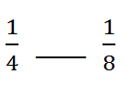

2. Compare using <, =, >.

3. Fill in a denominator to make the inequality true.
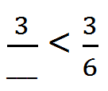

4. Compare using <, =, >.

- Label a fraction on the number line greater than 1/3.

- Fill in a denominator to make the inequality true.
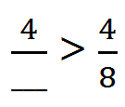

- Compare using <, =, >.

- Compare using <, =, >.

- Label a fraction on the number line that is less than ¾.

- Compare using <, =, >.

- Fill in a denominator to make the inequality true.
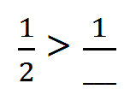

- Compare using <, =, >.
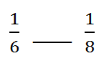

- Compare using <, =, >.

- Write a fraction greater than 4/6 _________________

- Compare using <, =, >.

- Label a fraction on the number line greater than 5/8.
- Which fraction is greater?
$\frac{6}{8}$ or $\frac{2}{8}$

- Use <, >, or = to make the statement true.

$\frac{5}{8}$ _____ $\frac{7}{8}$

- Write a fraction greater than ¼ _______________

- Which fraction is greater?
$\frac{4}{8}$ or $\frac{4}{6}$

- Compare using <, >, or =.

2/3 _________ 2/6

Practice Workbook E

3.MD.B.3 – Draw a scaled picture graph and a scaled bar graph to represent a data set with several categories. Solve one- and two-step “how many more” and “how many less” problems using information presented in scaled bar graphs.

1.
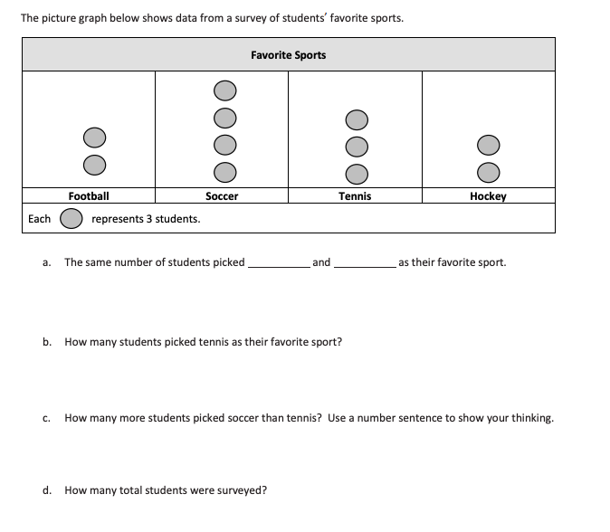
2. 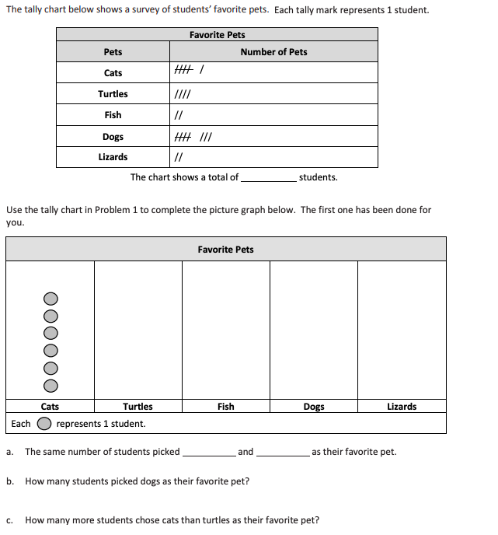
3. 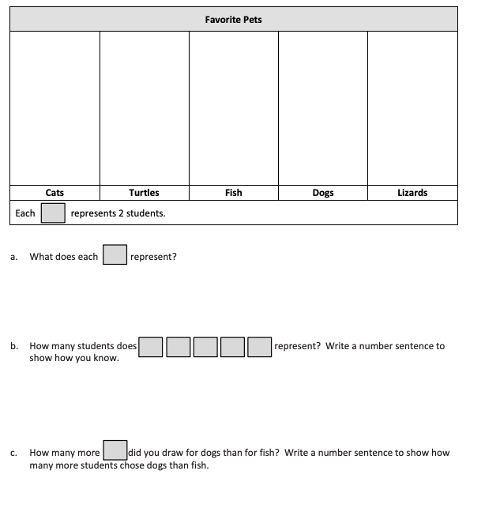
4. 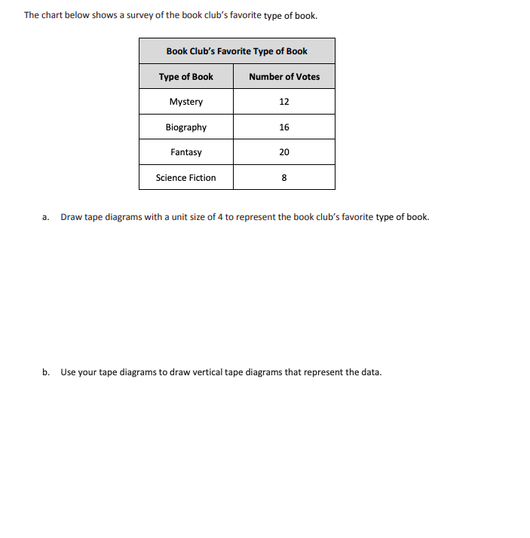
5. 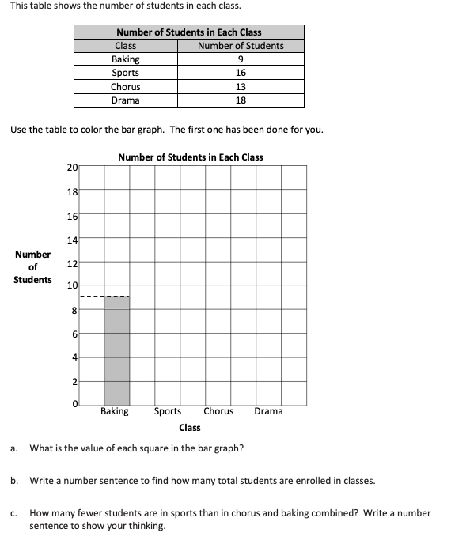
6. 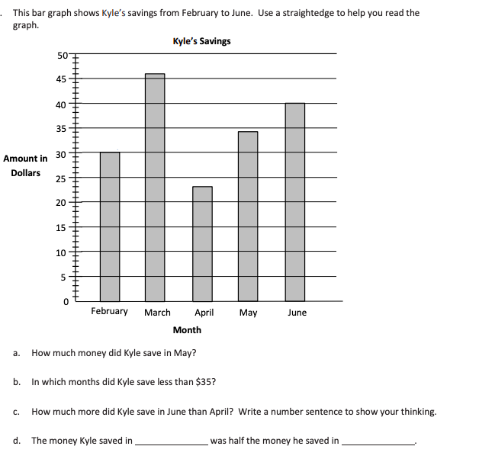
7. 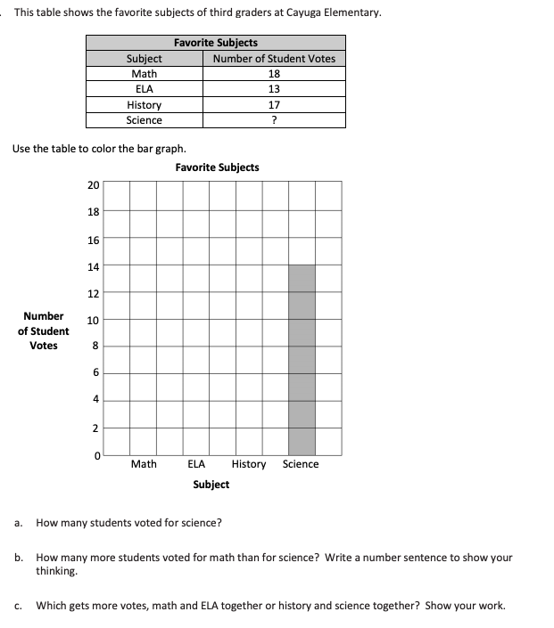
8. 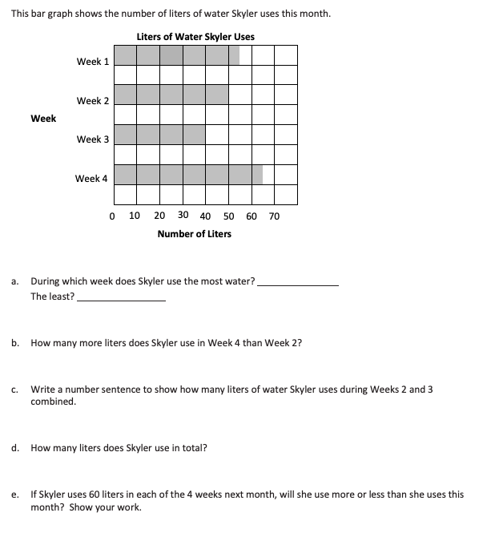
9. 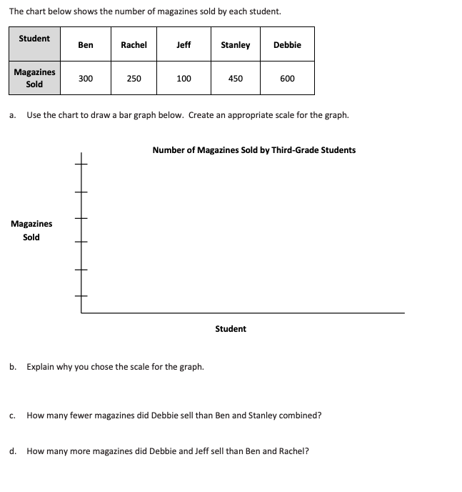
10. 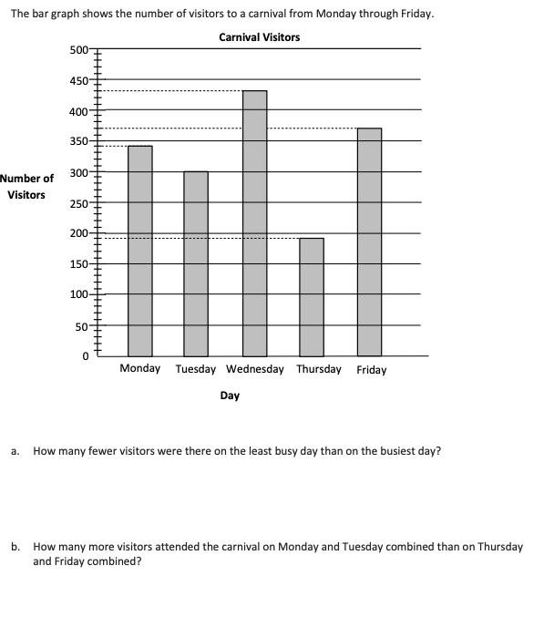
11. 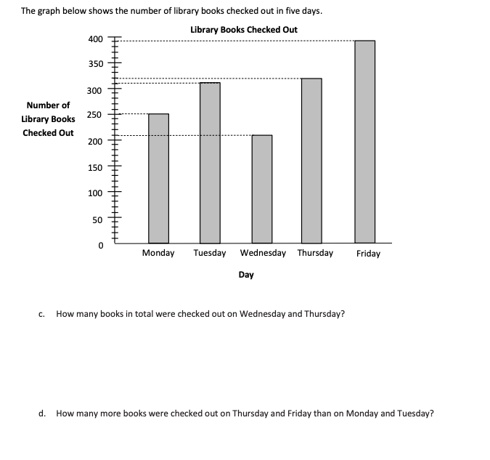
12. 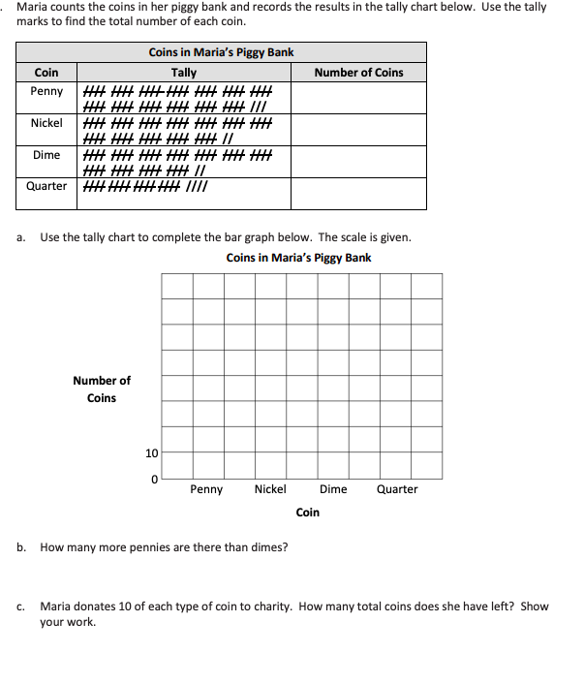
13. 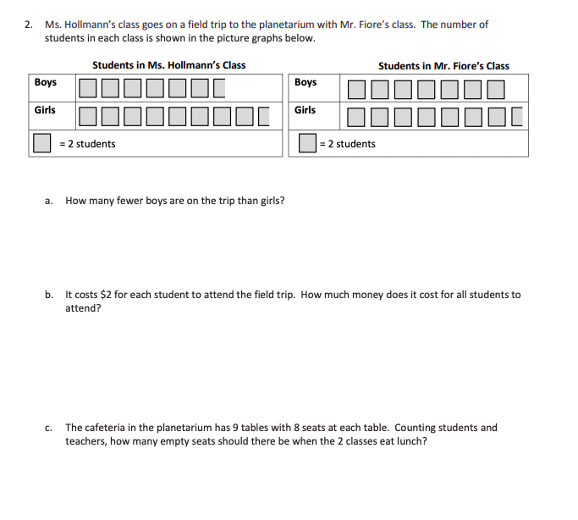

3.MD.B.4 – Generate measurement data by measuring lengths using rulers marked with halves or fourths of an inch. Show the data by making a line plot, where the horizontal line is marked off in appropriate units, whole numbers, halves, or quarters.

1. Measure to the nearest ¼ inch. ________________
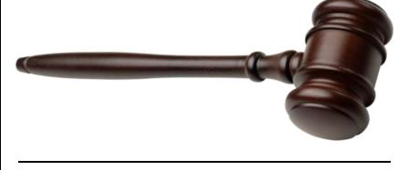

2. What is the length of the shape below? _____________

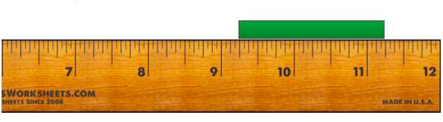
3. The line is about _________ inches long.
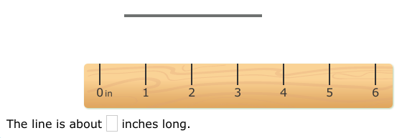

4. What is the length of the shape?
5. What is the length of the line to the nearest ¼ inch? _____________

6. Measure the shape below to the nearest ¼ inch. _______________
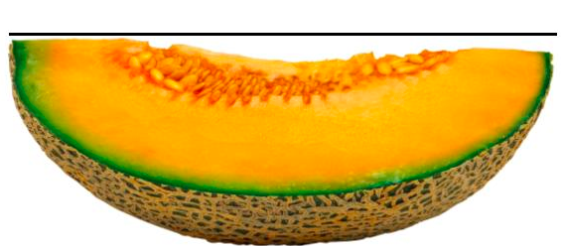

7. What is the length of the shape below? _________

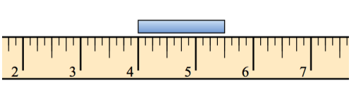
8. The line is about ________ inches long.
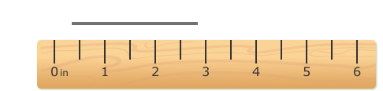

9. What is the length of the shape below? Measure to the nearest ¼ inch. _____________
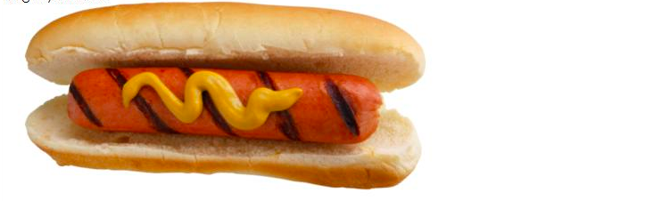

10. What is the length of the object below? _____________

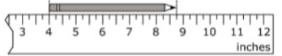

11. What is the length of the shape below? Measure to the nearest ¼ inch. _________

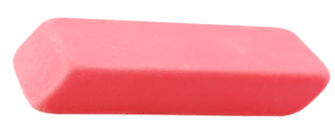

12. Tell the length of the shape, to the nearest ¼ inch. ____________

13. The line is about __________ inches long.
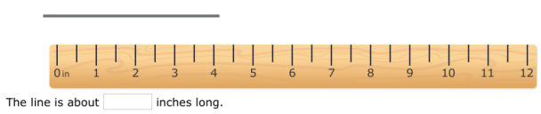

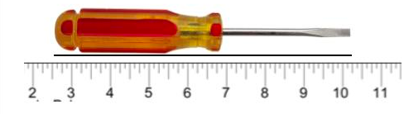
14. What is the length of the screwdriver in inches? ___________

15. The line is about ___________ inches long.
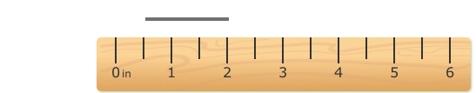

16. Tell the length of the line to the nearest ¼ inch. ________

17. The line is about _______ inches long.

18. Tell the length of the object to the nearest ¼ inch. _______________

- Tell the length of the line to the nearest ½ inch. ______________

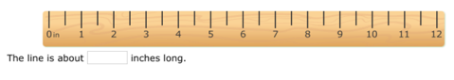

20. Tell the length of the object to the nearest ¼ inch. ____________

21. The line is about ______ inches long.

22. Tell the length of the line to the nearest ¼ inch. ___________

23. The line is about _____________ inches long. Measure to the nearest ½ inch.

24. Tell the length of the object to the nearest ½ inch. ___________

25. The line is about ________ inches long.

Practice Workbook F

3.OA.C.7 – Fluently multiply and divide within 100, using strategies such as the relationship between multiplication and division, (e.g., knowing that 8 x 5 =40, one knows 40 ÷ 5 = 8) or properties of operations. By the end of grade 3, know from memory all products of two one-digit numbers.

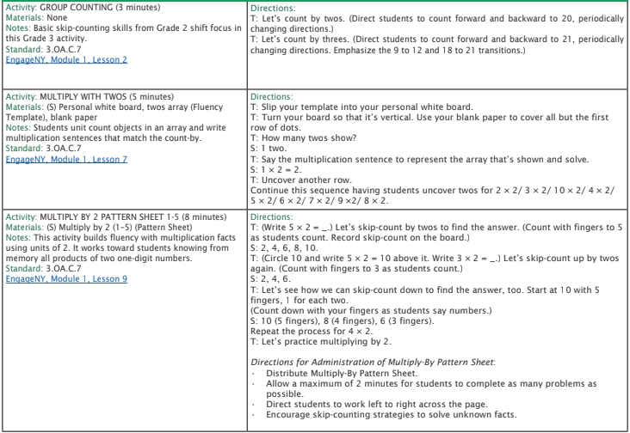

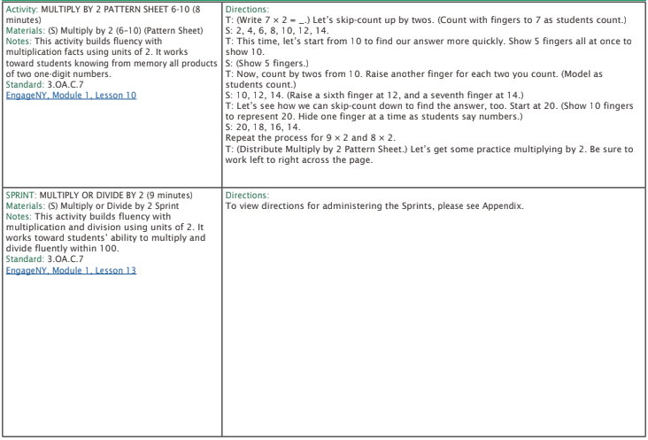

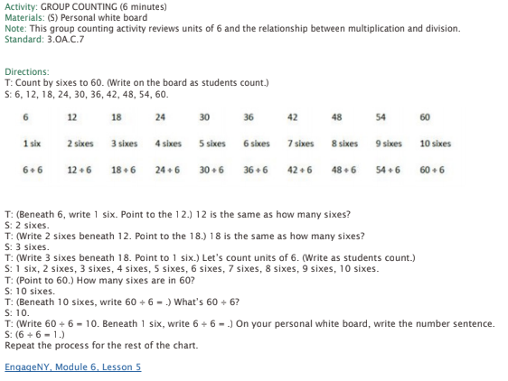

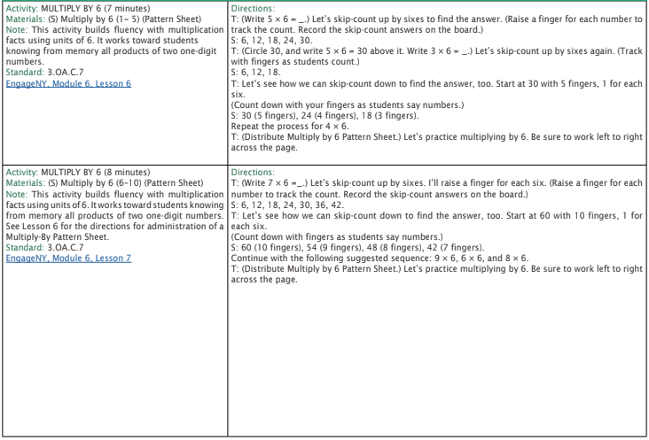

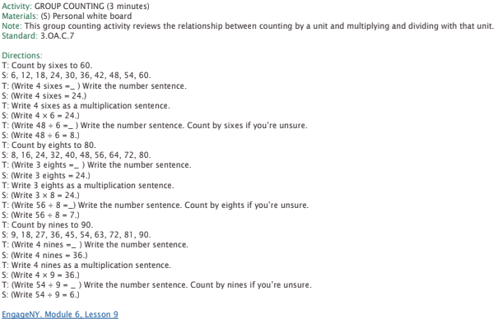

1. 4 x 5 = ______

2. 3 x 7 = _______

3. _______ x 6 = 18

4. 45 ÷ 9 = ________

5. 28 ÷ 4 = _________

6. 8 x ____ = 56

7. 81 ÷ _____ = 9

8. 10 x 6 = _______

9. _______ ÷ 9 = 6

10. 4 x ______ = 40

11. 2 x ______ = 22

12. 3 x 4 = _________

13. _______ ÷ 8 = 3

14. 5 ÷ 1 = _________

15. 21 ÷ 7 = ________

16. 63 ÷ _____ = 7

17. 6 x ______ = 36

18. 3 x 8 = ________

19. _____ x 4 = 36

20. 4 x 6 = ____________

21. 20 ÷ 2 = __________

22. 5 x 6 = ___________

23. 18 ÷ 2 = __________

24. 50 ÷ ________ = 5

25. 80 ÷ 8 = ___________

3.MD.C.7b – Multiply side lengths to find the areas of rectangles with whole number side lengths in the context of solving real-world and mathematical problems, and represent whole-number products as rectangular area in mathematical reasoning.

1. What is the area of the rectangle? __________

3 in

5 in

2. What is the area of a square with 4 inch sides? ____________

10 ft

2 ft

3. What is the area of the rectangle? __________

12 in

7 in

4. What is the area of the room shown here? ____________

9 ft

8 ft

5. Use the grid to create a rectangle with an area of 24 square units. Label the side lengths.

6. What is the area of the room shown here? ___________

11ft

8ft

7. What is the area of the rectangle? _______________

6m

3m

8. Use the grid to create a rectangle with an area of 15 square units. Label the side lengths.
9. Find the area of the shape shown here. __________

6cm

6cm

10. Find the area of a square with 8 inch sides. _____________

11. Find the area of the room shown here.____________

4ft

8ft

12. What is the area of the rectangle? ______________

4cm

7cm

13. Find the area of the rectangle shown below. __________

9m

3m

14. Use the grid below to draw a rectangle that has an area of 56 square units.

15. Find the area. ___________

6mm

4mm

16. Find the area. ___________

12ft

5ft

17. Find the area. ____________

6m

2m

18. Find the area. ___________

9ft

5ft

7ft

7ft
19. Find the area. __________

20. Find the area. ___________

6in

4 in

21. Use the grids to draw a rectangle with an area of 32 square units. Label the side lengths.

3.MD.C.7c – Use tiling to show in a concrete case that the area of a rectangle with whole-number side lengths a and b + c is the sum of a × b and a × c. Use area models to represent the distributive property in mathematical reasoning.

1. Use the distributive property to find the area of the shape. ____________
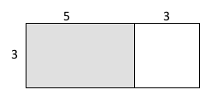
2. Use the distributive property to partition and find the area of the shape. ___________
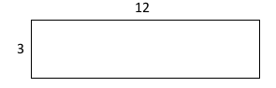
3. Use the distributive property to find the area of the shape. ____________
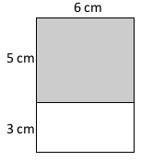

4. Use the distributive property to find the area of the shape. ____________
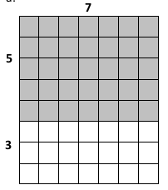

5. Fill in the missing side length. Use the distributive property to find the area of the shape. ____________
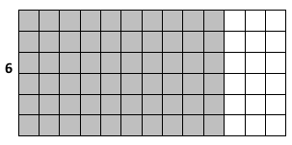

6. Fill in the missing side length. Complete the equation, then use the distributive property to find the area of the shape. ____________
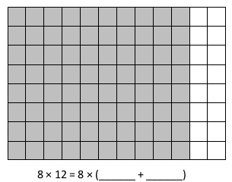

7. Use the distributive property to partition and find the area of the shape. ___________
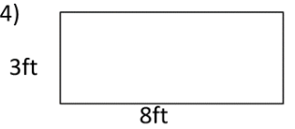

8. Fill in the missing side length. Complete the equation, then use the distributive property to find the area of the shape. ____________
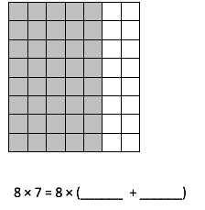

9. Use the distributive property to find the area of the shape. ____________
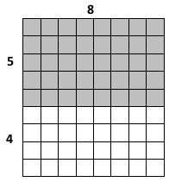

10. Fill in the missing side length. Complete the equation, then use the distributive property to find the area of the shape. ____________
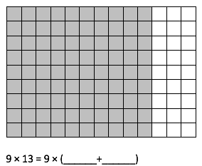

11. Fill in the missing side length, then use the distributive property to find the area of the shape. ____________

12. Fill in the missing side length. Complete the equation, then use the distributive property to find the area of the shape. ____________
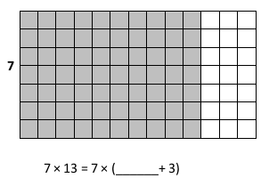
13. Fill in the missing side lengths, then use the distributive property to find the area. _______
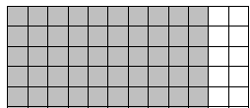

14. Fill in the missing side lengths, then use the distributive property to find the area.
Total area: _____________

15. Fill in the missing side lengths, then use the distributive property to find the area. _______
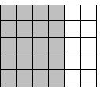

16. Fill in the missing side lengths, then use the distributive property to find the area.
________

17. Fill in the missing side length. Complete the equation, then use the distributive property to find the area of the shape. ____________

18. Fill in the missing side length, then use the distributive property to find the area of the shape. ____________
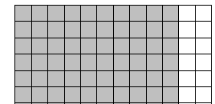

19. Fill in the missing side lengths, then use the distributive property to find the area.
Total Area: _______________

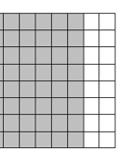
20. Fill in the missing side lengths, then use the distributive property to find the area. ____

21. Fill in the missing side lengths, then use the distributive property to find the area. ____

22. Fill in the missing side lengths, then use the distributive property to find the area. ____

23. Fill in the missing side lengths, then use the distributive property to find the area. ____

24. Fill in the missing side lengths, then use the distributive property to find the area. ____
25. Fill in the missing side lengths, then use the distributive property to find the area. ____

3.MD.D.8 – Solve real world mathematical problems involving perimeters of polygons, including finding the perimeter given the side lengths, finding an unknown side length, and exhibiting rectangles with the same perimeter and different areas or with the same area and different perimeters.

1.

2.

3.
4.

5.

6. 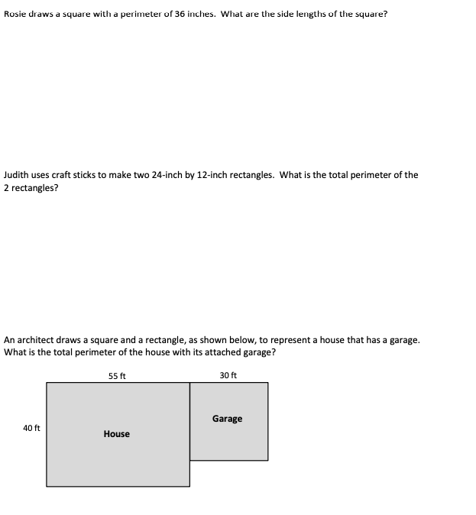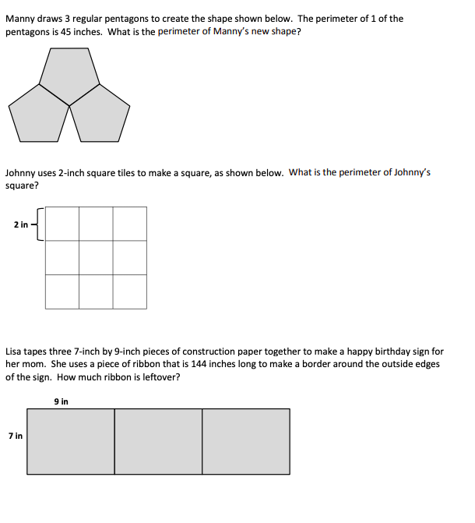
9.
8.
7.
12.
11.
10.

3.G.A.1 – Understand that shapes in different categories may share attributes. Recognize rhombuses, rectangles, and squares as examples of quadrilaterals, and draw examples of quadrilaterals that do not belong to any of these subcategories.

- For each polygon below, list as many attributes as you can:

- Complete the sentence about the shapes in number 1. All of the shapes are

_______________________ because they have four _______________.

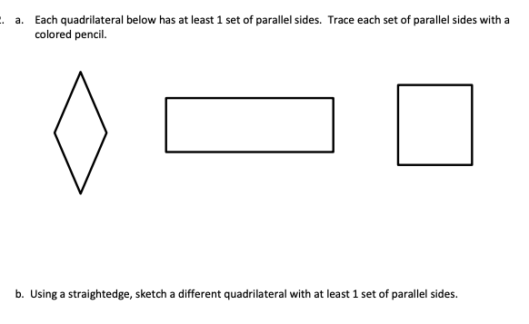

- Sketch a quadrilateral that is not a parallelogram.

- Sketch a rectangle that is not a square.

- Sketch a parallelogram that is not a rhombus.

- Write if the attribute is true or false in the table. 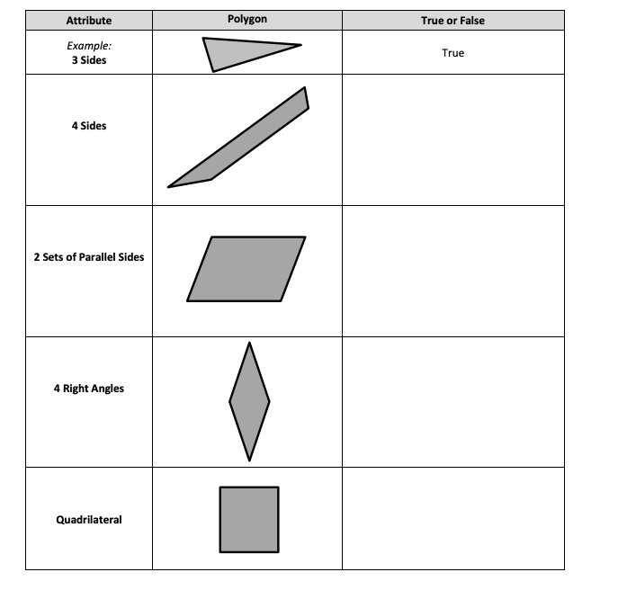

Copyright: Achievement First. Unless otherwise noted, all of the content in this resource is licensed under a Creative Commons Attribution International 4.0 (CC BY) license.
Scale Problem Image by Math Salamanders Limited, 2018. Achievement First does not own the copyright in “Fluency Problem” and claims no copyright in this material. The material is being used exclusively for non-profit educational purposes under fair use principles in U.S. Copyright laws. The user should make the judgment about whether this material may be used under fair use / fair dealing permissions in the user’s country.
Scale Problem Image by Math Salamanders Limited, 2018. Achievement First does not own the copyright in “Fluency Problem” and claims no copyright in this material. The material is being used exclusively for non-profit educational purposes under fair use principles in U.S. Copyright laws. The user should make the judgment about whether this material may be used under fair use / fair dealing permissions in the user’s country.
Scale Problem Image by Math Salamanders Limited, 2018. Achievement First does not own the copyright in “Fluency Problem” and claims no copyright in this material. The material is being used exclusively for non-profit educational purposes under fair use principles in U.S. Copyright laws. The user should make the judgment about whether this material may be used under fair use / fair dealing permissions in the user’s country.
Author and Source Unknown. Achievement First does not own the copyright in “Fluency Problem” and claims no copyright in this material. The material is being used exclusively for non-profit educational purposes under fair use principles in U.S. Copyright laws. The user should make the judgment about whether this material may be used under fair use / fair dealing permissions in the user’s country.
Capacity Image by Math Salamanders Limited, 2018. Achievement First does not own the copyright in “Fluency Problem” and claims no copyright in this material. The material is being used exclusively for non-profit educational purposes under fair use principles in U.S. Copyright laws. The user should make the judgment about whether this material may be used under fair use / fair dealing permissions in the user’s country.
Capacity Image by Math Salamanders Limited, 2018. Achievement First does not own the copyright in “Fluency Problem” and claims no copyright in this material. The material is being used exclusively for non-profit educational purposes under fair use principles in U.S. Copyright laws. The user should make the judgment about whether this material may be used under fair use / fair dealing permissions in the user’s country.
EngageNY Third Grade by EngageNY licensed under Creative Commons Attribution International 4.0 (CC BY-NC-SA.) Achievement First does not own the copyright in “Fluency Workbook” and claims no copyright in this material. The material is being used exclusively for non-profit educational purposes under fair use principles in U.S. Copyright laws. The user should make the judgment about whether this material may be used under fair use / fair dealing permissions in the user’s country.
EngageNY Third Grade by EngageNY licensed under Creative Commons Attribution International 4.0 (CC BY-NC-SA.) Achievement First does not own the copyright in “Fluency Workbook” and claims no copyright in this material. The material is being used exclusively for non-profit educational purposes under fair use principles in U.S. Copyright laws. The user should make the judgment about whether this material may be used under fair use / fair dealing permissions in the user’s country.
EngageNY Third Grade by EngageNY licensed under Creative Commons Attribution International 4.0 (CC BY-NC-SA.) Achievement First does not own the copyright in “Fluency Workbook” and claims no copyright in this material. The material is being used exclusively for non-profit educational purposes under fair use principles in U.S. Copyright laws. The user should make the judgment about whether this material may be used under fair use / fair dealing permissions in the user’s country.
EngageNY Third Grade by EngageNY licensed under Creative Commons Attribution International 4.0 (CC BY-NC-SA.) Achievement First does not own the copyright in “Fluency Workbook” and claims no copyright in this material. The material is being used exclusively for non-profit educational purposes under fair use principles in U.S. Copyright laws. The user should make the judgment about whether this material may be used under fair use / fair dealing permissions in the user’s country.
EngageNY Third Grade by EngageNY licensed under Creative Commons Attribution International 4.0 (CC BY-NC-SA.) Achievement First does not own the copyright in “Fluency Workbook” and claims no copyright in this material. The material is being used exclusively for non-profit educational purposes under fair use principles in U.S. Copyright laws. The user should make the judgment about whether this material may be used under fair use / fair dealing permissions in the user’s country.
EngageNY Third Grade by EngageNY licensed under Creative Commons Attribution International 4.0 (CC BY-NC-SA.) Achievement First does not own the copyright in “Fluency Workbook” and claims no copyright in this material. The material is being used exclusively for non-profit educational purposes under fair use principles in U.S. Copyright laws. The user should make the judgment about whether this material may be used under fair use / fair dealing permissions in the user’s country.
EngageNY Third Grade by EngageNY licensed under Creative Commons Attribution International 4.0 (CC BY-NC-SA.) Achievement First does not own the copyright in “Fluency Workbook” and claims no copyright in this material. The material is being used exclusively for non-profit educational purposes under fair use principles in U.S. Copyright laws. The user should make the judgment about whether this material may be used under fair use / fair dealing permissions in the user’s country.
EngageNY Third Grade by EngageNY licensed under Creative Commons Attribution International 4.0 (CC BY-NC-SA.) Achievement First does not own the copyright in “Fluency Workbook” and claims no copyright in this material. The material is being used exclusively for non-profit educational purposes under fair use principles in U.S. Copyright laws. The user should make the judgment about whether this material may be used under fair use / fair dealing permissions in the user’s country.
EngageNY Third Grade by EngageNY licensed under Creative Commons Attribution International 4.0 (CC BY-NC-SA.) Achievement First does not own the copyright in “Fluency Workbook” and claims no copyright in this material. The material is being used exclusively for non-profit educational purposes under fair use principles in U.S. Copyright laws. The user should make the judgment about whether this material may be used under fair use / fair dealing permissions in the user’s country.
EngageNY Third Grade by EngageNY licensed under Creative Commons Attribution International 4.0 (CC BY-NC-SA.) Achievement First does not own the copyright in “Fluency Workbook” and claims no copyright in this material. The material is being used exclusively for non-profit educational purposes under fair use principles in U.S. Copyright laws. The user should make the judgment about whether this material may be used under fair use / fair dealing permissions in the user’s country.
EngageNY Third Grade by EngageNY licensed under Creative Commons Attribution International 4.0 (CC BY-NC-SA.) Achievement First does not own the copyright in “Fluency Workbook” and claims no copyright in this material. The material is being used exclusively for non-profit educational purposes under fair use principles in U.S. Copyright laws. The user should make the judgment about whether this material may be used under fair use / fair dealing permissions in the user’s country.
EngageNY Third Grade by EngageNY licensed under Creative Commons Attribution International 4.0 (CC BY-NC-SA.) Achievement First does not own the copyright in “Fluency Workbook” and claims no copyright in this material. The material is being used exclusively for non-profit educational purposes under fair use principles in U.S. Copyright laws. The user should make the judgment about whether this material may be used under fair use / fair dealing permissions in the user’s country.
EngageNY Third Grade by EngageNY licensed under Creative Commons Attribution International 4.0 (CC BY-NC-SA.) Achievement First does not own the copyright in “Fluency Workbook” and claims no copyright in this material. The material is being used exclusively for non-profit educational purposes under fair use principles in U.S. Copyright laws. The user should make the judgment about whether this material may be used under fair use / fair dealing permissions in the user’s country.
EngageNY Third Grade by EngageNY licensed under Creative Commons Attribution International 4.0 (CC BY-NC-SA.) Achievement First does not own the copyright in “Fluency Workbook” and claims no copyright in this material. The material is being used exclusively for non-profit educational purposes under fair use principles in U.S. Copyright laws. The user should make the judgment about whether this material may be used under fair use / fair dealing permissions in the user’s country.
EngageNY Third Grade by EngageNY licensed under Creative Commons Attribution International 4.0 (CC BY-NC-SA.) Achievement First does not own the copyright in “Fluency Workbook” and claims no copyright in this material. The material is being used exclusively for non-profit educational purposes under fair use principles in U.S. Copyright laws. The user should make the judgment about whether this material may be used under fair use / fair dealing permissions in the user’s country.
EngageNY Third Grade by EngageNY licensed under Creative Commons Attribution International 4.0 (CC BY-NC-SA.) Achievement First does not own the copyright in “Fluency Workbook” and claims no copyright in this material. The material is being used exclusively for non-profit educational purposes under fair use principles in U.S. Copyright laws. The user should make the judgment about whether this material may be used under fair use / fair dealing permissions in the user’s country.
EngageNY Third Grade by EngageNY licensed under Creative Commons Attribution International 4.0 (CC BY-NC-SA.) Achievement First does not own the copyright in “Fluency Workbook” and claims no copyright in this material. The material is being used exclusively for non-profit educational purposes under fair use principles in U.S. Copyright laws. The user should make the judgment about whether this material may be used under fair use / fair dealing permissions in the user’s country.
This work, “Fluency Problems 3.MD.C.7c” is a revision of “Grade 3 Module 4” by EngageNY licensed under Creative Commons Attribution International 4.0 (CC BY-NC-SA), including images and partial images. Achievement First does not own the copyright in “Fluency Problems 3.MD.C.7c” and claims no copyright in this material. The material is being used exclusively for non-profit educational purposes under fair use principles in U.S. Copyright laws. The user should make the judgment about whether this material may be used under fair use / fair dealing permissions in the user’s country.
EngageNY Third Grade by EngageNY licensed under Creative Commons Attribution International 4.0 (CC BY-NC-SA.) Achievement First does not own the copyright in “Fluency Workbook” and claims no copyright in this material. The material is being used exclusively for non-profit educational purposes under fair use principles in U.S. Copyright laws. The user should make the judgment about whether this material may be used under fair use / fair dealing permissions in the user’s country.
EngageNY Third Grade by EngageNY licensed under Creative Commons Attribution International 4.0 (CC BY-NC-SA.) Achievement First does not own the copyright in “Fluency Workbook” and claims no copyright in this material. The material is being used exclusively for non-profit educational purposes under fair use principles in U.S. Copyright laws. The user should make the judgment about whether this material may be used under fair use / fair dealing permissions in the user’s country.
EngageNY Third Grade by EngageNY licensed under Creative Commons Attribution International 4.0 (CC BY-NC-SA.) Achievement First does not own the copyright in “Fluency Workbook” and claims no copyright in this material. The material is being used exclusively for non-profit educational purposes under fair use principles in U.S. Copyright laws. The user should make the judgment about whether this material may be used under fair use / fair dealing permissions in the user’s country.
EngageNY Third Grade by EngageNY licensed under Creative Commons Attribution International 4.0 (CC BY-NC-SA.) Achievement First does not own the copyright in “Fluency Workbook” and claims no copyright in this material. The material is being used exclusively for non-profit educational purposes under fair use principles in U.S. Copyright laws. The user should make the judgment about whether this material may be used under fair use / fair dealing permissions in the user’s country.
EngageNY Third Grade by EngageNY licensed under Creative Commons Attribution International 4.0 (CC BY-NC-SA.) Achievement First does not own the copyright in “Fluency Workbook” and claims no copyright in this material. The material is being used exclusively for non-profit educational purposes under fair use principles in U.S. Copyright laws. The user should make the judgment about whether this material may be used under fair use / fair dealing permissions in the user’s country.
EngageNY Third Grade by EngageNY licensed under Creative Commons Attribution International 4.0 (CC BY-NC-SA.) Achievement First does not own the copyright in “Fluency Workbook” and claims no copyright in this material. The material is being used exclusively for non-profit educational purposes under fair use principles in U.S. Copyright laws. The user should make the judgment about whether this material may be used under fair use / fair dealing permissions in the user’s country.

