Grade 4 math
Practice workbook
Achievement First Elementary Math

Practice Workbooks - Achievement First Elementary Math – Grade 4
Contents
Workbook A 4
4.OA.A.1 – Interpret a multiplication equation as a comparison and represent verbal statements of multiplicative comparisons as multiplication equations, e.g., interpret 35 = 5 x 7 as a statement that 35 is 5 times as many as 7, and 7 times as many as 5. 4
4.OA.B.4 – Using whole numbers in the range 1-100, find all factor pairs for a given whole number, recognize that a given whole number is a multiple of each of its factors, determine whether a given whole number is a multiple of a given one-digit number, and determine whether a given whole number is prime or composite. 8
4.OA.C.5 – Generate a number or shape pattern that follows a given rule. Identify apparent features of the pattern that were not explicit in the rule itself. 14
Workbook B 18
4.NBT.A.1 – Generalize place value understanding for multi-digit whole numbers. Recognize that in a multi-digit whole number less than or equal to 1,000,000, a digit in one place represents ten times what it represents in a place to its right. 18
4.NBT.A.2 – Read and write multi-digit whole numbers less than or equal to 1,000,000 using base-ten numerals, number names, and expanded form. Compare two multi-digit whole numbers based on the meanings of the digits in each place, using >, =, and < symbols to record the results of comparisons. 28
4.NBT.A.3 – Use place value understanding to round multi-digit whole numbers, less than or equal to 1,000,000 to any place. 34
Workbook C 39
4.NBT.B.4 – Fluently add and subtract multi-digit whole numbers, with sums less than or equal to 1,000,000, using the standard algorithm. 39
Workbook D 45
4.NBT.B.5 – Multiply a whole number of up to four digits by a one-digit number, and multiply two two-digit numbers, using strategies based on place value and the properties of operations and explain the calculations by using equations, rectangular arrays, and/or area models. 45
4.NBT.B.6 – Find whole-number quotients and remainders with up to 4-digit dividends and one-digit divisors, using strategies based on place value, the properties of operations, and/or the relationship between multiplication and division. Illustrate and explain the calculation by using equation, rectangular arrays, and/or area models. 51
4.MD.A.1 – Know relative sizes of measurement units within one system of units including ft, in; km, m, cm, g; lb, oz; l, ml; hr, min, sec. Within a single system of measurement, express measurement in a larger unit in terms of a smaller unit. Record measurement equivalents in a conversion two-column table. (Conversions are limited to one-step conversions.) 56
4.MD.A.3 – Apply the area and perimeter formula for rectangles in real-world and mathematical problems. 61
Workbook E 67
4.NF.A.1 – Explain why a fraction a/b is equivalent to a fraction (n x a)/(n x b) by using visual fraction models with attention to how the number and size of the parts differ even though the two fractions themselves are the same size. Use this principle to recognize and generate equivalent fractions. (Denominators are limited to 2, 3, 4, 5, 6, 8, 10, 12, and 100.) 67
4.NF.A.2 – Compare two fractions with different numerators and different denominators, e.g. by creating common denominators or numerators or by comparing to a benchmark fraction such as ½. Recognize that comparisons are valid only when the two fractions refer to the same whole. Record the results of comparisons with symbols >, =, or <, and justify the conclusions, e.g. by using a visual fraction model. (Denominators are limited to 2, 3, 4, 5, 6, 8, 10, 12, and 100.) 72
4.NF.B.3b – Decompose a fraction into a sum of fractions with the same denominator in more than one way, recording each decomposition in an equation. Justify decompositions, e.g. by using a visual fraction model. Examples 3/8 = 1/8 + 1/8 + 1/8, 3/8 = 2/8 + 1/8 (Denominators are limited to 2, 3, 4, 5, 6, 8, 10, 12, and 100.) 77
4.NF.B.3c – Add and subtract mixed numbers with like denominators, e.g. by replacing each mixed number with an equivalent fraction and/or by using properties of operations and the relationship between addition and subtraction. 81
4.NF.B.4a – Understand a fraction a/b as a multiple of 1/b. 86
4.NF.B.4 – Multiply a fraction by a whole number. 89
4.NF.B.4b – Understand a multiple of a/b as a multiple of 1/b, and use this understanding to multiply a fraction by a whole number. 89
Workbook F 92
4.NF.C.5 – Express a fraction with a denominator 10 as an equivalent fraction with a denominator 100 and use this technique to add two fractions with respective denominators 10 and 100. 92
4.NF.C.6 – Use decimal notation for fractions with denominators 10 or 100. 96
4.NF.C.7 – Compare two decimals to hundredths by reasoning about their size. Recognize that comparisons are valid only when two decimals refer to the same whole. Record the results of comparisons with the symbols >, =, or <, and justify the conclusions e.g. by using a visual model. 101
Workbook G 107
4.G.A.1 – Draw points, lines, line segments, rays, angles (right, acute, obtuse), and perpendicular and parallel lines. Identify these in two-dimensional figures. 107
4.G.A.3 – Recognize a line of symmetry for a two-dimensional figure as a line across the figure such that the figure can be folded along the line into matching parts. Identify line-symmetric figures and draw lines of symmetry. 112
Workbook H 117
4.MD.C.6 – Measure angles in whole-number degrees using a protractor. Sketch angles of specified measure. 117
4.MD.C.7 – Recognize angle measure as additive. When an angle is decomposed into non-overlapping parts, the angle measure of the whole is the sum of the angle measure of the parts. Solve addition and subtraction problems to find unknown angles on a diagram in real-world and mathematical problems, e.g., by using an equation with a letter for the unknown angle measure. 122

Workbook A

4.OA.A.1 – Interpret a multiplication equation as a comparison and represent verbal statements of multiplicative comparisons as multiplication equations, e.g., interpret 35 = 5 x 7 as a statement that 35 is 5 times as many as 7, and 7 times as many as 5.

- Which shows 5 times as many as 4?

a. 4 + 5 = _____ b. 4 ÷ 5 = _____ c. 4 x 5 = _____ d. 4 – 5 = _____

- 32 is four times as many as ______________.

- Which set of equations shows 2 times more than 15?

2 ÷ 15 = b 2 x 15 = b 2 ÷ b = 15
15 ÷ 2 = b 15 x 2 = b 15 x b = 2

Solve to find b: ___________________

- What is 6 times as many as 30? _______________________

- Which equation below shows 4 times as old as 7?

d. 4 x 7 = A e. A x 4 = 7 f. 7 ÷ A = 4 g. 7 ÷ 2 = A

- Which equations show a way to represent 3 times as many as 10? Circle all equations that could represent this problem.

a. 10 ÷ 3 = _________ b. 3 x _________ = 10 c. 10 x 3 = _________
d. _________ ÷ 3 = 10 e. _________ ÷ 10 = 3 f. 10 ÷ _________ = 3

- Which two equations represent the statement “56 is 8 times as many as 7?” Select the two correct answers.

a. 56 = 8 + 7 b. 56 = 8 x 7 c. 56 = 8 x 8 d. 56 = 7 + 8 e. 56 = 7 x 8

- 81 is 9 times as many as _________.

- Which equation shows how to find 8 times as many as 4?

a. 8 ÷ 4 = 2 b. 8 – 4 = 4 c. 4 x 8 = 32 d. 4 + 8 = 12

- Which statement is represented by the equation: 20 x 3 = 60

a. The number 20 is 3 less than 60.
b. The number 60 is 20 more than 3.
c. The number 20 is 3 times as much as 60.
d. The number 60 is 3 times as much as 20.
- 3 times as much as 6 is ________.

- Which equation can be used to determine 6 times as many as 30?

a. 30 – 6 = ? b. 30 ÷ 6 = ? c. 30 x 6 = ? d. 3- + 6 = ?

- Write an equation that represents the statement “56 is 8 times as many as 7.”

_____________________________
- Which statement is represented by the equation: 30 x 6 = 180?
a. The number 180 is 6 less than 30.
b. The number 180 is 30 more than 6.
c. The number 30 is 180 times more than 6.
d. The number 180 is 6 times more than 30.

- Write an equation that matches the statement below.
The number 90 is 3 times more than 30.

_____________________________

- Fill in the blanks to make the statements true.

- 4 times as much as 3 is _______.

- 10 times as much as 9 is _______.

- Fill in the blank to complete the comparison.
_____________ is 2 times as large as 7.

- Fill in the blanks to make the statements true.

- 2 times as much as 4 is _______.

- 10 times as much as 4 is _______.

- Which statement represents the given equation, 24 = 4 × 6?

- 24 is ¼ of 6
- b. 24 is 4 less than 6
- c. 24 is 4 times greater than 6
- d. 4 is 6 times greater than 24

- The number 28 is 4 times as large as 7.
Write this comparison as a multiplication equation.
_____________________________

- 64 is 8 times as many as ___________.

- Fill in the blank to complete the comparison.

20 is _____________times as large as 4.

- Write the multiplication equation that matches this statement: “16 is two times greater than 8.”

_____________________________

- Which equation represents this statement:

six times as much as twelve

- 12 $÷$ 6 = ?
- 6 + 12 = ?
- 6 x ? = 12
- 6 x 12 = ?

- 5 times as much as 6 is _________.

- 27 is 9 times as many as ____________.

4.OA.B.4 – Using whole numbers in the range 1-100, find all factor pairs for a given whole number, recognize that a given whole number is a multiple of each of its factors, determine whether a given whole number is a multiple of a given one-digit number, and determine whether a given whole number is prime or composite.

1. Which of these numbers is a multiple of 6?

a. 16 b. 41 c. 30 d. 25

2. Which factor of 80 is NOT a factor of 16?

a. 1 b. 4 c. 8 d. 10

3. Find all of the factor pairs for 49. Then decide if it is composite or prime.

Factors: ____________________________________

Composite or Prime? __________________________

4. Which of these is NOT a multiple of 7?

a. 15 b. 21 c. 35 d. 56

5. Decide which numbers are factors of 15. Cross out the numbers that are NOT factors. Then, list the factor pairs.

Possible Factors: 1, 2, 3, 4, 5, 6, 7, 8, 9, 10, 15

Factor Pairs: ______________________________________________

6. Create a factor rainbow for 45. Then list all the factors on the line below.

__________________________

7. Circle all of the numbers below that are factors of 15 and 24.

a. 1
b. 24
c. 15
d. 3
e. 0

8. Which of these is a multiple of 4? Circle all possible answers.

a. 12 b. 16 c. 4 d. 18

9. What are all of the factor pairs for 32?

__________________________

10. Find all of the factor pairs for 39. Then decide if it is composite or prime.

Factors: ____________________________________

Composite or Prime? __________________________

11. List five multiples of 8:

______ ______ ______ ______ ______

12. Which numbers are factors of both of 32 and 48? Circle all that apply.

1 2 3 4 6 8 12 16 24 48

13. In a through d, write whether each number is prime or composite. Prove your answer by listing the factors pairs of the given product.
 | Number | Factor Pairs | Prime or Composite?
a. | 34
b. | 46
c. | 53
d. | 83

14. Select the correct equation.

a. 35 ÷ 7 = 5 b. 45 ÷ 5 = 8 c. 3 x 8 = 32 d. 4 x 7 = 21

15. Which group of numbers lists factors of both 24 and 48?
a. 0, 3, 4, 48
b. 3, 6, 8 16
c. 1, 2, 16, 48
d. 3, 4, 12, 24
16. Find an odd number greater than 2 and less than 20 that is composite.

__________________________

17. Find four numbers that are factors of both 56 and 62.

________ ________ ________ _______

18. Find all of the factor pairs for the number 72. Circle One: Prime Composite

__________________________

19. Find a number that is a multiple of 7 and 8.

__________________________
20. Find all the common factors of 56 and 64. There are 4.

____________ ____________ ____________ ____________

22. How many factor pairs does the number 90 have?

_____________________

23. What is a number that is both a multiple of 6 and a multiple of 7?

_____________________

24. What are two common factors of 63 and 72?

_____________________

25. Find all of the factors for the number 40.

_____________________

4.OA.C.5 – Generate a number or shape pattern that follows a given rule. Identify apparent features of the pattern that were not explicit in the rule itself.

Determine the rule, and complete the pattern.
- 7, 14, ______, 28, ______, 42, _________

Rule: ___________________________________

- 3, ______, 12, 24, _______, 96, ________

Rule: ___________________________________

Hours Worked | 4 | 6 | 7 | 9 | 12
Bricks Laid | 120 | 180 | 210 | ________ | 360

Rule: ___________________________________

- 7, ______, 11, 13, _______, 17, ________

Rule: ___________________________________

- 42, 38, _______, _______, 26, ______

Rule: ___________________________________

Input | 2 | 3 | 4 | 6 | 7
Output | 3 | 6 | 10 | 21 | ____

Rule: ___________________________________

Input | Output
3 | 0
4 | 1
5 | 2
6
7
Rule: ___________________________________

Input | Output
1 | 6
2 | 7
3 | 8
4

Rule: ___________________________________

Input | Output
1
2
 | 30
4 | 40
 | 50

Rule: ___________________________________

- 7, 12, ______, 22, 27, _______

Rule: ___________________________________
- 5, 10, 20, 40, 80, ______, _______

Rule: ___________________________________

- 118, 106, 94, _______, 70, ______, _______

Rule: ___________________________________

- 37, ______, 55, 64, 73, _____, 91 ______

Rule: ___________________________________

- 30, 27, _____, 21, ______, _______, _________

Rule: ___________________________________

Input | 48 | 45 | 42 | 39 | 36
Output | 46 | 42 | 40 | 37 | ____

Rule: ___________________________________

Input | Output
2 | 4
4 | 8
6 | 12
8 | 16
10 | 20

Rule: ___________________________________

- 6, 12, ______, 24, ______, 36, _________

Rule: ___________________________________

- 2, ______, 14, 20, _______, 32, ________

Rule: ___________________________________

Input | 4 | 6 | 7 | 9 | 12
Output | 32 | 48 | 56 | ________ | 96

Rule: ___________________________________

- 7, ______, 15, 19, _______, 27, ________

Rule: ___________________________________

- 46, 37, _______, _______, 10, ______

Rule: ___________________________________

Input | 2 | 3 | 4 | 6 | 7
Output | 3 | 6 | 10 | 21 | ____

Rule: ___________________________________

Workbook B

4.NBT.A.1 – Generalize place value understanding for multi-digit whole numbers. Recognize that in a multi-digit whole number less than or equal to 1,000,000, a digit in one place represents ten times what it represents in a place to its right.
- The number 567 is multiplied by 100. Which statement is true about the 6 in the product?
a. The value of the digit 6 in the product is 6.
b. The value of the digit 6 in the product is 60.
c. The value of the digit 6 in the product is 600.
d. The value of the digit 6 in the product is 6000.

- What is ten times less than 300?

_____________________
- Which statement explains how the value of the 6 in the numbers 360 and 3600 are different?

- 360 is 100 times less than 3600
- 360 is ten times greater than 3600
- 3600 is 100 times greater than 360
- 3600 is ten times greater than 360

- 8 thousands = ______ hundreds
a. 8000 b. 8 c. 800 d. 80

- In the number 4,043, the 4 in the tens place is __________ times less than the 4 in the thousands place.

- What is ten times less than 3,500?

- 35
- 350
- 3.5
- 3,490

- Use whatever strategy helps you solve the problem.

3 tens x 100 = ______ tens = ____________

- What is 10,000 times more than 2?

- $20,000
- $200
- $2,000
- $210,000

- Anita is ten times older than her little sister. Her little sister is 3 years old. How old is Anita?

_____________________________

- The number 348 is multiplied by 10. What is the value of the digit 4 in the product?
a. The value of the digit 4 in the product is 4.
b. The value of the digit 4 in the product is 40.
c. The value of the digit 4 in the product is 400.
d. The value of the digit 4 in the product is 4000.
- The value of the digit 5 in the number 52,789 is 10 times the value of the digit 5 in which number?
a. 36,563
b. 45,642
c. 27,971
d. 502,622
12. Write a number that has a 3 that represents a value a hundred times less than the value represented by the 3 in the number 34,972.

_____________________________
13. In the number 48,789 how many times greater is the digit in the thousands place than the digit in the tens place?

14. The number 257 is multiplied by 1,000. What is the new value of the digit 5 in the product?

_____________________________

15. The number 234 is multiplied by 10. Which statement is true about the digit 2 in the product?
a. The value of the digit 2 in the product is 20.
b. The value of the digit 2 in the product is 200.
c. The value of the digit 2 in the product is 2,000.
d. The value of the digit 2 in the product is 20,000.

16. The number 147,976 has the digit 7 in two different places. How many times greater is the value represented by the 7 in the thousands place then the value of the 7 in the tens place?

_____________________________
17. The value of the 6 in 306,278 is 10 times the value of the 6 in which number?
a. 21,637
b. 360,541
c. 412,016
d. 521,367

18. The value of the digit 4 in the number 42,780 is 10 times the value of the digit 4 in which number?
a. 146,703
b. 426,135
c. 34,651
d. 10,400

19. 24,000 is _____ times more than 2,400.

a. 100 b. 10 c. 1,000 d. 10,000

20. 4,000 is _____ times less than 400,000.

a. 100 b. 10 c. 1,000 d. 10,000

21. Fill in the blank to make the statement true.
114,974
The 4 in the thousands place is _______ the value of the 4 in the ones place.

22. The number 324 is multiplied by 100. Which statement is true about the 2 in the product?
a. The value of the digit 3 in the product is 30.
b. The value of the digit 3 in the product is 300.
c. The value of the digit 3 in the product is 3,000.
d. The value of the digit 3 in the product is 30,000.

23. Fill in the blank to make the statement true. 324,312
The 3 in the hundred-thousands place is _______ the value of the 3 in the hundreds place.

24. Write a number in which the value of the digit 4 in the number 41,792 is 10 times the value a digit 4 in your number.
_____________________________
25. The value of the 7 in 173,891 is 1,000 times the value of the 7 in which number?

a. 319,702 b. 267,865 c. 420,379 d. 721,451

26. Write a number in which the value of the digit 7 in the number 52,729 is 10 times the value a digit 7 in your number.

_____________________________
27. The value of the 5 in 520,379 is 1,000 times the value of the 5 in which number?

a. 315,702 b. 267,568 c. 263,591 d. 751,461

- The value of the digit 6 in the number 62,789 is 10 times the value of the digit 6 in which number?
a. 31,643
b. 46,342
c. 27,961
d. 602,322
29. Write a number that has a 3 that represents a value a hundred times less than the value represented by the 3 in the number 304,254?

_____________________________
30. In the number 29,631 how many times greater is the digit in the thousands place than the digit in the tens place?

_____________________________
- The number 863 is multiplied by 1,000. What is the new value of the digit 6 in the product?

_____________________________
32. The number 765 is multiplied by 10. Which statement is true about the digit 7 in the product?
a. The value of the digit 7 in the product is 70.
b. The value of the digit 7 in the product is 700.
c. The value of the digit 7 in the product is 7,000.
d. The value of the digit 7 in the product is 70,000.

33. Write a number in which the value of the digit 2 in the number 52,729 is 10 times the value a digit 2 in your number.

_____________________________
34. The value of the 6 in 263,591 is 1,000 times the value of the 6 in which number?

a. 615,702 b. 267,518 c. 520,679 d. 751,461

- The value of the digit 7 in the number 62,789 is 10 times the value of the digit 7 in which number?
a. 376,643
b. 46,372
c. 27,961
d. 602,722

- Write a number that has a 4 that represents a value a hundred times less than the value represented by the 4 in the number 436,251?

_____________________________

4.NBT.A.2 – Read and write multi-digit whole numbers less than or equal to 1,000,000 using base-ten numerals, number names, and expanded form. Compare two multi-digit whole numbers based on the meanings of the digits in each place, using >, =, and < symbols to record the results of comparisons.

- Write 261,905 in expanded and written form.

Expanded: ______________________________________________________

Written: ________________________________________________________

- Write 16 ten-thousands + 5 thousands + 64 tens in standard form.
__________________________________________________________________
- Show two different ways to express 506,182 using written and expanded form:

Expanded: ______________________________________________________

Written: ________________________________________________________

- Do the following show 12,325? Write Yes or No for each.

a. | 10,000 + 2,000 + 300 + 20 + 5
b. | 123 thousands + 325 ones
c. | 1 thousand + 2 hundreds + 325 ones
d. | 10 thousand + 23 hundreds + 325 ones
e. | 5,000 + 7,000 + 300 + 25
f. | 12,300 + 20 + 5

- Fill in the table below:
Standard | Expanded | Written
 |  | Six hundred seventy-two thousand sixty-seven

- Write each number in standard form:

52 tens and 3 ones ___________________________

- Fill in the table below:

Standard | Expanded | Written
 | 500,000 + 60,000 + 1,000 + 900 + 30 + 4

- Fill in the table below:

Standard | Expanded | Written
705,910

- Which number makes the comparison true? Circle one.

_________ > 145,987

154,987 145,978

- Arrange these numbers from least to greatest.

354,792 453,927 453,729

______________________________________________

- Write a 4 digit number that is greater than 9,904, but less than 11, 321.

_____________________

- Rewrite the following numbers in standard form.

200,000 + 70,000 + 4,000 + 500 + 4 _____________________

2,000 + 800 + 10 _____________________

1,000 + 300 + 40 + 8 _____________________

200,000 + 30,000 + 2,000 + 70 + 4 _____________________

60,000 + 6,000 + 500 + 20 _____________________

5,000 + 600 + 50 + 2 _____________________

- Compare the numbers using < or >.

- 10,525 ______ 10,255
- 21,120 ______ 20,121
- 57,775 ______ 75,557
- 65,065 ______ 65,065
- 73,022 ______ 7,477
- 14,010 ______ 14,001
- 49,919 ______ 94,491
- 80,404 ______ 80,044

- What is the expanded form of 50,201?

___________________________________________________
- Which expression can be used to show 270,240 written in expanded form?
a. 200,000 + 7,000 + 200 + 4
b. 200,000 + 7,000 + 200 + 40
c. 200,000 + 70,000 + 200 + 40
d. 200,000 + 70,000 + 200 + 4

- Tell whether each statement is true or false.

 | True | False
4581 > 4000 + 800 + 50 +1
40 hundreds + 50 tens + 81 ones = 4,581
4 thousands + 8 hundreds + 1 ten + 5 ones > 4,581

- Compare the two numbers using < or >.

36,594 ______ 56,493
44,062 ______ 44,260
291,974 ______ 219,979

- Arrange these numbers from greatest to least. Re-write them in standard form.
300,000 + 5,000 + 60,000 ___________________________________
Three Hundred Six Thousand Two Hundred __________________________
30 + 300,000 + 70,000____________________________________________
_______________________________________________________________
- What is the expanded form of 50,201?
__________________________________________________________________

- Select True or False for each comparison.

 | True | False
5,418 > 5,000 + 800 + 40 + 1
50 hundreds + 40 tens + 81 ones = 4,581
5 thousands + 8 hundreds + 1 ten + 4 ones < 5,418

21. Read the unit form and write the number in standard form.

- 8 thousands 9 hundreds 4 ones = ____________________________________
- 20 thousands 9 tens 4 ones = ____________________________________

- 3 ten thousands 2 hundreds 4 tens 9 ones = ______________________________

- Write 206,345 in unit form.
__________________________________________________________________________

- Write 21,879 in unit form.

___________________________________________________________________________

- Write 670,348 in unit form.

___________________________________________________________________________

- Write each number in unit form:

763,802: _________________________________________________________

70,298: _________________________________________________________

309,185: _________________________________________________________

- Which is another way to write 8 ten thousands 3 thousands 7 ones 4 tens 5 hundreds?
a. 38,457 b. 83,754 c. 803,574 d. 83,547

- Which is another way to write 3 thousands 2 ten thousands 7 tens 1 hundred 8 ones?
a. 23,718 b. 23,178 c. 32,871 d. 32,781

- Write 345,206 in unit form.
___________________________________________________________________________

- Write 97,219 in unit form.

___________________________________________________________________________

- Write 804,670 in unit form.

___________________________________________________________________________

- Write 10,016 in word form.

________________________________________________________________

- Write a number that is greater than 34, 789

____________________

- Rewrite the following number in standard form:

30,000 + 4,000 + 90 + 2

____________________

- Compare the following numbers with <, >, or =.

14, 617 ______ 10,000 + 4,000 + 600 + 20

4.NBT.A.3 – Use place value understanding to round multi-digit whole numbers, less than or equal to 1,000,000 to any place.

- What is 355 rounded to the nearest 10? ____________________________

- What is 641 rounded to the nearest 100? ____________________________

- Which numbers round to 400, when rounded to the nearest hundred? Circle all that apply.

445 290 356 501 425 330 469

- The table below shows the amount of money that was made at the fundraiser carwash each day last weekend.
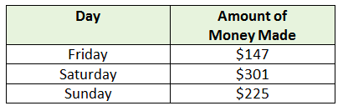

On which day does the amount of money made round to $200 when rounded to the nearest hundred?
Answer: ______________________________

- What is 561 rounded to the nearest ten? _________________
What is 561 rounded to the nearest hundred? _________________

- Jay rounded a number to the nearest ten and got 480. What could his original number have been?

___________________
- Sally rounded a number to the nearest hundred and got 600. Which number could be Sally’s original number?
a. 643
b. 400
c. 522
d. 701
e. 562
- Aiden rounded a number and got 340. Which below number could have been his original number?
336 347 350
___________________
- Write 3 numbers that round to 50,000 when rounded to the nearest 10,000.

_____________ _____________ _____________

- Round 664,418…
To the nearest ten: ______________
To the nearest hundred: ______________
To the nearest thousand: ______________
To the nearest ten thousand: ______________
To the nearest hundred thousand: ___________

- Which number rounds to 120,000 when rounded to the nearest ten thousand?

- 125,678
- 116,034
- 112,625
- 20,789

- Round each number to the nearest hundred-thousand:

6,532 _______________98,324______________ 834,239 ______________

- Jequan rounds 175,231 to 175,200; what place value was he rounding to?

________________________
- Round each number to the nearest ten-thousand.

3,976 ______________ 14,568_______________ 747,867 _________________

- To what place value would you be rounding if you rounded the number 117,290 to 120,000?

- Which two numbers round to 300,000 when rounded to the nearest hundred thousand?

a. 306,999
b. 352,384
c. 399,999
d. 245,678
e. 289,653

- Write a number that could be rounded to 340,000 when rounded to the nearest ten thousand.

________________________
18. Which two numbers could be rounded to 430,000 when rounded to the nearest ten thousand?
a. 328,782
b. 437,651
c. 435,826
d. 432,198
e. 424,307
- What is 478,901 rounded to the nearest ten thousand?

________________________
- What is the largest number that can be rounded to 2,500 when rounded to the nearest ten?

________________________
- What is 34,541 rounded to the nearest thousand?

________________________
- Find the smallest number that rounds to 400 when rounded to the nearest hundred.

________________________
- Find all of the numbers that round to 340 when rounded to the nearest ten.

________________________
- A is an unknown number. When you round A to the nearest thousand, you get 21,000. When you round A to the nearest hundred, you get 20,500.
Write A in the box that shows its location on the number line.
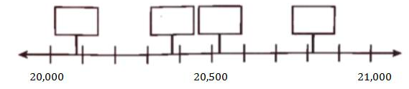
- Round 869,907 to the nearest hundred.

________________________

Workbook C

4.NBT.B.4 – Fluently add and subtract multi-digit whole numbers, with sums less than or equal to 1,000,000, using the standard algorithm.

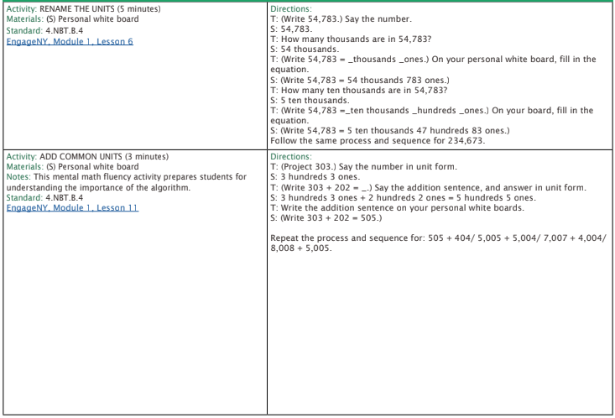
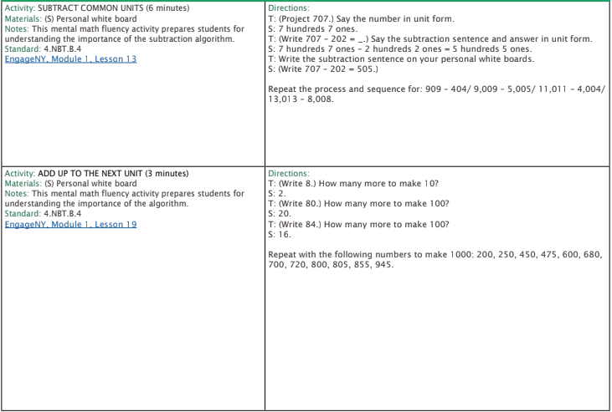
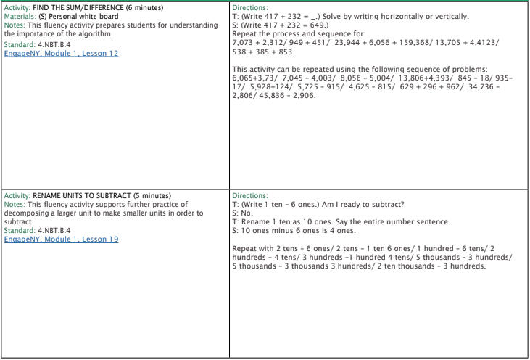
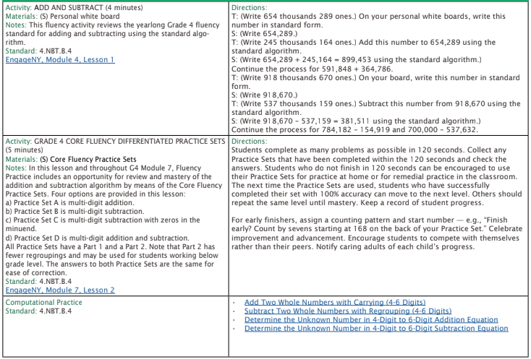

- Find the difference. 51,348 and 22,122. _________________

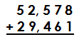
- Use the standard algorithm to solve.

- 2,265 + 15,426 _________________

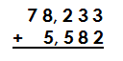
- Use the standard algorithm to solve.

- Use a strategy that makes sense to you to solve.

71,543 + 13,921 = _______________

- Use a strategy that makes sense to you to solve.

59,637 – 34,721 = _______________

- 462,722 - 208,519 = _____________________

- 786805 – 505817 = __________________________

- 56432 – 33224=__________________

- 34246+54231=__________________

- 506, 999 + 1, 287 = __________________

- 1,000 – 456 = _____________________

- 3434+443+2=__________________

- 7+5251+375=__________________

- 67,800 – 9, 893 = ___________________

Workbook D

4.NBT.B.5 – Multiply a whole number of up to four digits by a one-digit number, and multiply two two-digit numbers, using strategies based on place value and the properties of operations and explain the calculations by using equations, rectangular arrays, and/or area models.

- Solve.

12 x 9 = ______ | 22 x 41 = _______
92 x 33 = ______ | 17 x 82 = _______
15 x 12 = _______ | 51 x 15 = _______
19 x 63 = ______ | _______ = 11 x 18
_______ = 29 x 17 | _______ = 34 x 26
_______ = 36 x 49 | 47 x 14 = _____
27 x 56 = _______ | _______ = 18 x 32

- Find the product.

3 x 900 = ____________

- Use a place value array to solve.

4 x 534 = ______

- Find the product.

6 x 2,452 = ______

- Find the missing factor.

2 x ________ = 1,800

- Find the product.

3,025 x 6 = ________

- Find the product.

5 x 600 = ____________

- Solve.

32 x 21= __________

- Solve.

21 x 93 = ______ | 52 x 43 = _______
19 x 23 = ______ | 27 x 52 = _______
5 x 120 = _______ | 53 x 25 = _______
9 x 632 = ______ | _______ = 11 x 185
_______ = 296 x 7 | _______ = 348 x 2
_______ = 3,643 x 4 | 472 x 4 = _____
7 x 5,631 = _______ | _______ = 8 x 329

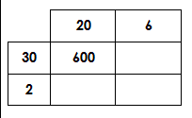
- Fill in the missing partial products. Then solve.

32 x 26 = _________

- Find the missing factor.

30 x ______ = 900

- Find the product.

6 x 2,304 = ___________

- Find the product.

8 x 300 = ______

- Calculate the product of 64 x 35.

- 32 x 24

- 481 x 9

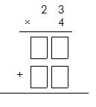
- Fill in the partial products and then solve.

- 29 x 41 = _____

- 5,607 x 7 = __________

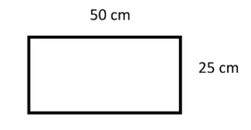
- Find the area.

_______________________________

- Write an equation that matches the area model.
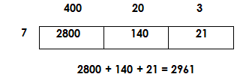

_________________________

- 2,546 x 6 = ________

- 34 x 22 = ________

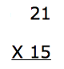

- 705 x 2

- 54 x 16

- 8,901 x 3

4.NBT.B.6 – Find whole-number quotients and remainders with up to 4-digit dividends and one-digit divisors, using strategies based on place value, the properties of operations, and/or the relationship between multiplication and division. Illustrate and explain the calculation by using equation, rectangular arrays, and/or area models.

- Stephanie solved a division problem using the area model. What division problem did she solve?

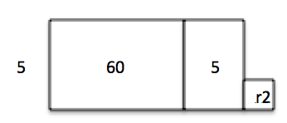
_________________________

- 5,082 ÷ 6 =

- Solve using the area model to finding missing side length.
1,071 ÷ 3 = ______________________________

- 308 ÷ 7 = ____________

- Solve 46 ÷ 3 using an area model.

- 448 ÷ 3 = ____________

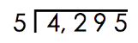
- Solve.

- 2031 ÷ 8 = ____________

- 462 ÷ 7 = ____________

- 28,000 ÷ 7 = _____________

- 508 ÷ 3 = ______________

- 1,010 ÷ 9 = _____________

- 576 ÷ 6 = _____________

- What is the missing number? 5,600 ÷ 8 = _________

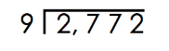
- Solve.

- 1,600 ÷ 40 = ____________

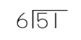
- Solve.

- 432 ÷ 4 = ____________

- Solve. 640 ÷ 80 = _____________

- 504 ÷ 6 = _____________

- 1,832 ÷ 3 = ______________

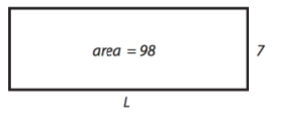
- Find the length of the side that is missing.

- 2,008 ÷ 4 = ___________

- 1,709 ÷ 3 = ____________

- 972 ÷ 6= ___________

4.MD.A.1 – Know relative sizes of measurement units within one system of units including ft, in; km, m, cm, g; lb, oz; l, ml; hr, min, sec. Within a single system of measurement, express measurement in a larger unit in terms of a smaller unit. Record measurement equivalents in a conversion two-column table. (Conversions are limited to one-step conversions.)
- Circle the best unit of measurement.
2 meters or 20 centimeters
Liters | Milliliters
1
2
5
10
15
- Fill in the conversion table.

- Jorge wants to measure the height of his dinner table. Which tool would be best for Jorge to use?
A. ruler B. yardstick C. thermometer D. tablespoon

- A spoon holds:
- Less than a cup
- 1 cup
- 1 quart
- 1 pint

- 5 gallons 3 quarts = __________ quarts

Meters | Centimeters
1
5
15
22
30
- Fill in the conversion table.

- Which unit of measure would be best to use to measure the mass of a car?

- meters B. kilograms C. grams D. ounces

- Which unit of measure would be best to measure the length of a bus?

- Inches b. ounces c. feet d. miles

- Complete the table.
Gallons | Quarts
1
2
4
12
15

- Which unit of measure would be best to measure the capacity of a coffee mug?

- Ounces b. Liters c. Teaspoons d. Cups

- Complete the table.
Quarts | Pints
1
2
6
10
16

- Circle the correct response. A pool holds…

30 gallons or 3,000 gallons
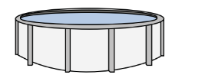

- 7 gallons 2 quarts = __________ quarts

- 3 quarts 1 pint = __________ pints

Yards | Feet
1
2
5
7
- Fill in the conversion table.

- 9 pints 3 cups = __________ cups

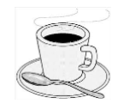
- Circle one. 2 cups 2 quarts

- Answer true or false for the following statement. If it is false rewrite one side to make it true.
1 gallon < 5 quarts __________________

- Fill in the conversion table.
Pounds | Ounces
1
2
5
10
15

- Answer true or false for the following statement. If it is false rewrite one side to make it true.
4 liters = 4,000 milliliters __________________

- Answer true or false for the following statement. If it is false rewrite one side to make it true.
15 pints < 28 cups __________________

Feet | Inches
1
2
5
10

- 5 feet 7 inches = ___________ inches

- 13 yards 6 feet = __________ feet

- 6 liters 893 mL = ____________ milliliters

4.MD.A.3 – Apply the area and perimeter formula for rectangles in real-world and mathematical problems.

- Find the perimeter of the shape below.
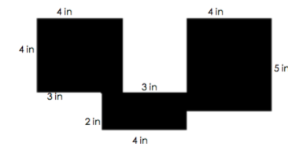

Perimeter ____________
- What is the area and perimeter of a square that has side lengths that are all 8 inches long?

Area________________ Perimeter____________

- What is the area of the shape below?

Area ______________

- What is the area of the shape?

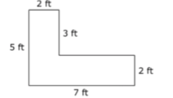

Area _______________

- Find the area and perimeter of rectangle A, which has a length of 4 feet and a width of 2 feet.

Area____________ Perimeter _____________
- What is the area and perimeter of a shape that is 5 inches wide and 9 inches long?

Area____________ Perimeter _____________

- Find the perimeter of the shape below.
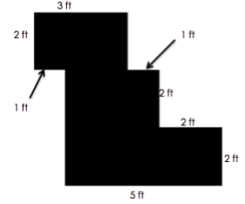

Perimeter _____________
- A rectangular flowerbed in the city park has an area of 12 meters. The width of the flowerbed is 3 meters. What is the length of the flowerbed?

______________________
- A rectangle is 6 meters wide. The length is 2 meters more than its width. What is the area and perimeter of the rectangle?

Area____________ Perimeter _____________

- What is the length of the missing side?
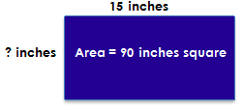

______________________
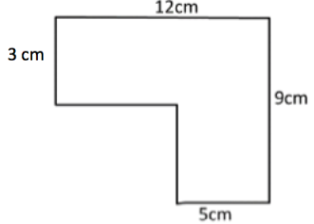
- What is the perimeter of this shape?

Perimeter _____________

- Find the area and perimeter of a shape that has a length of 7 feet and a width of 10 feet.

Area____________ Perimeter _____________
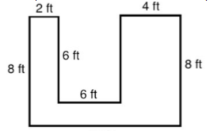
- Find the area of the shape.

Area____________

- What is the perimeter of the shape?
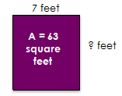
Area____________ Perimeter _____________

- What is the area and perimeter of a square that has a side length of 13 ft?

Area____________ Perimeter ____________

- Find the area of the shape.

Area____________

- What is the perimeter of the shape below?

Perimeter____________

- What is the perimeter of the shape below?

Perimeter____________
- What is the area of the shape below?

Area____________

- What is the area and perimeter of a rectangle with a length of 10 ft. and a width of 24 ft.?

Area____________ Perimeter _____________

- What is the area of the shape below?

Area____________

- What is the area and perimeter of a square with a length of 15 inches?

Area____________ Perimeter _____________

- What is the perimeter of the shape below?

Perimeter _____________

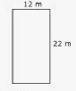
- How many meters of fencing would you need for the garden shown below?

____________________

- What is the area of the garden above?

Area____________

Workbook E

4.NF.A.1 – Explain why a fraction a/b is equivalent to a fraction (n x a)/(n x b) by using visual fraction models with attention to how the number and size of the parts differ even though the two fractions themselves are the same size. Use this principle to recognize and generate equivalent fractions. (Denominators are limited to 2, 3, 4, 5, 6, 8, 10, 12, and 100.)

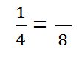
1. Find the missing digit to make the expression true:

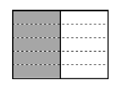
2. Write two equivalent fractions to describe this picture.

____________ and _____________

3. Which fraction is equivalent to 3/4 ?

a. 8/12 b. 7/8 c. 9/12 d. 3/8

4. The figure below has 2/3 of its whole shaded gray.

Decide if each fraction is equal to 2/3. Select Yes or No for each fraction.
 | Yes | No
4
6
1
2
8
12
5. Which digit belongs in the numerator to make the expression true?

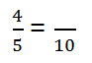
a. 9
b. 4
c. 2
d. 8

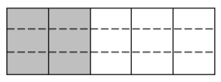
6. Write two equivalent fractions to describe the picture below:

____________ and ______________

- Use multiplication to find an equivalent fraction for $\frac{5}{6}$.

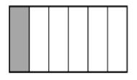
- Find two equivalent fractions for the fraction shown in the model below.

____________ and ______________

- Which of these is an equivalent fraction for 1/3 ?

a. 1/6
b. 3/6
c. 2/3
d. 3/9

- Which fractions is equivalent to the shaded picture below:

a. 3/5
b. 4/10
c. 8/15
d. 6/20
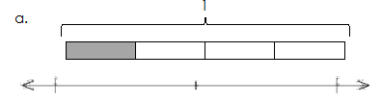
- Use the number line to find an equivalent fraction for the one shown in the model.

_______________________
- Partition a number line from 0 to 1 into fourths. Decompose 3/4 to show two different equivalent fractions.

______________ and ________________

- Vera wants to find how many twelfths are equal to ½. Which tape diagram below could she use to find her equivalent fraction?
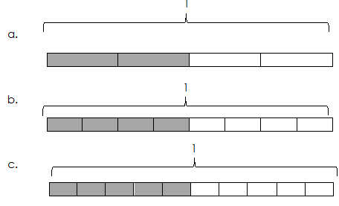

- Write two fractions that are equivalent to 1/3

____________ and ___________

- Which fraction is equal to 2/5?
A. 1/10
B. 2/10
C. 4/10
D. 5/10

- Find two equivalent fractions for

____________ and ___________

- Write two equivalent fractions for the picture shown below:

____________ and ___________
- Write two equivalent fractions for $\frac{8}{12}$

____________ and ___________
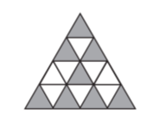
- Write an equivalent fraction for the model shown below:

__________________
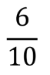
- Write two equivalent fractions for

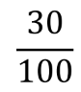
____________ and ___________
- Write two equivalent fractions for

____________ and ___________
- Write an equivalent fraction for the one shown in the model below:
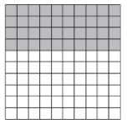

___________
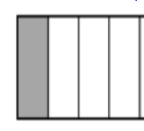
- Write two equivalent fractions for the one shown in the model below:

____________ and ___________

4.NF.A.2 – Compare two fractions with different numerators and different denominators, e.g. by creating common denominators or numerators or by comparing to a benchmark fraction such as ½. Recognize that comparisons are valid only when the two fractions refer to the same whole. Record the results of comparisons with symbols >, =, or <, and justify the conclusions, e.g. by using a visual fraction model. (Denominators are limited to 2, 3, 4, 5, 6, 8, 10, 12, and 100.)

- Select True or False for each comparison.

 | True | False
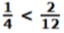
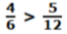

- Which fraction is greater than ¾ ?
A 6/9 B 3/6 C 5/8 D 9/10

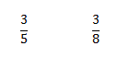
- Compare:

- Compare the following fraction by using <, >, or =.

2/6 of a gallon of paint ______ 2/6 of a teaspoon of paint

- Compare the following fractions by using <, >, or =.

2/4 of a pencil bag _______ 2/4 of a back pack

- On the lines below write an X next to all the fractions that are more than ½.

a. ¾ _________ b. 5/12 _________ c. 2/5 _________

- Put the following fractions in order from least to greatest:

6/6, 2/5, 5/10, 5/8, 8/6

_______________________________

- Compare using <, >, or =.
$\frac{4}{10}$ ______ $\frac{2}{3}$

- Compare using <, >, or =.
$\frac{3}{10}$ ______ $\frac{3}{8}$

- Mr. Liu asked the students in his fourth grade class to measure their heights. Here are some of the heights they recorded:
Sarah 4 2/3 feet J’dah 4 ¼ feet Andy 4 ½ feet Hassan 4 ¾ feet
List the four students from tallest to shortest.

________________________________________
- A recipe uses 3/5 cups butter, 3/4 cups sugar, and 1/2 cup light brown sugar. Order the ingredients from least to greatest.

________________________________________

- Compare using <, >, or =.
½ ______ $\frac{3}{5}$

- Mary, Edna, and Lucy ran these distances on Saturday:
* Mary ran 5/8 mile.
* Edna ran 2/3 mile.
* Lucy ran 3/4 mile.
Who ran the longest distance?
_______________________

- On the lines below write a X next to all the fractions that are more than ¾.

- 6/8 _________ b. 5/12 _________ c. 4/5 _________

- Write these fractions in order from greatest to least: ½, 2/5, 6/10, ¼.

_______________________
- Write a fraction in the box to make the statement true.
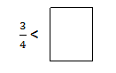

- Fill in the circle with <, >, or = to make a true statement.

- Fill in the circle with <, >, or = to make a true statement.
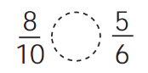

- Which fraction is greater than 2/5?

a. 1/10
b. 2/10
c. 4/10
d. 5/10

- Write two different fractions that could replace the question mark.
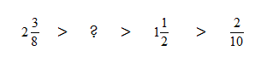

_______________ and _________________
- Write a fraction in the box to make the statement true.

$\frac{3}{5}$ <

- Write two fractions greater than ½ on the lines below.

_______________ and _________________

4.NF.B.3b – Decompose a fraction into a sum of fractions with the same denominator in more than one way, recording each decomposition in an equation. Justify decompositions, e.g. by using a visual fraction model. Examples 3/8 = 1/8 + 1/8 + 1/8, 3/8 = 2/8 + 1/8 (Denominators are limited to 2, 3, 4, 5, 6, 8, 10, 12, and 100.)

- Write 7/8 as the sum of three fractions.

- Write two different addition sentences to represent the model:

__________________________________ and _________________________________

- Draw and label tape diagrams to model the decomposition.
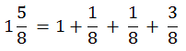

- Record this fraction’s decomposition into addition number sentences.
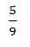

=
________________________________

- ¼ + ¼ + ¼ = ________________________________

- Write an expression that shows 3/5 as a sum of unit fractions.

- Record this fraction as a decomposition of unit fractions using addition.

$\frac{4}{12}$ =
________________________________

- Record this fraction as a decomposition of unit fractions using addition.

$\frac{4}{12}$ =
________________________________

- Record this fraction as a decomposition of unit fractions using addition.
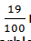

= ________________________________

- 1/8 + 3/8 + 2/8 = _____________________________

- Write 5/6 as a sum of unit fractions.

- Write 7/12 as a sum of unit fractions.

15. Write 4/6 as a sum of three fractions..

- 1/5 + 3/5 + 2/5 = _____________________________

- Add.
$$\frac{3}{10}+\frac{2}{10}+\frac{4}{10}=________$$

- Add.

$$\frac{5}{12}+\frac{2}{12}=_____________$$

- Write 7/10 as a sum of 3 fractions.

________________________________

- Write 5/8 as a sum of two fractions.

________________________________

- Decompose 4/6 in two different ways using addition.

____________________ and _______________________

4.NF.B.3c – Add and subtract mixed numbers with like denominators, e.g. by replacing each mixed number with an equivalent fraction and/or by using properties of operations and the relationship between addition and subtraction.
1. Find the sum.
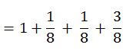

2. Solve.
$$5\frac{3}{8}-1\frac{1}{8}$$

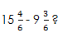
3. Solve.

___________________
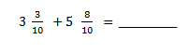
4. Solve.

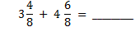
5. Solve.
- Solve.

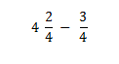
- Solve.

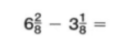
- Solve.
- Solve.
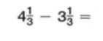

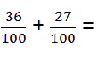
- Solve.

- What value can you write to make the statement true?
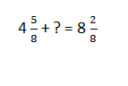

_____________________________

- The shaded parts of the fraction strips below represent two fractions. What is the sum of the two fractions?
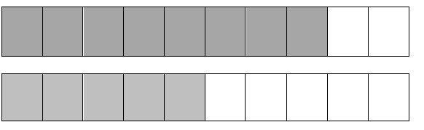

_____________________________

- 3 $\frac{3}{5}$ + 7 $\frac{4}{5}$ = ______

- 8 $\frac{1}{9}$ – 1 $\frac{7}{9}$ = _______

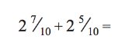

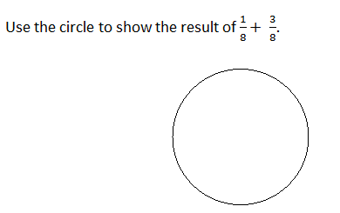

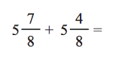

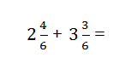

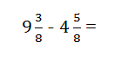

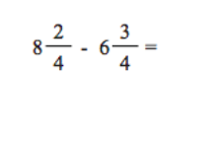

- What value makes the equation true?
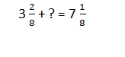

______________________
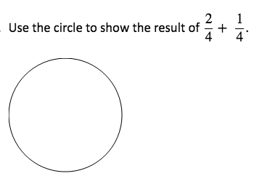

4.NF.B.4a – Understand a fraction a/b as a multiple of 1/b.

- Solve.
$\frac{1}{2}$x5

- Complete the multiplication sentence.
$$2 x\frac{2}{11}= x\frac{1}{11}$$

- Solve.

$$8 x\frac{1}{4}$$

- ¼ x 5 = ___________

- Complete the multiplication sentence.
$$\frac{4}{3}=4 x\frac{}{3}$$

- Complete the multiplication sentence.

$$\frac{6}{6}=6 x\frac{1}{}$$

- $\frac{1}{7}x 5$

- Is each product less than 1, equal to 1, or greater than 1? Place each product in the correct box.
$$\frac{1}{4}x 3 4 x\frac{1}{2}$$
$$\frac{1}{3}x 1$$

Less than 1 | Equal to 1 | Greater than 1

- 12 x ¼ = _________________

- 5 x 1/6 = _________________

4.NF.B.4 – Multiply a fraction by a whole number.

4.NF.B.4b – Understand a multiple of a/b as a multiple of 1/b, and use this understanding to multiply a fraction by a whole number.
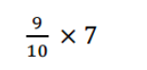

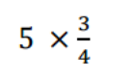

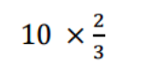

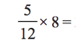

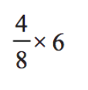

- ¾ x 12 = ________________

- _______ x 4 = $\frac{8}{10}$

- $\frac{3}{8}$x 4 = _______________

- ½ x 10 = ______________

- ¼ x 5 = _______________

- _______ x 6 = 12/10

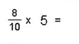

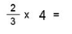

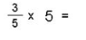

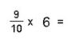

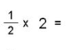

Workbook F

4.NF.C.5 – Express a fraction with a denominator 10 as an equivalent fraction with a denominator 100 and use this technique to add two fractions with respective denominators 10 and 100.
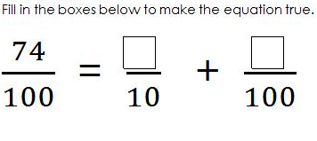

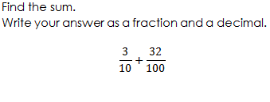

- Write an expression that is equal to 120/100.

- Add:
$$\frac{2}{10}+\frac{32}{100}$$

- Write the equivalent fraction with a denominator of 100.

$$\frac{1}{10}=\frac{}{100}$$

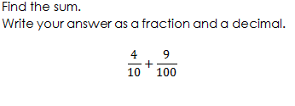

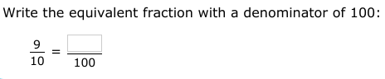
- Write the equivalent fraction with a denominator of 100.

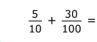
- Add.

- Subtract.
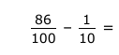

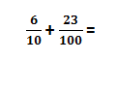

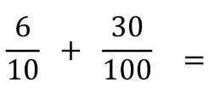

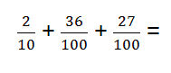

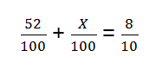

- $\frac{4}{10 }$ + $\frac{13}{100 }$ =

- $\frac{9}{100 }$ + $\frac{35}{100 }$ + $\frac{2}{10 }$ =

- $\frac{50}{100 }$ + $\frac{5}{100 }$ =

- $\frac{17}{100 }$ + $\frac{60}{100 }$ =

- $\frac{67}{100 }$ + $\frac{5}{10 }$ =

- $\frac{24}{100 }$ + $\frac{8}{10 }$ =

4.NF.C.6 – Use decimal notation for fractions with denominators 10 or 100.

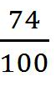

1. Rewrite as a decimal.

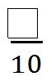
____________________
2. 0.8 =

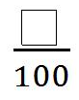
3.
= 0.9

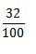
4. Rewrite as a decimal.

___________________

5. Rewrite as a decimal.
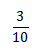

___________________

6. 0.09 =

7. Select whether the equations are true or false.

 | True | False
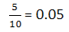
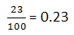
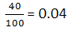
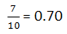

- Five students had to write the number 31 5/100 as a decimal. Circle the student(s) that were incorrect.
Sam  31.500 | Justin  31.05 | Marcus  31.005 | Tina  31,050 | Nikki  31.050

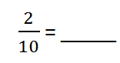
- Write the fraction in decimal format.

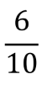
- Convert the following to a decimal.
- Convert the following to a decimal.

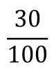
- Convert the following to a decimal.

- Which fraction is equal to 0.02?

a. 2/10 b. 2/100 c. 20/100 d. ½

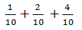
- Rewrite the sum as a decimal.

_______________________

- Write the amount of money with a dollar sign and a decimal point.

4 dollars + 8 dimes + 6 pennies

_______________________

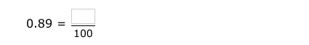
- Write 0.89 as a fraction with a denominator of 100.

- Rewrite 0.99 as a fraction.

_____________________
- Write 3/10 as a decimal number.

_____________________
- Write 35 9/10 as a decimal number.

_____________________

- Represent 15/100 of a dollar in decimal form, using a dollar sign.

_____________________

- Write 1.19 as a mixed number.

_____________________
- Write $\frac{13}{100}$ as a decimal.

____________________

- Write the amount below in expanded form using decimal place value.
$6.04

____________________
- Write 12.04 as a mixed number.

____________________
- Write 5 $\frac{6}{10}$ as a decimal.

____________________

4.NF.C.7 – Compare two decimals to hundredths by reasoning about their size. Recognize that comparisons are valid only when two decimals refer to the same whole. Record the results of comparisons with the symbols >, =, or <, and justify the conclusions e.g. by using a visual model.

1. Which comparison is correct?

a. 0.5 meter > 0.05 meter b. 0.05 meter > 0.4 meter
c. 0.2 meter < 0.04 meter d. 0.4 meter > 0.54 meter

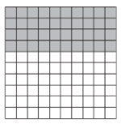
2. Which decimal is less than the fraction shaded in the grid?
a. 0.46
b. 0.50
c. 0.36
d. 0.40
3. Shade the decimal amount on the given grids and plot them on the number line. Then use the model to compare the decimals using <, > or =.
0.5 _______ 0.67
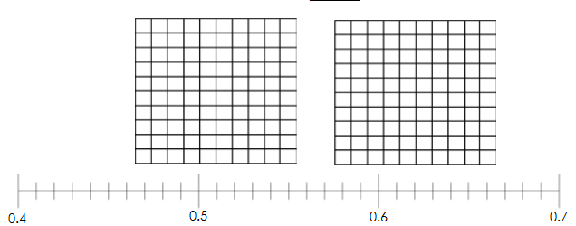

4. Compare using <, >, or =.
0.19 _______ 0.2

5. Compare using <, >, or =.
0.89 _______ 0.8
6. Which three comparisons are correct?
A) 0.3 inch > 0.03 inch
B) 0.03 inch > 0.2 inch
C) 0.2 inch < 0.4 inch
D) 0.4 inch > 0.54 inch
E) 0.76 inch > 0.50 inch
F) 0.54 inch < 0.03 inch

7. Place each decimal on the number line; then write an inequality to compare.
0.34 ______ 0.28
8. Which number has the greatest value?

a. 0.63 b. 6.30 c. 0.03 d. 0.60
9. Shade the decimal amount on the given grids and plot them on the number line. Then use the model to compare the decimals using <, > or =.
1.9 _______ 0.9
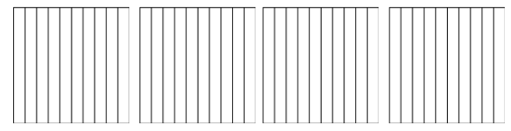

10. Compare using <, >, or =.
0.8 _______ 0.80

- Fill in the blanks with <, >, or = to make the comparisons true.
0.2 _____ 0.31 | 0.35 _____ 0.19
0.09 _____ 0.11 | 0.64 _____ 0.6

- Place each decimal on the number line; then write an inequality to compare.
  - _____ 0.08

13. Write the decimals in order from least to greatest.
0.7 0.4 0.18 1.9
____________________________________
14. Fill in the blanks with <, >, or = to make the comparisons true.

0.55 _____ 0.64 | 0.39 _____ 0.37
0.41 _____ 0.14 | 0.71 _____ 0.65

- Compare using <, >, or =.

1.18 __________ 1.3

- Write the row of decimals in order from least to greatest.
2.34 1.98 5.77 1.35
____________________________________________________

- Write the decimals in order form greatest to least.

0.98 0.8 1.1 0.09

_________________________________________

- Write the decimals in order from greatest to least.
7.35 7.27 8.68 7.79
________________________________________________

- Which decimal is less than the one shown in this diagram?

0.90 0.96 0.95 0.94

- Compare using <, >, or =.

0.27 ______ 0. 3
21. Which decimals are less than the one shown in this diagram?

  - 0.1 0.22 0.23

22. Put these numbers in order from greatest to least.

5.77 4.33 4.9 4.07
______________________________________________________
- Which decimal is less than the one shown in this diagram?

0.4 0.52 0.8 0.6

- Compare using <, >, or =.
13.32 ________ 13. 44

25. Write two decimals that are greater than the one shown in the diagram.

___________ and ___________

Workbook G

4.G.A.1 – Draw points, lines, line segments, rays, angles (right, acute, obtuse), and perpendicular and parallel lines. Identify these in two-dimensional figures.

- Use the following directions to draw a figure in the box to the right.
a. Draw two points: 𝐴 and 𝐵.
b. Use a straightedge to draw ray 𝐴𝐵⃑.
c. Draw a new point that is not on ray 𝐴𝐵⃑. Label it 𝐶.
d. Draw 𝐴𝐶̅.

- Draw a shape that has at least one set of parallel lines and one set of perpendicular lines.

- Identify at least two of perpendicular lines for the shape.
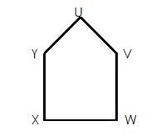 _____________and ________________
- Draw a set of parallel lines.

- Draw an acute angle.

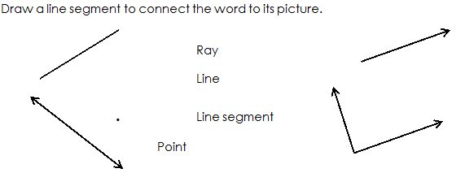
6.

- Draw an obtuse angle.

- Identify a set of parallel lines. _______________
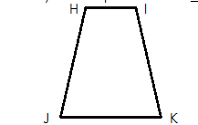

- Draw a right angle.

- Write if each is a point, line segment, line, or ray.
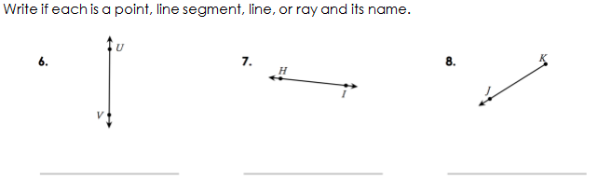

_____________ ____________ _____________
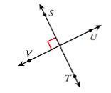
- What type of lines are these?

_____________________________

- Label each figure as a point, line segment, line, or ray.

__________________ _______________ ______________

- Draw a set of parallel lines.

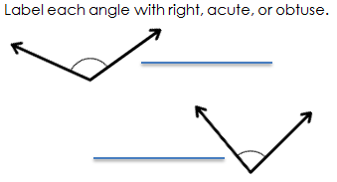
14.

- Draw a shape with one set of perpendicular lines and one acute angle.

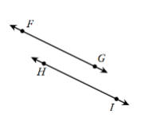
- What type of lines are shown below?

_________________________
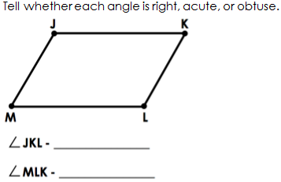

- Draw a line segment; label it BC.

- Draw a ray. Label it AB.

- Draw a shape with 1 obtuse angle.
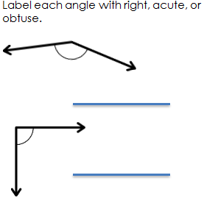

- Draw a set of perpendicular lines.

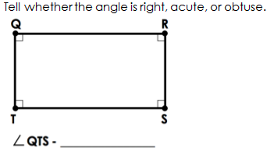

- Draw a shape with 1 set of parallel lines.

- Draw an acute angle.

4.G.A.3 – Recognize a line of symmetry for a two-dimensional figure as a line across the figure such that the figure can be folded along the line into matching parts. Identify line-symmetric figures and draw lines of symmetry.

Draw a line of symmetry through the shape below.
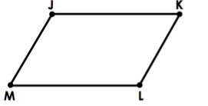

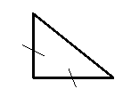
- How many lines of symmetry does the shape below contain? Draw them and write the number on the line.

__________________

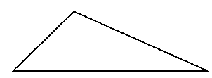
- How many lines of symmetry does the shape below contain? Draw them and write the number on the line.

__________________
- Draw a shape with at least two lines of symmetry.

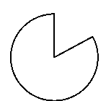
- How many lines of symmetry does the shape below contain? Draw them and write the number on the line.

__________________
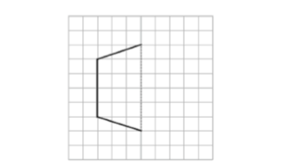
- Half of the figure below has been drawn. Use the line of symmetry represented by the dotted line, to complete the figure.

- Draw a shape with at least two lines of symmetry.

- Draw all the lines of symmetry for this shape.

- Draw a shape with 0 lines of symmetry.

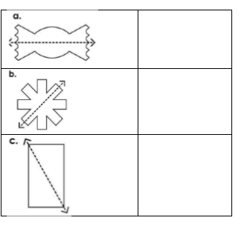
- Tell whether the dotted line on each shape represents a line of symmetry. Write yes or no on the line next to the shape.

- Draw all lines of symmetry for the shape below.

- Is the dotted line a line of symmetry?

__________________

- Draw lines of symmetry on the shape below.
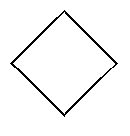

- How many lines of symmetry does this shape have?

__________________

- True or false: The shape below has one line of symmetry.

___________________
- Is the line below a line of symmetry?

___________________

- Draw a shape with two lines of symmetry.

- How many lines of symmetry does this shape have? Draw them.

___________________
- Draw a shape with no lines of symmetry.

- Draw all the lines of symmetry for this shape.

Workbook H

4.MD.C.6 – Measure angles in whole-number degrees using a protractor. Sketch angles of specified measure.

- Use a protractor to find the measure of the angle below; then write it on the line.
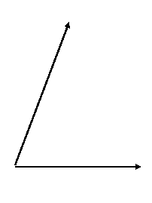

____________________

- Draw an angle that measures 65$°$.

- Draw a right angle.

- Draw an angle that measures 120$°.$

- Use a protractor to find the measure of the angle below; then write it on the line.

____________________
- Use a protractor to find the measure of the angle below; then write it on the line.
_________________
- Draw an obtuse angle. Use a protractor to find and record its measurement on the line.

_________________

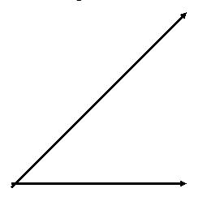
- Use a protractor to find the measure of the angle below; then write it on the line.

_________________
- Draw an acute angle. Use a protractor to find and record its measurement on the line.

_________________
- Draw an angle that is exactly half as big as a right angle.

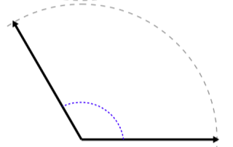
- Use a protractor to measure the angle.

_________________

- Draw an angle that measures 50$°$.

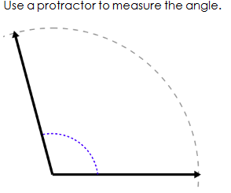
- Use a protractor to measure the angle.

_________________

- Draw an obtuse angle. Use a protractor to record its measurement on the line.

_________________
- Draw an angle that measures 145$°$.

- Which choice best represents ∟ABC?

- 67º
- 142 º
- 100 º
- 15 º

- Draw an angle that measures 25$°$.

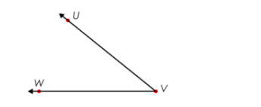
- What is the angle measurement of Angle UVW?

________________________

- Draw an acute angle. Use a protractor to record its measurement.

_________________________
- Draw an angle that measures 105$°$.

- Use a protractor to measure the angle.
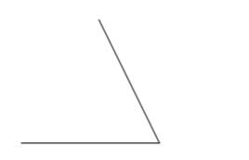

_____________________

- Draw a right angle.

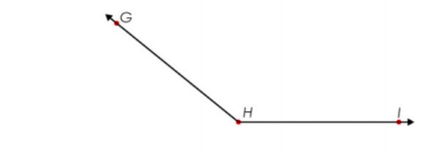
- What is the angle measurement of Angle GHI?

______________________

- Draw an angle that measures 165$°$.

- Draw an angle that measures 53$°$.

4.MD.C.7 – Recognize angle measure as additive. When an angle is decomposed into non-overlapping parts, the angle measure of the whole is the sum of the angle measure of the parts. Solve addition and subtraction problems to find unknown angles on a diagram in real-world and mathematical problems, e.g., by using an equation with a letter for the unknown angle measure.

- Find the measurement of Angle A
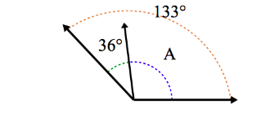

__________________

- Circle the pair of angles that are supplementary angles.
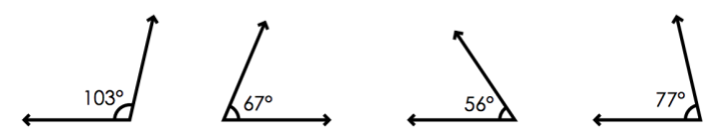

- Write an equation, and solve for the unknown angle measurements numerically.

________º + _________º + _________º = __________º
cº = _________º
- Two angles add up to 65$°$. What could their measurements be?

_________________

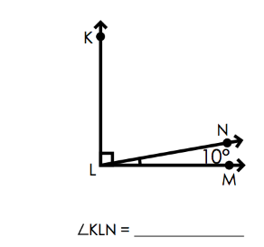
- Find the missing angle.

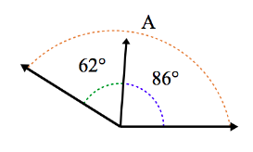
- What is the value of A?

__________________

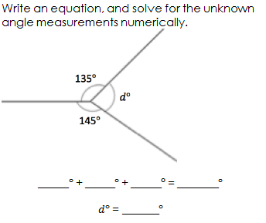
- Write and equation and solve for the unknown angle measurements numerically.

________º + _________º + _________º = __________º
dº = _________º
- Two angles are complementary. What could their measurements be?

__________________
- Two angles add up to 87$°$. What could their measurements be?

__________________
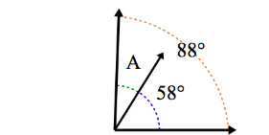
- Find the measurement of Angle A.

__________________

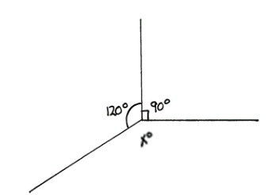
- What is the measurement of angle X?

__________________

- Two angles add up to 145$°$. What could their measurements be?

__________________
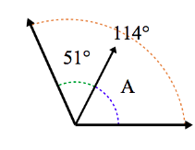
- What is the value of A?

______________
- Write an equation and solve for the unknown angle measurements numerically.

________º + _________º + _________º = __________º
dº = _________º

- Angle ABC is complementary. If angle AB measures 13$°$. What is the measurement of angle BC?

____________________
- Angle JKL is supplementary. If angle JK measures 97$°$. What is the measurement of angle KL?

____________________

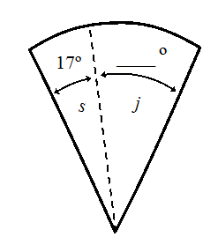
- The total of Angle SJ is 75$°$. What is the measurement of angle J?

____________________

- Angle a measures 23$°$ and Angle b measures 15$°.$ What is the total of angle AB?
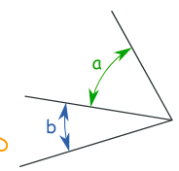

____________________

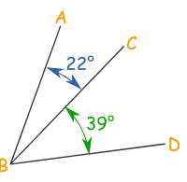
- What is the total of angle ABD?

____________________

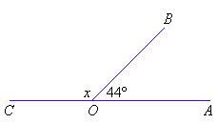
- What is the measure of angle X?

____________________

Copyright: Achievement First. Unless otherwise noted, all of the content in this resource is licensed under a Creative Commons Attribution International 4.0 (CC BY) license.
“Grade 4 Module 3” by EngageNY licensed under Creative Commons Attribution International 4.0 (CC BY-NC-SA.). Achievement First does not own the copyright in “Fluency Problem” and claims no copyright in this material. The material is being used exclusively for non-profit educational purposes under fair use principles in U.S. Copyright laws. The user should make the judgment about whether this material may be used under fair use / fair dealing permissions in the user’s country.
Multiplicative Compare Problem by Khan Academy, 2018. Achievement First does not own the copyright in “Fluency Problem” and claims no copyright in this material. The material is being used exclusively for non-profit educational purposes under fair use principles in U.S. Copyright laws. The user should make the judgment about whether this material may be used under fair use / fair dealing permissions in the user’s country.
“Grade 4 Module 3” by EngageNY licensed under Creative Commons Attribution International 4.0 (CC BY-NC-SA.). Achievement First does not own the copyright in “Fluency Problem” and claims no copyright in this material. The material is being used exclusively for non-profit educational purposes under fair use principles in U.S. Copyright laws. The user should make the judgment about whether this material may be used under fair use / fair dealing permissions in the user’s country.
Multiplicative Compare Problem by Khan Academy, 2018. Achievement First does not own the copyright in “Fluency Problem” and claims no copyright in this material. The material is being used exclusively for non-profit educational purposes under fair use principles in U.S. Copyright laws. The user should make the judgment about whether this material may be used under fair use / fair dealing permissions in the user’s country.
Author and Source Unknown. Achievement First does not own the copyright in “Fluency Problem” and claims no copyright in this material. The material is being used exclusively for non-profit educational purposes under fair use principles in U.S. Copyright laws. The user should make the judgment about whether this material may be used under fair use / fair dealing permissions in the user’s country.
Author and Source Unknown. Achievement First does not own the copyright in “Fluency Problem” and claims no copyright in this material. The material is being used exclusively for non-profit educational purposes under fair use principles in U.S. Copyright laws. The user should make the judgment about whether this material may be used under fair use / fair dealing permissions in the user’s country.

